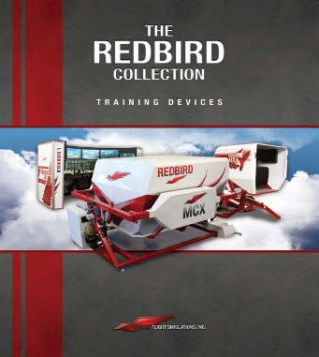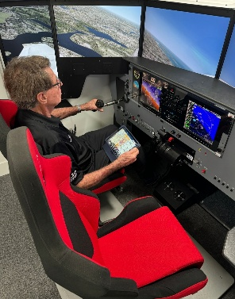
REDBIRD ADVANCED TRAINING DEVICE THE MODERN WAY TO TRAINING
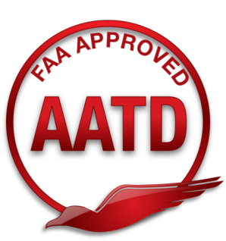
REDBIRD FMX AATD LD/CL SPECIAL CIRRUS SR22
Manufactured May 2022 Low time 440Hrs Condition: Excellent

Configurations:
- Cessna C-172 G1000 with 3 axis KAP140 WAAS enabled Autopilot.
Control loaded Cessna style Yoke with PTT, electric trim and Autopilot disconnect. Cessna style Vernier (Push/Pull) throttle and mixture controls.
- Cessna C-182R (RB1000) with Garmin WAAS enabled Garmin GNS 430/530 stack, ADF and 3 axis KAP140 WAAS enabled Autopilot. Control loaded Cessna style Yoke with PTT, electric trim and Autopilot disconnect. Cessna style Vernier (Push/Pull) throttle, propeller and mixture controls.
- Cirrus SR22 Perspective with GFC 700 G1000 Garmin 3 axis, WAAS enabled autopilot. Control loaded Cirrus style control stick with PTT, pitch and roll electric trim and Autopilot disconnect. Cirrus style throttle, mixture and fuel pump controls.
Options:
- Current RealNav 4 subscription with Quarterly updates.
- Corvus – Sync Foreflight to Redbird for GPS location data, AHARS data and ADS-B TIS-B information.
- Upgraded Custom Captains chairs
- Custom charging cables (2) for iPhone, iPad or Android type web enabled devices for navigation and sim control.
- Aluminum Redbird Acrylic mounting hardware panel wall support
Always monitored and maintained under Redbird Maintenance Contract assuring that all programing (Redbird, RealNav and Windows) is up to date.
All original FAA documentation required by AC 61-136B including Redbird Navigator Manual Letters of Authorization (Loa), Qualification and Approval Guide (QAG) and Redbirds Assembly/Disassembly Instructions.

Simulator broker.com IFRVNY@AOL.COM (818) 371-8653 Independent broker not affiliated with Red Bird Simulation

