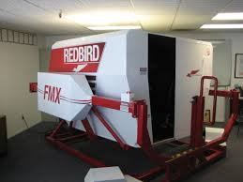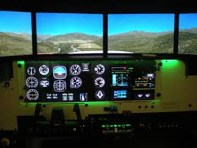

REDBIRD FMX FULL MOTION AATD USED

Manufacture 2014
Electric motion platform

• Fully enclosed cockpit
• +200° wrap-around visuals
• Quick-change cockpit configuration
Single-engine PA-28-configuration
- Instructor station
- Standard 6 pack configuration
- G-530/430 & 6 pack cockpit display
- Multiengine Baron configuration
- G-1000 glass MFD/PFD display
- WASS RNAV 2014
- Upgraded CPU 2020
- Control loading yolk.
- Complete terrain and airport database
- Operates on a standard 110 volt outlet
- FAA Certified AATD

Installation & recertification
Maintenance contract available Redbird AATD Manufacture SimulatorBroker.com (818)-371-8653 IFRVNY@AOL.COM
Independent Simulator broker not affiliated with Red Bird simulation

The purchase of an FMX includes any one cockpit from

