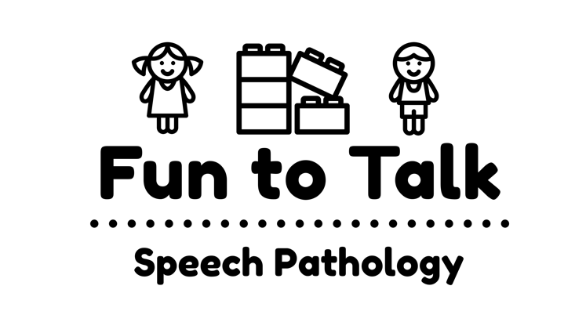
350 Aberdeen Street,
Manifold Heights, VIC 3218
Email: funtotalkspeech@gmail.com
Web: www.funtotalk.com.au
Phone/Fax: 03 5298 1793
ABN: 90 747 869 390

PRIVACY POLICY
1st July 2018

1. PART 1 – ABOUT THIS POLICY

1.1 Purpose
Fun to Talk Speech Pathology is committed to protecting the privacy of personal information we collect and hold about individuals.
Fun to Talk Speech Pathology complies with the Australian Privacy Principles (APPs) under the Privacy Act 1988 (Cth), other privacy laws that govern how private sector health service providers like Fun to Talk Speech Pathology handle your personal information (including your health information), and Speech Pathology Australia’s Code of Ethics (2010).
This Privacy Policy explains how Fun to Talk Speech Pathology manages the personal information we collect, use and disclose.
Fun to Talk Speech Pathology is a private speech pathology practice under the ownership of Stephen McKay

2. PART 2 – HOW (name of the practice) HANDLES YOUR PERSONAL INFORMATION

2.1 Fun to Talk Speech Pathology’s Legal Obligations
In order to provide you with the health care services that you have requested, Fun to Talk Speech Pathology will need to collect and use your personal information. If you provide incomplete or inaccurate information to us or withhold personal and health information from us we may not be able to provide you with the services you are seeking.
2.2 What information does Fun to Talk Speech Pathology collect?
We will only collect the information we need for the particular function or activity we are carrying out.
We collect information from you that is necessary to provide you with speech pathology services and to manage our relationship with you. The information we collect includes: your name, date of birth, address, health fund details and information about your health history and family history. We require this information to assist the speech pathologist to diagnose and treat you.
2.3 How does Fun to Talk Speech Pathology collect health information?
We will usually collect your health information directly from you. Sometimes, we may need to collect information about you from a third party (such as a relative or another health service provider).
2.4 How does Fun to Talk Speech Pathology use your information?
Fun to Talk Speech Pathology uses your personal information for the purpose you have given the information to us. We will use your information to provide speech pathology services to you, to manage our relationship with you and to contact you in relation to matters concerning your care. We may also use your information for other purposes permitted under the Privacy Act 1988.
Who might we disclose your information to?
We may disclose your information to the following people:
(a) disclosure to other health professionals involved in your treatment
Your personal information will generally only be used by the speech pathologist involved in your care, however on occasion your care may be provided by a number of health professionals (for example., speech pathologist, occupational therapist and/or psychologist) working or consulting together. We may disclose your information to these health professionals as part of the process of providing your care and to other health professionals involved in your care.
(b) the referrer
Fun to Talk Speech Pathology will usually send a discharge summary to the referrer (i.e., your medical practitioner) following discharge from Fun to Talk Speech Pathology or at other times, as required for your care.
If you do not wish us to provide a copy of your discharge summary to the referrer you must let us know. Also, if the referrer’s details have changed please let us know.
(c) Relatives, guardian, close friends or legal representative
We may provide information about your condition to your parent, child, other relatives, close personal friends, guardians, or to a responsible person for you, unless you tell us that you do not wish us to disclose your health information to any such person.
Other uses and disclosures
In order to provide the best possible environment in which to treat you, we may also use or disclose your personal and health information where necessary for:
- activities such as quality assurance processes, accreditation, audits, risk and claims management, patient satisfaction surveys and staff education and training;
- invoicing, billing and account management;
- to liaise with your health fund, Medicare or the Department of Veteran's Affairs and where required provide information to your health fund, Medicare or the Department of Veteran's Affairs to verify treatment provided to you;
- the purpose of sending you standard reminders, for example for appointments and follow-up care, by text message or email to the number or address which you have provided to us.
(f) Other uses with your consent
With your consent we may also use your information for other purposes such as including you on a marketing mail list, or research. Please note, however, that unless you provide us with your express consent for this purpose, we will not use your information in this way. We will not disclose your personal information to any individual who is outside Australia.
2.5 Access to and correction of your health information
You have a right to access the personal and health information that we hold about you. You can also request an amendment to your personal and health information should you believe that it is inaccurate.
If we do not agree to change your medical record/personal information in accordance with your request, we will permit you to make a statement of the requested changes and we will enclose this with your record.
Should you wish to obtain access to or request changes to your health record you can ask for our Privacy Officer (see details below) who can give you more detailed information about Fun to Talk Speech Pathology's access and correction procedure.
Please note that Fun to Talk Speech Pathology may recover reasonable costs associated with supplying this information to you.
2.6 Data Quality
Fun to Talk Speech Pathology will take reasonable steps to ensure that your personal information which we may collect, use or disclose is accurate, complete and up-to-date.
2.7 Data Security
Fun to Talk Speech Pathology will take reasonable steps to protect your personal information from misuse, interference, loss, unauthorised access, modification or disclosure. We use technologies and processes such as access control procedures, network firewalls, encryption and physical security to protect your privacy.
Fun to Talk Speech Pathology will destroy or permanently de-identify any of your information which is in its possession or control and which is no longer needed for the purpose for which it was collected provided Fun to Talk Speech Pathology is not required under an Australian law or court/tribunal or otherwise to retain the information.
2.8 What to do if you have a complaint about privacy issues
If:
(a) you have questions or comments about this Privacy Policy;
(b) Fun to Talk Speech Pathology does not agree to provide you with access to your personal information; or
(c) you have or a complaint about our information handling practices,
You can lodge a complaint with Fun to Talk Speech Pathology on the details below. We will promptly review your complaint and provide a response to you.
2.9 How to contact us if you have a complaint about privacy issues
By letter: Privacy Officer, Fun to Talk Speech Pathology, 350 Aberdeen Street, Manifold Heights, VIC 3218.
By email: funtotalkspeech@gmail.com
By telephone: 03 5298 1793

PART 3 – HOW FUN TO TALK SPEECH PATHOLOGY HANDLES YOUR PERSONAL INFORMATION WHEN YOU VISIT OUR WEBSITE

This section of our Privacy Policy explains how we handle your personal information which is collected from our website: www.funtotalk.com.au.
This Privacy Policy applies to your use of our website and the use of any of the facilities on our website.
3.1 Collection
When you use our website, we do not attempt to identify you as an individual user and we will not collect personal information about you unless you specifically provide this to us.
Sometimes, we may collect your personal information if you choose to provide this to us via an online form or by email, for example, if you:
- submit a general enquiry via our contacts page;
- send a written complaint or enquiry to our Privacy Officer.
When you use our website, our Internet Service Provider (ISP) may record and log for statistical purposes the following information about your visit:
- your computer address;
- your top level name (for example, .com, .gov, .org, .au etc.);
- the date and time of your visit;
- the pages and documents you access during your visit; and
- the browser you are using.
Our web-site management agent may use statistical data collected by our ISP to evaluate the effectiveness of our web-site.
3.2 Cookies
A "cookie" is a device that allows our server to identify and interact more effectively with your computer. Cookies do not identify individual users, but they do identify your ISP and your browser type.
This website uses temporary cookies. This means that upon closing your browser, the temporary cookie assigned to you will be destroyed and no personal information is maintained which will identify you at a later date.
Personal information such as your email address is not collected unless you provide it to us. We do not disclose domain names or aggregate information to third parties other than agents who assist us with this website and who are under obligations of confidentiality. You may be able to configure your browser to accept or reject all cookies and to notify you when a cookie is used. We suggest that you refer to your browser instructions or help screens to learn more about these functions. However, please note that if you configure your browser so as not to receive any cookies, a certain level of functionality of the Fun to Talk Speech Pathology website and other websites may be lost.
3.3 Links to third party websites
We may create links to third party websites. We are not responsible for the content or privacy practices employed by websites that are linked from our website.
3.4 Use and disclosure
We will use any personal information collected via our website in accordance with our privacy policy.

