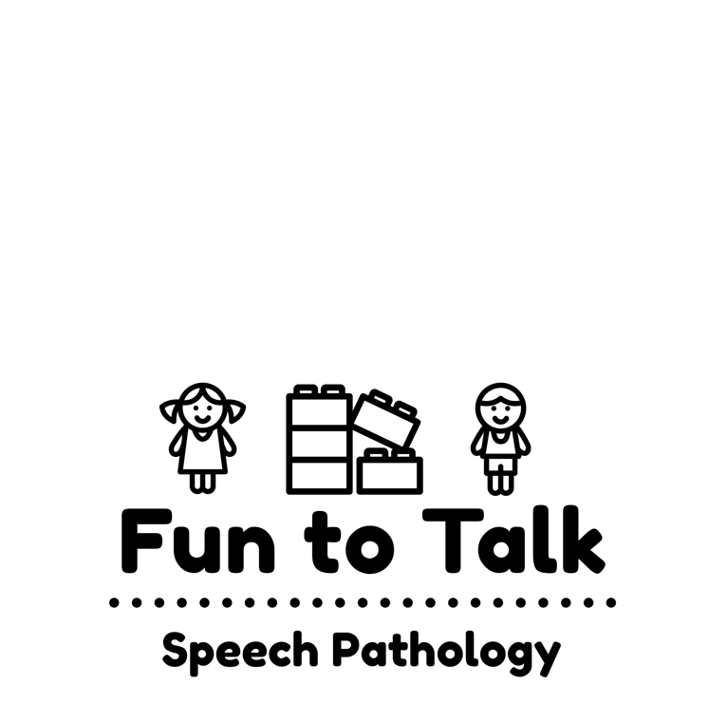

**350 Aberdeen Street,**

**Manifold Heights, VIC 3218**

**Email:** [**funtotalkspeech@gmail.com**](mailto:funtotalkspeech@gmail.com)

**Web: www.funtotalk.com.au**

**Phone/Fax: 03 5298 1793**

**ABN: 90 747 869 390**

**Contact Details of Universal & Local Support Services**

Speech Pathology Australia www.speechpathologyaustralia.org.au  
Association for Children with a Disability www.acd.org.au  
Better Health Channel www.betterhealth.vic.gov.au  
ECIA Victoria Chapter www.eciavic.gov.au  
Play Connect www.playgroup.org.au  
Australian Psychological Society www.psychology.org.au  
Raising Children Network www.raisingchildren.net.au  
Autism Victoria – Amaze www.amaze.org.au  
Aspergers Victoria www.aspergersvic.org.au  
Gateways Support Services www.autismhelp.info  
Floortime information www.icdl.com

Social Thinking www.socialthinking.com

Tony Attwood www.tonyattwood.com.au  
Sue Larkey www.suelarkey.com.au  
Suite 101 - http://www.suite101.com/autismaspergerssyndrome  
Free Printables has free visual support downloads - http://visualaidsforlearning.com/  
Geelong Paediatric Group www.g-pg.com.au  
Bernie Jenner and Associates – no website but can email admin@jenner.com.au

Monash University ACTNOW  www.med.monash.edu.au/scs/psychiatry/.../act-now/fact-sheets.html