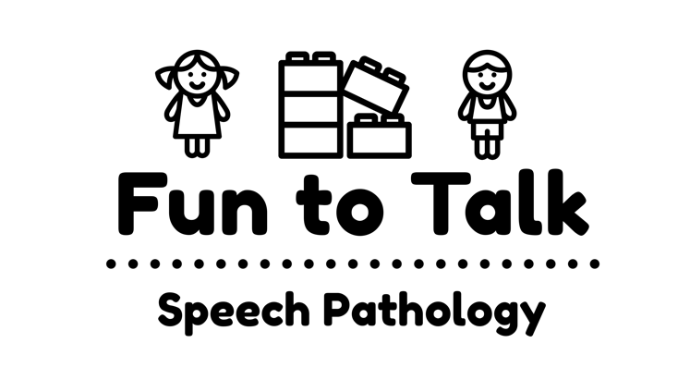
350 Aberdeen Street,
Manifold Heights, VIC 3218
Email: funtotalkspeech@gmail.com
Web: www.funtotalk.com.au
Phone/Fax: 03 5298 1793
ABN: 90 747 869 390

Victorian Early Years Learning and Development Framework

The Victorian Early Years Learning and Development Framework informs the work that Fun to Talk conducts with children, their families and their educators. In particular, Fun to Talk is committed to achieving the following outcomes for all children:

- Children have a strong sense of identity.
  - Children who have a strong sense of identity feel comfortable within local, social and cultural practices important in their lives.

- Children are connected with and contribute to their world.
  - Children strive for connection and seek belonging - to people, country, place and communities that help them to learn about local ways.

- Children have a strong sense of wellbeing.
  - Children who have a strong sense of wellbeing develop a range of social skills and dispositions. They learn to be comfortable in the range of settings that are part of their lives.

- Children are confident and involved learners.
  - Children who are confident and involved learners have positive dispositions toward learning, experience challenge and success in their learning and are able to contribute positively and effectively to other children’s learning.

- Children are effective communicators.
  - Children’s wellbeing, identity, sense of agency and capacity to make friends is connected to the development of communication skills, and strongly linked to their capacity to express feelings and thoughts, and to be understood.

Fun to Talk aims to achieve the above outcomes for all children by ensuring that we are:

- Working in partnership relationships with families by:
  - creating a welcoming and inclusive environment where all families are encouraged to participate in and contribute to experiences that enhance children’s learning and development.

- Having high expectations for every child by:
  - ensuring that every child experiences success and is motivated to accept new challenges through which to learn and grow.

- Maintaining respectful and responsive relationships by:
  - developing learning programs that are responsive to each child and which build on their culture, strengths, interests and knowledge.

- Promoting equity and diversity by:
  - ensuring that the interests, abilities and culture of every child and their family are understood and valued

- Assessing for learning and development by:
  - providing families with information and ideas to support the child’s learning at home and in other services.

- Integrating play into learning by:
  - encouraging all children from birth to explore, solve problems, communicate, think, create and construct ideas and understandings.

- Partnering with professionals by:
  - collating and use the evidence of children’s prior and current learning and development to build continuity in learning and development.

- Engaging in reflective practice by:
  - gathering information, including the views and perspectives of each child, and using this it to inform, review and enrich decision-making.

- Supporting children’s transitions by:
  - working together to provide consistent environments for children between home and other forms of care and education

