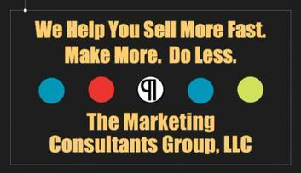
The Marketing Consultants Group LLC’s
World’s Greatest Tailgate Party Sweepstakes Benefit Non-Profits
Connect
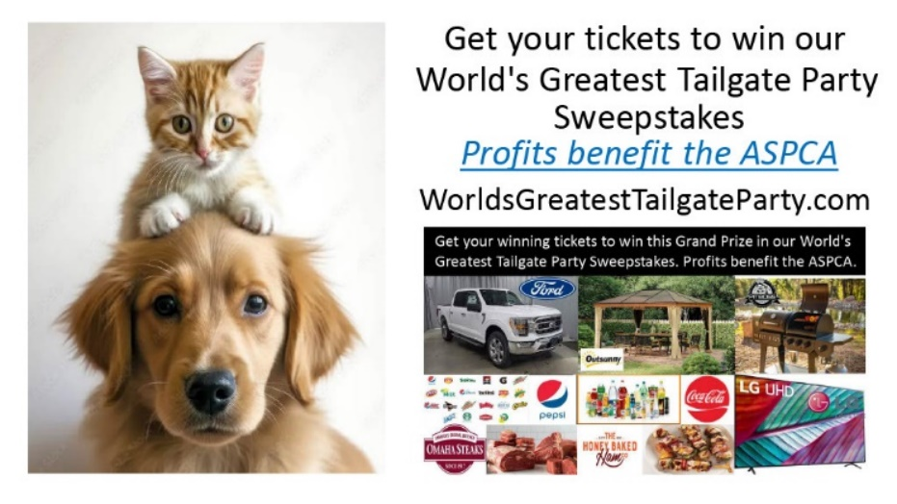
Your Brand to Millions of Fans & Socially Responsive Consumers - Helping To Make a Difference
for Deserving Non-Profits

Our Multiple Sweepstake Events will be promoted in our Video Sales Letters, Press Releases & Live Events by Celebrities, Sports Celebrities & Influencers to millions of fans year-round.
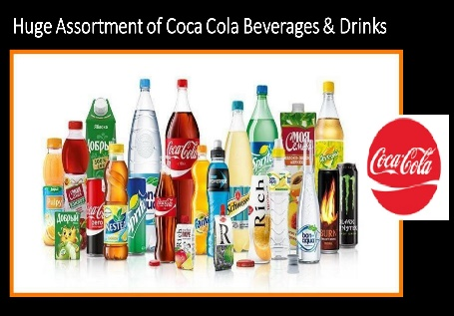
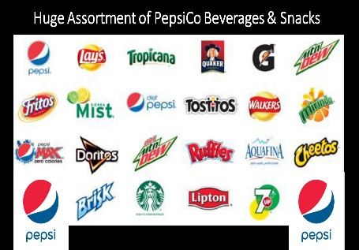
Promotional Campaigns
Reach millions of consumers yearly.
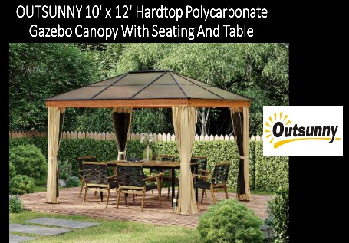
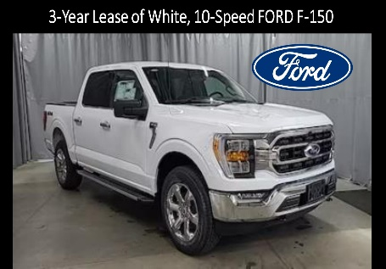
Diversity
African American, Latina, Caucasian,
Asian, Multinationals worldwide.

Charitable Partners
ASPCA, Habitat for Humanity, St. Jude Children’s Research Hospital, The Salvation Army
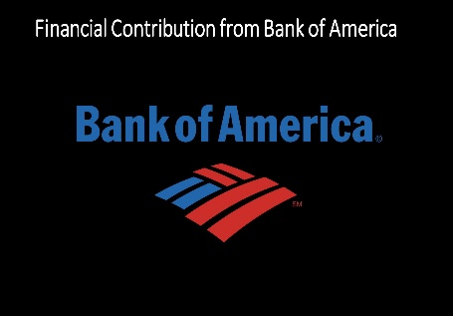
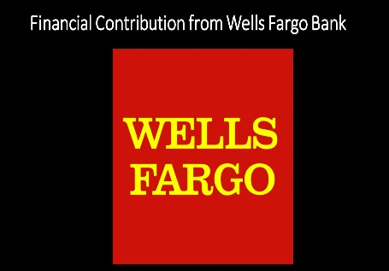
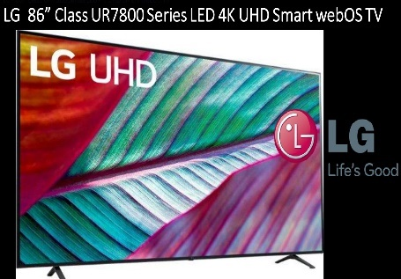
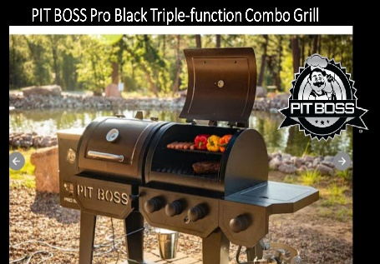
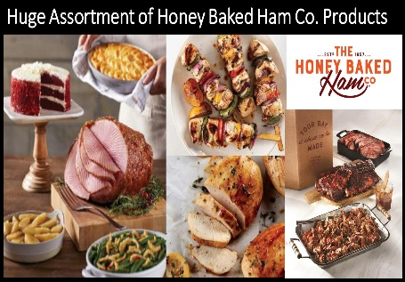
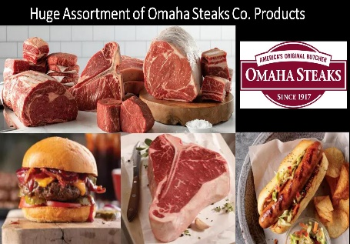
Sponsors
Ford, GM, Toyota, Nissan, Chevrolet, Dodge, Outdoorsy, LG, Pit Boss, Omaha Steaks, Honeybaked Ham Co., PepsiCo, Coca-Cola, Wells Fargo, Bank of America, Chase, Citibank
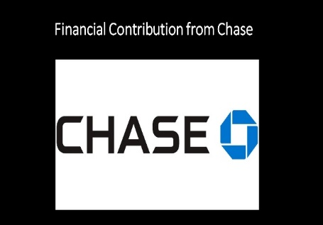
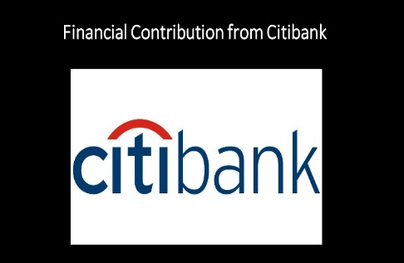
WorldsGreatestTailgateParty.com
Support@MarketingConsultantsGroup.com
Here’s how our World’s Greatest Tailgate Party Sweepstakes will work for our Sponsors, Celebrity Influencers, Non-Profits and Consumers.

Our Celebrities, Sports Celebrities and Influencers will promote our Sweepstakes and our Sponsor’s brands in our video ads and press releases to millions of Sports Fans and Non-Profit contributors.

Sponsors will get increased exposure and good will from their participation in our Sweepstakes campaigns for socially responsible Nonprofits.

Sponsors will also get email lists and phone numbers of consumer participants to our Sweepstakes contests so they can continue to market to them, grow their customer base and increase sales.

There’s no heavy lifting for our Celebrity Influencers because they will utilize our video ads and press releases to promote our Sweepstakes to their fans on their social media sites.

Along with our administrative suppliers who will handle the ticketing, we will handle overall administration of the Sweepstakes and provide the collateral materials needed (video ads and press releases) for our Celebrity Influencer Promoters and Sponsors.

Non-Profits will benefit from the profits from our Sweepstakes without any heavy lifting.

Sponsor Promotional Opportunities

Some of our promotional opportunities include but are not limited to:

- Inclusion as Sponsors of our new, exciting, year-round, national Sweepstakes campaigns.

- Your Brand, Products and/or Services will be featured in our Video Sales Letters and used by Celebrities, Sports Celebrities and Influencers to promote our World’s Greatest Tailgate Party Sweepstakes to millions of their fans on their Facebook, Instagram, Pinterest, Tik Tok and You Tube social media sites.

- We have access to a database of 59,000+ Celebrities, Sports Celebrities and Influencers and will engage as many as possible to promote our national, year-round Sweepstakes.

- Featured on our World’s Greatest Tailgate Party Sweepstakes website (WorldsGreatestTailgateParty.com)

- Featured on our Marketing Consultants Group, LLC web site, Pinterest page, Instagram page. Facebook page and YouTube channel.

- Cross promotions.

- Sponsor exhibitor opportunities, signage, and your company representatives at live events.

- Online Sweepstakes promoting your company as a Sponsor.

- Option to provide prizes, giveaways and cash for our consumer contests.

- Promotion in upcoming traditional media.

- Dedicated campaign with pre-marketing and follow-up promotion

- Email blasts to communities of sports fans and non-profit contributors with purchasing power.

- Placement in press releases to national media outlets.

- Participation in the Marketing Consultants Group, LLC’s “Making A Difference” Awards.

- Utilize Ronnie Schmidt, CEO, and the Marketing Consultants Group, LLC’s marketing prowess to help you get better sales results for less cost with less effort.

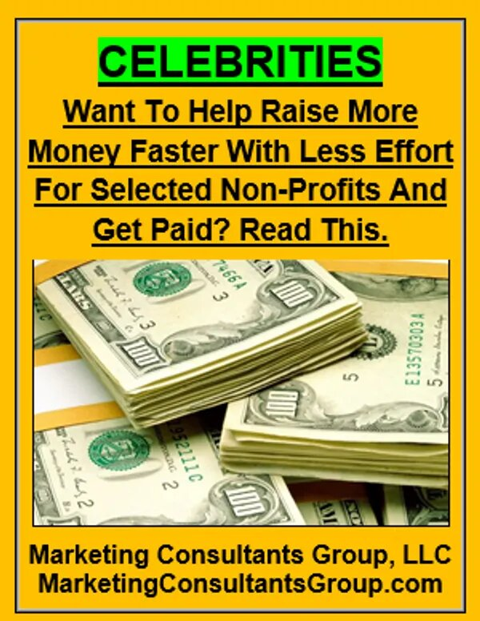
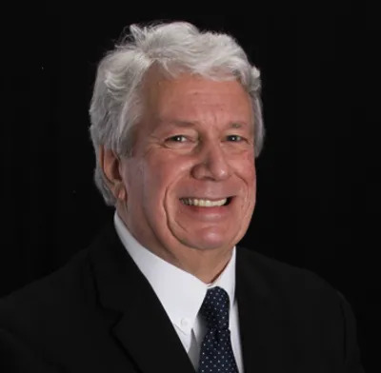
Why partner with the Marketing Consultants Group, LLC and Ronnie Schmidt, CEO
Ronnie Schmidt, CEO, Marketing Consultants Group, LLC is Author of the following:

- CELEBRITIES Want To Help Raise More Money With Less Effort For Selected Non-Profits And Get Paid?

- Consumer Friendly Marketing With THE WOW FACTOR, and

- Creator of the “World’s Greatest Tailgate Party” Sweepstakes.

- Enhance Visibility in our “World’s Greatest Tailgate Party” Sweepstakes and video sales letters promoted by our Celebrity Influencers on social media to their fans and potential contributors to raise more funds faster for Non-Profits.

- Increase your Extended Reach and Good Will: In speaking, traditional media, podcast, extensive online media presence and press release opportunities.

- Expand your Target Audience through online marketing campaigns, being featured in video sales letters and continually promoted by each campaign’s group of Celebrity Influencers.

- Enhance your Cause-Related Marketing by participating in a brand that empowers Non-Profits and the people who love them and contribute to them.

- Gain Additional Media Attention: Multi-media campaigns include print, press releases, strategic alliances, videos and events.

- Boost Brand Recognition with our multimedia opportunities, signage, and your company representatives as VIPs at our multiple Sweepstakes Grand Prize drawings.

- Exclusivity in your category.
Who is Ronnie Schmidt? Marketing Consultants Group, LLC CEO
Since 1971 after graduating from Penn State University, Ronnie held sales and marketing management positions with six (6) Fortune 500 companies including Fram, Boise-Cascade, Honeywell, Amstar- Domino Sugar, CooperVision, Bausch & Lomb. He has been solely responsible for sales of over $252,000,000 in products and services.
In 2013, he founded sought-after Marketing Consultants Group, LLC.
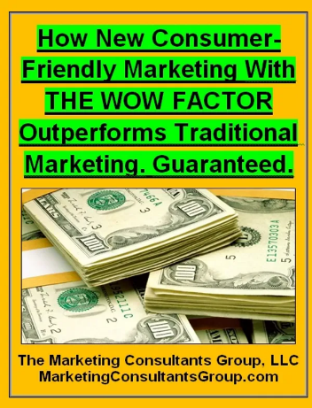
CELEBRITIES Want To Help Raise More Money Faster With Less Effort For Selected Non-Profits And Get Paid? Read This.

How New Consumer Friendly Marketing With THE WOW FACTOR Outperforms Traditional Marketing. Guaranteed.

Ronnie Schmidt’s articles explain how to run his highly-effective fundraising marketing campaigns.

Celebrities, Sports Celebrities and Influencers will promote our
“World’s Greatest Tailgate Party” Sweepstakes Video Sales
Letters to millions of their fans on their social media sites.

Here’s how your “World’s Greatest Tailgate Party” Sweepstakes
Grand Prize Sponsor’s Page will look in our Video Sales Letters.
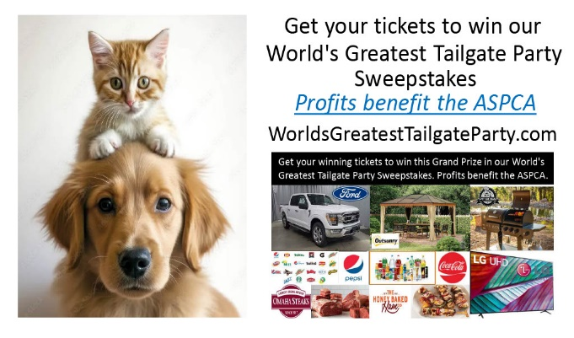

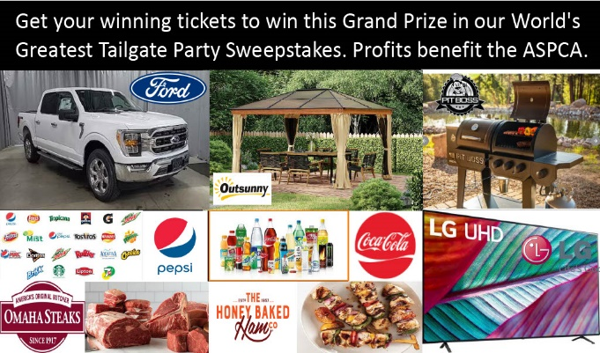

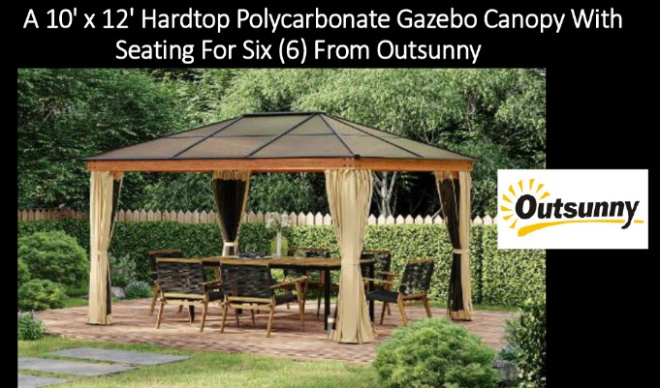

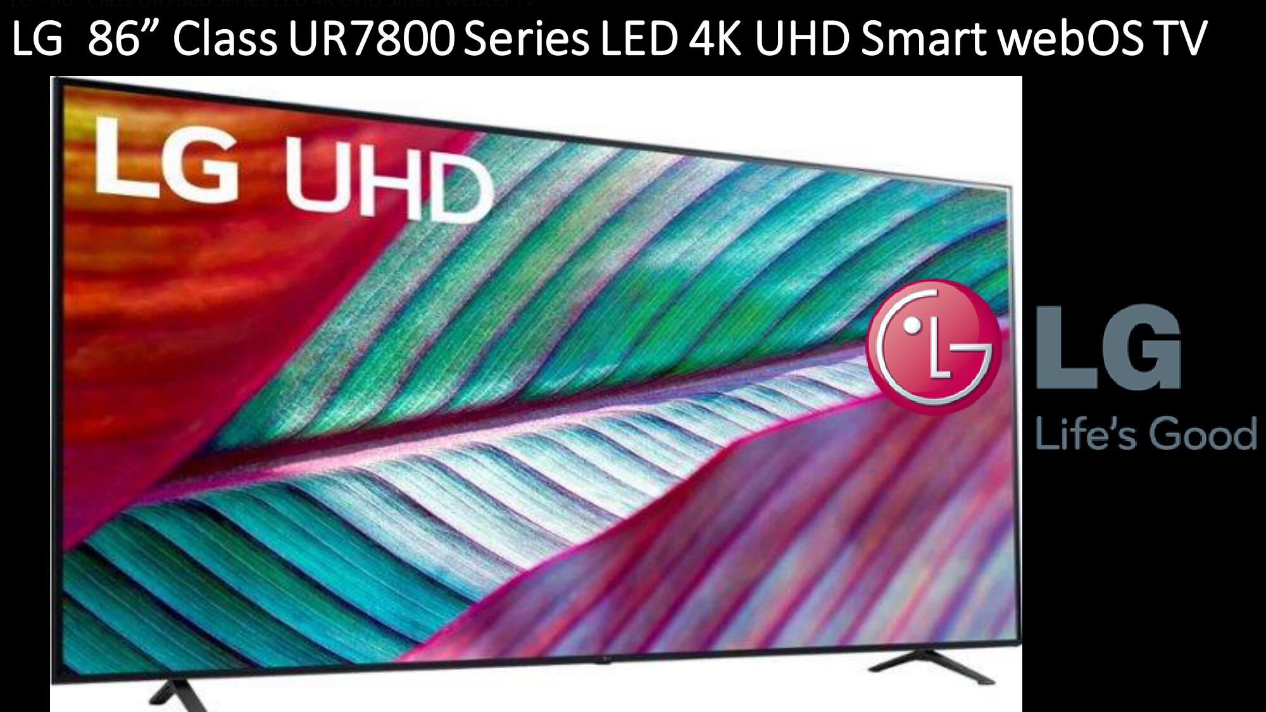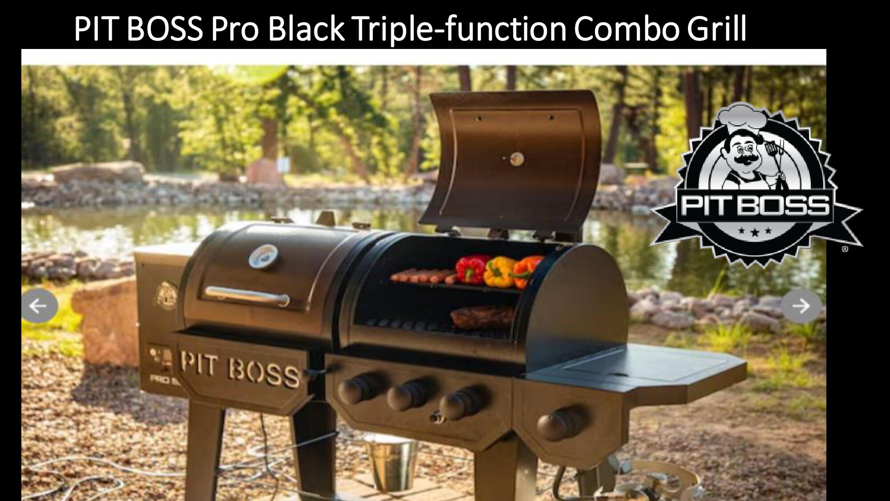

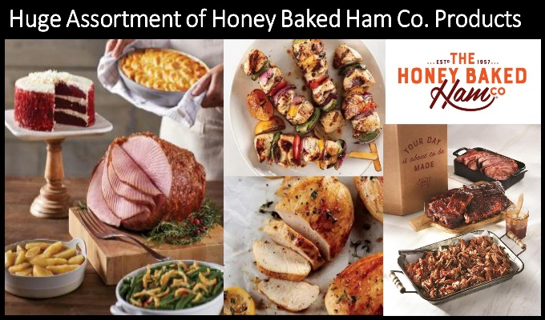
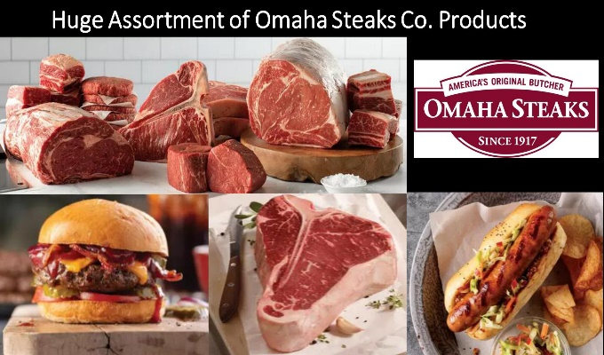

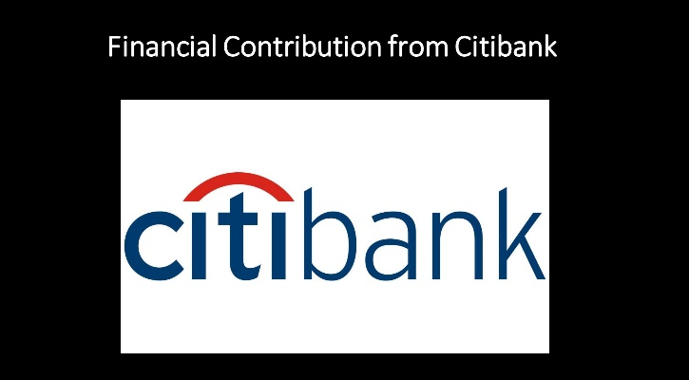
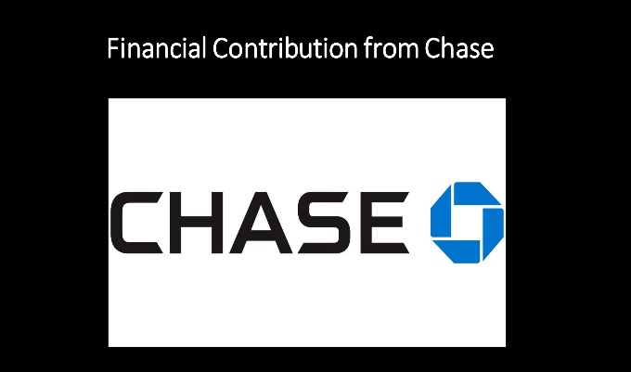
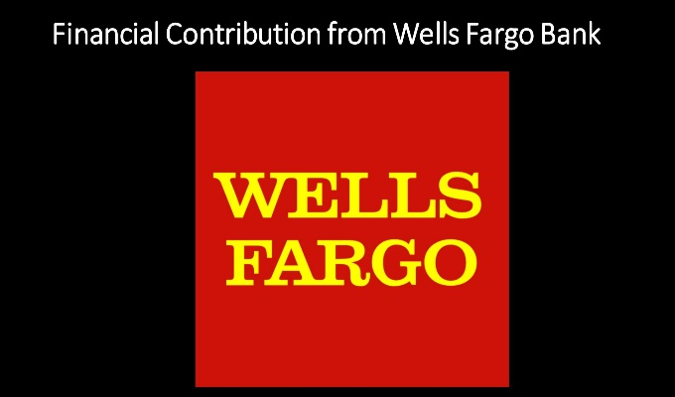
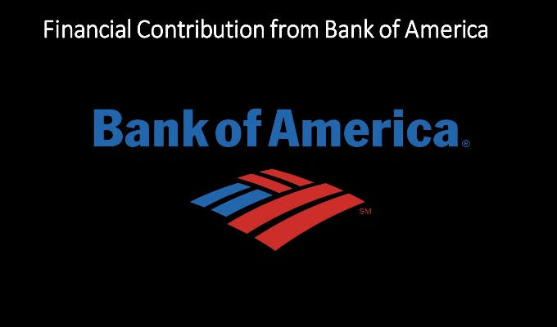
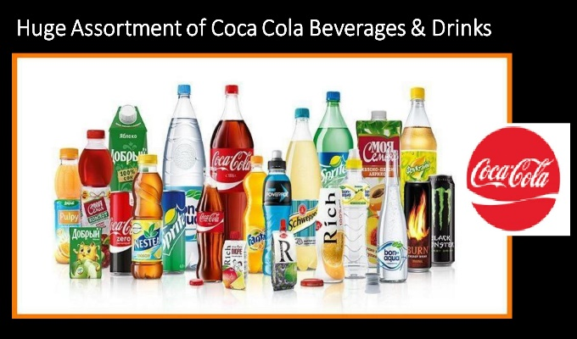
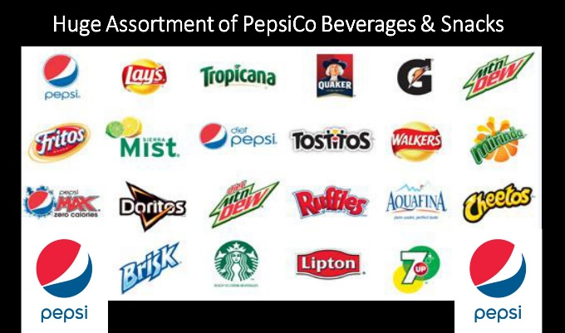
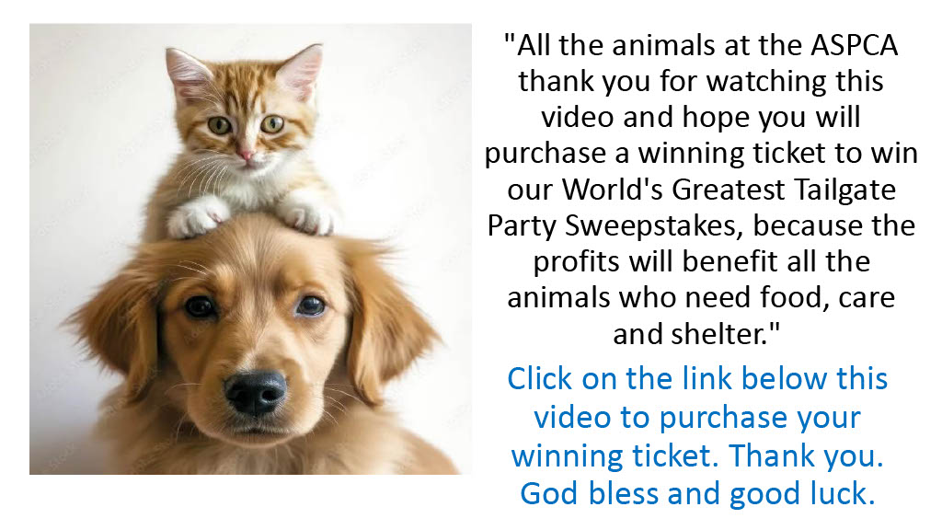

Interested in participating as a Sponsor or Celebrity Influencer? Call Ronnie Schmidt, CEO, Marketing Consultants Group, LLC at 920-396-5290 or Ronnie.Schmidt@MarketingConsultantsGroup.com Sponsors, visit WorldsGreatestTailgateParty.com/sponsors.
Celebrity Influencers, visit WorldsGreatestTailgateParty.com/influencers.

Don't read this unless you're looking to connect your brand with Non-Profit contributors in this US$ 276.2 Billion market.

Nonprofit Organizations Market size was valued at US$ 276.72 Bn. in 2022 & the total revenue is expected to grow at a CAGR of 4.53% through 2023 to 2029, reaching nearly US$ 377.34 Bn. by 2029.

Nonprofit Organizations Market Overview:

Since 2015, the global market for Nonprofits Organizations has grown at a CAGR of 3.6 % to over $ 276.72 Billion in 2022. The market was dropped by -0.9 % in 2022, from $ 250.96 Billion in 2022. The reduction is mainly due to many countries' enacting lockdown & social distance norms, as well as a global economic slowdown caused by the COVID-19 outburst & the actions taken to combat it. After that, from 2021 to 2023, the market is expected to recover & increase at a CAGR of 5.3 %. The market is expected to reach $345.32 Billion by the end of 2029 at a CAGR of 4.53 %. Due to their unique conditions, nonprofit organizations often have a more tough time developing & implementing efficient marketing strategies. This, combined with an overabundance of social agencies, might make it tough to stand out and develop a successful strategy.

Strong economic expansion in developing countries & an increase in customer disposable income drove growth during the historic period. Government limitations on some sorts of financing sources, as well as money misuse, had a negative impact on growth during the historic period. Increased corporate social responsibility, more environmentally friendly awareness, & increased internet usage will all contribute to future growth. Geopolitical tensions, tight regulations, & COVID-19 are all factors that could slow the growth of the Nonprofit Organizations Market in the future.

Nonprofit Organizations Market Dynamics:
The market for nonprofit organizations will rise as corporate social responsibility improves. Corporate Social Responsibility is a concept in which businesses incorporate social & environmental issues into their operations & interactions with stakeholders. Companies are increasingly emphasizing corporate social responsibility as an important component of their overall strategy to promote social concerns.

Furthermore, millennials like to associate with firms which support social concerns. Companies' CSR spending is growing because of this. For instance, as part of its 2025 responsibility targets, Sysco, an American multinational food products firm, will distribute 200 Mn meals & contribute $50 Mn to local communities. Growing CSR will positively impact the market for nonprofit organizations going forward.

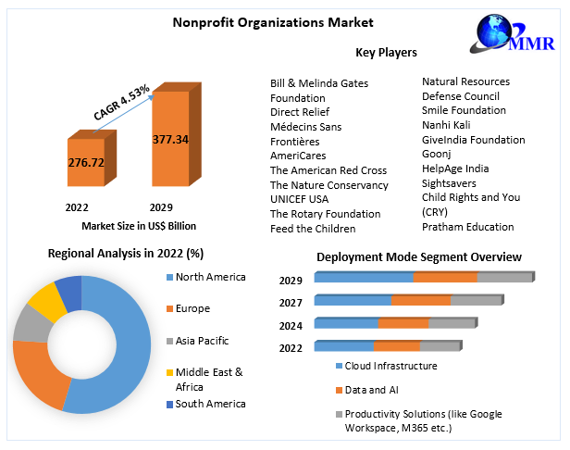

Nonprofit Organizations Market Trends:

Increasing mobile usage:

Donors are increasingly using mobile technologies to donate to charities as it is convenient. Nonprofit organizations can use mobile technology to better communicate with their supporters & generate money more swiftly & conveniently. Donations via mobile applications are frequently encouraged by nonprofit organizations. For example, Micro-donation apps such as Instead & One Today, allow users to make daily donations of up to USD 1 to charity organizations of their choice. According to the MMR report study, internet donations accounted for 7.6 percent of total fundraising revenue in the year 2017, & 21 percent of these online gifts were made using a mobile device.

Descriptive & Predictive Analytics:

Predictive & descriptive analytics are increasingly used by nonprofit organizations to generate relevant data insights. These businesses use descriptive analytics to make simple reports or detect non-compliance after transactions have been completed. Predictive analytics can help organizations gain a better knowledge of the relative effectiveness of numerous programs, allowing resources to be better targeted for better results.

2022 Nonprofit organizations: Main Facts & Figures:

Worldwide, there are about ten million nonprofit organizations.

In the U.S, there are over 1.3 Mn 501(c) organizations.

Nonprofit organizations make about 5-10% of the United States economy & employ around 10% of the country's workforce.

The nonprofit sector in the U.S employs about 11.9 Mn people, making it the country's 3rd largest employer after retail & manufacturing.

Most nonprofit organizations do not rely solely on donations, contrary to popular opinion.

Fees for programs, commodities, & services account for 48% of revenue for public charities.

The government contributes 33%.

Charitable donations account for 13% of the total.

Investments & other sources account for 6% of the total.

Recommendations:

To take advantage of the opportunities, the MMR report study suggests that non-profits organizations market companies to include mobile technologies for donations, spend in CRM software to track donations, focus on NGO-corporate companies, leverage predictive
& descriptive analytics, create operations in emerging markets, organize events & campaigns, rise visibility through a high-performance website, increase adoption of the internet & social media & focus on partnership with corporates.

The objective of the report is to present a comprehensive analysis of the Global Non-profit Organizations Market to the stakeholders in the industry. The past and current status of the industry with the forecasted Market size and trends are presented in the report with the analysis of complicated data in simple language. The report covers all the aspects of the industry with a dedicated study of key players that include Market leaders, followers, and new entrants.

PORTER, PESTEL analysis with the potential impact of micro-economic factors of the Market have been presented in the report. External as well as internal factors that are supposed to affect the business positively or negatively have been analyzed, which will give a clear futuristic view of the industry to the decision-makers.

The report also helps in understanding the Global Nonprofit organizations Market dynamics, structure by analyzing the Market segments and project the Global Nonprofit organizations Market size. Clear representation of competitive analysis of key players by Product, price, financial position, Product portfolio, growth strategies, and regional presence in the Global Nonprofit organizations Market make the report investor’s guide.

Nonprofit organizations Market Scope:

Base Year | 2022 | Forecast Period | 2023-2029
Historical Data | CAGR | Market Size in 2022 | Market Size in 2029
2018 to 2022 | 4.53% | US$ 276.72 Bn | US$ 377.34 Bn
Segments Covered
by Type  Human Services Groups  Education Organizations  Health Care Organizations  Environment and animals  Religion related |  | by Deployment Mode  Cloud Infrastructure  Data and AI  Productivity Solutions (like Google Workspace, M365 etc.) | by Organization Size  Large Enterprise  Small & Medium Enterprise
Regions Covered
North America  United States  Canada  Mexico | Europe  UK  France  Germany  Italy  Spain  Sweden  Austria  Rest of Europe | Asia Pacific  China  S Korea  Japan  India  Australia  Indonesia  Malaysia  Vietnam  Taiwan  Bangladesh  Pakistan  Rest of APAC | Middle East and Africa  South Africa  GCC  Egypt  Nigeria  Rest of ME&A | South America  Brazil  Argentina  Rest of South America

FAQ’S:

1) What is the share of the Global Nonprofit organizations Market in 2022?
Answer: The Global Nonprofit Organizations Market was accounted for US$ 276.72 Billion in the year 2022.

2) Which Type of segment is dominating the Global Nonprofit organizations Market?
Answer: Health Care Organizations sector is the dominating end use segment in the market.

3) Which factor acts as the driving factor for the growth of the Nonprofit organizations Market?
Answer: The major factors for the growth of the Global Nonprofit organizations market includes Increasing Corporate Social Responsibility.

Interested in participating as a Sponsor or Celebrity Influencer? Call Ronnie Schmidt, CEO, Marketing Consultants Group, LLC at 920-396-5290 or Ronnie.Schmidt@MarketingConsultantsGroup.com Sponsors, visit WorldsGreatestTailgateParty.com/sponsors.
Celebrity Influencers, visit WorldsGreatestTailgateParty.com/influencers.

