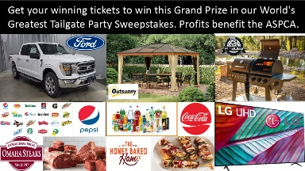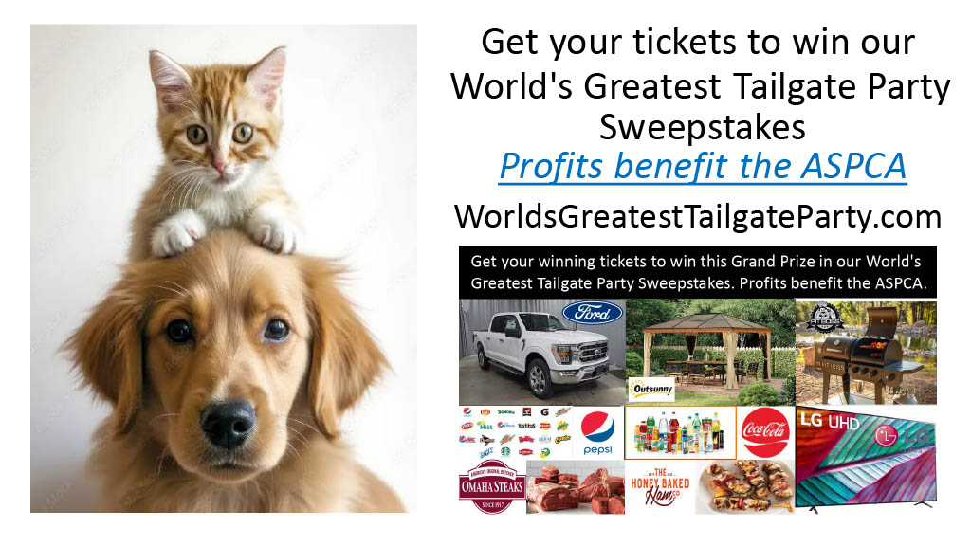
Marketing Consultants Group LLC‘s “World‘s Greatest Tailgate Party“ Sweepstakes Benefit Non-Profits _____________________________________________________________________________________

