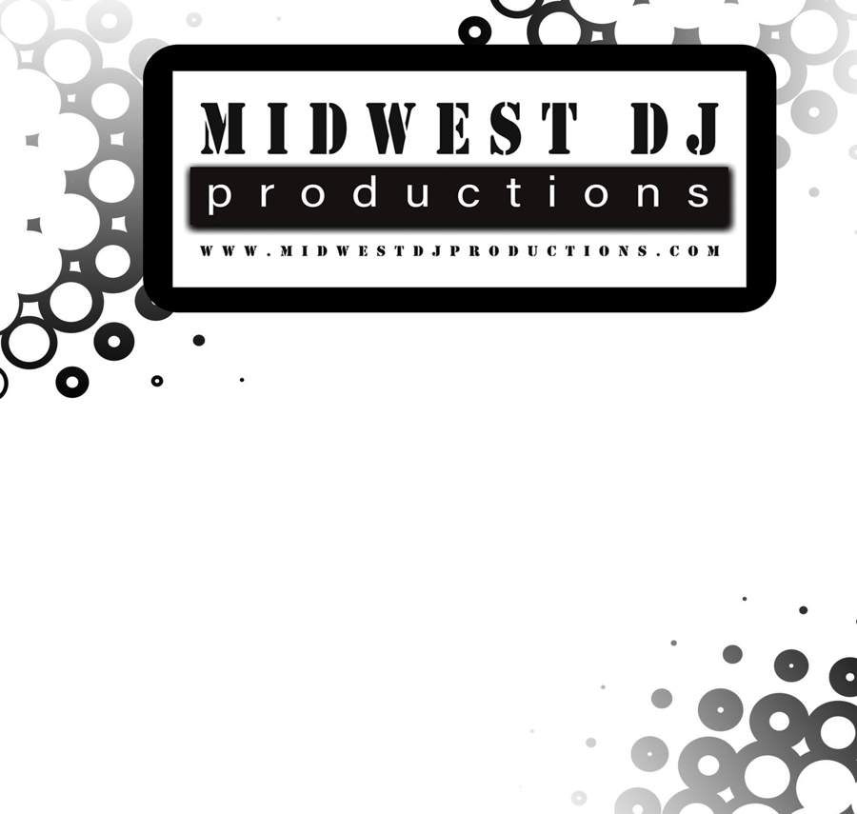
Wedding Music Timeline Guide

Ceremony

Pre-Ceremony Songs

Procession Song

Bride Entrance Song

Recessional Song

Special Requests

- Cocktail Hour Music
Songs

- Grand Entrance
Song

Bridal Party Names

- Welcome Toast

Given By

Dinner Music

- Maid of Honor/ Best Man Toasts

Given By

Reception

Reception Songs – 1st Priority

Reception Songs – 2nd Priority

VIP Dances

- First Dance
Song

- Father - Daughter Dance
Song

- Mother - Son Dance
Song

- Snowball Dance
Song

- Cake Cutting Ceremony
Song

Games and More Special Dances

- Bride & Groom Shoe Game

- Prank a Groomsman Game

- Jimmy Fallon Style Bride & Groom Karaoke Battle
Songs

- Anniversary Dance
Song

- Dollar Dance
Songs

- Garter Belt Removal
Song

- Garter Belt Toss

Song

- Bouquet Toss
Song

Last Song

SPECIAL ANNOUNCEMENTS REQUESTS

