G-BOOT FAQ

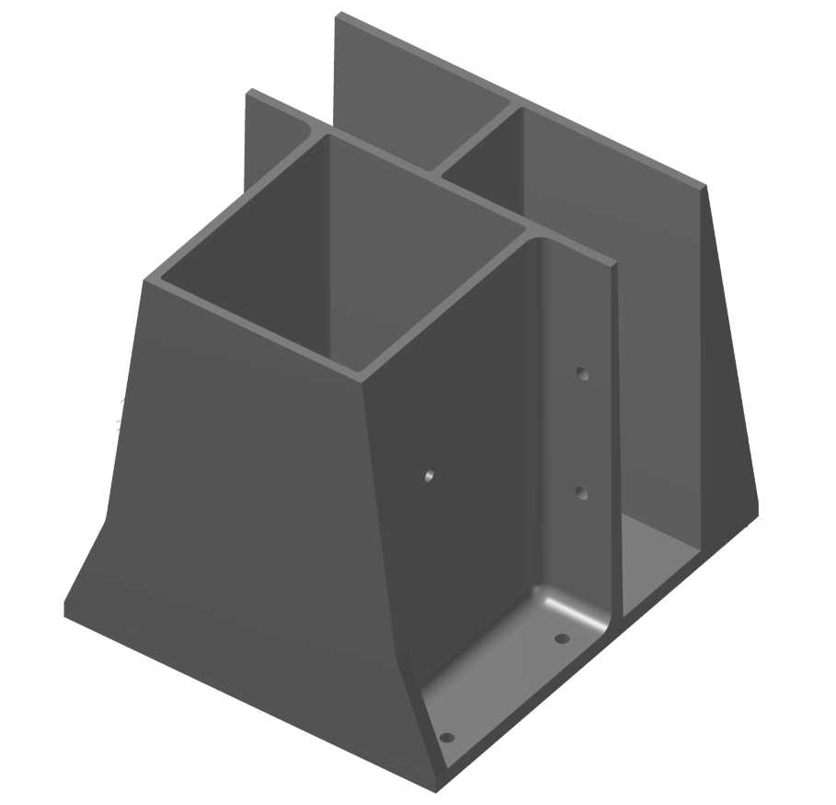
1. How much does each boot cost?
A. Each boot costs $21 and included the required
fasteners to secure the boot into a wood nailer.

2. How much does each G-BOOT weigh?
A. Each plastic boot is easy to handle and weighs
approximately 2.05 pounds.

3. Is the G-BOOT reusable?
A. Yes, you can reuse the G-BOOT. Prior to each
installation, the boot should be inspected for crack,
tears, breaks or other damage.

4. G-BOOT cost vs. metal guardrail cost.
A. Two G-Boots and 4 – 2x 4’s, to make an 8-foot
section, with labor costs approximately $55. An 8 –
foot section of metal guardrail, with two bases
without labor, costs approximately $155 plus shipping.

5. What substrates can the G-BOOT be installed on?
A. The G-BOOT can be used on new construction or
existing buildings and installed directly onto 22-`18Ga.
metal deck, through a wood nailer and into metal deck
and concrete. The competent person is responsible to ensure
the substrate will support the intended load.

COPYRIGHT 2019 | SAFETY KEVIN, LLC IS A VETERAN OWNED BUSINESS | KEVIN@SAFETYKEVIN.COM

