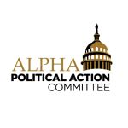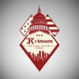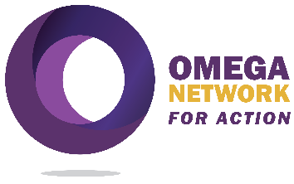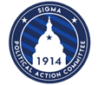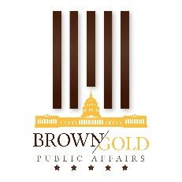
FOR IMMEDIATE RELEASE
AUGUST 15, 2024
Divine Nine Fraternities PACs and C4s Election Focus is on Black Men

The collective political action committees of the Divine Nine fraternities stand united in raising issues of importance to Black men during the 2024 election cycle.

During a press briefing at the National Press Club in Washington, DC, the political action committees addressed concerns across several policy areas that affect Black men – education, higher education, criminal justice reform, health and wellness, labor market participation and wealth generation, and voting rights. The PACs were joined at the press conference by a national officer of Groove Phi Groove Social Fellowship, Inc., a national Black male organization.

As the November election approaches, the collective D9 fraternities’ PACs are united in
educating Black men on these key issues, engaging in voter registration and mobilizing voter turnout, and protecting the integrity of voting procedures at local polling places. The PACs will work with other Black male organizations, like Groove Phi Groove Social Fellowship, to penetrate communities and organize voters. Given what is at stake in November, our collective organizations are united in elevating the concerns of Black men.

This statement is released under the auspices of the Alpha Political Action Committee, the Krimson Political Action Council, Omega Network for Action, SigmaPAC 1914, and the Brown and Gold PAC.

