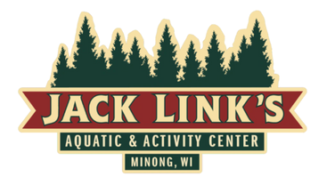
Limbs: Basic Water Acclimation
Must learn to Pass:
- Enter the pool using the stairs without help.
- Getting into pool safely using the wall or edge without help.
- Up and down at least 8 times inhaling out of water, exhaling in water – Bubbles.
- Front Float – Back Float – Pancake Flip
- Water safety and life jacket safety
- Back Float to standing position.
Twigs: Body Positioning
Must learn to Pass:
- Front Glide
- Back Glide
- Treading water – Scissor kick or frog kick
- How to spot emergency or distressed swimmers – What to do?
- Alternating arms and legs
- Breath control
Branches: Stroke Development
Must learn to Pass:
- Moving independently to chest deep water
- Front, back, pancake no assist.
- Swim alternating arms and legs.
- Frog Kick, Scissor Kick, Flutter kick, Dolphin Kick
- Arm position from Front Crawl
- Leg position front crawl
- Arm position back Stroke
- Leg position Back Stroke
- Flip Turns
Trees: Advance Stroke Form
Must learn to Pass:
FOREST: Stroke Performance
- All 5 Strokes Mastered
- Must be able to tread water for 5 minutes.
- Know Principles of Water safety and rescue.

- Front Crawl
- Back Crawl
- Side Stroke
- Breaststroke
- Butterfly Stroke
- Deep water Treading

