Susquehanna Tax Solutions
6 N. Main Street, Suite B
Stewartstown, PA. 17363
717-746-4230 www.susqtax.com
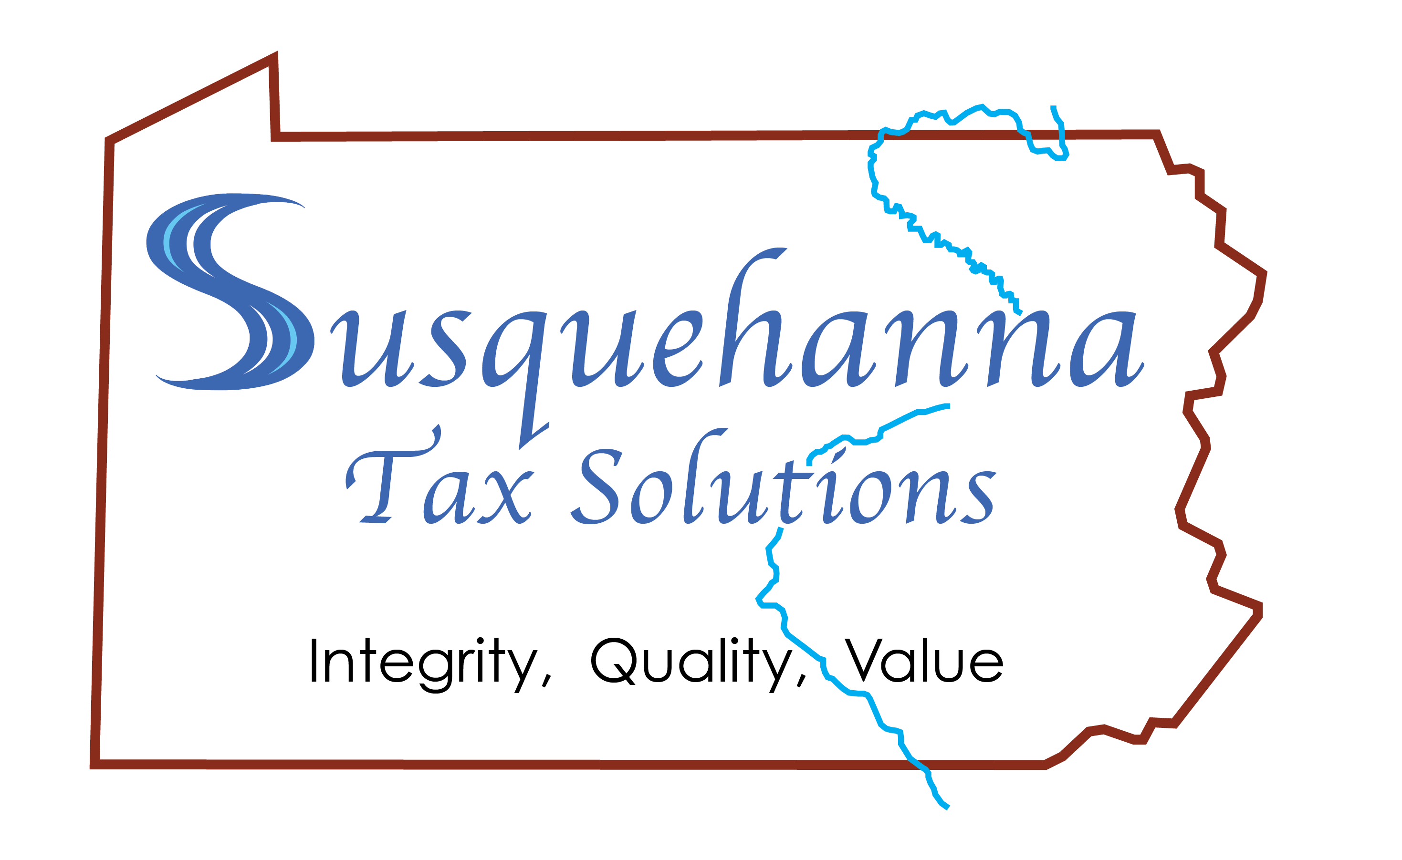

TAX PREPARATION CHECKLIST
Use the checklist below to assist you in gathering the documents, forms, and records you’ll need to complete your income tax return. Every item below may not apply to you and the list is not all inclusive. Last year’s return is also a valuable resource for gathering information for this year’s return. You should bring anything else you think would be helpful.
Please complete the questionnaire on the last page and submit a copy of it when you give us your other supporting documents.

NEW CLIENT?

In order to comply with government regulations, we will need a copy of the following:
- Driver’s license
- Spouse’s driver’s license
- Social security number or tax ID ◻ Birth Certificate for dependents
- Social security card for dependents
- Last two previous years’ tax returns
- Voided check (for direct deposit, if wanted)

SOURCES OF INCOME

Employed
- W2(s) (Include your detailed year-end paystub/payroll statement)
- Employment related stock options
Unemployed
- Unemployment compensation
Self Employed
- 1099-Misc or Self Employment Income and expense records from any source
- Business Expenses; Rental Property; Farming expenses
- Car expenses: actual expenses or mileage for business purposes, need contemporaneous records
- Record of estimated tax payments made (Form 1040–ES)
- Business-use asset information (cost, date placed in service, etc.) for depreciation
- Office in home information, if applicable
Retirement Income
- Pension and Annuity income
- Social Security Benefit statements
Investments, Dividends
- 1099(s) (Interest, Dividends, Sale of Stock, etc.)
- Bank, Savings & Loan, and Credit Union Accounts
- Interest, dividend income
- Mutual Funds and Money Market Accounts
- State Income Tax Refunds
- Brokerage or Investment Company Accounts
- Sales of Stock and Stock Dividends
- Federal Municipal, or Corporate Bonds
- IRS interest paid on income tax refund
- IRA or Qualified Plan distributions (you should receive a 1099-R even if reinvested)
- Contributions to HSAs, IRAs, SEPs or Keoghs (may be reflected on Form 5498)
- K-1's from Partnerships, S-Corporations, Estates or Trusts
- Health Savings Plan Accounts including employer-sponsored Section 125 Café plans
- Dates of acquisition and records of your cost or other basis in property you sold (if basis is not reported on 1099-B)

Rental Income
- Records of income and expenses
- Rental asset information (cost, date placed in service, etc.) for depreciation
- Record of estimated tax payments made (Form 1040–ES)
Miscellaneous Income and Losses
- Record of alimony paid/received with ex-spouse’s name and SSN
- Non-taxable (Municipal bond or bond fund) income
- Gambling Winnings (also provide information concerning losses if appropriate, to offset winnings)
- Disability Income (from state or from Employer-funded insurance policy)
- Hobby income and expenses (Hobby income is taxable if over $600 net; expenses only if positive net income)

DEDUCTIONS

Under the 2018 tax bill, many itemized deductions were either eliminated or limited and the standard deduction was dramatically increased. As a result, most people will be taking the standard deduction.
Home Ownership
- Forms 1098 or other mortgage interest statements
- Property Taxes, Real Estate, Personal Property Taxes, Sales Taxes (as alternative to state income tax)
- Receipts for energy-saving home improvements (e.g., solar panels, solar water heater) You must also have and retain documentation from supplier concerning qualification of materials for tax credits.
- Mortgage used for anything other than buying, building or improving your residence(s)?
Charitable Donations
- Cash or check contributions - You must have receipts from charitable organization
- In Kind – Need receipt showing name and address of charity, details of items donated, and date and value
- Amounts of miles driven for charitable or medical purposes
Health/Medical Expenses
- Medical/Dental Expenses not reimbursed by insurance, including Medical Insurance premiums
- Form 1095-A if you enrolled in an insurance plan through the Marketplace (Exchange)
- Long-term Care Insurance premiums
Childcare/Household Expenses
- Fees paid to a licensed day care center or family day care for care of an infant or preschooler (provide name, tax ID, address, and amount paid)
- Wages paid to babysitters, nannies, housekeepers, home health care provider, etc (Provide
Names, SSNs, addresses, salary paid, and payroll taxes withheld)
Educational Expenses
- College Tuition or continuing professional education expenses for yourself or dependents (Form 1098-T from education institutions)
- Student Loan Interest Paid (Form 1098-E)
State and Local Taxes
- State and Local Income Taxes
- Invoice showing amount of vehicle sales tax paid
Retirement & Other Savings
- Early withdrawal penalties on Certificates of Deposit or Savings Accounts

MISCELLANEOUS INFORMATION

- Online purchases where sales tax was not paid. Please provide total dollar amount spent.
- Verify banking information is the same as the previous year (if you used direct deposit last year)
- Name change this year. (This needs to be reported to social security or your return will not match)
- Family additions (need social security numbers, birthdates, and copy of birth certificate and Social
Security card)

TAX PREPARATION QUESTIONAIRRE

Please complete the questions below and submit a copy of this page when you give us your other supporting documents. Due to regulations, we need an answer of either yes or no. Depending on your answers, further discussion and documentation may be required.

- Stimulus: Did you receive 2021 Recovery Rebate (Stimulus) payments?
☐Yes ☐No ☐Not eligible

- Cryptocurrency: Did you buy, sell, exchange, transfer, give, or receive any cryptocurrency, such as Bitcoin, during the last year?
☐Yes ☐No

- Foreign Bank/Financial Account: Did you have financial interest in or signatory authority over any financial account (such as a bank account, securities account, or brokerage account) located in a foreign country?
☐Yes ☐No

- Independent Contractors: If you own a business, did you make any payments that would require you to file Form 1099?
☐Yes ☐No ☐N/A

If yes, did you or will you file the required Form(s) 1099?
☐Yes ☐No ☐N/A

- Household Employees: Did you have any household employees?
☐Yes ☐No

- Health Insurance: Did you purchase health insurance through a government-sponsored Marketplace?
☐Yes ☐No

