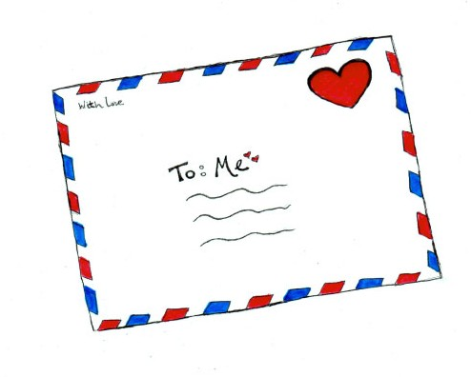Love Letter

When was the last time you showed yourself some love? You deserve your love just as much as anyone else. When you really start to open up your heart and give yourself that love, you'll find that your happiness levels naturally increase. It's difficult to be truly happy when you hate who you are. Take the time to write a letter to yourself now. No hate, judgements or shaming allowed! Only love, love love!

