Be Your Own Superhero!

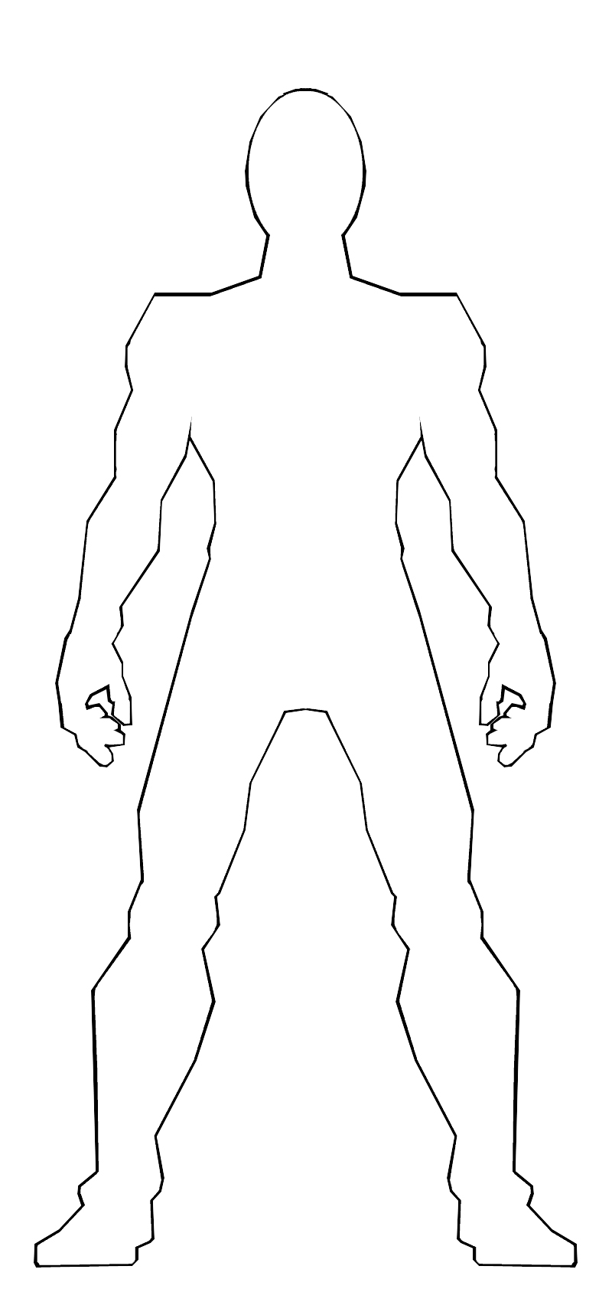
Think of all the superhero qualities you'd like to possess (flight, super strength, super speed, etc). Using the template, create a superhero version of yourself. You can use a photo of yourself, or draw in your details. Personalise it by adding an outfit and accessories that symbolise you in all your glory. Know that you are the superhero of your own life! You may not have comic book style abilities, but you have immense strength, integrity, spirit and character within you right now. Stick on your cape, put your underpants over your tights, and go forth in all your awesomeness!

