A Brief History of the Rowland Corners General Store
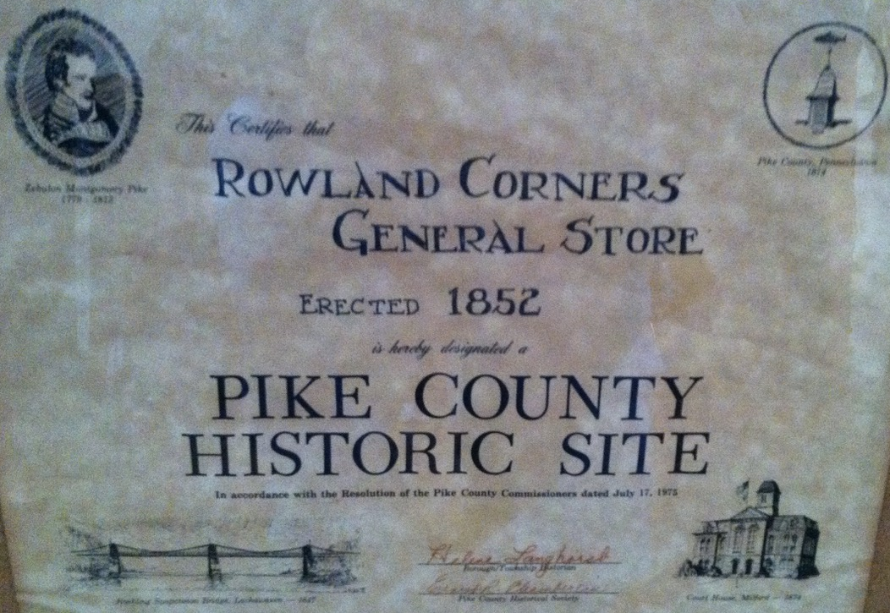
This certificate, currently in the possession of Charlie Weissman, states that
“This certifies that Rowland Corners General Store, erected 1852, is hereby designated a PIKE COUNTY HISTORIC SITE In Accordance with the Resolution of the Pike County Commissioners dated July 17, 1975”.
Signed,
Helene Langhorst, Borough/Township Historian
Ernest R. Chamberlin, Pike County Historic Society
The document shows 1852 as the starting date for the Rowland Corners General Store, founded by George H. Rowland. Until 1899, Rowland was Lock Number 10 on the Delaware and Hudson Canal. Old canal maps show that the building was originally a barn and stable for the mules that pulled the barges along the canal. This is shown in the following picture from when the canal was still operating:

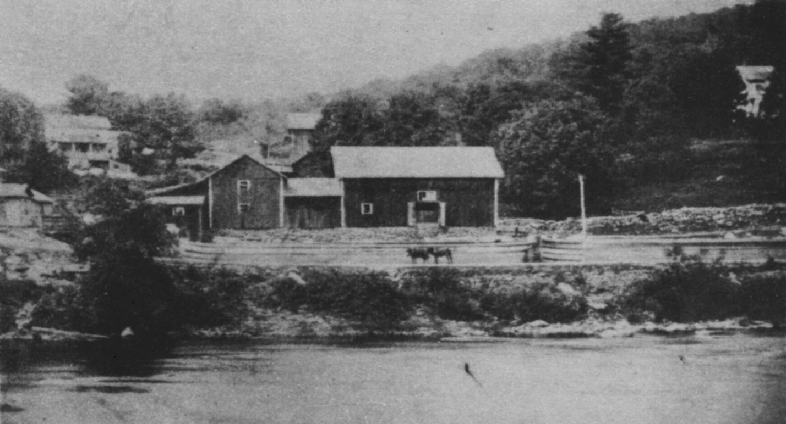
George H. Rowland built his homestead there in 1852, shown in the upper right corner, and from 1852 until the 1960s, the Rowland family operated the Rowland General Store either in the Rowland Café building or in a building across the street. Local oral history suggests that the building was also used as a dance hall in the 1920s or 1930s. In the 1950s and 1960s the basement was used as an automobile repair garage run by Connie Cortright and Sig Olsen.
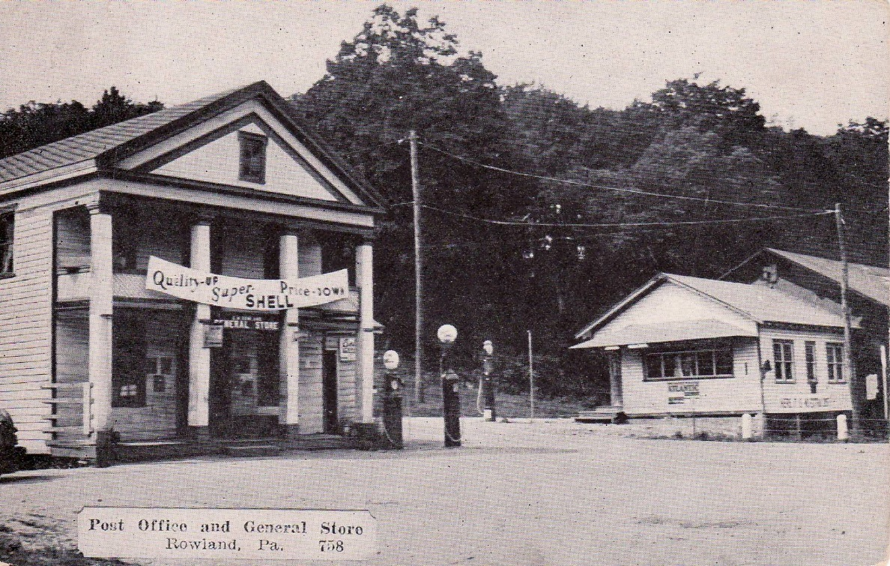
In 1933 there were gas stations on both sides of the street in downtown Rowland, Shell and Atlantic. The front entrance to the building was on the left corner.
Here is the history of the building through the deed records since the 1960s:
On April 20, 1965, George W. Rowland and Evelyn O. Rowland sold the building to Helen Talbot and Astrid Bensen, doing business as the Rowland Corners General Store.
Deed Book Volume 191 Page 1009.
On May 3, 1971, Helen Talbot and Astrid Bensen, doing business as the Rowland Corner General Store, sold the building to Charles T. Bright and Doris M. Bright.
Deed Book Volume 247 Page 1052.
The Brights renovated the building and added the upstairs apartment.
On August 25, 1975, Charles T. Bright and Doris M. Bright sold the building to William R. Desmond and Nancy M. Desmond. The Desmonds opened up a luncheonette in the building, along with continuing the General Store.
Deed Book Volume 514 page 195
The postcard below shows the store in the middle 1970s. The Exxon brand name was created in 1973, and S & H Green Stamps were most popular in the 1960s and 1970s.
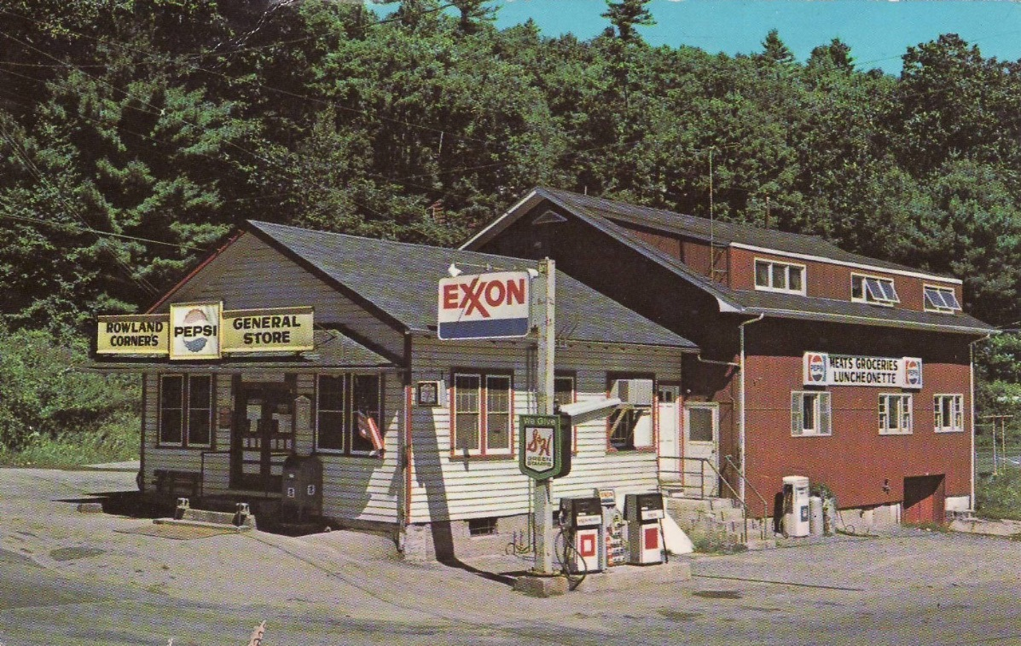
The sign on the side of the building says “Meats Groceries Luncheonette”, so during this time period the building served as both a General Store and a restaurant. The Rowland Post Office was also in the building for many years.
On May 24, 1983, William R. Desmond and Nancy M. Desmond sold the building to Carl Bateman and Constance Bateman. The Batemans continued the general store and deli.
Deed Book Volume 865 Page 128

On March 9, 1987, Carl Bateman and Constance Bateman sold the property to Michael Annunziato and Paula C. Annunziato.
Deed Book Volume 1115 Page 186
On November 2, 1989, Michael Annunziato and Paula C. Annunziato sold the building to Michael A. Castellano and Deborah A. Castellano with an erroneous deed.
Record book Volume 179 page 110
On March 19, 1990, Michael Annunziato and Paula C. Annunziato sold the building to Michael A. Castellano and Deborah A. Castellano with a corrected deed.
Record Book Volume 278 page 130
On July 1, 1995, Michael A. Castellano and Deborah A. Castellano sold the building to Michael Annunziato and Paula C. Annunziato.
Deed Book Volume 1080, Page 238.
The Annunziatos and Castellanos opened a pizzeria in the building along with the general store.
On December 19, 2000, Michael A. Annunziato and Paula C. Annunziato sold the property to Corkey Bodge and Amy Roberto, with no title search.
Deed Book Volume 1871 page 1835
Corkey continued with the pizzeria and store. Around this time a beauty salon was added to the back of the building.
On November 18, 2005, Corkey Bodge and Amy Roberto sold the building to David Bates and Dawn K. Bates.
Deed Book Volume 2147, page R838.
The Bates renovated the building and expanded the restaurant while still keeping groceries.
On March 10, 2008, David Bates and Dawn K. Bates sold the property to PJ Group Ventures, Peter Pudlin and Joseph Graziano.
Deed Book Volume 2269, page 1963
PJ Group Ventures expanded the restaurant and removed the general store. Since 2008 the building has been a restaurant.
On September 20, 2012, PJ Group Ventures sold the building to Robert Tellefsen.
Deed Book Volume 2399 page 821.
Tellefsen continued to use the building as a pizzeria and restaurant. The upstairs and back of the building were rented as residences. Small knick knacks were sold on a table.
In 2014 Peter Pudlin died, leaving his estate to Zaya Givardize.
On June 7, 2017, Peter Pudlin and Joseph Graziano foreclosed on Robert Tellefsen to reclaim ownership of the building through a Deed in Lieu signed September 20, 2012.
Deed Book Volume 2525 page 690.
The last event at the Rowland Café was the funeral service for Frances Christianson on May 30, 2016.
On October 10, 2018, Joseph Graziano and Zaya Givardize sold the property to Kenneth W. Christianson, Jr.
Deed Book 2563 Page 495
Pending Township approval, tentative plans are to allow the Rowland Cooperative to operate the building as a general store, restaurant, café and pizzeria.

Respectfully submitted,

Kenneth W. Christianson, Jr.
President, The Rowland Cooperative

