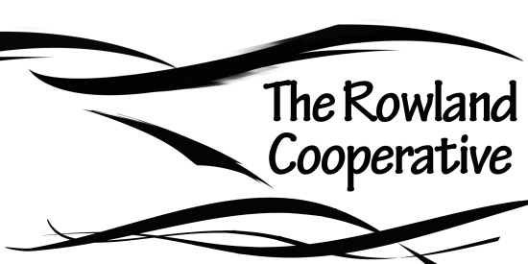

P.O. Box 146, Rowland, Pennsylvania, 18457

Dear friend,

You are cordially invited to a general information session concerning the Rowland Cooperative on Saturday, April 27 at 12:00 noon at the Rowland Cafe.

In 2012, several concerned residents of Rowland joined forces to form the Rowland Cooperative. The mission of the co-op is to “encourage the preservation, promotion, and prosperity of the hamlet of Rowland, Pa.” So far we have made a capital investment in the Rowland Cafe building and business. We hope to sponsor local community projects, events, and farmers’ markets in 2013. We are committed to developing and supporting local food markets in the Rowland area.

If you are interested in learning more or in joining the co-op, please attend our general information session, where we will discuss the co-op and explore possible future directions. Your ideas are welcome! We hope to see you there!

If you are not able to attend the meeting but would like to learn more, please contact Kenny Christianson at 570-949-4282.

Thank you,

Kenny Christianson

For the Rowland Co-op.