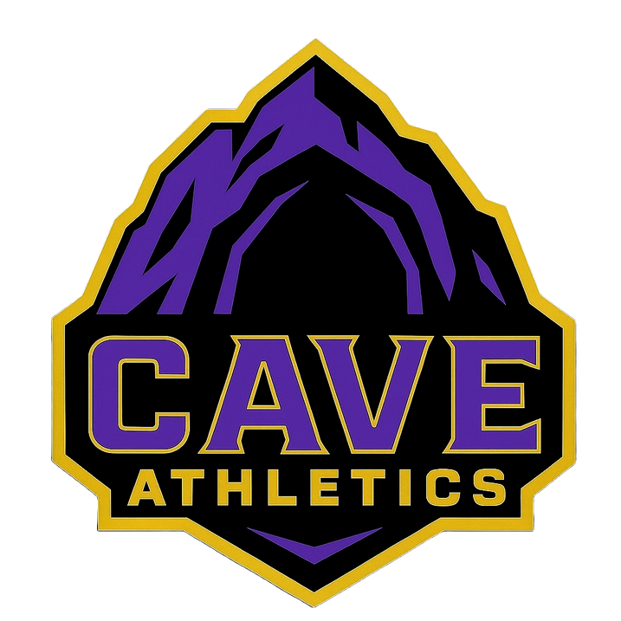
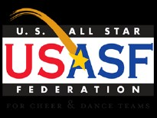
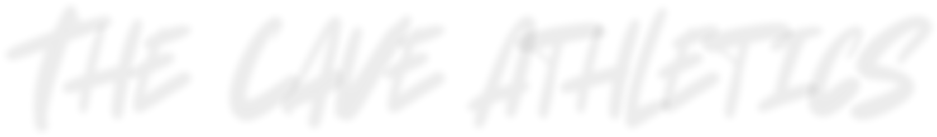

The Cave Athletics
2026-2027
Financial Obligations
The Cave Athletics utilizes an automatic billing system for both tuition and package payments. Fees will post to your account on the 1st of the month in which it is due and will subsequently collection the 3rd. If you prefer NOT to charge the card on file, you must bring in cash or check by the 1st of the month (or sooner should the gym be closed). Checks are to be made payable to The Cave Athletics
All accounts are required to have a valid credit card on file at all times, even if paying by cash or check monthly. No account will be allowed to have fees roll over from month to month. Athletes with a balance will not be allowed to participate in classes until all fees are paid in full.
If there is a balance on your account, we reserve the right to with-hold jackets, medals, shirts, etc. In addition, if there is a balance on your account, it needs to be settled within 2 weeks or it may result in dismissal from The Cave Athletics Cheer program.

Fee Breakdown
Monthly Tuition: Tiny and mini$65.00 Youth Jr, Sn - $75.00 Sept- 2026 - Aug 2027 All payments will be charged on the 1st and collected on the 3rd. Families with multiple athletes will receive a discount off any additional sibling’s team tuition. The discount will be applied to the youngest team athlete tuition when applicable. All other fees will apply per athlete.
REMINDER: A written notice of withdrawal must be given to info@thecaveathletics.com by the 31st of the month prior to void being charged for the next month’s tuition.

Team Cost: 1st payment Sept 2nd November
Music: $250.00 Per team. This will be split evenly with final team numbers
Competition Fees:
RISE: $35 PER ATHLETE
AMERICA ON STAGE: $25 PER ATHLETE
Out of State : $115 PER ATHLETE
Uniform: $175 October 2026
Uniforms will be a every other year purchase. We will size for these at the first practice. We are also doing a sponsor my uniform for each team to help families with this cost. Uniform for Prep included built in shorts with skirt and shell. For all team except Senior the mesh liner will be included in the uniform.
***ALL FEES ARE NON-REFUNDABLE REGARDLESS OF THE REASON***
Kuna, ID 83634 • 208-918-0270• www.thecaveathletics.com

Fee Breakdown (Continued)
Bow: Included with uniform
Annually we will have a new team bow. The bow is required for the uniform cost, however it is additional as this is a per year cost. There is a spot on the Sponsor my uniform fundraiser page.
Practice wear : $65.00 Sept 1, 2026
This is a custom optional purchase. We do prefer and highly suggest the practice gear, however it will not be required this season.
Optional Items: See Below Varies
- Backpack: Purple tactical Backpack with custom logo and custom name - $65.00
- Make-up Kit: $30
- Warm-ups: This includes Pants and Zip Jacket $140
- Extra Practice bows- $10-$25
Pro Shop:
Additional gym branded items can be found in our pro shop.
Fundraising & Sponsorships:
We offer a variety of fundraising opportunities throughout the season. This involves extra work outside of cheer. Please know, we have seen people pay for their whole year of cheerleading through fundraising! Any SURPLUS of credits from FUNDRAISERS are nonrefundable and will be applied and used toward the benefit of The Cave Athletics, events, and merchandise. It will NOT turn into income for our staff. A sample sponsorship letter will be provided to each parent/athlete
***ALL FEES ARE NON-REFUNDABLE REGARDLESS OF THE REASON***

Holidays/Breaks
The Cave Athletics Cheer Program is a 12-month program. We will begin meeting and practicing in September and continue through the month of August. Athletes are expected to attend all competitions and performances as a team. We realize many children and young adults are involved in a variety of activities; however, we cannot make exceptions for schedule conflicts. We expect top priority and 100% commitment and attendance. There is an optional parade appearance for Kuna Days the first weekend of August. The following dates are available holidays and vacations for the 2026-2027 season:
- Labor Day: September 4-7, 2026
- Thanksgiving Break: November 23 – 29, 2026
- Christmas/New Year Break: Dec 21, 26 – January 3, 2027
- Spring Break: March 15-21 2027
- Memorial Day: May 28-31, 2027

Other Important Dates
- Contract and all paperwork due By Sept, 15 2026
- USASF is due by December 1st. This is a $50 fee due directly to USASF. This is required per USASF to compete in any competitions. This is how they verify age's.
***Please review the 2025-2026 Calendar for a complete breakdown of our team schedule this season.***

Parent Policies
Communication:
As a parent, you will receive information in several ways, such as emails text and group chats. You can also check your Cave Athletics Parent portal under Info> Bulletin Board for new updates as well. There will be a team group chat thread, You will be added by the same email on the form packet.
Practice’s:
Parents/friends are asked to stay in the lobby and not to come into the training area. We want your child to get the most out of every practice. In order for this to happen, we need their full attention. If there are distractions, the whole team is affected and it may also become a safety issue. Coaches may close practices at any time for any reason. If a parent or anyone is observed speaking negatively about a team, coach, parent or cheerleader, he/she will be talked to and/or asked to leave. If this kind of behavior continues to be an issue, the child may be removed from the team.
Transportation:
All transportation/accommodations to competitions are solely the responsibility of each family. We will make every effort to provide information in a timely manner so that you can properly prepare. However, missing practices because you are traveling to/from a competition is not acceptable.
Stay:
Even though we will not be going to any varsity competitions nor any play to stay requirement. Any out of state competitions we do want to try to accommodate the team staying together. We know this may not be an option for everyone's budget and will take recommendations for team stays.
Parental Support:
- We encourage ALL parents to sit together and support ALL Cave Athletics Cheer teams.
- Parents are also encouraged to show support wearing The Cave Athletics clothing/gear to competitions.
- Showing respect for the coaching staff, other teams and hosting organizations is expected, as you are there representing The Cave Athletics and your child.

Team & Athlete Policies
Practice & Absences:
Attendance is crucial to team success. We do not have people on the bench waiting for your Athlete to miss a practice/performance. A missed practice means your athletes stunts do not go up. If you need to request an absence, please let your team coach know by email or phone call. Throughout the season, particularly the 2 weeks prior to competition, we will have No Absence Weeks. During a No Absence Week, there are no absences allowed, and missing a practice during this time, will result in a fine and/or may result in the athlete being removed from the team or performance.
**There are no excused absences from a competition**
No jewelry of any kind is allowed. This includes earrings, necklaces, rings, watches, permanent bracelets, etc. If your athlete has permanent jewelry they will be asked to remove and that may include being cut off. Do NOT get a new piercing during the competition season. If they do, it will be removed for competition – NO EXCEPTIONS. We are not responsible for any jewelry left at the gym or competition. Nails must be no longer than sports cut length.
IMPORTANT:
If an injury should occur that results in the athlete’s inability to perform or participate on our team, Alternates are still expected to attend all practices and competitions. If you choose to remove your athlete due to injury No refunds will be given.
Competitions:
Some competitions may require us to compete on a week day and/or may require your athlete to miss part/full day of school. When selecting competitions, this is something we take into consideration. We will strive to keep our athletes from missing as much school as possible, but sometimes it is inevitable. You will be provided a school excuse note to provide to your school attendance office. You are expected to arrive at competition ON TIME based on the “meet time” given by your team coach. Every athlete must be in full uniform from head to toe. This means clean uniform top and bottom, hair properly done with your team bow, full make-up, white no show socks, clean cheer shoes and no jewelry, gum, or polish. Appropriate undergarments should be worn at all times so as not to distract from the uniform design. For awards, athletes should look “performance ready.” This means no backpacks, cell phones, or t-shirts. Athletes should be in full hair and make-up and look as if they are about to take the floor to compete. Athletes must attend awards ceremonies pertaining to their team. Failure to attend awards will result in extra conditioning after the following practice.

Team & Athlete Policies (Continued)
Private Lessons:
As a member of The Cave Athletics Cheer Program, you will not be allowed to participate in classes and/or private lessons with a coach that is not employed by The Cave Athletics. If you are interested in additional instruction, please log onto your parent portal and schedule the private lesson with the desired coach.
Extra Classes:
As a member of The Cave Athletics Program, you will have opportunity to participate in extra classes, this may include Strength, Agility, Conditioning, Tumbling or other classes. You are expected to wear approved practice like clothing. Attendance is still a high priority and missing the class can hurt your overall growth. There will be no credit provided for a missed class by the Athlete.
Extra Practices:
There will be extra practices scheduled throughout the season. This will include choreography camp and clean up practices. This may be scheduled on a weekday or weekend. Attendance is mandatory, and will be given with plenty of notice.
Competition Schedule:
We will be competing in 2 in state competitions and 1 out of state competition. We will also have a Beginning of Season showcase in December and again in May for End of Season.
Rise - TBD This will be in the valley (Jan. 2026 it was at Middleton Middle School)
American On Stage - TBD (typically Feb)
America On Stage - TBD (typically Feb)
Kuna Cheer Showcase - TBD
Big Sky Basketball
Meridian Farmers Market
MCDA-Tahoe Take Over - Tahoe Blue Event Center, 75 Hwy 50, Stateline, NV 89449, USA April 10-11 2027

Program Rules & Regulations for Parents & Athletes
- I understand that Athlete and Parent are held to the expectations from the tryout packet as well as all the below:
- I will not be involved in any matter of disrespect towards any members of the CA staff
- Anyone threatening to quit or pull their child from the team, may be dismissed from the program.
- I understand that if I choose to quit all package payments will be paid in FULL. In addition, if I quit in the middle of the season, there is a fee.
- I understand that I cannot create or sell my own CA apparel. CA own the rights to the name and logo. All ideas for apparel must be emailed and approved by us. This includes the use of team names on designs.
- I will not participate in negative gossip or communications that adversely affect CA. This includes, but is not limited to Facebook, Instagram, Twitter, Snapchat, GroupMe, TikTok, or other apps/sites.
- I will not post any CA music, choreography, routines, stunts, etc. on any websites or social media platforms.
- I will maintain and/or improve the skills I performed at tryouts through hard work and dedication.
- I understand that only perfected skills will be choreographed into the routine.
- I will not hold or threaten to hold my child from practices or competitions as a form of punishment.
- I will conduct myself with respect and integrity, displaying positive sportsmanship at all times.
- I will abide by my team’s hair and makeup policy.
- I will not hold The Cave Athletics responsible for any lost or stolen items.
- I will not use inappropriate language in practice, at events, or at any time while representing The Cave Athletics, or while in Cave Athletic attire.
- I understand that bullying is never acceptable and is strictly prohibited. Should I be found bullying, I understand that I may be at risk for removal from my team.
- I understand that The Cave Athletics reserves the right to change a team level or division at any point during the season.
- I understand that I am making a full season commitment. I will honor my commitment.
- I understand that the parent viewing area should be a positive place and I may be prohibited from using it if I
cannot maintain a positive attitude.
- I understand that uniforms are to be used only at competitions/performances and should only be worn by The Cave Athletics athletes. I will take care of my uniform or I will be responsible for replacing damaged/dirty uniforms.
- I understand that competitions and exhibitions are mandatory performances.
- I understand that tuition is not pro-rated for holidays, competitions, absences, injuries, etc.
- I understand that cheerleaders, parents, relatives and friends are never allowed to contact competition companies or their officials for any reason. Please contact CA if you have questions or comments relating to competition companies or their officials.
- I understand that if I plan to drop from any CA classes and/or team, I must give a 30-day written notice for withdrawal to Info@thecaveathletics.com.
- I understand that if I quit or am removed from the program/class or become injured at any point during the season, I will not get any form of refund.
- I have read the entire 2026 – 2027 Cave Athletics packet and will abide by its contents.
Parent/Guardian Signature: ____________________________________________ Date: _______________________
Parent/Guardian Signature: ____________________________________________ Date: _______________________
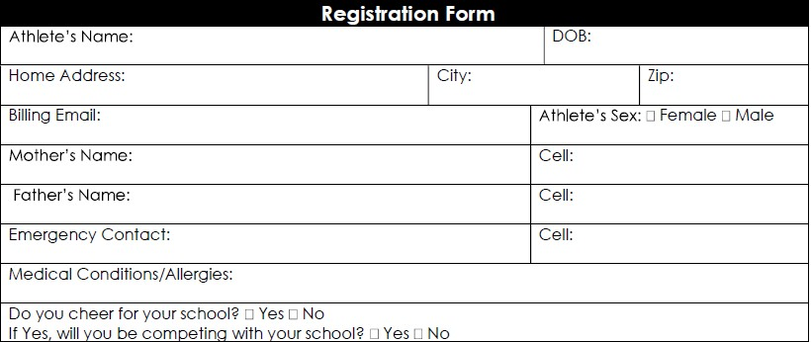
By signing this document, you are waiving certain legal rights.
Please read this document carefully before signing.

Release, Waiver and Indemnity
I, __________________________________ , (“Releasor”) the parent or legal guardian of the above named athlete hereafter referred to as (“Athlete”) do hereby permit the athlete to participate in programs, competitions, gymnastics, tumbling, cheerleading, or any other physical activity while a student at The Cave Athletics, or its affiliates hereinafter referred to as “CA”. By granting permission for “athlete” to participate in programs at “CA” or in which “CA” is participating elsewhere.
In consideration of student being permitted by CA to participate in the above activities, Releasor agrees to the following terms and conditions:
I understand there is personal risk involved in any activity that involves motion, height or rotation and that these activities can result in serious injury, death, or disability.
I declare “athlete” has been seen by a physician and is cleared to participate in physical activities such as gymnastics, cheerleading and tumbling.
I authorize “CA” to use photographs, videos, and/or other likenesses of “student” for use in “CA” promotional materials and sales, and wave any rights of compensation or ownership there to.
I understand the first month’s tuition will be required to be paid in full when registering for classes/activities at “CA”. I understand that I must give written notice on or before the 1st day of the month, one month prior to dropping any class/activity at “CA”.
Furthermore, I understand that if I do not provide “CA” this notice in writing, my tuition will be forfeited.
I understand that “CA” does not refund tuition for any reason.

Payment Policy
I understand I am required to keep a current credit card on file with “CA”, and that I am required to complete a credit card authorization form. If my credit card on file expires or I wish to place a different credit card on file it is my responsibility to do so before the 1st day of the month.
All charges for cheer at “CA” are billed on or about the 1st day of each month and become due immediately. Customers have until the 5th day of each month to pay the balance due on their account via cash, check, etc. All amounts remaining due on the 5th day of the month will be charged to the credit card on file for the account. Any accounts with a balance due after the 5th day of the month will automatically be charged a $25.00 late fee. and the athlete(s) associated with the account may be withheld from participating in activities at “CA”. This includes accounts in which the credit card transaction on their account is declined.
understand that any check/money order returned unpaid for any reason will incur a $25.00 return fee and a $25.00 late fee.
RELEASOR HEREBY FULL RELEASES AND FOREVER DISCHARGES
employees, representatives and insurers, of and from any and all liability to Releasor for any damage to or loss of athlete or releasor’s property, injury, or death arising directly or indirectly out of athlete’s participation in programs, activities or use of CA’s facilities, INCUDING ANY SUCH DAMAGE OR
LOSS THAT IS CAUSED BY AN ACT OR OMISSION ON THE PART OF CA, WHETHER OR
NOT SUCH DAMAGE OR LOSS ARE CAUSED OR CONTRIBUTED BY THE SOLE, GROSS OR
CONCURRENT NEGLIGENCE, OMISSION, STRICT LIABILITY, WILLFUL MISCONDUCT OR FAULT OF CA AND WHETHER OR NOT CAUSED BY A PRE-EXISITING CONDITION.
RELEASOR FURTHER AGREES TO INDEMNIFY, DEFEND, AND HOLD HARMLESS “CA” for, from and against
any and all liabilities, damages, claims, lawsuits, costs (including court costs, attorney’s fees and costs of investigation), and actions of any kind or description, including claims or suits brought by Releasor or a third party (collectively “claims”) (including any claims which arise by reason or indemnification or assumption of liability contained herein for any damages to or loss of athlete’s property and injury to or death of athlete arising directly or indirectly out of athlete being granted access or use of CA facilities or patriation in programs and activities INCLUDING ANY CLAIM FOR DAMAGE, LOSS, INJURY OR DEATH THAT
IS CAUSED BY AN ACT OR OMISSION ON THE PART OF CA, WHETHER OR NOT SUCH CLAIM FOR DAMAGE,
LOSS, INJURY OR DEATH ARE CAUSED OR CONTRIBUTED BY THE SOLE, GROSS OR CONCURRENT NEGLIGENCE, OMISSION, STRICT LIABILITY, WILLFUL MISCONDUCT OR FAULT OF CA AND WHETHER OR NOT CAUSED BY A PREEXISTING CONDITION.
This release, waiver and indemnity shall be governed by and constructed in accordance with the laws of the State of Idaho (exclusive of any principles of conflicts of laws which would direct application of the substantive laws of another jurisdiction). Venue for any dispute which arises in connection with this release, waiver and indemnity shall be in Ada County, Idaho.
I have read, understand and execute this release, waiver and indemnity:
Signature: ______________________________________________________ Date: _______________________
Email: ________________________________________________________________________________________
Signature: ______________________________________________________ Date: _______________________
Email: ________________________________________________________________________________________
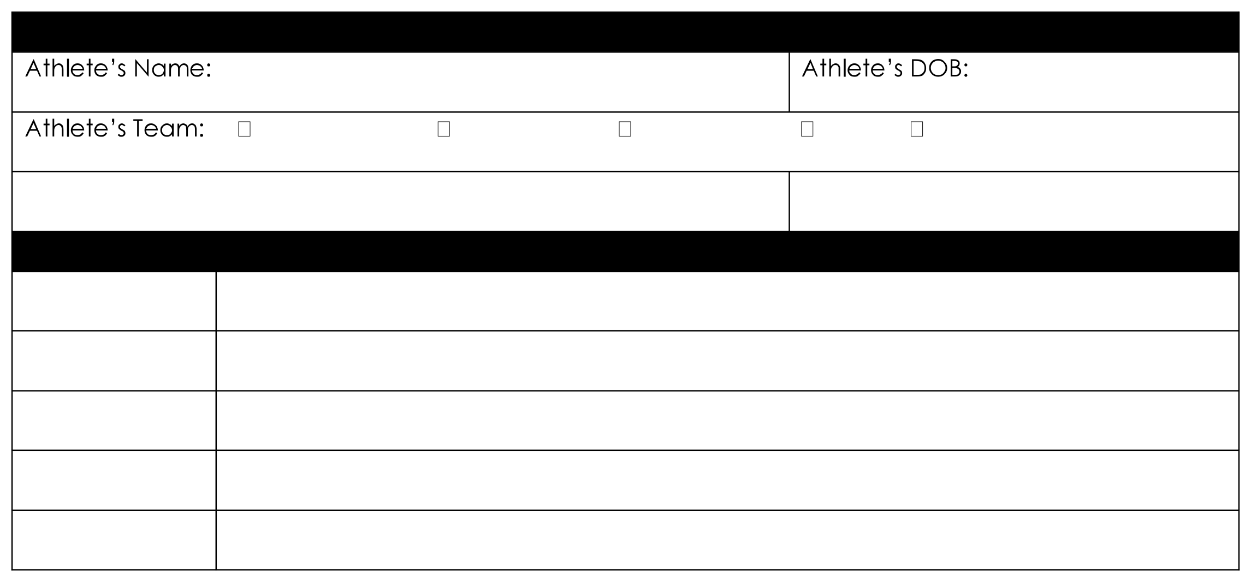
Summer Vacation Plans
Date:
Date:
Date:
Date:
Date:
Parent(s) Name:
Reason:
Reason:
Reason:
Reason:
Reason:
Tiny
Grizzly
Youth
Junior
Senior

Parent(s) Phone Number:
Panda
Honey
Kodiak
Polar

Mini
Credit Card Authorization Form

Card Holder Information
Name on Card:
City: State: Zip:

Payment Authorization
Card Type: Visa Mastercard
Card Number: ________-________-________-________ Expiration
Date: ________________________________ Card Identification
Number: ____________________
Please reference the picture to the right for the location of this number on your card(CVV2). 2 digits on back.
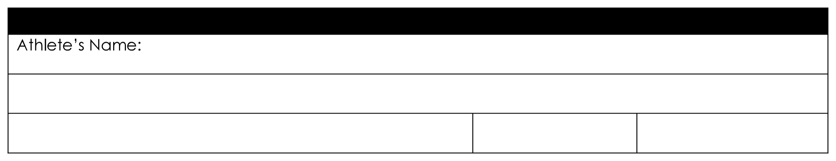


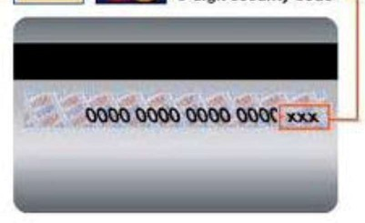
I/We hereby authorize The Cave Athletics “CA” or its affiliates to charge this credit card on a monthly basis for the amount due on our account. My/Our credit card will be charged on or about the 1st day of each month for the amount due. If necessary, The Cave Athletics may initiate credit adjustments for any charges made in error. The Cave Athletics may also charge my card for periodic miscellaneous charges at my request. This authorization is to remain in full force and effect until The Cave Athletics has received written notification from me (or either of us) of termination of service in such time and such a manner as to afford The Cave Athletics reasonable opportunity to act upon it. Written notice may be provided either to the address or email above.
Signature: ______________________________________________________ Date: _______________________ Email:
________________________________________________________________________________________

Payment Policy
All package payment charges at The Cave Athletics are billed on or about the 1st day of each month and become due immediately. Customers have until the 5th of each month to pay the balance due on their account by cash, check, etc. All amounts remaining after the 5th day of the month will be charge to the credit card on file for the account. Any accounts with a balance due after the 6th day of the month will automatically be charged a $25.00 late fee, and the athlete(s) associated with the account may be withheld from participating in activities at The Cave Athletics. This includes accounts in which a credit card transaction on their account is declined for any reason.

We agree to support our child(ren)‘s position in the The Cave Athletics All-Star Cheer Program. We also agree that neither of us will sign our child(ren) up for any activity that conflicts with the The Cave Atheltics team schedule. It is important to our child(ren) to participate in extra-curricular activities, and we agree to cooperate with each other to make sure this is possible. If either parent does not bring their child(ren) to
practice/competition, the athlete may be removed from the team, or our gym altogether and be liable for all package payments.
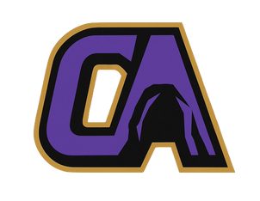
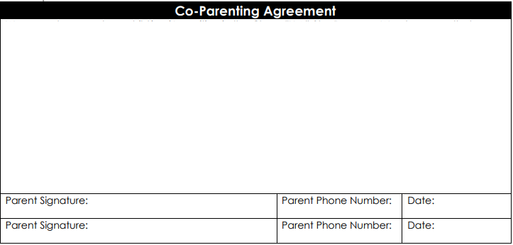
We agree to support our child(ren)‘s position in the The Cave Athletics All-Star Cheer Program. We also agree that neither of us will sign our child(ren) up for any activity that conflicts with the Cheer FX team schedule. It is important to our child(ren) to participate in extra-curricular activities, and we agree to cooperate with each other to make sure this is possible. If either parent does not bring their child(ren) to practice/competition, the athlete may be removed from the team, or our gym altogether and be liable for all package payments.

