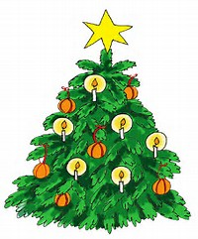
2018 Festival of Trees Registration Form
Sponsorship - $100 or $50
(Cash or Checks may be payable to Festival of Trees)
Deadline: November 7, 2018 with payment of sponsorship
We would like to invite individuals, families, companies, or organizations to help us light the Courthouse Square with the Festival of Trees. How it works is you select the sponsorship you would like to sponsor. There will be a tree placed somewhere on the square that you would locate by looking for the sign that has your name on it & then you decorate the tree however you please for the community to enjoy during the holiday season. The sponsorship from the trees will go to assist the Christmas Sharing organization which places the money right back into the community as well as helping individuals and families during the holiday season. There is a sheet that has the rules and guidelines that have been implemented to assist with this celebration.
-------------------------------------------------------------------------------------------------------------------------------------------------------------
Upon completion please email form to ccksfestival@gmail.com or drop off any entries and payment at Mayo’s.

I have read and understand the Rules and Guidelines for sponsoring a tree in the 2018 Festival of Trees.

Decorating of trees will begin November 15 through November 23, 2018.

I understand that I must retrieve my decorations by January 6, 2019, so that the City of Clay Center can dispose of the trees.

Your name – the way it will appear on the sign for your tree: (Family or Business name only) limit to 40 characters

Contact Name:

Phone:

Email:

You may call or text any questions to Laura 785-632-7393 or DeeDee 785-632-7343. You also may email at the following address: ccksfestival@gmail.com.

