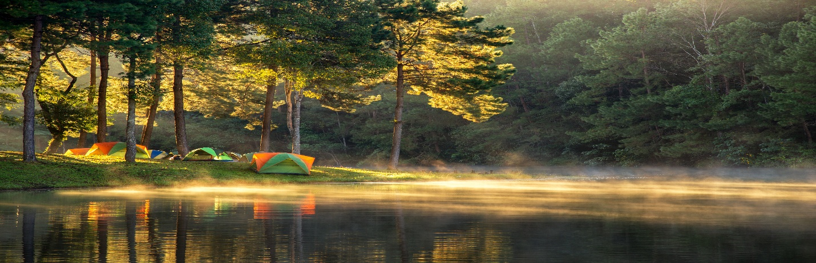**27TH Annual Men’s Retreat**

**Friend of Bill W,**

October 3-5, 2025

Bayshore Camp

450 N. MILLER, SEBWAING MI 48759

Come join us for a whole weekend of recovery and spiritual fitness. $170 gets you 5 meals and 2 nights of lodging along with 3 presentations, 3 breakout sessions, 2 open talks and a little bit of time for all Bayshore’s amenities.

***Must brings***

Pillow, blankets, personal toiletries, towel and washcloth.

***Bonus items to bring***

Food for the “hog trough”, fishing poles, books for the free book exchange table

3 different kinds of lodging available. Bunk house with everyone, individual rooms above the dining area or campsites. No smoking or vaping in buildings. Check in starts at 3pm on Friday October 3rd.

You can make your reservation by calling, texting, mailing the bottom of the flyer to

Brian Voss 989-286-1461[Bvoss53.b53@gmail.com](mailto:Bvoss53.b53@gmail.com)

1082 Valley Drive, Caro MI 48723

BRING A FRIEND OR MAKE SOME NEW ONES. ALL ARE WELCOME. SOME SCHOLARSHIPS ARE AVAILABLE

NAME ______________________________________________________________

ADDRESS ____________________________________________________________

PHONE ________________________________________________________________

EMAIL ____________________________________________________________________

TOTAL AMOUNT ENCLOSED $170______ OR DEPOSIT $50__________