The Trail’s End


Good Sam Matean’s RV Club
A Good Sam RV Club May 17, 2018
A Message from the President
Terry Augustine


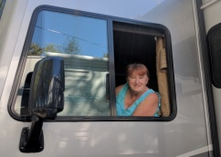
Summer is almost here! It seems like it was just March and raining. The trip to Red Bluff was great. The weather was wonderful, the river was full and the evening fire by the club house was beautiful. What more can you ask for? During the day many people took excursions to wineries, museums and my favorite the quilt shops.
I called Wine Country RV to get their activity schedule while we are there in June. There will be wine tasting from local vineyards on Friday June 1st from 3 to 5. On Saturday there will be a band up by the club house in the early evening.
The Charity committee will be collecting toiletries on this outing. If you can bring a larger item that would be great. In case you lost the list of what the charity committee will be collecting here it is:
June- Toiletries (large size)
August – Back packs or shopping bags
September- Gloves
October- Jackets and winter clothing
November- Canned food and Pet food
December- A gift for the Vets and Toys for Tots
See you in June!
Terry


Good Sam Matean’s Meeting Minutes

Date______May 6, 2018___________ Location ___Durango RV Resort, Corning____

Meeting called: to Order:: Time _____09:20__________

Number of rigs: 9____

Roll Call of Officers: All present except Treasurer and Secretary

Members Present: Terry, Merle, Jean, Ted, Carolyn, JoAnn, Buzz, Lou, Madlyn, Bob, Margie, Sara, Zvi, Barbara, Allan, Mary Ellen

Introduction of Guests: none

Secretary reading of the previous minutes: without objection m/s/p

OFFICERS REPORTS:
Treasurer: checking acct balance $4388, Gen Fund $4345, Charity $43, Petty Cash $113

Wagon Master: site cost @53/nite.
Next month’s campout at Wine Country, Paso Robles only 14 sites available but we need 17. Also, higher cost ($68) than originally planned due to weekend rate. Discussed cancelling the outing or using treasury to help defray the cost for the two weekend nites, but a motion was presented to pay the $68 rate; vote was passed with one member opposed. Merle was applauded for doing a great job as Wagon master.

Birthdays/Anniversaries/Sunshine: We sang happy birthday to Ted. Anniversaries: Hubers May 4, Caspersons May 30.

Publicity: no report

Legislative Rep: Barbara attended the NorCal meeting in Lodi and passed out a report. They are looking for replacement of officers and, if none, may have to merge with SoCal.
There was a discussion on reassigning points for the Chapter of the Year award.

Historian: Madlyn and Sara will get together to hand over job requirements.

COMMITTEE REPORTS
Charity Committee: JoAnn reported delivery to Second Harvest Food Bank of 74 pounds of canned goods. June donations will be toiletries of a larger size.
Terry discussed the homeless problem in Santa Clara and San Mateo counties. She mention there is presently 27,000 homeless children. She is a member of the Tiny House project and will supply a list for donations later.

New Member Committee: Ted is in contact with three new couples who may join our group.

GOOFY AWARD: Goofy will stay with Terry because she forgot her vest.

OLD BUSINESS: none

NEW BUSINESS: Madlyn took a vote if the storage bins should be continued. Most said leave the two bins and use petty cash to replenish supplies. She suggested using pizza delivery on Friday nights but that is yet to be determined.

ANNOUNCEMENTS

Next month’s Trailboss statement: June campout will be hosted by Kirschenbaums and Hubers in Paso Robles

ADJOURN: 10:30

Minutes submitted by asst. secretary Mary Ellen Huber

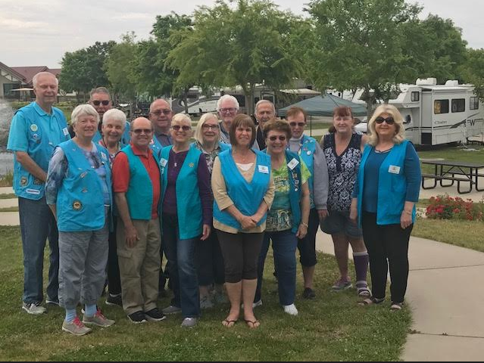
Durango Resorts, Red Bluff May, 2018

PRESIDENTS AND/OR SECRETARIES, PLEASE READ THE FOLLOWING AS CORRESPONDENCE AT YOUR NEXT CAMPOUT/MEETING, OR EMAIL TO ALL MEMBERS IN YOUR CHAPTER.

Hi All,

I have been informed formally that Earl Irons, Rally registrar, and Gary and Regina Black, Rally Wagonmaster and Check-in chair, have resigned from their respective positions on the NorCal Rally staff. I have been also informed that Maryann Schmidt, Raffle Chair may also resign her position. These individuals have been an asset to the Rally and during SCM's, with their expertise, and tireless devotion to providing the best service possible for successful events. It is with a sadden heart that I have to see these people go,they will be sorely missed, but we must move on, and attempt to get volunteers to step-up to fulfill these positions..

I ask that each of our Presidents to discuss with their respective chapter members that these positions are critical and need to be filled. If anyone shows an interest and would like to take over the reigns for these positions, that they should contact me at the earliest convenience. I am confident that these outgoing individuals will work with those that are interested, and share with them the mechanics of performing the jobs. I know that Earl has everything down on his computer and I feel as though he would definitely share those files. Gary and Reginas' positions are not computerized, but can be learned with a minimal amount of instruction. Same will apply with Maryann. .

I want to emphasize that these positions are not full time. The registrar position does take some considerable time as. It requires making timely bank deposits, recording attendees and maintaining lists, sending confirmation letters, and then spending some time during the Rally with the completion of the registration process. The upside of this, is the ability to meet with new people and make new friends. the Wagonmaster position is basically parking the Rally attendees rigs in an orderly manner, and the Check-in position is greeting and meeting the attendees and making sure that they are properly registered. The Raffle chair, is in charge of selling raffle tickets for various activities as planned by the Rally staff.

Like I said, these are critical positions that need to be filled. In the event that they are not filled, then the Rally can not occur.

We are in need for some fresh ideas from all of the members in NorCal on how we should proceed with the Rally, or have a Rally at all. Please survey your members for their ideas on what they would like to see and do during the Rally. I have been approached by a few people that have passed along their ideas to me, and they feel as though we should not give up on what has been a fun event. I have contacted my SoCal counterpart in an effort to see if a super combined, NorCal/SoCal, California Rally would be feasable. There are a lot of answers that would be needed to stage this event. It would be held somewhere between Fresno and Bakersfield, if we could find a suitable venue that could handle it. In the meantime, once I receive most of your ideas, I will call for a staff meeting to sort out those ideas and see which of them can be made as doable. Although I feel as though that this years Rally was a success, it also had its failures. We need to fix those if we have any chance at succeeding n the future. One of those fixes is already in the offing. That is having one of our own to handle the ladies luncheon AND the Saturday night dinner. This individual did an outstanding job for the ladies luncheon this year and has the credentials to provide a sumptuous and satidfying dinner as well. I am considering having daytime Bingo, such as they have at Super Rallies, this in an attempt to have another activity that all attendees can enjoy., particularly during the daytime. Maybe eliminating card games, dominoes and the such due to a lack of participation. Then find another attraction to take their place. I have other thoughts about the restructuring of the Rally, and if we are going to do this, then time is of the essence, and we need to get after it now. I urge each of you Presidents to make this survey soon, and then forward the results to me in a timely manner so that the staff can consider these propositions.

I truly hope that all our ladies have had a special and wonderful Mothers Day today, with many more to come.

Thank you,

Wayne

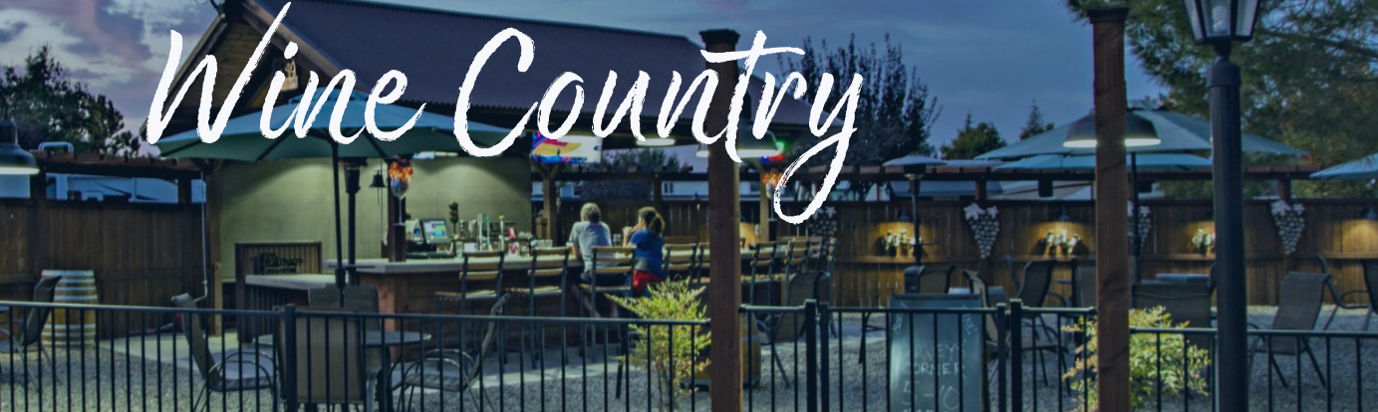
The resort is conveniently located in the Paso Robles wine region,centrally located within walking distance of the Ravine Water Park, and only a short drive away from the famous Hearst Castle in San Simeon. You can also enjoy local boutique shopping, fine dining, wine tours, championship golf courses, craft breweries and much more.
2500 AIRPORT ROAD. PASO ROBLES 93446 866-550-2117

Amenities

WiFi Access
Cable TV Access
Restroom & Shower Facilities
Laundry Facilities ($)
On-Site Store ($)
Campfires Permitted
Ice ($)
LP Gas ($)
Propane ($)
On-Site Food Service ($)
Pet Friendly
Pet Area
Clubhouse
Picnic Area
Swimming Pool
Hot Tub
Cornhole
Fitness Center
Biking
Game Room

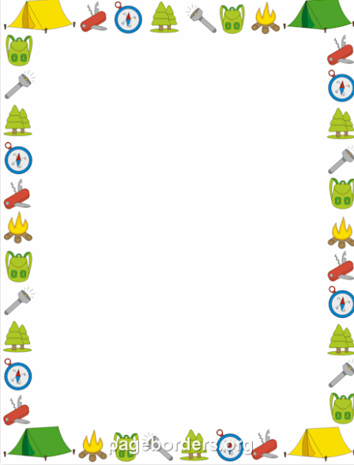

Campout at Wine Country in Paso Robles
Trail Bosses: Hubers and Kirschenbaums
Theme: Summer Fun!

Friday
Happy Hour 5pm
Dinner 6pm:
Bring appetizers to share
Dessert: Ice Cream __Augustine_________

Saturday
Breakfast
Waffles, Butter & Syrup__Hosts_______
Scrambled Eggs ________Hosts_________
Juice ______Martens__________________
Bacon ______________________________
Turkey Bacon________________________
Bagels & Cream Cheese ___Bengel_______
Fruit ________Del Grande____ _________

Dinner 6pm
Lasagnas ____Hosts__________
Salad _______Kohr____________________
Salad ___________________________
Garlic Bread ______________________
Dessert _____Dingle_____________________
Dessert ___Bob Balter & Margie______________

Good Sam Mateans 2019
Date Park/Tel # Address Trail bosses
January 01/03 - 01/06 | French Camp Rsrt  209-234-1544 | Booked | 3919 E French Camp Rd  Manteca, 95336 | Kohr  Thomas
February 1/31–02/03 | Laguna Seca  831755-4899 | Pending  Book in Sept//Oct | 1025 Monterey-Salinas Hwy 68  Monterrey, 93940 | Bengel  Dingle
March 2/28 – 03/03 | Vineyard RV  866-447-8797 | Booked | 4985 Midway Rd  Vacaville, 95688
April 04/04 – 04/07 | Angels Camp Rsrt  209-736-0404 | Booked | 3069 Hwy 49 South  Angels Camp, 95222
May 05/02 – 05/05 | Sugar Barge Rsrt  925-684-9075 | Booked  (30 amp only) | 1440 Sugar Barge Rd  Bethel Island, 94511
June 06/06 – 06/09 | Duck Island Rsrt  916-777-6663 | Awaiting Contract | 16814 CA-160  Rio Vista, 94571
July no outing
August 08/01 – 08/04 | Olema Campground  415-663-8106 | Book  August 1, 2018 | 10155 CA-1  Olema,94950
September 9/05-9/08 | Calistoga RV Park  707-942-5221 | Pending | 1601 N Oak St.  Calistoga, 94515
October 10/03 – 10/06 | Yanks RV Rsrt  831-740-8007 | Pending | 40399 Livingston RD  Greenfield, 93927
November 10/31-11/03 | Heritage RV Park  530-824-6130 | Pending | 975 Hwy 99 W  Corning, 96021
December 12/05-12/08 | Vines RV Rsrt  805-467-2100 | Booked | 88 Wellsona Rd.  Paso Robles, 93446 | Club Committee
5/17/2018

Good Sam Mateans 2018
Date Park/Tel # Address Trail bosses
January 01/04 - 01/07 | Gilroy Garlic RV  408-848-8018 | 650 Holloway Road  Gilroy, CA 95020 | Augustine  Meyer
February 2/01–02/04 | Vineyard RV  866-447-8797 | 4985 Midway RD.  Vacaville, CA 95688 | Bengel  Valentine
March 3/01 – 03/04 | Heritage RV  530-824-6130 | Corning, CA 96021 | Kohr  Baumgarten
April 04/05 – 04/08 | Betabel RV  831-623-2202 | San Juan Batista | Melville  Thomas
May 05/03 – 05/06 | Durango Resorts  866-770-7001 | 100 Lake Ave.  Red Bluff 96080 | Del Grande
June 05/31 – 06/03 | Wine Country RV Resort  (on airport road) | 2500 Airport Rd. Paso Robles 93446 | Huber Kirschenbaum
July no outing
August 08/02 – 08/05 | Bodega Bay RV  707-875-3701 | 2001 N Hwy 1  Bodega Bay 94923
September 9/06-9/09 | French Camp  800-350-5232 | 3919 French Camp  Manteca 95336 | Moore  Martens
October 10/04 – 10/07 | Casa de Fruta  408-842-0316 | 10031 PachecoPass Hwy Hollister 95023r | Fischer  Dusine
November 11/01-11/04 | Los Banos RV  209-826-5542 | 28485 Gonzaga Rd  Los Banos, 95242 | Grundy
December 11/29-12/02 | Flag City RV  209-339-8300 | 6120 Banner Road  Lodi, CA 95242 | Club Committee

4/21/2018

