2020 NORTHERN CALIFORNIA STATE RALLY
COMMERCIAL VENDOR REGISTRATION

CASA de FRUTA RV RESORT, HOLLISTER, CA

October 22, 23, 24, 2020

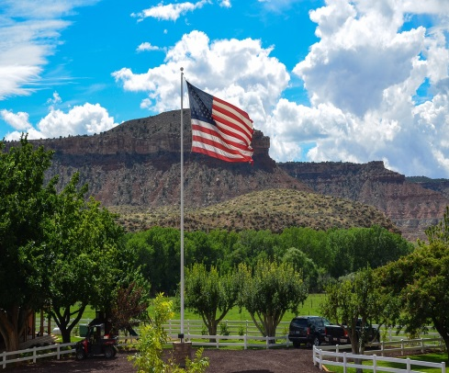
America the Beautiful

Set-Up Date: October 20, 2020, 1:00 pm to 4:00 pm, or, October 21, 2020, 9:00 am to 4:00 pm
Sell Dates: (Early Day) Wed. October 21, 2020, Noon to 4:00 pm
Thurs. October 22, 2020, and Fri. October 23, 2020, 9:00 am to 4:00 pm
Saturday, October 24, 2020, 9:00 am to Noon

2020 Rally Theme, “Salute to America the Beautiful”

NAME__________________________________________________________________________________________________________

COMPANY NAME_________________________________________________________________________________________________

ADDRESS_______________________________________________CITY:_______________________________STATE____ZIP__________

PHONE NUMBER: (H)______________________(C)_______________________EMAIL________________________________

SALES PERMIT #_________________________________________(REQUIRED OF ALL VENDORS)
RATES:
RV PARKING: (Full Hook-Ups)
Monday through Saturday nights…….$35.00 per night

VENDING SPACE: WITH OR WITHOUT AN RV
Inside 10’ X 10’ Space, With ONE Table….…………………………………………………………..…$ 60.00
Inside 10’ X 20’ Space, With TWO Tables….……………………………………………………….….$ 80.00
Outside Space, (Sell From Your Trailer)………………………………………………………………..$ 125.00

PRODUCTS THAT YOU SELL__________________________________________________________________________________
ARE YOU INTERESTED IN DOING A SEMINAR: YES________ NO________
PLEASE DESCRIBE THE PRESENTATION:________________________________________________________________________
WOULD YOU LIKE TO DONATE A GIFT(S) FOR THE MERCHANT’S DRAWING? YES________ NO________

RV TYPE:
M/H______ 5TH WHEEL________ TRAVEL-TRAILER________ LENGTH_______FT. # SLIDES___________

SATURDAY NIGHT SIT DOWN, BUFFET DINNER: NUMBER ATTENDING: _____@ $22.00 PER PERSON = $____________

Please make checks payable to: NorCal Good Sam Association. No refunds after October 14, 2020.

Mail this registration and check to: Al Quint, Registrar, 6001 Myrtlewood Ct., Citrus Heights, CA 95621

Questions: Call either Cricket or Walter Weight @ 916-548-3141 –or- email: weweight@surewest.net
1.

EMERGENCY NOTIFICATION
IN THE CASE OF AN EMERGENCY, PLEASE NOTIFY
NAME:_______________________________________RELATIONSHIP:_____________________
ADDRESS:_______________________CITY:_____________________STATE:____ ZIP:_________
HOME PHONE: __________________CELL PHONE: ____________________

INSURANCE LIABILITY
All participants must accept full responsibility for the welfare and safety of themselves, guests, and vehicles
while attending this Rally, and relieve the NORTHERN CALIFORNIA GOOD SAM ASSOCIATION, of liability from damage and/or injury caused by events not under their control.

Please furnish a “Liability Rider”, if you have coverage naming: Northern California Good Sam Club.

Thank You

2.

