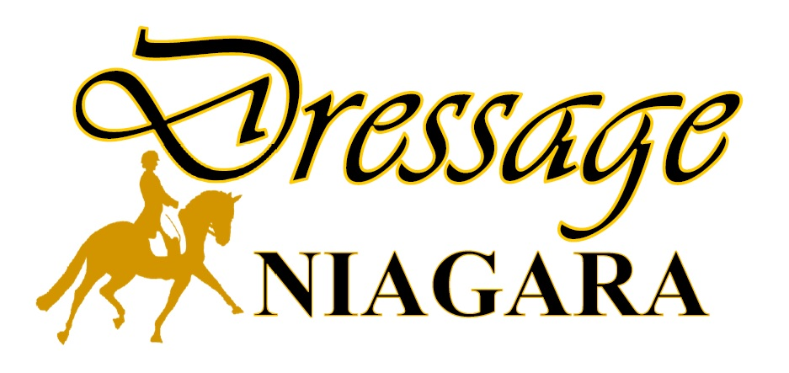

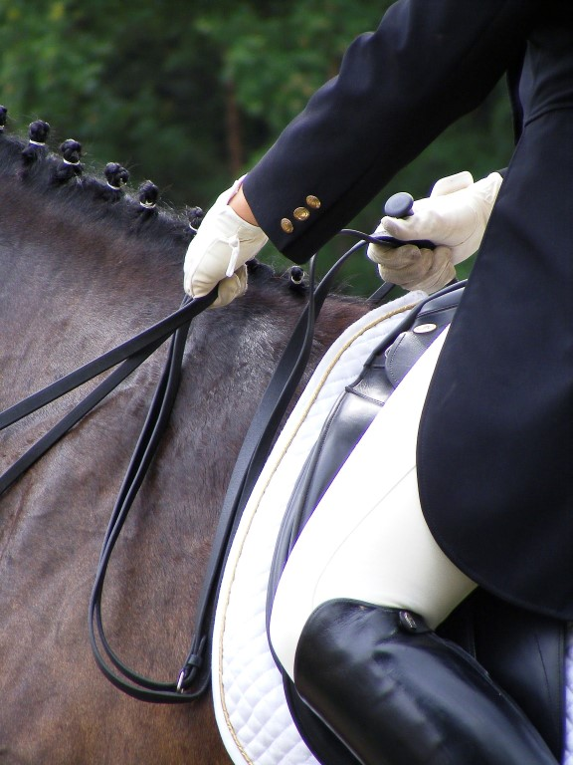
EC Sanctioned Show Series 2025

Bronze and Silver
Dressage Competitions

WSDAC Sanctioned

PRIZE LIST

Additional questions may be directed to the Competition Coordinator, Cheryl Semotok at 905-609-0987, 416-712-0416, or appy_gal@hotmail.com.
CLASSES, TESTS & DIVISIONS:

Divisions Offered
Categories:
Open, Junior, and Adult Amateur. For full definition of categories and eligibility to compete, please see Article E 3.4.

Classes/Tests:
Bronze & Silver Competition: All EC Dressage and Para Dressage tests; FEI tests Prix St. George and Intermediate 1, and Materiale classes.

Para Dressage: All EC & FEI tests are available upon request for both Bronze and Silver entries. Para-Equestrian classes will be governed by EC Para Dressage rules (Section E Chapter 6). Athletes must submit copies of his/her EC Para-Dressage Dispensation Certificate and/or a copy of the EC Classification Master List with his/her entries and carry copies with them at all times while on the competition grounds.

Miscellaneous Classes (Bronze only): Western-Style Dressage, Pas de Deux, Quadrille, and Prix Caprilli will be offered but not rated for EC awards (Article A503.3). All WDAA tests will be offered for the WSDAC classes which will be required to follow the WSDAC rulebook; however, all other EC rules such as those pertaining to memberships, sport licenses, equine medication control, EC National Passports/FEI Passports/Horse Recordings and entry status will apply (A503.5).

Additional Information:
EC Introductory through to Fourth Level, Freestyle, Para Dressage, and Materiale classes may be downloaded from: https://equestrian.ca/compete/athlete-resources/tests/

FEI Level tests: http://inside.fei.org/fei/your-role/organisers/dressage/tests

FEI Para Dressage tests: https://inside.fei.org/fei/your-role/organisers/p-e-dressage/tests

Western Dressage tests: https://westernstyledressage.ca/rules-and-tests

Prix Caprilli may be downloaded from: http://www.cadora.ca/pdf/CADORA_prixcaprillitest.pdf

Pas de Deux and Quadrille Freestyle tests may be downloaded from: https://www.usdf.org/downloads/forms/index.asp?TypePass=Tests
COMPETITION SCHEDULE :

Bronze/Silver Competition #1: Sunday, June 29, 2025
Closing Date: Sunday, June 22, 2025 (with late fees Tuesday, June 24, 2025)
Location: West Niagara Agricultural Society, 7402 Mud St., Grassie, ON L0R 1M0
Judge: Beth Murray (SS) Steward: Maria-Jose Figueira (SM)
Tests: All Levels
Bronze/Silver Competition #2: Sunday, July 27, 2025
Closing Date: Sunday, July 20, 2025 (with late fees Tuesday, July 22, 2025)
Location: West Niagara Agricultural Society, 7402 Mud St., Grassie, ON L0R 1M0
Judge: Vivian Hemsley (SM) Steward: Maria-Jose Figueira (SM)
Tests: All Levels
Bronze/Silver Competition #3: Sunday, August 24, 2025
Closing Date: Sunday, August 17, 2025 (with late fees Tuesday, August 19, 2025)
Location: West Niagara Agricultural Society, 7402 Mud St., Grassie, ON L0R 1M0
Judge: Lynne Poole (SM) Steward: Maria-Jose Figueira (SM)
Tests: All Levels

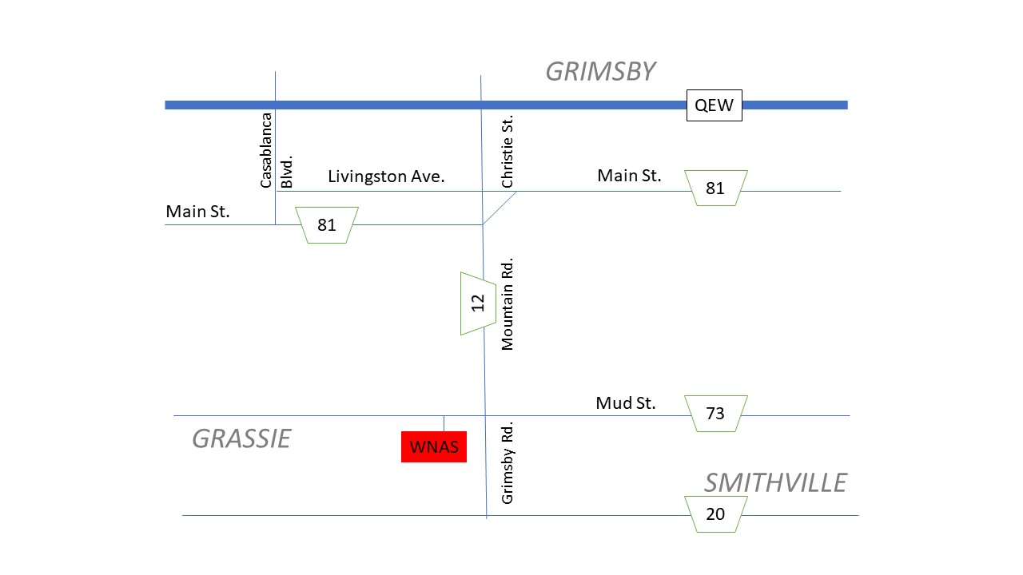

WHAT YOU NEED TO SHOW:
Requirements | Bronze | Silver | Non-Competing
Mandatory:
Ontario Equestrian Membership for Rider and Owner† | X | X | X
Ontario Equestrian Membership for Person Responsible for Horse * | X | X
Equestrian Canada Sport License for Rider and Owner†  (Bronze required to show Bronze Level; Silver to show Silver Level; either for non-compete) ** | X | X | X
Equestrian Canada Sport License for Person Responsible for Horse* | X | X
Equestrian Canada Horse Recording with paid Annual Activation Fee *** |  | X
Equine Vaccinations **** | X | X | X
Optional:
Dressage Niagara Membership  (Reduced entry fees & eligibility for Dressage Niagara Year End Awards) | X | X
Ontario Dressage Membership | X | X
Western-Style Dressage Association of Canada Membership | X

† NEW FOR 2025

* The Person Responsible for a horse is the individual responsible and accountable for the care, training, custody, and performance of the horse. The Person Responsible may be the trainer, owner, rider, agent, or coach (Articles A203.4 and A1011). This person must possess a valid sport license.

** Bronze license holders wishing to compete in the Silver EC competition may purchase a Single Event Upgrade directly from EC (Article A211). Horse Recording requirements are still applicable to the level of competition.

*** All Canadian entries are required to hold an EC Horse Recording and have paid the EC Horse Recording annual Activation Fee to compete (Article A602.4). Foreign entries must sign an affidavit (See A404.2).

**** All horses attending EC sanctioned competitions must have been administered Equine Influenza and Equine Herpes Virus (1&4) vaccinations within 6 months (+21 days grace period) before arrival at the event. No horse shall receive vaccination within 7 days prior to arrival at the event. Horses not in compliance with this rule may be asked to leave the event site at the discretion of Competition Management. The person(s) responsible must declare that the horse listed on that entry form has met the vaccination requirements under Section A519.

Proof of negative Coggins test is recommended; however, Dressage Niagara will not be enforcing this test. We will be checking with EC regarding any potential outbreaks of Equine Infectious Anemia.

ENTRY FEES & FORMS:

SILVER Competitions:
All EC Levels; all FEI Levels; Materiale
$40 per class Dressage Niagara members $50 per class non-members

BRONZE Competitions:
All EC Levels; all FEI Levels; Materiale; all WSDAC levels; Prix Caprilli
$30 per class Dressage Niagara members $40 per class non-members

For Pas de Deux and Quadrille Freestyle classes
$15 per entry Dressage Niagara members $20 per entry non-members

Hors Concours:
Entries will be accepted at the discretion of the Competition Committee. Regular entry fees apply and must be received by the show closing date. See also Article E 7.11.11.

Non-Competing (Schooling) Fee:
$30 per horse Dressage Niagara members $40 per horse non-members

STABLING:
Cost per stall: $40 for the day + $40 refundable stall cleaning fee. No overnight permitted. Shavings can be purchased for $12/bag.
Note: Stalls must be cleaned prior to leaving the show grounds; the stall cleaning fee will be returned by Compete Easy after proof of a clean stall.
First come first served – limited # of stalls available.

Additional Fees: | Bronze | Silver | Non-competing
Administration Fee (per horse/rider entry) | $20 | $20 | $20
Event Processing Fee (per horse/rider entry) | 5% | 5% | 5%
EC Dressage Levy (per horse) | $12 | $12 | NA
EC Drug Testing Fee (per horse) | $4 | $8 | NA
Late Fees* (per horse/rider entry) | $35 | $35 | $35
Change Fees (per horse/rider entry) | $10 | $10 | $10
*Late entries only accepted if space permits and at the discretion of the Competition Committee.
Membership:
Dressage Niagara Membership is for the Calendar year: $25 for senior memberships and $20 for junior memberships. Please visit http://www.dressageniagara.com/membership.html for more information. To receive the discounted membership entry fees, memberships obtained prior to the show date deadline will receive a promotional code to use on Compete Easy. You can also pay for your Dressage Niagara membership with Compete Easy when you enter your respective show.

Entry Forms
Please visit https://www.competeeasy.com/ for online entries. Please ensure that all required information, membership numbers, liability waiver, and signatures are included in your submission.

Payment
Full payment must be included with entries. Compete Easy will accept credit cards and PayPal.

Refunds
Test entry fees only will be refunded for illness or lameness upon receipt of a personal medical or equine veterinary certificate, which must be submitted to the Show Coordinator within five days after the show. Administration, processing, and stabling/bedding fees are not refundable.

Closing Dates for Entries and Changes to Entries
Entries must be completed on or before the closing date listed prior to each show, otherwise subject to $35 late fee, as listed above. A late entry is any entry which is entered after the competition closing date (Article A807). Dressage Niagara reserves the right to refuse entries due to scheduling capacity and for incomplete or incorrect documentation. Any changes to an entry will be subjected to a $10 change fee. This includes any changes, edits or additions to the entry after submission, either completed by the rider or by the competition organizer/manager.

Show Schedule
Order of go schedule will be made available 3 days before the show date.

First Aid will be on site (Article A508 Emergencies).
Concussion Protocol is in effect (Article A101 Accidents & Return to Sport).
Veterinarian and farrier will be on call.

COMPETITION RULES:

- The Dressage Niagara competition is sanctioned as a Bronze and Silver competition member of Equestrian Canada c/o House of Sport 2451 Riverside Drive, Ottawa, Ontario, K1H 7X7 and is governed by the rules of EC.” (A602.1).

- Every class offered herein is covered by the rules and specifications of the current rules of EC and will be held and judged in accordance with the EC Rule Book (A602.2).

- For the Silver competition, all Canadian entries are required to hold an EC Horse Recording and have paid the EC Horse Recording annual Activation Fee to compete (A602.4). Foreign entries must sign an affidavit (See A404).

- Any horse entered in any class at a competition may be selected for equine medication control while at the event location (Article A602.5).

- Per Article A801, every entry at an EC-sanctioned competition shall constitute an agreement by the person(s) responsible that the owner, lessee, trainer, manager, agent, coach, driver or rider and horse shall be subject to the EC constitution and all rules of EC and any additional rules set by the competition. It is the responsibility of all individuals participating in any capacity in EC- sanctioned competitions to be knowledgeable regarding the EC constitution and the applicable rules of EC and the additional rules, if any, imposed by the competition. Do not participate in this EC-sanctioned competition in any capacity if you do not consent to be bound by the constitution and rules of EC and any additional rules imposed by the competition (Article A602.7).

- All horses attending Equestrian Canada sanctioned competitions must have met the requirements of Article A519, Vaccinations. See Rules of Equestrian Canada, Section A, General Regulations, Article A519, Vaccinations.

- When registering for EC sanctioned competitions, athletes must indicate the name of their coach on the entry form or specify that they are self-coached. Coaches from other countries, must be in good standing with their home federation and must declare/have proof of insurance. See Rules of Equestrian Canada, Section A, General Regulations, Article 102, Safe Sport Environments.

- All horses on the show grounds, whether showing or schooling, must wear their assigned competition number at all times. Exception: Horses stabled permanently on the competition site are exempt unless competing (Article E 7.11.2).

- Per Article E 9.5, elimination from a class, an entry shall be eliminated under the following circumstances:
  - evidence of blood on the horse (environmental causes such as insect bites shall not normally be cause for elimination). If a competitor is eliminated for this reason, they must report directly to the stewards for a tack check.
  - use of illegal equipment (Article E 4)
  - failure to submit to a tack check as required (Article E 4.16)
  - contravention of dress rules (Article E 4)
  - unauthorized assistance (Articles E 9.3.15, E 9.1.2, and E 4.15)
  - three errors of course (Article E 9.3.2)
  - resistance of more than 20 seconds in a test (Article E 9.3.12)
  - fall of horse or athlete during the test. (Article E 9.3.10)
  - dangerous/unruly behaviour of horse (Articles E 7.11.7 & E 9.3.12)
  - all four feet of the horse leave the arena (Article E 9.3.11)
  - exceeding 30 seconds to enter the arena after the start of the music in the freestyle test (Article E 9.3.16)
  - dismounting during a dressage test (Article E 9.4)
  - scoring less than 40% of the total marks obtainable in the test (Article E 9.9.8)
  - lameness (Article E 9.3.6)
  - second offence at a given competition for not wearing assigned number in competition or while out of the stall. (Article E 7.11.2)
  - taking more than 90 seconds to enter the arena at A after the start signal (Article E 9.3.7)

- Safety Headgear (Article E 4.0): All athletes, regardless of age or level of competition, must wear properly fitted and fastened safety approved protective headgear at all times when mounted at any EC-sanctioned Dressage competition at the event location. Note: At the tack check, which follows the test, the steward may ask the rider to dismount so that the helmet may be inspected for the safety standard labelling.

- Music for a Freestyle test must be in a format compatible with the onsite audio system and handed in to the Show Office two hours before the class starts. Please contact the show coordinator prior to entry submission to verify compatibility; 2 copies must be made available. The athlete is responsible for making sure they do a sound check at a time convenient to the show organizer. Each athlete may have a representative in the sound system/show office booth to supervise the handling of the music (Article E 10.3).

- Riders are to use only designated areas for warm-up and lunging.

- Riders/coaches are to observe proper riding etiquette during warm-up.

- Dogs must be on leash and under the handler’s control while on the property. Unruly or disruptive dogs will be asked to leave the official show grounds area.

- Hand walking your horse in the competition ring is NOT permitted on show days.
- Show grounds will be open 2 hours before the show start time and will close 1 hour after the show concludes. The show office will be open 1 hour before the show start time and 1 hour after the show concludes.

- While on the show grounds all horses must always have a person responsible present.

EC Statement Of Principles – Horse Welfare (Section A Page iii):
- EC requires adherence to humane treatment of horses in all activities under its jurisdiction.
- All participants shall be bound by the Horse Welfare Code of Conduct.
- EC is committed to:
  - upholding the welfare of the horse, regardless of monetary value, as a primary consideration in all activities;
  - requiring that horses be treated with kindness, respect, and the compassion that they deserve, and that they never be subjected to maltreatment;
  - ensuring that owners, trainers, and exhibitors and their agents exercise appropriate care and responsibility in the handling, treatment, and transportation of their horses, as well as horses placed in their care for any purpose;
  - providing for the continuous wellbeing of the horse by encouraging routine inspection and consultation with health care professionals and competition officials to achieve the highest possible standards of nutrition, health, comfort, and safety;
  - continuing to support scientific studies on equine health and welfare;
  - requiring owners, trainers, and exhibitors to know and follow their sanctioning organization’s rules, and to work within industry regulations in all equestrian competitions; and,
  - reviewing, revising, and developing competition rules and regulations that protect the welfare of the horse.

COMPETITION RIBBONS & STANDINGS:

When there is more than 1 entry per class, ribbons may be awarded to 4th place. Placings are decided by total points and if points are tied, the award will be given to the competitor with the higher Collective Marks. If the Collective Marks are tied, the competitors remain tied, and the next placing is omitted (Articles E 9.9.4 & E 9.9.6).

Any horse receiving less than 50% of the total points obtainable in a test shall not be eligible for awards, ribbons, or prizes. Any horse receiving less than 40% of the total points obtainable in a test will be eliminated from that class (Articles E 9.9.7 & E 9.9.8).

When there is only one horse in a class, ribbons and prizes shall be awarded in accordance with the following chart of percentages (Article E 9.9.10):
.
1st .... 63% or higher
2nd .... 60% to 62.999%
3rd .... 58% to 59.999%
4th .... No ribbons or prizes shall be
awarded below 3rd position

High Point EC Champion of the Day Award
Bronze and Silver Division EC High Point Champions will be awarded to both a Junior and Senior rider of their respective Division (i.e. Bronze HP Junior, Bronze HP Senior, Silver HP Junior, Silver HP Senior). The High Point Champions of the Day will be established by the average highest two test scores from the horse/rider combination, achieved in their designated classes (e.g. Training Level). Scores from different levels and different competitions cannot be combined. In the event of a tie, the athlete with the highest collective mark is declared the winner.

At all EC competitions, any horse receiving less than 50% on a technical test will not be eligible for any class awards, championships, or reserve championships (Article E 9.10).

NEW!!! High Point Western Dressage Champion of the Day Award
High Point Champions will be awarded to both a Junior and Senior rider. The High Point Champions of the Day will be established by the average highest two test scores from the horse/rider combination, achieved in their designated classes (e.g. Basic Level). Scores from different levels and different competitions cannot be combined. In the event of a tie, the athlete with the highest collective mark is declared the winner.

Thoroughbred Incentive Program (TIP) High Point Champion of the Day Award
Bronze and Silver Division TIP High Point Champions will be awarded to both a Junior and Senior rider of their respective Division (i.e., Bronze TIP HP Junior, Bronze TIP HP Senior, Silver TIP HP Junior, Silver TIP HP Senior) for the top Thoroughbred registered with TIP. The TIP High Point Champions of the Day will be established by the average highest two test score from the horse/rider combination, achieved in their designated classes. Scores from different levels and different competitions cannot be combined. In the event of a tie, the athlete with the highest collective mark is declared the winner.

TIP High Score of the Day Award
A TIP High Score Champion will be awarded to a single exhibitor in any division and will be based on their highest test score of the day, plus additional points for the degree of difficulty of the test, shown below. In the event of a tie, the athlete with the highest collective mark is declared the winner.
Introductory +0 Third Level +7
Training +1 Fourth Level +9
First Level +3 FEI Levels +11
Second Level +5

Note: To be eligible to receive TIP awards, Riders/Owners are responsible for registering their Thoroughbred by visiting the Jockey Club TIP Website at http://tjctip.com/APPLYTIPNUMBER, and adding their TIP Membership Number to Dressage Niagara Show Entry Forms.

DRESSAGE NIAGARA ANNUAL AWARDS:

To qualify for Dressage Niagara year-end awards, you must be a member in good standing of Dressage Niagara by the first show date, and either you or your designate have completed four (4) hours of volunteer service with Dressage Niagara by the completion of the last scheduled show date. For more information about how you can volunteer, please contact our Volunteer Coordinator.

Bronze & Silver Level Champions
Champion and Reserve Champion awards may be presented to the top Junior, Adult Amateur and Open riders in each class level at Dressage Niagara Bronze and Silver shows.

The winners will be decided by totalling the three highest scores of EC or WDAA tests - one must be from the highest test at the level - by the same horse-rider combinations from at least two Dressage Niagara Bronze or at least two Dressage Niagara Silver competitions ridden in the 2025 competition year. Winners of FEI, Freestyle, Materiale, Pas de Deux, Quadrille, and Prix Caprilli tests will be determined by totaling the two highest tests over 2 or more Bronze or Silver competitions. A minimum average of 50% is required for these awards. In the case of a tie for the Champion award, two members will receive the award and no Reserve Champion will be awarded. In the case of a tie for Reserve Champion, two awards will be given.

A horse/rider combination may only win the Champion award once at the Introductory Level. Champion awards at the Training through FEI levels may be won a maximum of two times by the same horse/rider combination.

ATTENTION GLANBROOK CADORA MEMBERS!!! You can now use 1 of your scores from the Glanbrook CADORA EC show series towards DN’s Year-End High Point Champion awards and vice versa! DN members must also be a member in good standing with Glanbrook CADORA by the first show date and have shown at least 2 DN shows and 1 Glanbrook CADORA show to be eligible for DN year-end awards. You must be a member of both clubs before your scores will count and the above conditions must be met. Please visit http://www.glanbrookcadora.com/membership.html for more information about Glanbrook CADORA membership.

NEW!!! Ontario Dressage High Score of the Year Award
A High Score Champion will be awarded to a Dressage Niagara member in any division who is also a member in good standing of Ontario Dressage. The award will be based on their highest single test score percentage of the 2025 year, plus additional points for the degree of difficulty of the test, shown below. In the event of a tie, the athlete with the highest collective mark is declared the winner.
Introductory +0 Third Level +7
Training +1 Fourth Level +9
First Level +3 FEI Levels +11
Second Level +5

The Perfect 8 Award
This award can be earned by any Dressage Niagara member who achieves an 8 for ‘Rider Position’ in their Collective Marks. Only scores earned during the 2025 season at Dressage Niagara competitions will be considered. A copy of the relevant test is to be submitted by the competitor or coach to the Show Coordinator by September 15, 2025, to be eligible for this award.

Dressage Niagara Award for Excellence Showing at the Gold Level
This distinction may be awarded to any Dressage Niagara member who has demonstrated excellence showing at one or more EC-sanctioned Gold Shows during the 2025 season. Submissions for nominees should be made by the competitor or coach to the Show Coordinator by September 15, 2025, to be eligible for this award. Juniors, Adult Amateurs and Open riders riding at any level are all eligible for this award.

Volunteer Award
Awarded to the volunteer who routinely assists Dressage Niagara ensuring the successful outcome of an event or events. This person willingly undertakes a service for the club without payment and is looked upon as an ambassador of the sport of Dressage and specifically viewed as an honourable ambassador of Dressage Niagara. This person need not be a member of Dressage Niagara but it would be a factor in the overall award process. Submissions for nominees should be made to the Show Coordinator by September 15, 2025, to be eligible for this award.

Dressage Niagara Award of Recognition
This distinction is awarded to any Dressage Niagara member who may have overcome obstacles throughout the show season but has always maintained their composure and developed positively throughout the year. This individual must always present themselves with good sportsman like behaviour. Submissions for nominees should be made to the Show Coordinator by September 15, 2025, to be eligible for this award.

Dressage Niagara Coaching Award
This distinction is awarded to the Dressage Niagara member who demonstrates a significant contribution to the development of the dressage performance of individuals and/or the advancement of coaching in the sport of dressage. This individual must always present themselves with good sportsman like behavior, demonstrates commitment to continuing education and skill development, attention to the personal growth of their students, commitment to the health and wellness of both the human and equine athlete, and be an active Certified Coach. Submissions for nominees with testimonials should be made to the Show Coordinator by September 15, 2025, to be eligible for this award.

Team Challenge
This award will be presented to the Team comprising three to four Dressage Niagara members who have attended and competed in at least 2 shows at any Level or Division in the 2025 show season. The top three scores from each show will be subtotalled and the three highest subtotals will be added to determine the winning Team at year end.

Complete a Team Registration Form with your team’s name, & names of your horse and rider combinations before the first show.

To be eligible for the team challenge:
- Riders must be Dressage Niagara members.
- Teams must be registered by the close of the first show.
- Bronze and Silver competitors are eligible to be part of a team as well as Junior, Adult Amateur and Open riders; however, a Team can only have a maximum of 1 Open rider and 2 Introductory riders.

NEW!!! The Marilyn Elkin Junior Rider Prize
Our long-time EC Steward, Marilyn Elkin, passed away suddenly early in 2024. Her friend and EC M Judge, Vivian Hemsley, has proposed a program to Marilyn's family, and they are pleased to announce the Marilyn Elkin Junior Rider Prize for Dressage Niagara.

An application will be available for eligible Junior riders who compete at Dressage Niagara shows, on borrowed or leased horses. Marilyn never did own her own horse but part-boarded several horses and was a great "Auntie" to Vivian's horses and others; Vivian feels that this prize to assist these junior riders would be Marilyn's focus. Dressage Niagara has been a second home for Marilyn during her career as an EC Steward and always looked forward to her days there and appreciated your support.

Funds for the program will be provided by the sale of Marilyn's equine items and by donor contributions. The inventory is being compiled and will be available in early 2025. Should you wish to donate to the program please contact Vivian by email at vhemsley@sympatico.ca. Details of the total collected will be disclosed once the sale is completed. This will determine the actual amount of the prize and how it will be disbursed. More to follow!

