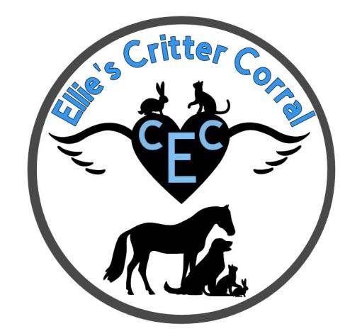
Pet Photo Release Form
I hereby agree and consent to the following:
- Release to use my pet’s likeness in any photograph, video, or other digital media (“photos”) taken or to be taken during any boarding stay with Ellie’s Critter Corral in any and all publications, including print or web-based publications.
- I authorize Ellie’s Critter Corral to copy, edit, enhance, crop or otherwise alter any photo for use in their publications. I also waive any rights for approval or inspection of any photos.
- I understand and agree that all photos are the property of Ellie’s Critter Corral and may not be returned to me.
- I acknowledge that I am not entitled to any compensation or royalties with respect to the use of the photos.
- I agree to release and forever discharge Ellie’s Critter Corral and its affiliates, successors and assigns, officers, employees, representatives, partners, agents and anyone claiming through obligations, promises, agreements, disputes, demands, damages, caused of action of any nature or kind, known or unknown, which I, and anyone claiming on behalf of me, may have or claim to have against Ellie’s Critter Corral in connection with this release.

I confirm that I have carefully read and fully understand all the provisions of this photo release form and am freely, knowingly, and voluntarily signing.

Signature _________________________________________ Date ___________________

Printed Name _________________________________________________

