Mission Statement  †  The First Presbyterian Church of Seneca Falls, New York, a member of the Covenant Network, acknowledges one community of people under God. Therefore, our mission is to serve this community guided by the example of Jesus Christ and led by the Spirit of God. We actively seek to minister to all. We value Presbyterian tradition, the education of all seekers, outreach to those in need and acceptance for those who have found different answers to God’s call. For each of us, our Christian journey requires faith, hope and love.  Love God | Love People  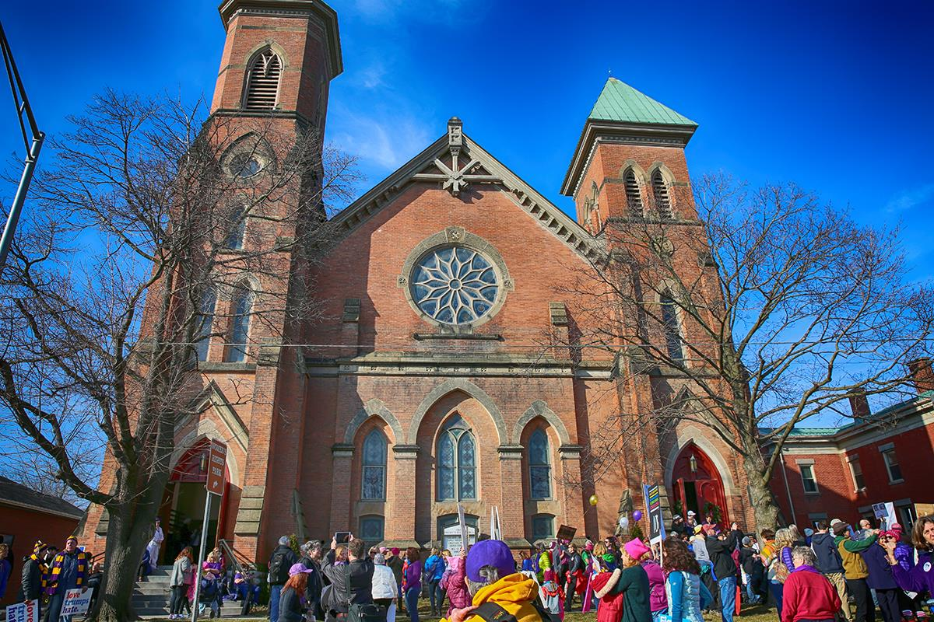  Wedding and Building Use  If you would like use our church as the venue for your upcoming wedding please visit the website, www.fpressf.com, for the form and information.  If you would like to use the church for a special event please visit the website, www.fpressf.com, fill out the form and return it to us. | Welcome!  Make yourself at home.  Sunday Worship Service  Worship Service 10 am  Nursery 10am-11am  Communion is 1ST Sunday of every month  Coffee Hour 11 am  Our building is handicap accessible  Love God | Love People  History  We are proud to be one of nearly 11,000 congregations who make up the PC(USA), our congregation also enjoys being the longest serving church in the community.  During our 202 years we have ministered from four buildings, been well-led by pastors, hosted historic moments in the women’s rights movement and helped establish a liberal arts college.  Having embarked upon our third century of ministry and service, we are confident that our “best” will continue to be found in other similar grand moments. We invite you to browse our website, check out any of the links to our denominational and area websites, and plan to join us for worship. | 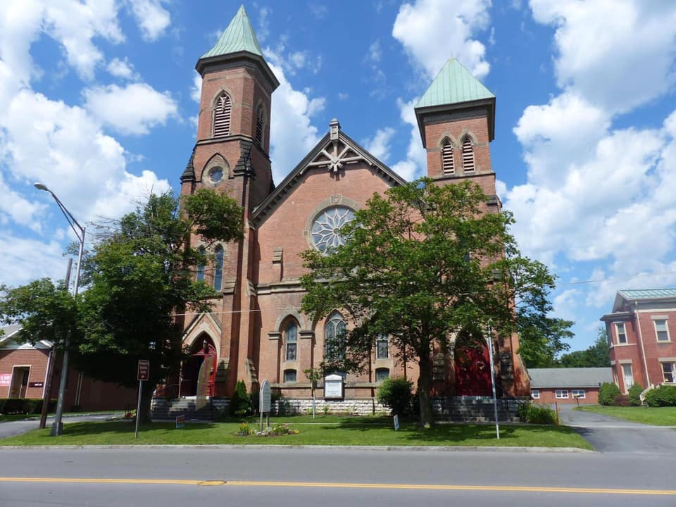  THE FIRST PRESBYTERIAN CHURCH OF SENECA FALLS, NY  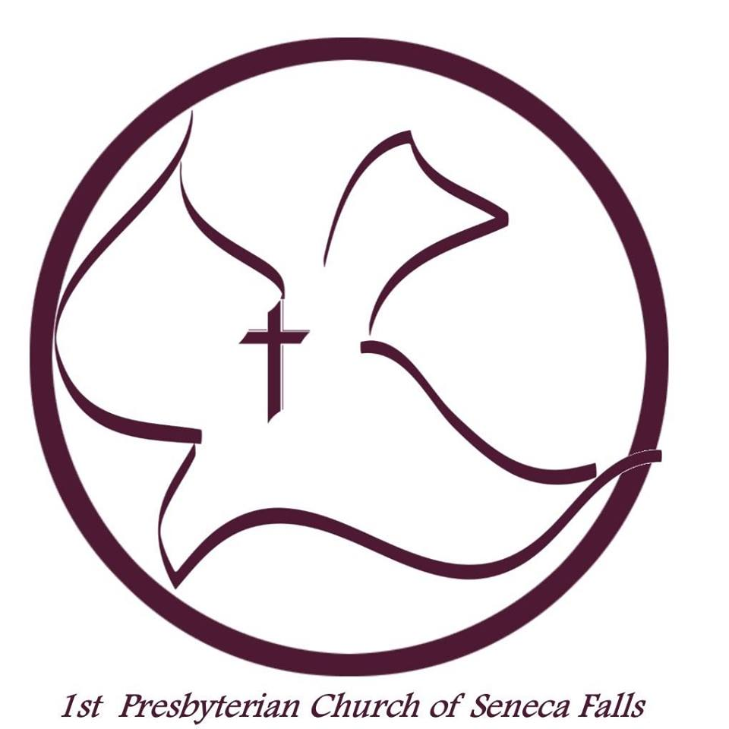  www.fpressf.com  315. 568.6636 | firstpres13148@gmail.com  Reverend Leah Ntuala, Pastor  Reverend Dr Peter J Crego, Pastor Emeritus
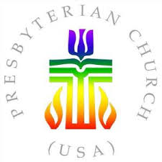  Relax  Make yourself at home, grab some coffee, and feel free to participate as much or as little as you feel comfortable.  Drop off the Kids  We provide Nursery care for children 5 and under in conjunction with the main Sunday Service. If your child is beyond the age of Nursery care, or if you wish to have your children remain in worship, please help yourself to one of the worship bags located on the back of the last pew in the center aisle. There are also a worship centers in the Sanctuary. One is located in the last pew on the left with a rocking chair. The other is located up in the church balcony.  Contact Us  The First Presbyterian Church  23 Cayuga St. |P.O. BOX 383  Seneca Falls, NY 13148  315.568.6636| firstpres13148@gmail.com  Visit us on the web: www .fpressf.com | The Chancel Choir  Jen Braun Director/Organist  Our Church Choir rehearses on Wednesday evenings from 5pm-6pm and welcomes new choristers in all sections. The choir meets downstairs in the Hawley Room.  The Hand Bell Ensemble  Carol Millis, Director  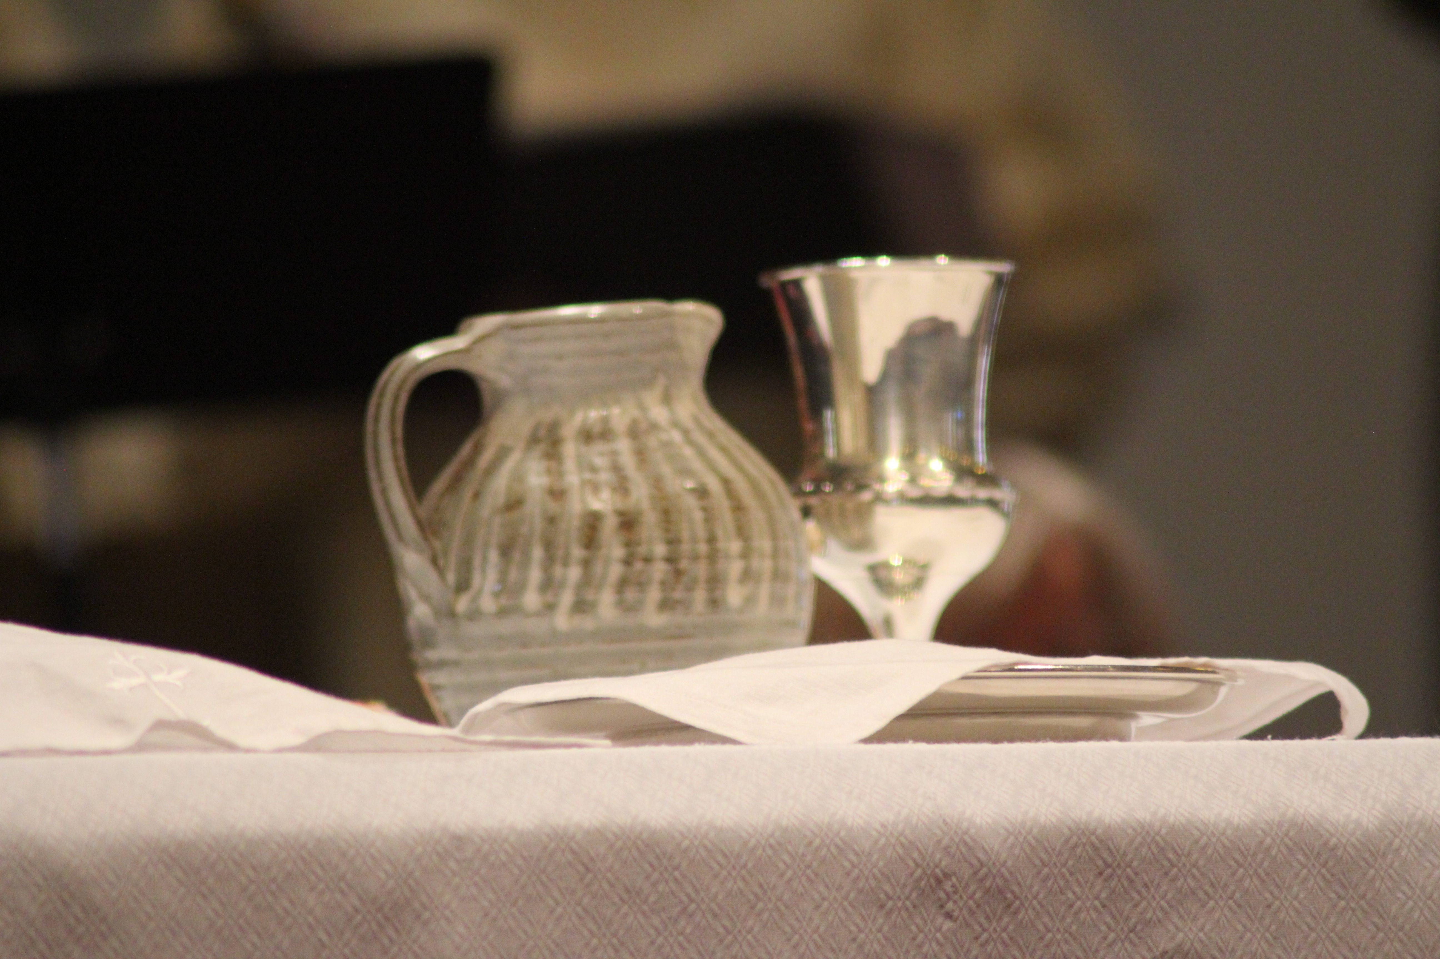  The Bell Room on the second floor, and rings once a month for church services. Hand bells are a beautiful way to be a part of the church service. Contact the church to learn how to become a Bell Ringer.  Ministry Together  Coffee Hour Following worship on Sunday morning, members from the community or the church host a conversation. It is an opportunity to be educated on issues affecting our community and to learn more about one another.  Women’s Circle The Women’s Circle is a Bible study and service group. We meet at 12:30pm on the 1st Monday of every month, Sept-May, in the Hawley Room. We have a Bible study and work on service projects. Bring a lunch and your ideas.  Potluck Dinner/Game Night All are welcome on the 1st Friday of September, February and May from 5:30pm-8pm in the church basement. Bring a dish to share and a game to play. Fun for all ages!  Love God | Love People | Ministry Teams  Session is the governing body of our church.  Building and Property is responsible for the maintenance of all property of the church.  Christian Education administers, promotes, coordinates, and evaluates the total education program of the congregation from infant to adult.  Membership and Parish Life provides a variety of fellowship offerings that encourage members and friends to get to know each other as part of our church family. This committee also works to strengthen the fellowship of the members of the congregation and to reach out to those without a church home, inviting them to join us.  Nominating makes nominations at the Annual Meeting for all elective offices, seeking to spread offices of the church among as many of the church members as possible.  Outreach serves as the primary recruiting arm of this congregation and mission are in the community.  Personnel serves in an advisory capacity and as a liaison between the staff, the congregation, and Session.  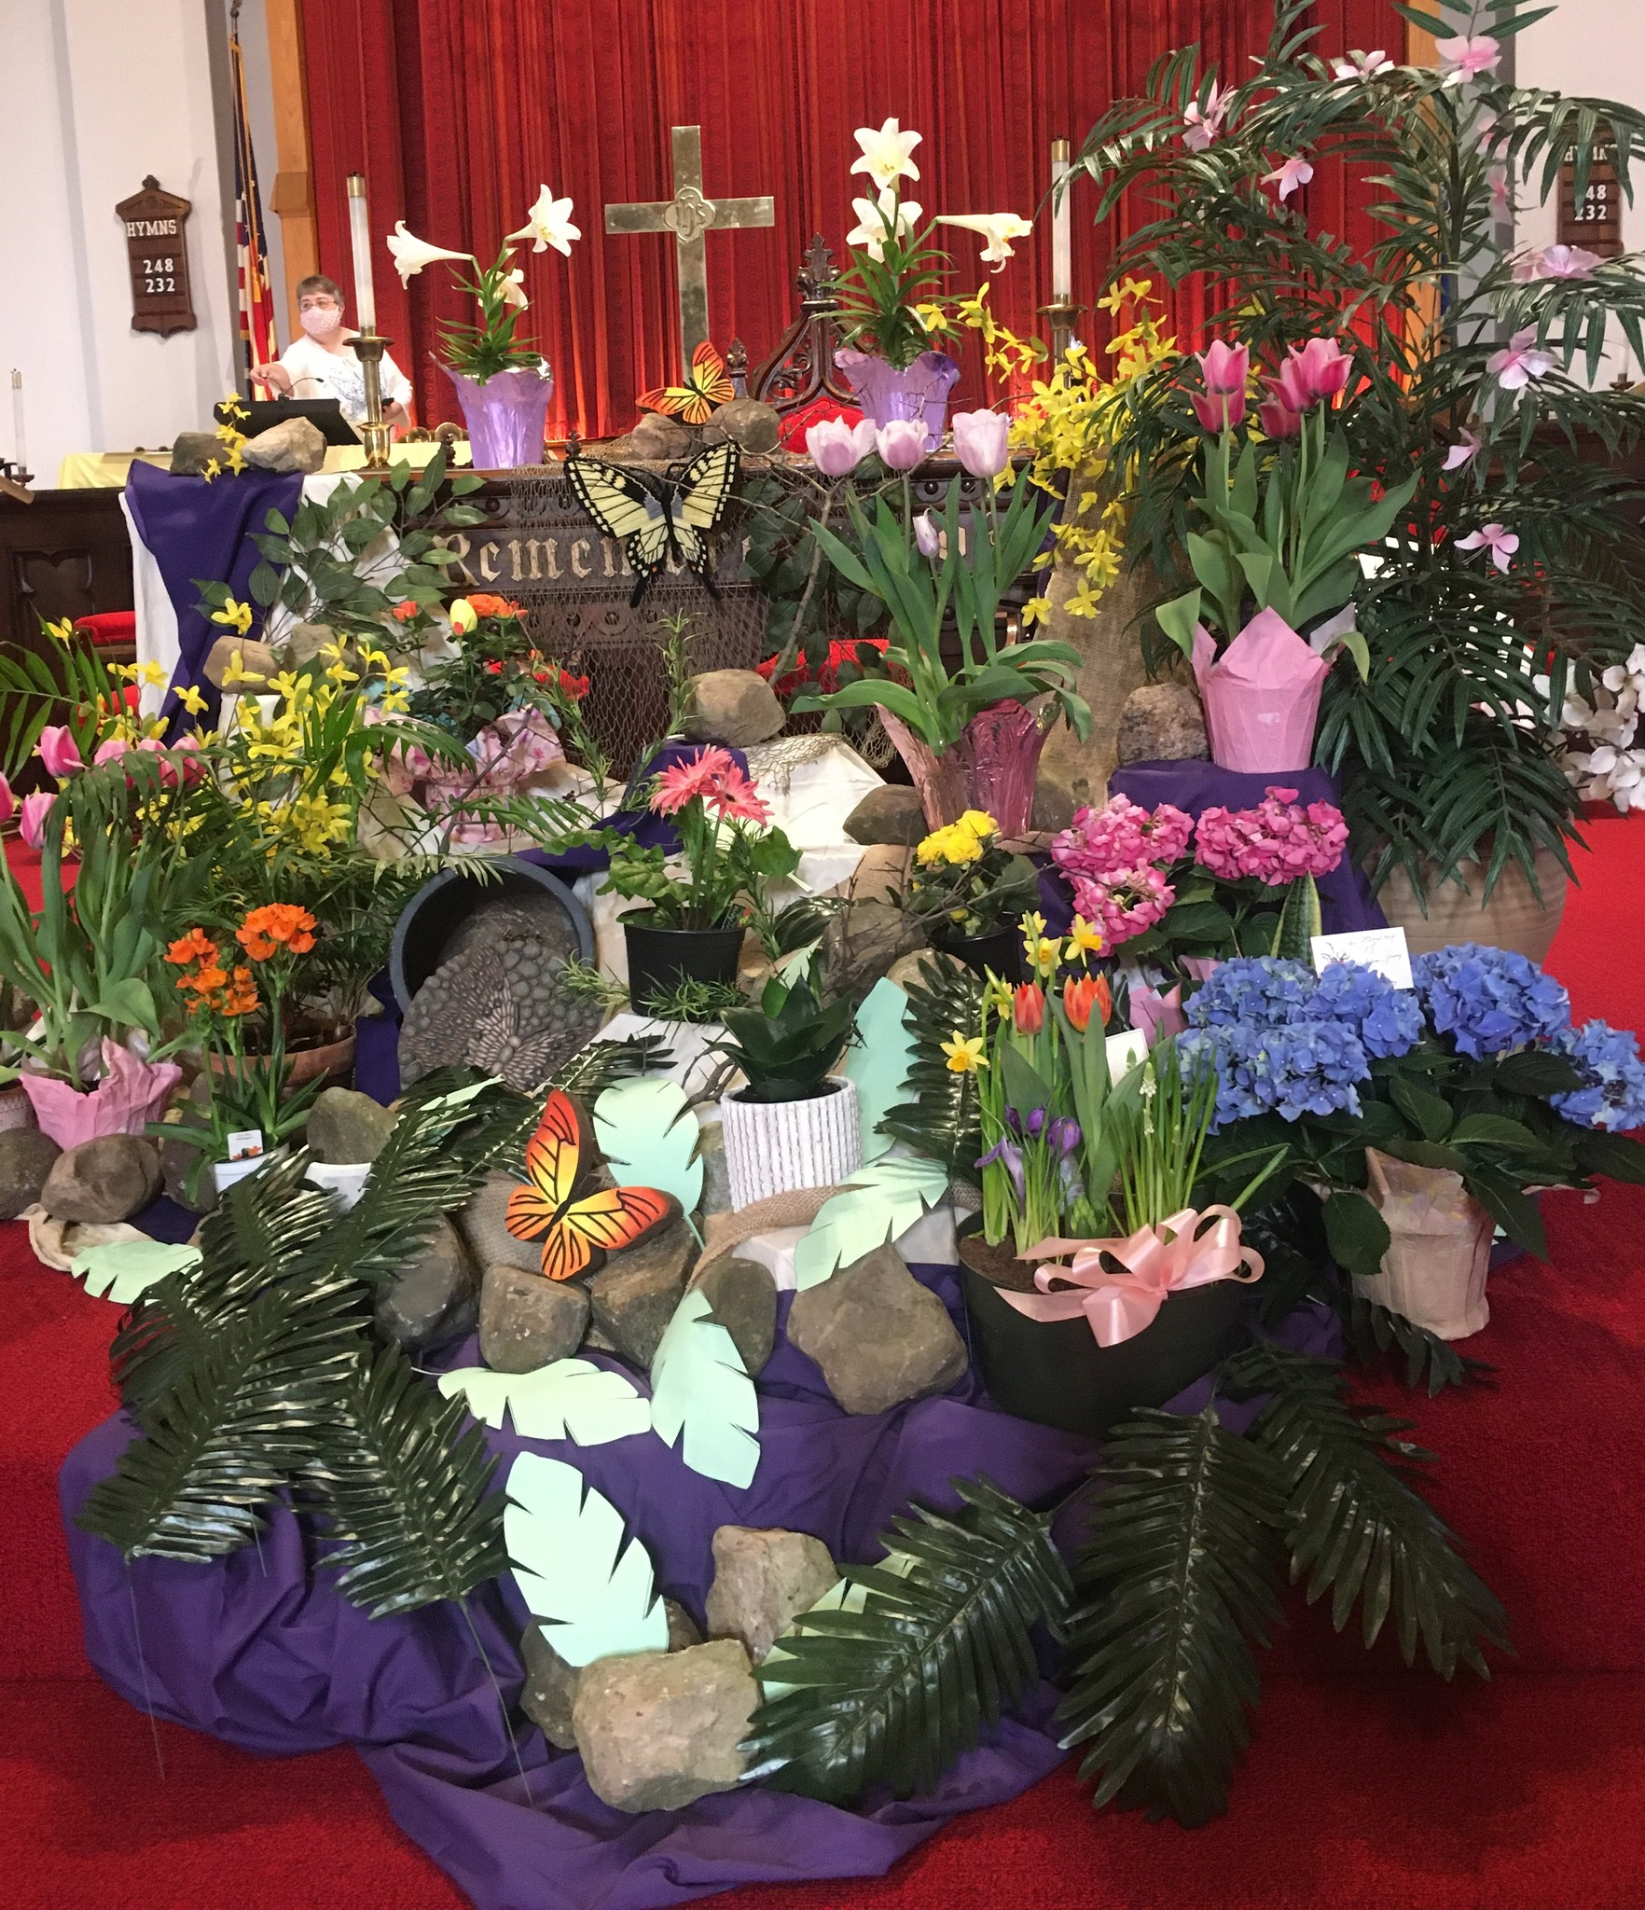  Stewardship and Finance is responsible for stewardship planning, bills, budget and monies of the church.

