Memorial Planning Checklist

The following checklist is not intended to be all inclusive or instructional. You may want to incorporate all of the elements listed or none of them! Use this tool to help you brainstorm and track your planning.

Consult any and all documents your loved one may have prepared for you about their passing. Even some legal documents have sections regarding their wishes regarding a memorial or celebration of life event.

Reach out to loved ones who may want to be involved in the planning process.

Discuss your budget openly and set a limit.

Discuss your guest list and estimate the number of attendees if possible.

Choose a date. It’s usually easiest to choose your date first. However, if the venue is especially significant to you and your loved ones, sometimes it’s best to see what dates they have available first.

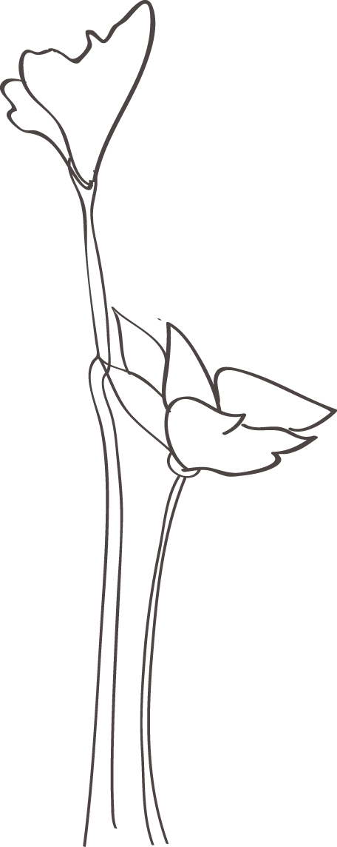

Choose your venue. Remember that this can be as formal or informal as YOU choose. I have hosted memorial services in backyards, churches, graveyards, and riverbanks. If you choose a large or well-known venue, be sure to call them ASAP as their calendars often fill up quickly.

Choose an officiant. A good officiant will manage the memorial day like a host and an emcee ensuring everything goes according to schedule and smoothing over any surprises so that you and your loved ones are able to focus on the grief and memorializing of the day.

Meet with your officiant. As your officiant I will help you plan your order of events and help you tailor this day towards the unique celebration of life you envision for your loved one.

Invitations. Now that you have a date and a location it’s time to send out invitations. You can order formal paper invitations, use a web service for email invites, or simply call your friends and family. Remember, there is no one right way to do any of this!

Create a program for the day of the memorial. I always encourage printing a simple program. People find it soothing to know the order of events and it serves as a lovely memento for guests. We can include things like a photo or favorite quote to make it even more personal. Once you have the program created, consider printing solutions. Would you like it professionally printed? Can you delegate this task to a friend with a good printer and a quick run to Kinkos?

Consider offering refreshments and either delegate to another friend or family member or contact a caterer.

Consider live streaming /video/photography needs and either delegate to another friend or family member or reach out to a professional videographer.

Consider AV additions to your memorial. Will you need a microphone / speakers / screen / projector? Most venues supply these items, but you may need to specify what you need when making your reservation. You can also rent AV equipment.

Consider music. Music can be a key part of the memorial day either as focus points or to provide ambience. Many local musicians are available to provide background music, vocal performances, or the full band or DJ experience. If you decide to download music, do it sooner than later and listen to it fully to check for quality issues.

Consider decorations. Depending on your venue you may want to add plants, flowers, or other décor items.

Consider photos. Many memorials include meaningful photos. If you wish to have some on display, I suggest choosing a recent portrait and then a few fun ones from throughout your loved one’s life. Graphic companies can help enlarge old photos and assist with the display.

Consider reserving a block of hotel rooms for out-of-town guests. (Ask about group rates.)

Consider any special touches. This is where you let your creativity flow and envision what your loved one would have really wanted for this day. We can send guests home with mementos of your loved one’s favorite candy or flower. We can order in a life-size cutout of your loved one’s favorite athlete to “attend” the day. We can release butterflies or balloons. It’s ok to be silly and it’s ok to be solemn.

Other Tasks: __________________________________________________________________________________

___________________________________________________________________________________

___________________________________________________________________________________

___________________________________________________________________________________

Schedule time to grieve. Set aside a day before the memorial to process your loss. Humans need both community and solitude to move through loss. If at all possible, do not neglect this step. Your heart and your healing deserve the time.