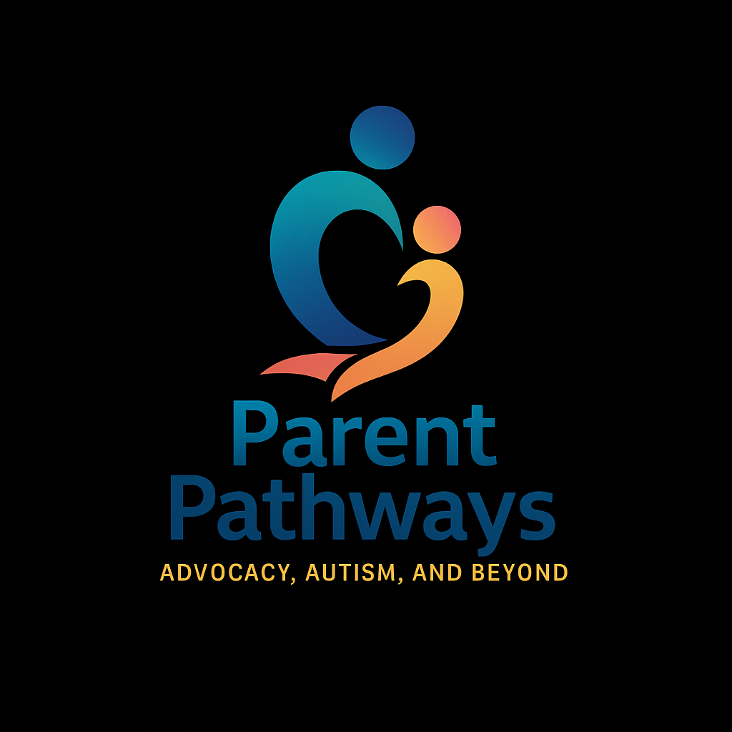
The Ultimate Parent Guide to Applying for DDD Services in Arizona
A step-by-step walkthrough, with real-world insight for families of children with disabilities

🔷 What Is DDD and Why Does It Matter?
The Division of Developmental Disabilities (DDD) is a part of Arizona’s Department of Economic Security (DES). It connects eligible individuals with services that help them lead safe, meaningful, and supported lives in their homes and communities. These services include habilitation (skill-building), attendant care, respite, therapies, and in some cases, behavior support.
For many families, DDD is the gateway to long-term support — both practically and financially. But accessing these services depends on getting through a complex and often intimidating application process.
This guide is designed to walk you through that process from start to finish, with deep insight into what you need, what to expect, and how to prepare.

🔷 Step 1: Understand Eligibility — The Three Key Requirements
Before applying, it’s important to know if your child potentially qualifies. Arizona law outlines three criteria, and your child must meet all three:
1. Arizona Residency
Your child must legally reside in the state of Arizona. Proof of residency may be required (e.g., utility bill, lease, school records). You must have been residing in AZ for at least 6 months.
2. Qualifying Diagnosis
Your child must have a diagnosis that began before age 18 and is expected to be lifelong. DDD recognizes four primary conditions:
- Autism Spectrum Disorder (ASD)
- Intellectual Disability (ID)
- Cerebral Palsy (CP)
- Epilepsy (Seizure Disorder)
Note: If your child has a genetic disorder (like Down syndrome) or rare condition, eligibility depends on how the condition impacts daily life. Some children with ADHD or learning disabilities alone may not qualify unless there's evidence of functional impairment.
3. Substantial Functional Limitations in 3+ Life Areas
This is often the most misunderstood part. Your child must demonstrate serious difficulty in at least three of the following seven areas:
- Self-care (eating, bathing, dressing, toileting)
- Communication (verbal, nonverbal, expressive/receptive language)
- Learning (adapting, memory, cognitive processing)
- Mobility (walking, transferring, coordination)
- Self-direction (decision-making, safety awareness, emotional regulation)
- Capacity for independent living (performing tasks without help)
- Economic self-sufficiency (not usually applicable for children)
Parent tip: Don’t rely only on what your child can do — focus on what they need support to do, how consistent those skills are, and how much adult supervision is required.

🔷 Step 2: Gather Documentation
Before you fill out the application, gather every relevant document you can find. This helps build a strong case and shows patterns across time and providers.
Include:
- Psychological evaluations (diagnoses, cognitive scores, adaptive functioning)
- IEPs or MET reports from school
- Speech, OT, PT evaluations
- Progress notes from ABA or therapy providers
- Pediatrician notes, hospital discharge summaries (if applicable)
- Developmental screenings (M-CHAT, Vineland, ADOS, etc.)
Tip: Highlight or tag key phrases like “requires full assistance,” “delayed adaptive skills,” “safety risk,” or “in need of constant supervision.”

🔷 Step 3: Complete the Application Thoroughly
Download the application at: https://des.az.gov/ddd
Be descriptive. Don’t just list a diagnosis — explain what that looks like for your child on a daily basis. Example:
❌ Autism
✅ Diagnosed with Autism Spectrum Disorder at age 3. Needs visual schedules and hand-over-hand help with hygiene. Struggles with transitions, limited verbal communication, and frequent meltdowns when routines change.
Where possible:
- Use specific language (“requires adult help for all dressing tasks” vs. “has trouble dressing”)
- Be truthful, not hopeful — this is not the time to minimize needs
- Focus on function, not academic skills
Pro tip: It’s okay if your child has strengths — but eligibility is based on areas of limitation. Be honest about where your child needs help, even if it’s painful to put into words.

🔷 Step 4: Submit the Application
Send your application via:
- Email: DDDApply@azdes.gov
- Drop-off/mail: Local DES/DDD office (addresses at des.az.gov)
Include all supporting documents in one submission. Keep a copy of your full packet. After submitting, follow up by phone within a week:
📞 DDD Customer Service: (844) 770-9500, option 1

🔷 Step 5: Prepare for the Eligibility Interview
If your child’s paperwork meets the basic criteria, you’ll be contacted by a DDD Eligibility Specialist to schedule an interview. This interview is typically 60–90 minutes and can be conducted in person or virtually.
During the interview:
- You’ll answer structured questions about your child’s skills and challenges in each of the 7 life areas
- You may be asked to rate independence on a scale (e.g., “Can your child prepare a meal without help?”)
- You’ll review how your child functions at home, school, in the community, and during routines
Parent insight: Be as detailed and realistic as possible. Don’t sugarcoat. This is not about proving your love — it’s about showing the needs that qualify your child for help.

🔷 Step 6: The Decision
DDD will review your application, documents, and interview notes. You will receive a written eligibility determination within 30–45 days.
- Approved: You’ll be assigned a Support Coordinator who will contact you to begin service planning.
- Denied: You will receive a denial letter with instructions on how to appeal. You have 35 days from the denial to request a hearing.
Appeals Tip: Don’t panic. Many initial denials are due to missing documentation or unclear descriptions. You can resubmit with updated information, request a peer review, or pursue a fair hearing.

🔷 Step 7: Next Steps After Approval
Once approved:
- A Support Coordinator will contact you to begin your Person-Centered Service Plan (PCSP)
- You’ll discuss your child’s needs, goals, and services (like habilitation, respite, and attendant care)
- You’ll choose a service agency or opt to be a Parent Provider (if ALTCS eligible)
- You may also begin applying for ALTCS, which is required for full funding of most DDD services

🔷 Common Questions
Can I be paid to care for my child?
Yes — under the Parents as Paid Caregivers program (PPCG), parents may be paid to provide attendant care if the child is ALTCS eligible. (As of 2025, capped at 40 hours per week per child.)
Do I need an advocate?
It’s not required, but many parents benefit from working with someone who understands how to describe needs clearly, especially when preparing for interviews or appeals. Ask us how we ca become your Advocate.
What if my child is young and “doing okay”?
Eligibility isn’t based on diagnosis alone — but if your child needs reminders for safety, help with routines, or constant supervision, document it. Many children qualify even if they appear high-functioning.

🔷 Tools for Success
- ✅ Keep a binder or folder with all evaluations, DDD letters, and notes
- ✅ Practice describing your child’s needs out loud before the interview
- ✅ Keep a log of behaviors or incidents that show support needs (wandering, meltdowns, unsafe behaviors)
- ✅ Ask providers for documentation with functional wording — not just academic or medical

📌 Contact & Support
- DDD Website: https://des.az.gov/ddd
- Email: DDDApply@azdes.gov
- Phone: (844) 770-9500, option 1
- Parent Pathways Support: https://parent-pathways.org

💬 Final Thought
Applying for DDD isn’t just about filling out a form — it’s about advocating for your child’s right to be supported, understood, and included. This process may feel overwhelming, but you are not alone. You’re already doing the hardest part: showing up, speaking out, and believing in your child’s future.

