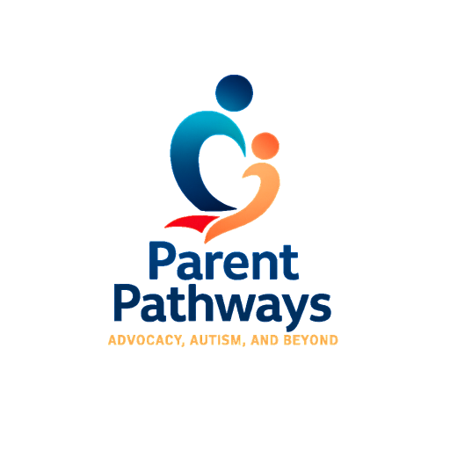
Parent Pathways Empowerment Guide
Essential Questions to Ask at Your First DDD HCBS (Home & Community-Based Services) Meeting
Bring this guide to your first meeting—and write answers right next to each question so nothing slips through the cracks!

🧠 Eligibility & Coverage
- Is my child currently ALTCS-approved?

- If not, what steps are needed to complete eligibility?

- What services are covered under HCBS?

- What’s the difference between ALTCS vs. DDD coverage?

- How will changes in our situation affect eligibility?

🧩 Available HCBS Services
- What is Habilitation (HAH) and how will it help my child?

- What respite services are available and how many hours?

- Is Attendant Care an option? Who can provide it?

- What is LHA (Life & Home Adaptation), and how does it differ from HAH?

- Can my child receive transportation services for community access?

- Are there behavioral health supports connected to DDD or AHCCCS?

🏡 Home Environment & Safety Support
- Are there services to improve safety or home adaptations?

- Can DDD help with durable medical equipment or assistive tech?

- Is funding available for home modifications (e.g., gates, ramps)?

🧾 Training & Support for Caregivers
- Are there parent/caregiver trainings available?

- Can we request coaching, mentoring, or behavioral consultation?

🧑‍🤝‍🧑 Providers & Staffing
- Can I choose or recommend a provider or agency?

- Can a family member be a paid provider?

- What if a provider isn’t a good fit—how do we proceed?

- How do providers get selected, trained, and screened?

🗓️ Scheduling & Service Hours
- How many service hours are allotted weekly for each service?

- Can hours be split across different services?

- Is the schedule flexible for holidays, breaks, illness?

- Who tracks and documents service hours?

📄 ISP & Goal Planning
- When will the Individual Support Plan (ISP) be developed or reviewed?

- Can I help write HAH/LHA goals?

- How will goal progress be measured and documented?

- Can goals be adjusted mid-year if needed?

- How are goals personalized and kept meaningful?

📚 Education & School Collaboration
- Does DDD coordinate with schools or IEP teams?

- Can services be provided before or after school?

- How can DDD goals align with IEP or transition goals?

💬 Communication & Advocacy
- What’s the best way to contact my coordinator?

- How often will check-ins or meetings occur?

- What if I disagree with a decision or denial?

- What parent resources or support groups are available?

- Can I request Field Support Visits or additional coaching?

🧾 Billing, Reimbursements & Documentation
- Do I need to track hours or documentation myself?

- Are reimbursements or stipends available for mileage or supplies?

- Who do I contact if there's an issue with billing or hours?

🔁 Reviews & Future Planning
- How often are services reviewed, and can I request reviews off-cycle?

- What happens during the annual ISP review?

- How do we prepare for transitions (aging out, adult services)?

✨ Bonus Tips from Parent Pathways
- You are your child’s strongest voice—ask confidently.
- Bring this guide, a pen, and a phone or notepad to meetings.
- Save all DDD documents in a well-organized binder.
- Don’t hesitate to request follow-up or get answers in writing.
- If you would like personalized support, we can attend your PCSP meetings with you!



