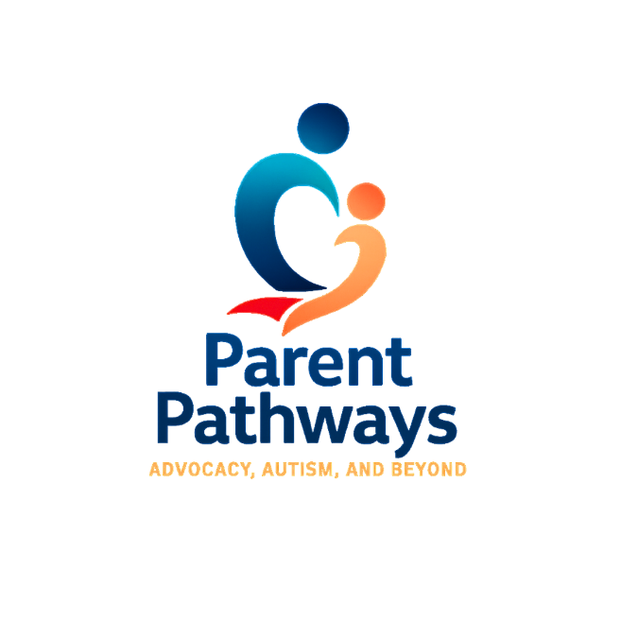
🌈 Parent Wish List & Support Request Form
Your voice matters. Let us know how we can support your family.
At Parent Pathways, we understand that sometimes, just having someone to reach out to makes all the difference. This form helps us learn about your family’s needs so we can do our best to connect you with resources, donations, and support.

🧑 Parent/Caregiver Information
Full Name:

Email Address:

Phone Number (Optional):

Preferred Method of Contact:
[ ] Email [ ] Text [ ] Phone Call
City & Zip Code:

👨‍👩‍👧 About Your Family
Number of Children in the Home: ___________
Ages of Children: ___________________________________
Are any of your children on the autism spectrum or have special needs?
[ ] Yes [ ] No [ ] Prefer not to say

🎁 What Items Are You Requesting?
(Check all that apply)
Children’s Needs:
[ ] Clothing (include sizes below)
[ ] Shoes (include sizes below)
[ ] Diapers/Wipes
[ ] Toys/Games
[ ] Sensory Items
[ ] Books
[ ] School Supplies
Household Needs:
[ ] Food
[ ] Hygiene Products
[ ] Cleaning Supplies
[ ] Household Items (bedding, kitchenware)
[ ] Gift Cards (grocery, gas, etc.)
Other Needs or Special Requests:

Clothing/Shoe Sizes (If applicable):

💬 Additional Notes or Information You’d Like to Share:

📦 How Would You Like to Receive Items?
[ ] I can pick up locally
[ ] I need delivery or drop-off
[ ] I’m open to either
Address (if delivery is needed):

❤️ Agreement
[ ] I understand that Parent Pathways is a community-led support group currently working toward nonprofit status. All assistance is based on availability.
[ ] I confirm that the information I’ve shared is true and submitted in good faith.

Signature: ____________________________________ Date: ___________________

