

December 2020

*South Dakota Federation of Republican Women*

*Merry Christmas*

1

R E P O R T S

I N S I D E T H I S I S S U E :

2020 Spotlight 2-3

Members

SDFRW Christmas 3

Tree

From the Desk of 4

the President

From th Desk of the 5

President – Elect

SDFRW Cyberspace 6

Report

2021 Newsletter 7

Report

S P E C I A L P O I N T S O F I N T E R E S T :

* 2020 Spotlight Members
* SDFRW Capitol Christmas Tree
* Comments From President
* Comments from the President- Elect

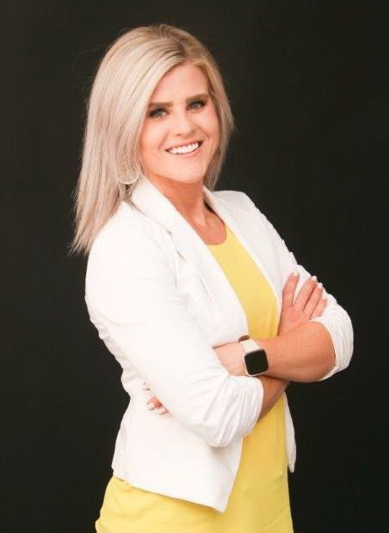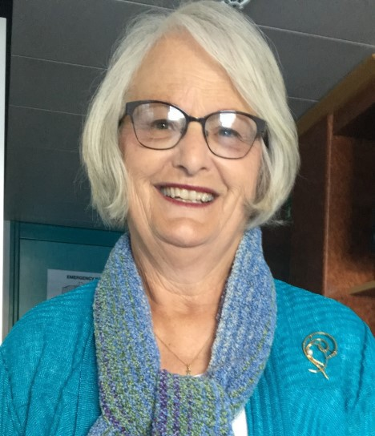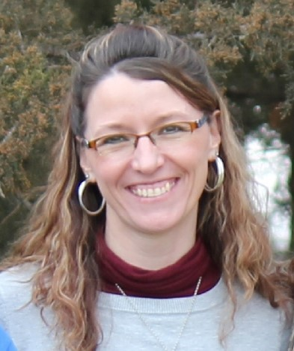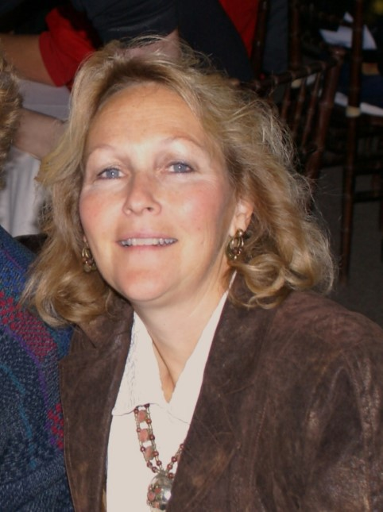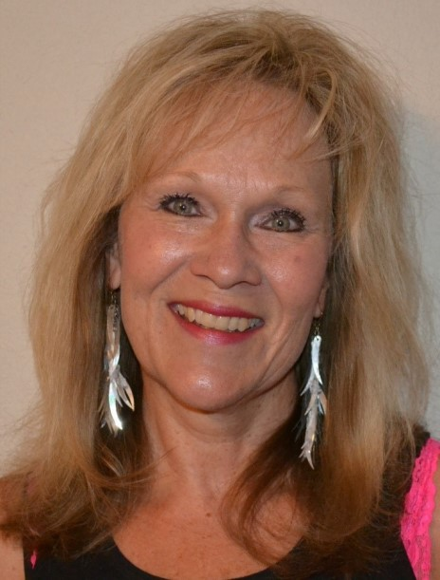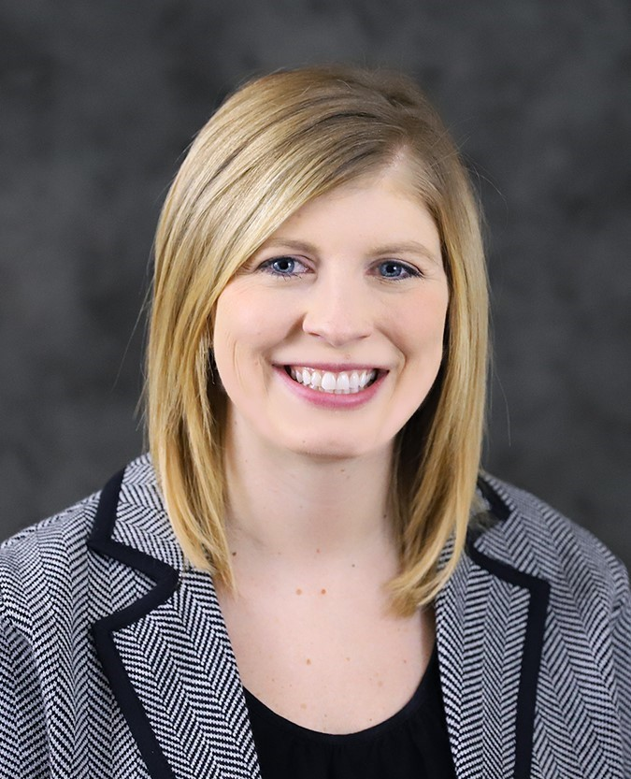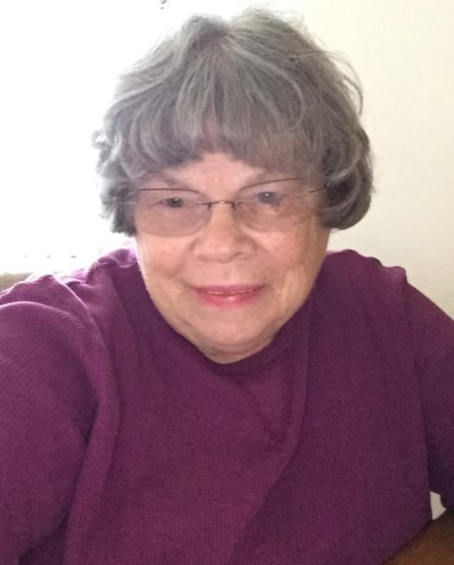

**2 0 2 0**

**S p o t l i g h t**

**M e m b e r s**

March

January

February

April

May

June

July

October

September

More Fabulous Featured Women

Continued on the next page….

2

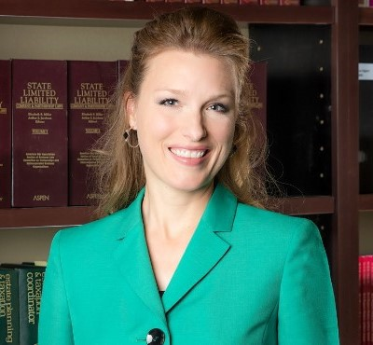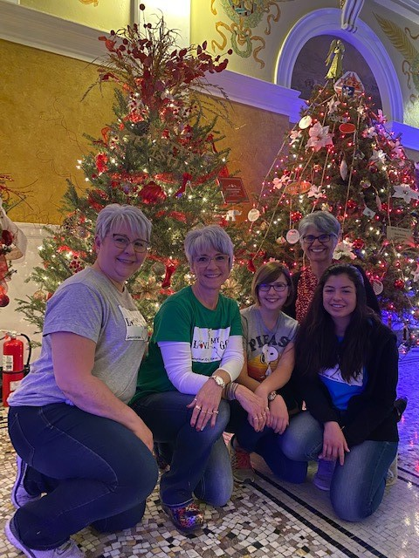

*South Dakota Federation of Republican Women*

**2 0 2 0**

**S p o t l i g h t**

**M e m b e r s**

November

December

**Our Capitol Christmas Tree**

Decorated by the Brown County Area

Republican Women

3



*South Dakota Federation of Republican Women*

*From the Desk of the President*

As the year comes to an end and we enter a new one, so does my presidency of SDFRW. It has been a pleasure to work with so many women of

strength and passion for our state and our nation. I stepped in to serve under abnormal circumstances 18 months ago. We started out in a small, rocky fish- ing boat with winds from all sides and a couple of holes in the hull. But today, we are a mighty ship gliding full steam ahead. With the challenge of the year 2020, I believe it has happened only to open our eyes and give us the courage to do what looks to be a more challenging year than the last. In fact, it is amazing what we accomplished, ‘despite’ spending most of the year in a pandemic. The way we continue to preserve our way of life and protect our constitution is through having a strong voice, serving with ‘boots on the ground’, and to stand united. We all know that the world is run by those who ‘show up’.

It has been exciting to draw out the gifts and talents of these ladies and utilize them for very good things. We have enjoyed unity and are becoming a better, well-oiled machine as we move forward. I thank our club Presidents for step- ping up to do great things in their communities as well as secretaries and treasurers who have duties to fulfill. We have some outstanding members. Our full Executive Board has dealt with challenging decisions and have worked through both hardships and blessings together in a positive way. I’m thankful for our treasurer, Tina Mulally, who goes above and beyond her duties to make things run smoothly. I am proud to hand off the gavel to my 1st Vice President, Penny Sattgast. She has been extremely engaged and will do a wonderful job as our next President. I’m thankful for every member of SDFRW and for the support I have received during my tenure.

May we realize that “Hindsight is 2020” as we look forward to the unknown new year and remember that life is what we ‘purpose’ to make it.

May you all be richly blessed in the coming months and years. “The Best Is Yet to Come”.

*Sandy Rhoden SDFRW President*

4



*South Dakota Federation of Republican Women*

From the Desk of the President-Elect

Dear SDFRW members,

What an amazing honor and privilege it is to have been elected to serve as your new President for the 2021-2022 term! I am so proud to belong to an organization that has worked tirelessly to make a difference amidst the many obstacles that 2020 has inherently placed before us. Under the leadership of President Sandy Rhoden,

SDFRW has accomplished so much, as she has truly put us ‘on the map’ as an

organization that knows how to put ‘boots on the ground’!

I am excited to keep our ‘boots on the ground’ efforts moving across all focus areas and plan to not only continue our youth engagement efforts, but grow them

exponentially, as our youth are the future of the Republican party and will be the ones left to protect and defend our freedoms.

**2 Timothy 4:7 states, “I have fought the good fight, I have finished the race, I have kept the faith."**

Under my leadership, I will work towards ensuring that our organization:

Continues to fight the good fight: (as we promote good republican candidates and stand up to liberal ideas and infiltration into our schools and public polices).

Finishes each race: (as we work hard and support one another to achieve and deliver real results with our identified goals).

Keeps the faith: (as we always remember that God guides us and gives us our

strength through all our endeavors.

God bless every one of you and have a Merry Christmas!

Kind Regards,

Penny Sattgast- SDFRW President-Elect

5



*South Dakota Federation of Republican Women*

S D F R W C y b e r s p a c e V i r t u a l C l u b

Just before Thanksgiving, our Cyberspace Club enjoyed a mini-concert by Camille & Haley -- the singer/songwriters whose viral hit "Keep America Great" had over 30 **million** views in just 2 weeks!! When they were done singing, they stayed to chat with us a while. They're absolutely right: SDFRW is more than a political group. It's a sisterhood! To hear their comments, check out our Facebook page! Just type @CyberspaceRepublicanWomen into

your search bar and it'll come right up.

Over the last two months, Cyberspace has had the privilege to visit with some incredible people across the nation! In addition to Camille and Haley, we've hosted Zoom calls with US Senatorial Candidate John James, US Senator Martha McSally, Texas Senator Dawn Buckingham, and North Carolina Senatorial Candidate Mark Cavaliero. We also co-hosted SDFRW's first ever Prayer Warrior Zoom Call. We've attracted viewers from across the country, and we're just getting started! To join in the fun, activate your

membership for 2021! Remember that though you can only be an Active Member in one club, you can have an Associate Membership in as many clubs as you'd like! Men and out-of-staters can be Associate Members as well. If you or someone you know is interested in tuning in to our Cyberspace Zoom Calls, drop us a line at SDFRWCyberspace@[gmail.com](http://gmail.com/)

6



*South Dakota Federation of Republican Women*

***Next Quarterly Meeting:***

***Year 2021***

*Newsletter Reports Update for 2021*

**Clubs**

**Codington, Cenkota & Pennington Brown, Minnehaha/Lincoln, Meade**

**Cyberspace, Beadle, Fall River & Charles Mix**

**Newsletter Months**

**January, April, July, October February, May, August, November March, June, September, December**

**Questions? Contact Jeni Boerger…** [**sdfrwweb@gmail.com**](mailto:sdfrwweb@gmail.com)

7

**WE’RE ON THE WEB!**

[**www.sdfrw.org**](http://www.sdfrw.org/)

**If you’d be interested in donating an item for**

**our**

**2020**

**auction,**

**please**

**respond**

**to**

**this**

**message and let us know!**

If you have any questions or if you’re interested

in becoming a member of SDFRW, please contact Sandy Rhoden, Penny Sattgast, or Catherine Barranco at: [SDFRWemail@gmail.com](mailto:SDFRWemail@gmail.com)

Thank you again for your support!

The SDFRW Executive Committee

Jeni Boerger, Newsletter Editor Phone: 605-596-4339

Cell: 605-460-1766

E-mail[: sdfrwweb@gmail.com](mailto:sdfrwweb@gmail.com)

8