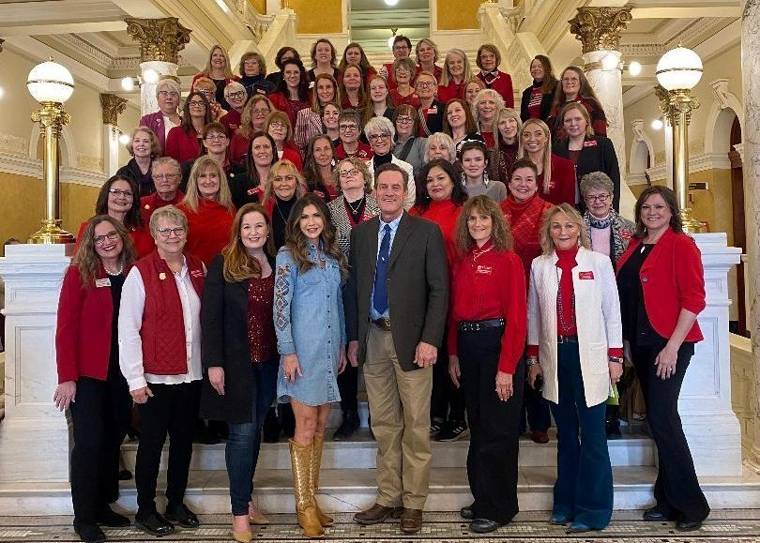

**February 2024**

*South Dakota Federation of Republican Women*

***SDFRW Legislative Day***

**What a fantastic Legislative Day & Board Meeting!**

What an incredible Legislative Day we had!! Pictures with Gov. Kristi Noem and Lt. Gov.

Larry Rhoden Tours of the Governor's Mansion and Capitol Dome Walking through

the secret tunnels under the Capitol Introductions in the House and Senate

Chambers and fantastic speakers:

* Governor's Communications Director Ian Fury
* SD Supreme Court Chief Justice Steven Jensen
* PUC Commissioner & Fmr. Secretary of State Chris Nelson

* Cabinet Secretary of Tribal Relations Dave Flute

* 3-time NFL Team Captain, Minnesota Vikings' Jack Brewer

Special thank you to South Dakota 2nd Lady & SDFRW Past President Sandy Rhoden for

making this a truly special day for SDFRW!

1

**R E P O R T S**

**I N S I D E T H I S**

**I S S U E :**

Main Article 1-2

CenKota Report 3-4

NFRW Article 5

Meade Co. Report 6

Membership Report 7

Republican Playdate 8

SDFRW Updates 9-

13

**S P E C I A L P O I N T S O F I N T E R E S T :**

* Cenkota Report
* Meade Co. Report
* NRFW Article
* Membership Report
* Republican Playdate
* Rushmore

Regents

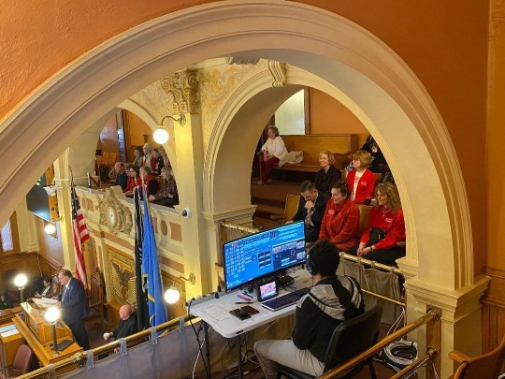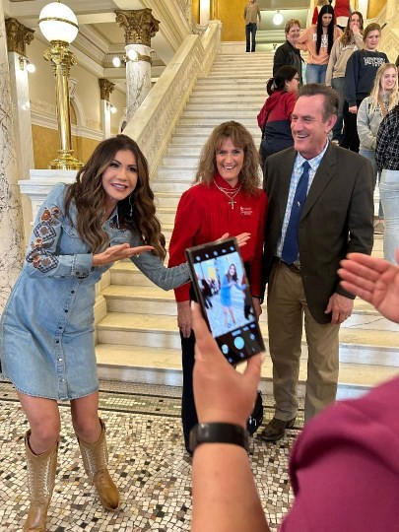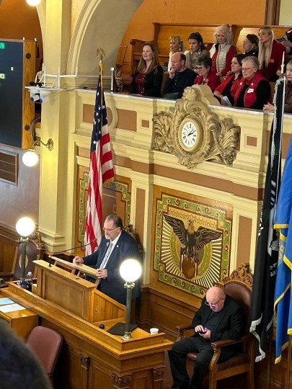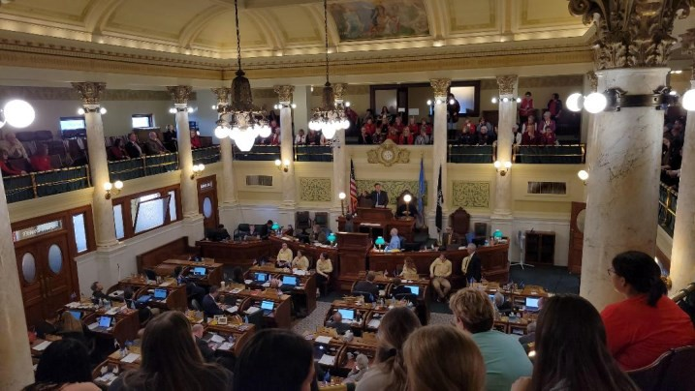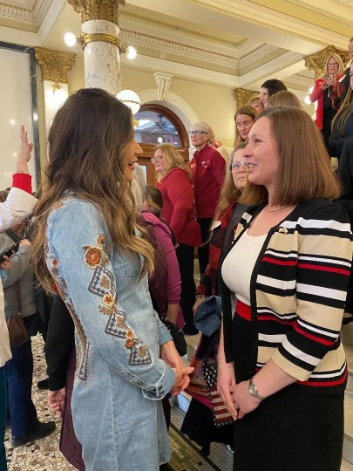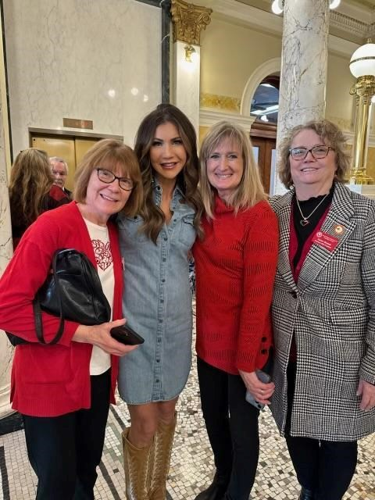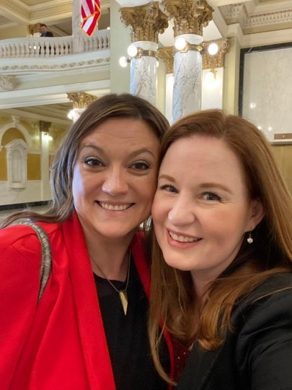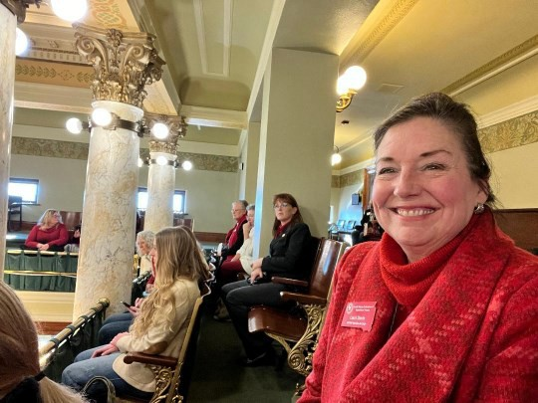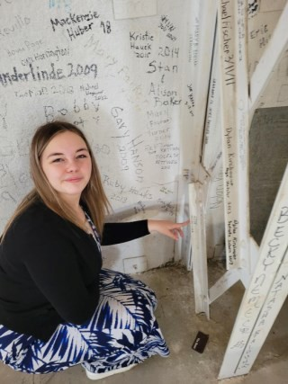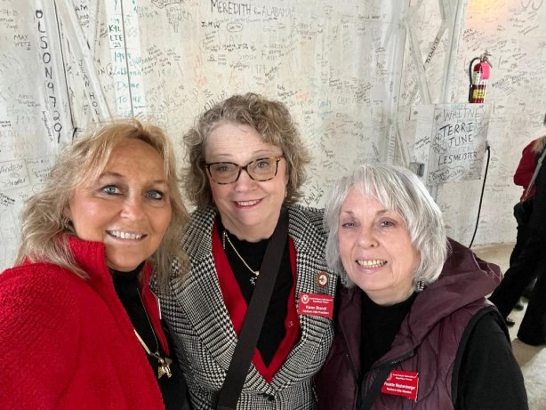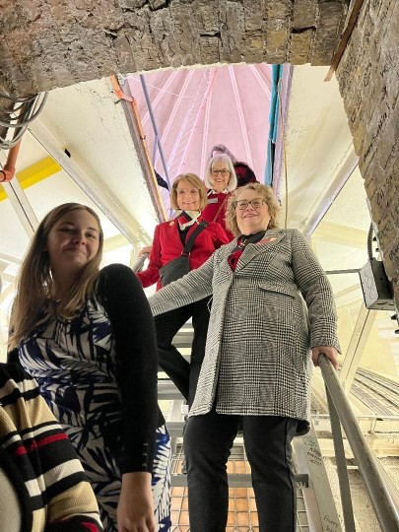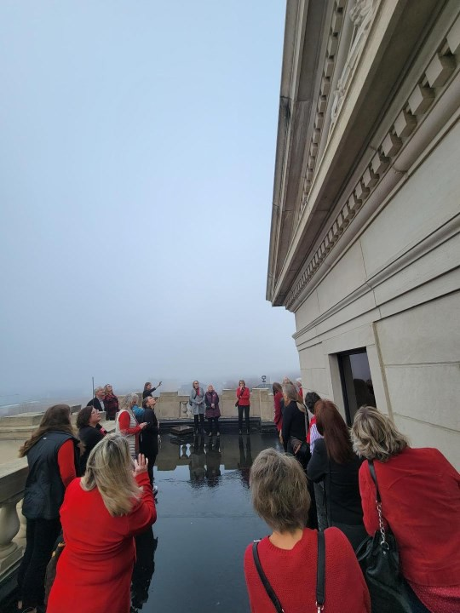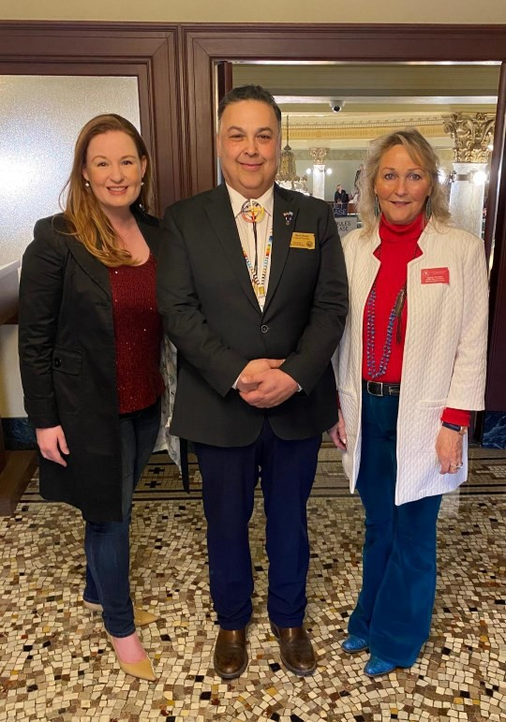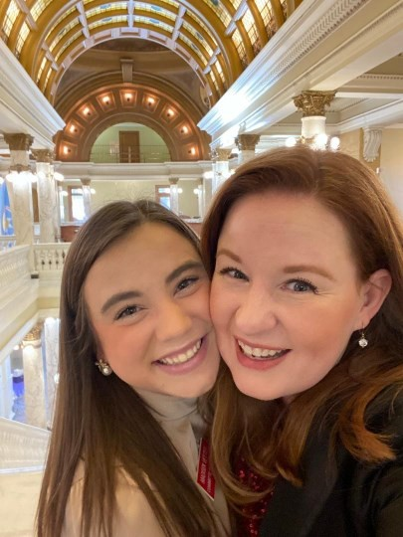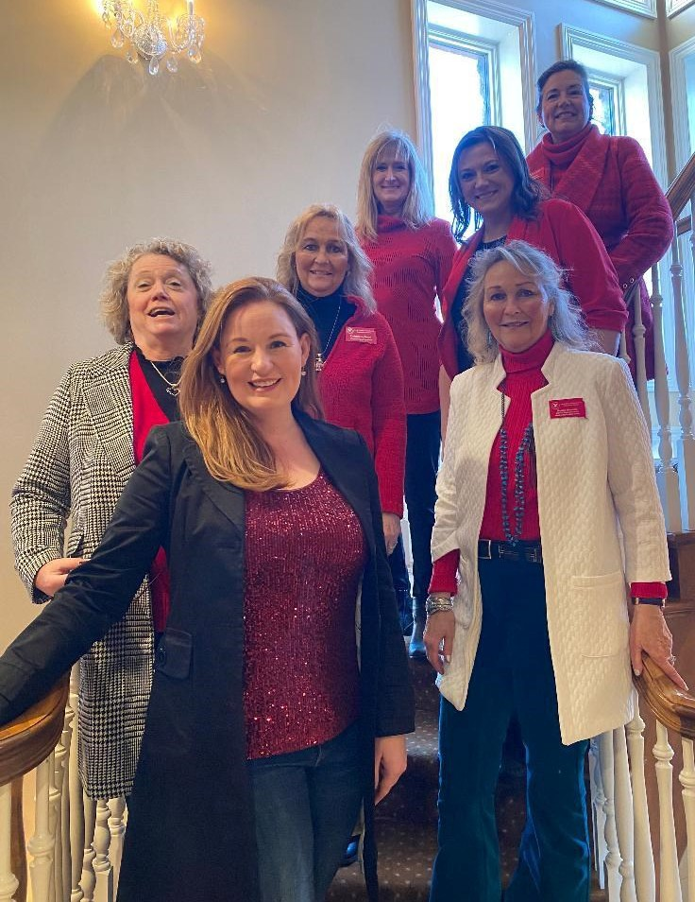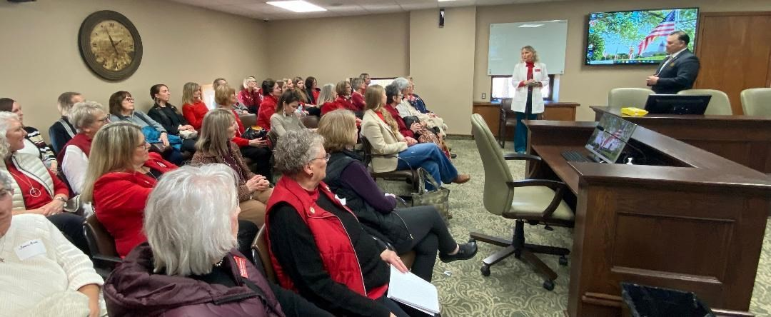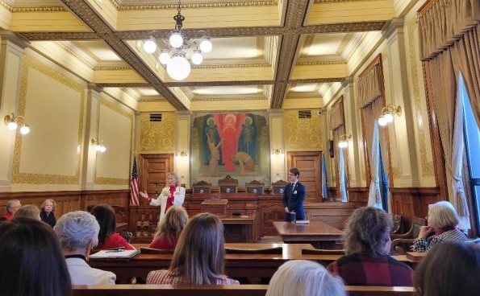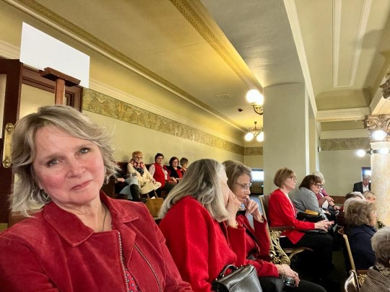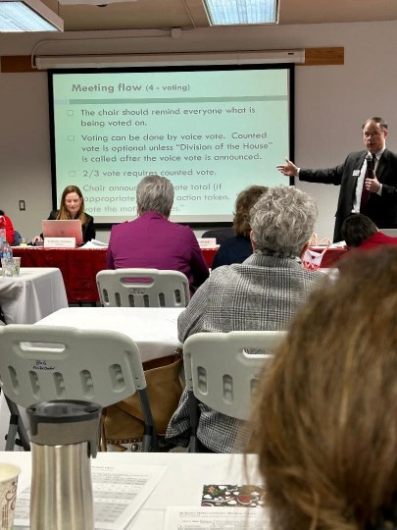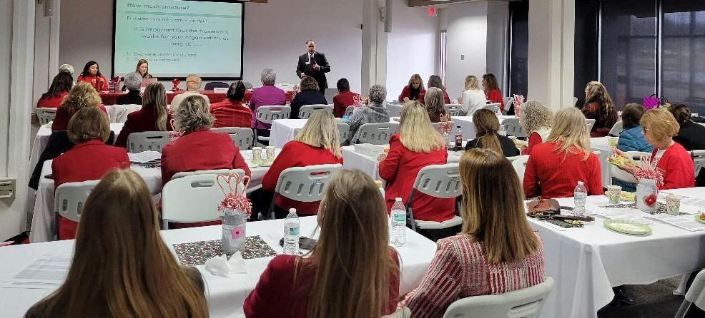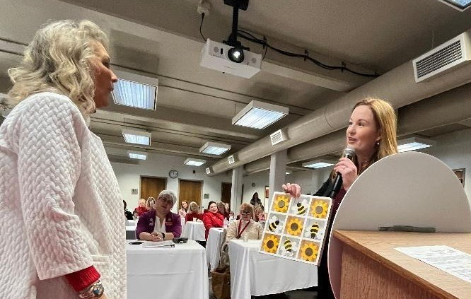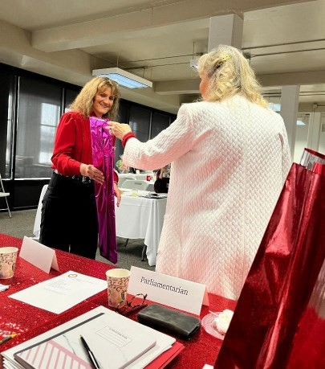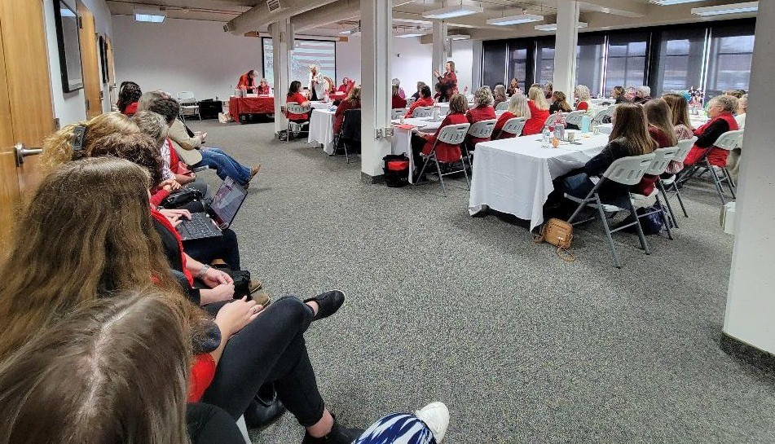

*South Dakota Federation of Republican Women*

2

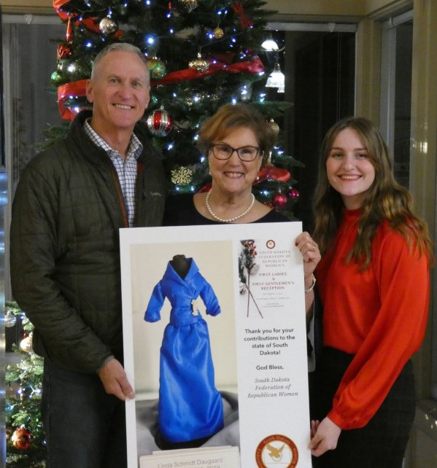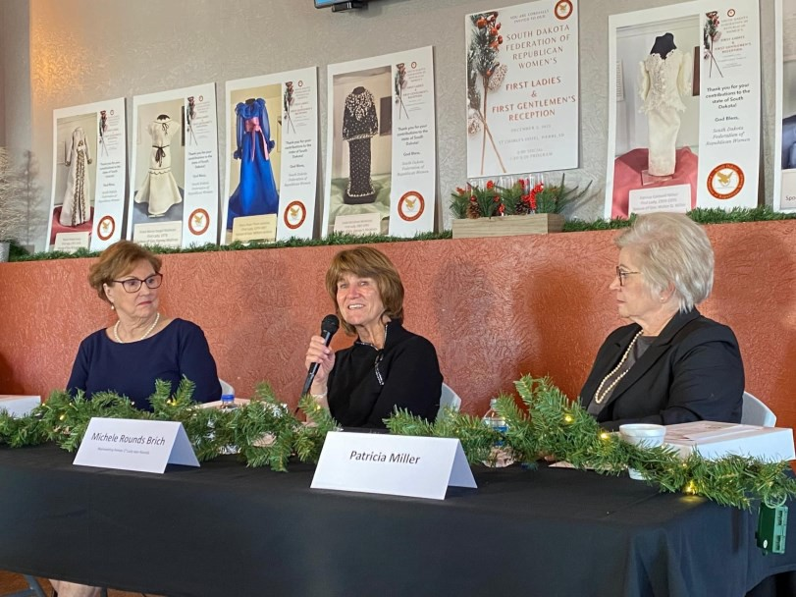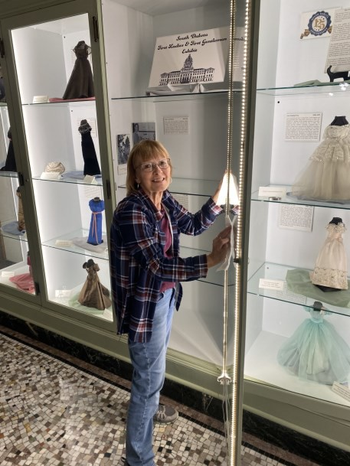

*South Dakota Federation of Republican Women*

**C e n k o t a R e p u b l i c a n W o m e n**

**CenKota Republican Women** have been busy and here are some of the highlights!

**October:**

-Several members worked to clean and maintain the 1st Ladies and 1st Gentleman Exhibit at the South Dakota State Capitol.

CenKota Members included: CenKota President & 1st Ladies and 1st Gentlemen Committee Chair-Claire Rydberg, Penny Sattgast, Penny Nelson, and Secretary of State Monae Johnson.

CenKota Associate Members included: State Auditor Rich Sattgast, School and Public Lands Commissioner Brock Greenfield, Attorney General Marty Jackley, and Ryan Bruner.

**November:**

-Our monthly meeting included having State Representative and Co-Chair of the Life Defense Fund,

Jon Hansen speak.

**December:**

-CenKota Members Claire Rydberg and Penny Sattgast attended the SDFRW December Board of Directors Meeting.

* CenKota President & 1st Ladies and 1st Gentlemen Committee Chair-Claire Rydberg, along with CenKota VP and Committee member-Penny Sattgast worked with others to lead the 1st ever SDFRW 1st Ladies and 1st Gentlemen’s Reception at the St. Charles Hotel in Pierre. Former 1st Lady Pat Miller, Former 1st Lady Linda Daugaard, and Michele Brich (representing former 1st Lady Jean Rounds) were all in attendance. In addition, former Governor Dennis Daugaard was present for the festivities!
* Associate Member Rich Sattgast helped once again to take down the SDFRW Christmas tree that was beautifully displayed during Christmas at the Capitol.

**January:**

-Our monthly meeting included having SD Secretary of State Monae Johnson speak.

3

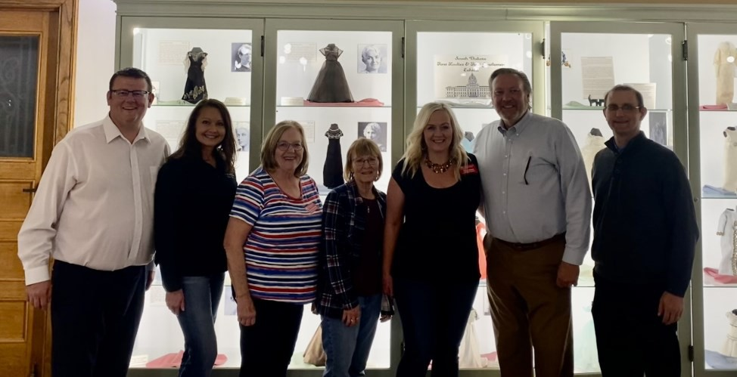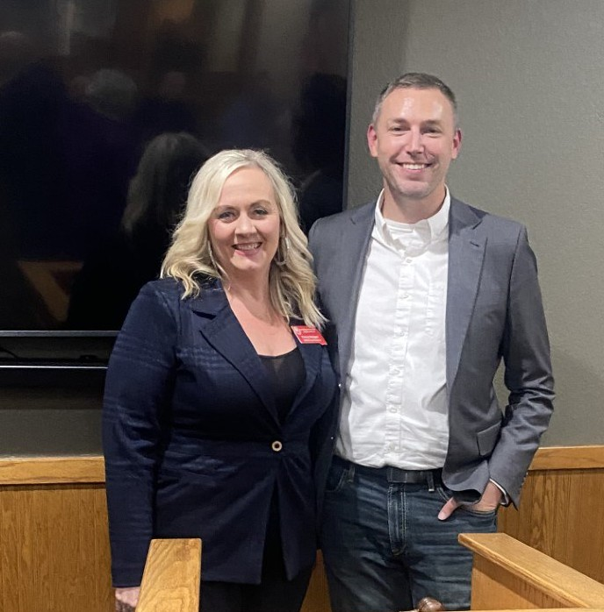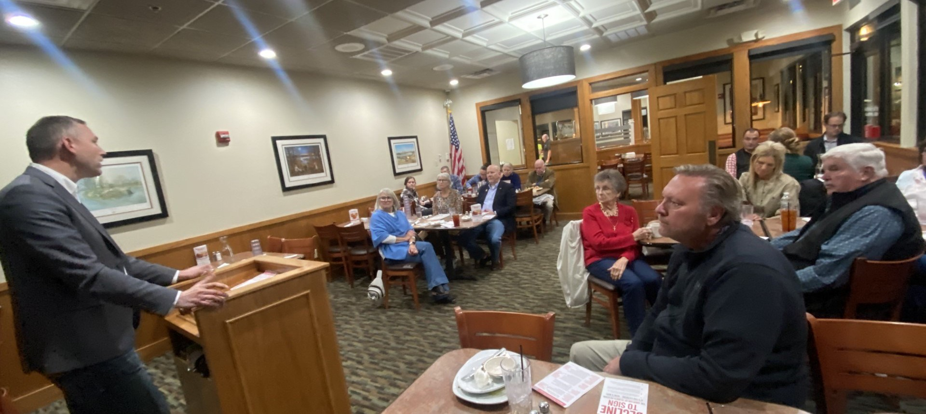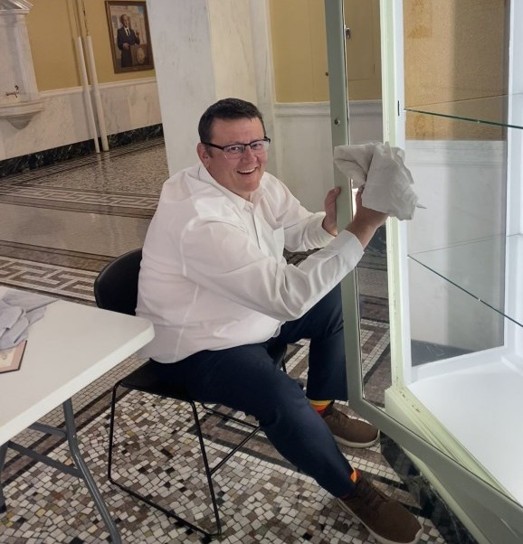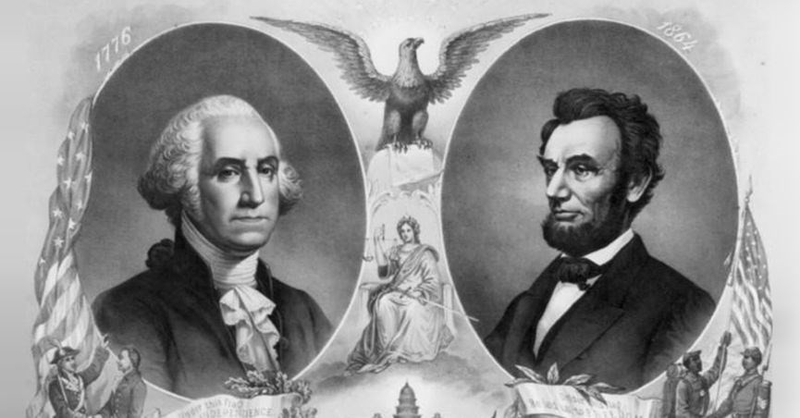

*South Dakota Federation of Republican Women*

Happy President’s Day!

4

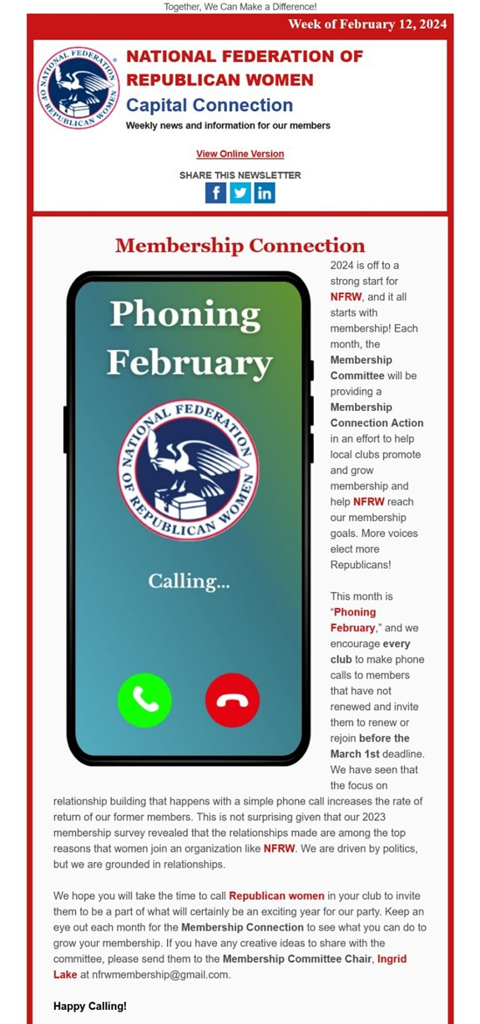

*South Dakota Federation of Republican Women*

**This month’s Featured Article from NFRW**

5

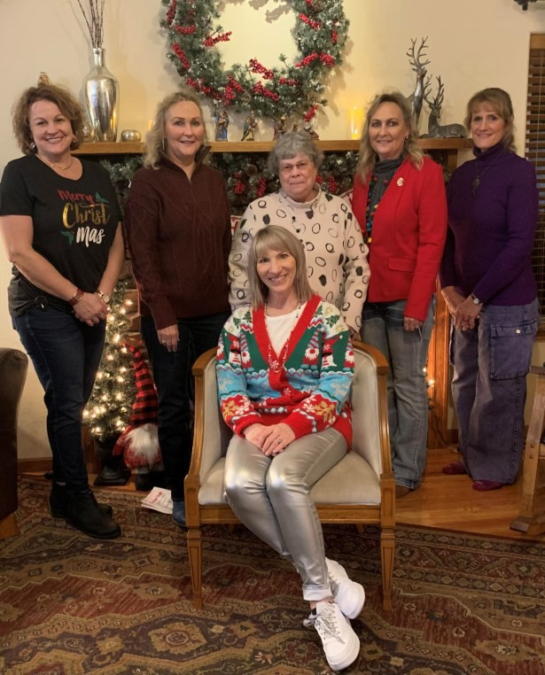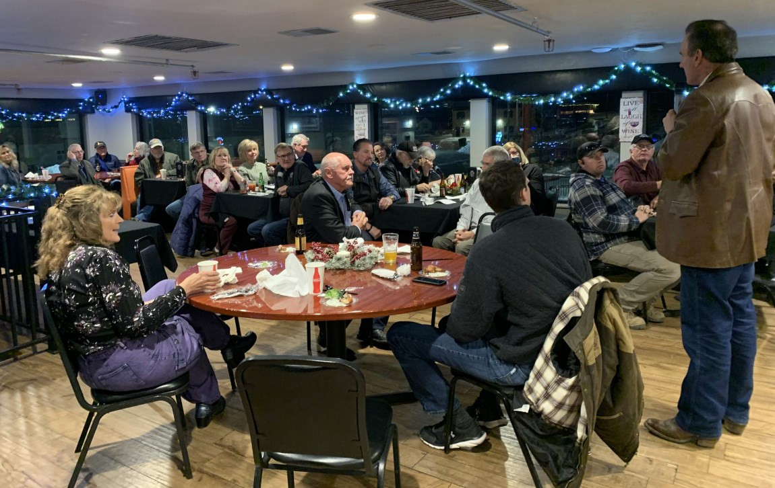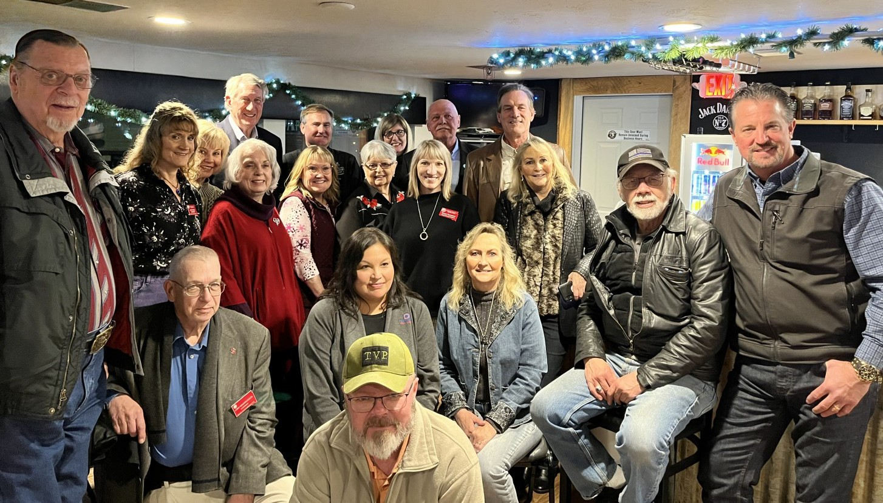

*South Dakota Federation of Republican Women*

**M e a d e C o u n t y R e p u b l i c a n W o m e n**

Meade County Republican Women wrapped up 2023 by celebrating Christmas and the hard work accomplished. Special recognition was given to the officers.

Front row: Lana Speed-Anderson (Secretary) Sandy Rhoden (First Vice President) Maggie Hunt (Treasurer) Lorie Hausmann (Chaplin), center Teresa Thompson (President)

MCRW started out the new year on a "***Wing and a Prayer***!” In January, Lt. Governor, Larry Rhoden, Senator Dean Wink, Representative Gary Cammack (Majority Whip), and Representative Kirk Chaffee (Majority Whip) were invited to a gathering where they enjoyed hot ***Wings*** and

were ***Prayed*** over to be sent off properly to the South Dakota 2024 Legislature. The delegation

also gave us a summary of the work ahead of them. Many came out to brave the cold and we had guests from the Northern Hills Republican Women. The final photo is all the members and associates who attended and the delegation with Lt. Gov Larry Rhoden.

6



*South Dakota Federation of Republican Women*

**It’s time for our club Membership Drives!**

We were incredibly proud to set an SDFRW membership record in 2023! Let’s do it again this year!! Yes, it's fun when more people get involved -- as the saying goes, the more the merrier! But a strong membership is so much more than that: it’s a larger pool of talent and energy from people who are determined to save our country. The more members we have, the more we’ll accomplish. If we accomplish enough, we’ll pry our country loose from the Democrats’ grip. We made terrific progress in 2022 when we took back the U.S. House. Now it’s time to fight for both the White House and the U.S. Senate. Help us get ready by growing your club to its strongest membership yet!

According to the Federation’s bylaws, to remain a member in good standing, **NFRW must receive your dues no later than March 1st**. It takes time for your dues to go from you to your club Treasurer, who then sends a portion of your dues to our SDFRW Treasurer, who then sends a portion to NFRW. If you haven’t renewed your membership, please do so soon!

And if you have friends who haven’t yet joined, encourage them to!

We’re holding our **5th annual SDFRW Membership Competition** this year – more details to come! Club membership increases will be measured relative to their 2023 membership levels. This year’s competition will again include four categories:

Largest Active Membership Increase Largest % Active Membership Increase Largest Associate Membership Increase Largest % Associate Membership Increase

If you know of any potential new members you think we should contact, please reach out to Catherine Barranco at [president@SDFRW.org](mailto:president@SDFRW.org) or

Membership Chair Lauri Davis at [ldavis6632@gmail.com](mailto:ldavis6632@gmail.com)

7



*South Dakota Federation of Republican Women*

**Republican Parents’ Playdate is March 24th**

Bring your kiddos to play with other Republican kids while you relax with complimentary refreshments in the company of other Republican Parents!

Everyone gets a free game of laser tag – parents included!

If you know of Republican parents you think would be interested – whether they’re SDFRW members or not! – please contact Megan Assman-Kool (Youth Liaison Chair) at [meganmassman@gmail.com](mailto:meganmassman@gmail.com)

8



*South Dakota Federation of Republican Women*

**What is a Rushmore Regent?**

A Rushmore Regent is a member of SDFRW, dedicated to strengthening the Republican Party.

A Regent has a vision of strong, God loving, conservative women leading this state and this nation.

A Rushmore Regent has an emphasis on philanthropy and strives to make a positive political impact on South Dakota through monetary contributions to woman candidates running for office.

A Rushmore Regent plays an influential role at the local and state levels and invests in the future of Republican women.

A Rushmore Regent’s membership is $100…merely the price of a tank of gas, a dress from Dillards, a pair of designer jeans.

Rushmore Regents have lifetime honorary memberships for South Dakota First Ladies, Governors and Lt Governors. There is honorary membership for the current women serving as Republican United States Senators or Representatives.

Honorary membership is also be extended to the current SDFRW President during her term in office.

We invite any, and all SDFRW members to become a Regent.

I would like to offer a prayer.

Precious Father in heaven. Thank you for these beautiful ladies who have influenced the success of our South Dakota woman candidates. Thank you for their unselfish desire to support and encourage strong SDFRW women to run for public office. Bless our Rushmore Regents. Bless you Father God. Amen

Contact **Rushmore Regents Chair Connie J Wagner** at [**cjwagner1952@gmail.com**](mailto:cjwagner1952@gmail.com)with questions!

9



*South Dakota Federation of Republican Women*

**Presenting the new Republican Event Calendar!**

SDFRW's Republican Events Calendar is already a massive hit with Republicans across South Dakota!! We’ve released a 2-minute video demonstrating the many helpful features of our calendar -- please share with your clubs, GOPs, and Republicans

everywhere!

[**https://youtu.be/ePeLcMWsFwU?si=SmZgll10EuYkHGWe**](https://youtu.be/ePeLcMWsFwU?si=SmZgll10EuYkHGWe&fbclid=IwAR3Dn6Tr2TiON_Tq3MkIvG_2HPh8cfUjLPig96-J1B0OOD1z0n0cV9g9JBo)

Now we need your help!

1. To submit events, complete the fillable form below the calendar on the website. Alternatively, send them to SDFRW Website Chair Jen Boerger at [SDFRWweb@gmail.com](mailto:SDFRWweb@gmail.com) or email me at [president@SDFRW.org.](mailto:president@SDFRW.org) From time to time, computers act up and messages may not go through. I’m blessed with a capable and responsive team – **if you submit an event and don’t see it posted within 48 hours, call**

**or text me personally at 605-323-8849.** My team and I will make sure we get it done!

2. We can only post what people send us. If you’re hosting an event, let us know! if

there’s an update, send the new information and we’ll make the change. If you’re

planning to attend an event, always confirm with its organizers *before* you go.

3. This calendar is a tool – it’s only helpful if people use it. Please spread the word to

all Republicans: if you want to know about Party events, check out

**https://SDFRW.org/calendar**

With your help, we’ll connect Republicans from across South Dakota!

10



*South Dakota Federation of Republican Women*

Calendar of Events

Feb:

15 - Beadle County Republican Women

12pm Ryan’s Hanger Huron, SD

15 - Brown Co. Area Republican Women 11am Allevity Aberdeen, SD

15 - Pennington County Republican Women 11:30am Holiday Inn Downtown Rapid City, SD

16 - Codington County Republican Women 11:30am Pizza Ranch Watertown, SD

20 - James River Republican Women

5pm Leo’s Good Food Redfield, SD

25 - Minnehaha-Lincoln Republican Women 11:30am SD Military Heritage Alliance Sioux Falls, SD

Mar:

01- Meade County Republican Women 5:30pm Pizza Ranch Sturgis, SD

05– Northern Hills Republican Women

5:30pm Guadalajara's Mexican Restaurant,

Spearfish SD

15 - Codington County Republican Women 11:30am Pizza Ranch Watertown, SD

19 - James River Republican Women

5pm Leo’s Good Food Redfield, SD

19 - Aurora-Douglas Republican Women 7pm Aurora Reformed Church, Aurora Center SD

21 - Beadle County Republican Women

12pm Ryan’s Hanger Huron, SD

21 - Brown Co. Area Republican Women 11am Allevity Aberdeen, SD

21 - Pennington County Republican Women 11:30am Holiday Inn Downtown Rapid City, SD

**Important SDFRW Dates**

Please save these important dates in your calendar!

Keep checking SDFRW Website Calendar for more events!

**Sun, Mar 3 – SDFRW Zoom Call: Election Workers,**

**Poll Watchers, and Notary Publics**

**Sun, Mar 24 – Republican Parents’ Playdate** in **Sioux Falls**

**Thurs, Apr 4 – An Evening with Friends: SDFRW Fun**E**dr**m**ais**p**e**t**r**yin **Watertown**

**Sat, Apr 27 – Board Meeting** in **Oacoma**

**Thurs, Sept 26 thru Sun, Sept 29 – SDFRW Biennial**

**Convention** in **Rapid City**

**Sat, Dec 7 – Christmas at the Capitol + Winter Board**

**Meeting** including a special **Pearl Harbor and WWII**

**Remembrance Program** in **Pierre**

11

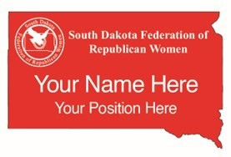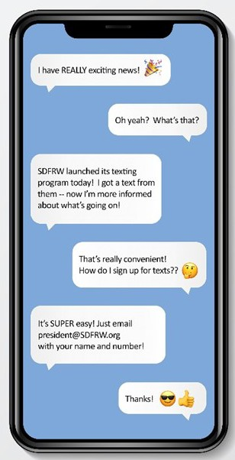

*South Dakota Federation of Republican Women*

**Order your SDFRW Magnetic Name Badge!**

Name badges are not just for officers – every SDFRW member is welcome to order one! If you'd like an SDFRW name badge, please email **Catherine Barranco** at [**president@SDFRW.org**](mailto:president@SDFRW.org)with your name exactly as you'd like it to appear on your badge and send a check for **$10 made out to SDFRW to Connie Wagner**, **27072 SD Hwy 45, Platte, SD 57369**. **If you could write "Name Badge" in the memo line, that would be a huge help.** We don't want it to get mixed up with the membership checks!

If you hold a position within SDFRW or one of the clubs, please include that as well. There’s only room for one

title, so if you serve in more than one position, please pick your favorite to be listed on your name badge. **Remember – we’ll send the vendor your name exactly as you email it to Catherine, so please double check that everything is spelled correctly!**

Pin backs are also available if you prefer a pin to a magnet – just indicate that preference in your email. **If you**

**have a medical device that can be disrupted by magnets, such as a pacemaker, be sure to request a pin back!**

Would you like SDFRW to text you?

Would you like to receive texts about upcoming SDFRW events and announcements?

FCC laws are prickly when it comes to texts, so in order for you to take part in the texting program, you must formally request to opt in. So,

if you’d like to receive texted reminders and notices, email Catherine Barranco at [president@SDFRW.org](mailto:president@SDFRW.org) with your name and the cell number where you’d like to receive texts.

12

*South Dakota Federation of Republican Women*

***2024 Newsletter Monthly Schedule***

**January, April, July, & October:**

**Cenkota, Codington, James River, Northern Hills &**

**Pennington**

**February, May, August & November:**

**Aurora-Douglas, Brown, Minnehaha -Lincoln, & Meade**

**March, June, September & December:**

**Cyberspace, Beadle, Fall River, Sioux River**

**& South Central**

***Please find your Club and Write down the months that you***

***are in the Newsletter.***

**The reports are due the 27th of the prior to the month featured.**

**Clubs may submit at anytime with club updates, photos.**

**Send any questions, reports &/or pictures to:** [**sdfrwnews@gmail.com**](mailto:sdfrwnews@gmail.com)

**Newsletter Chair: Jen Boerger**

13



**See Us Now!**

[www.sdfrw.org](http://www.sdfrw.org/)

@SoDakFRW

SoDakFRW

@SouthDakotaFRW

*America Home of the Free & the Brave!*

14