

September 2020

*South Dakota Federation of Republican Women*

**SDFRW**

**Call To Action!**

**Americanism across state borders**

**An Article by Catherine Barranco, SDFRW 2nd Vice President**

**Continued Page 2**

1

R E P O R T S

I N S I D E T H I S I S S U E :

Americanism Across 2 State Borders

Beadle Co. Report 3

2020 SDFRW 4

Fundraiser

S P E C I A L P O I N T S O F I N T E R E S T :

* SDFRW

Call to Action

* 2020 SDFRW Fundraiser
* Club Reports
* This Month in History

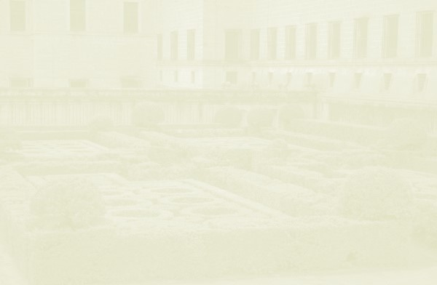

*South Dakota Federation of Republican Women*

Americanism Across State Borders

By Catherine Barranco, SDFRW 2nd Vice President

Dear Friends,

We’re blessed to call the United State our home. Yet, this November, we face the terrifying prospect of losing the country we love. To save it, we must do more than re-elect President Donald Trump.

**We must defend the Senate.** As we saw in January, shameless Democrats will stop at nothing to impeach Trump. Ignoring genuine perils threatening America, they assail our President with outrageous allegations of imagined crimes. Lefttists abhor this great man — who forged unprecedented trade agreements and tax cuts, who elevated our Black and Jewish communities more than any administration prior, who put Crist back in Christmas, defended the unborn, and protected our constitutional right to bear arms. The Democrat’s irrational hatred runs so deep that they cheer the burning of cities, the murder of policemen, the collapse of our economy, and the sacrifice of fundamental liberty. Democrats believe a nation in flames will abandon its President. The horrifying truth: it might. Even if America re-elects Donald Trump, scheming Democrats will resume their attacks, with freshly fabricated charges. The last line of defense between the President and his

removal is a republican Senate majority. Unless we hold the Senate, the conspirator’s plot may succeed.

South Dakota voters will support President Trump, Senator Mike Rounds, Congressman Dusty Johnson, and other candidates fighting to defend our way of life. But we can do more. To save this nation, we **MUST** do more! John Thune and Mike Rounds, both strong American stalwarts, represent South Dakota. But few other states are so fortunate. Accordingly, The SD Federation of Republican Women calls all true patriots — men and women alike — to help bring victory to battleground states! Whether you prefer to stay home or travel, near or far, there are waysto join the fight. By contributing your time, talent, and treasure, you can make a huge difference.

Here is a link to a signup page where you can indicate interest in ways to help senate campaigns. If you prefer to reach out to us directly, please contact Catherine at [COB@CatherineBarranco.com or](mailto:COB@CatherineBarranco.comor) Kristin at [PKBradsky@aol.com.](mailto:PKBradsky@aol.com)

Sign Up Link: <http://signup.com/go/BWFuDdA>

Thank you for your help. God bless America!

The South Dakota Federation of Republican Women

2



*South Dakota Federation of Republican Women*

B e a d l e C o u n t y R e p u b l i c a n W o m e n

The Beadle County Republican Women met in August for the first time since March. We met at the outdoor shelter, Voorhees Shelter, at Central Park. We will continue to practice social distancing and wearing masks until the Covid 19 scare has lessened!

Our guest speaker was State Representative Lynn Schneider, who has been appointed by Governor Noem in the replacement of the late Representative Bob Glanzer. Lynn is a well-known businessman, community volunteer and respected community leader—in addition to being a husband, father, grandfather.

We are preparing the State Fair Republican Building for the upcoming Fair. Due to the pandemic, the building will be occupied for Constitutional Officers/ Candidates/representatives only and not provide our usual respite for fair goers. We are not subjecting our Republican volunteers to constant contact with the general public.

Many BCRW members proudly viewed the Suffrage Program on PBS this month. With much anticipation we are viewing the National Republican Convention and are proud of our Governor Kristi Noem for her involvement!

We look forward to the SDFRW Convention in Sioux Falls in September.

*Women in History*

•

**September** 12, 1910 – Alice Stebbins Wells, a former social worker, becomes the first woman police officer with arrest powers in the U.S. (Los Angeles, CA)

•

**September** 14, 1964 – Helen Keller receives the Presidential Medal of Freedom along with 4 other women

3



*South Dakota Federation of Republican Women*

2020 Donation / Free T-Shirt Fundraiser

Take the form on the following page, fill out how much you would like to Donate.

You may donate as much or as little as you wish.

HOWEVER, To receive a FREE T-Shirt, there needs to be a minimum of $20 donation to SDFRW

There are three types of T-Shirt’s to choose from: Women’s Fit, Universal Fit, and Universal Youth Fit.

*For Clarity, below are a few examples scenarios:*

*i. $10 donation– not eligible for a free T-Shirt*

*Ii. $20 donation—eligible for a total of one (1) free T-Shirt Iii. $30 donation—still eligible for just one (1) free T-Shirt*

*Iv. $40 donation—now eligible for two (2) Free T-Shirts*

Return the Form to:

Penny Sattgast c/o SDFRW

1919 Brighton Court

Pierre, SD 57501

4

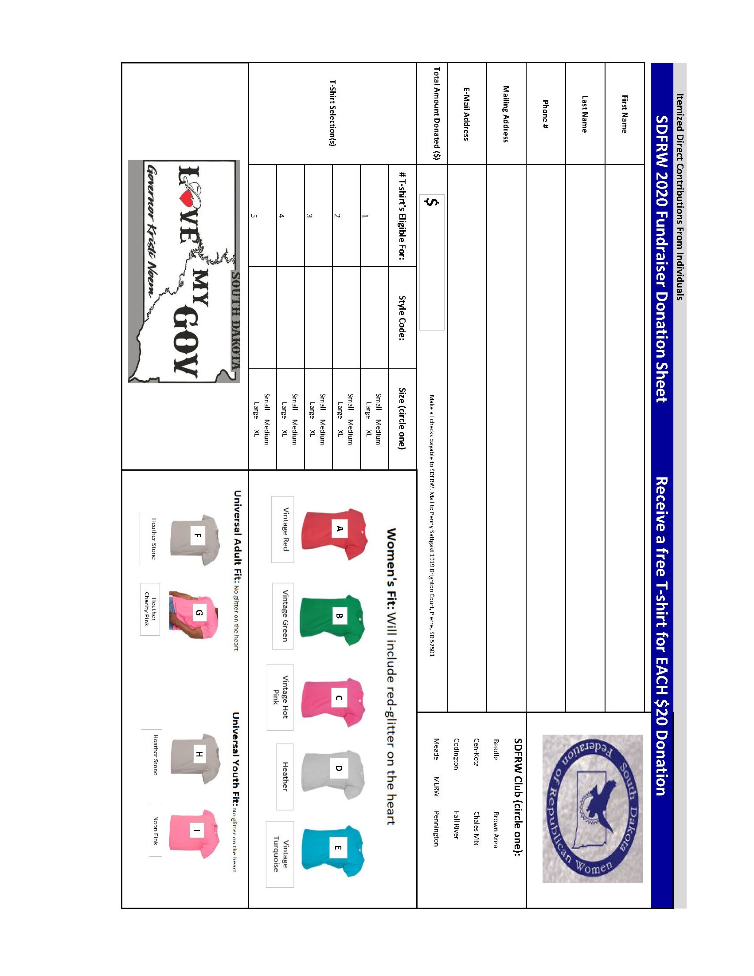

*South Dakota Federation of Republican Women*

5

**WE’RE ON THE WEB!**

[**www.sdfrw.org**](http://www.sdfrw.org/)

**If you’d be interested in donating an item for**

**our**

**2020**

**auction,**

**please**

**respond**

**to**

**this**

**message and let us know!**

If you have any questions or if you’re interested

in becoming a member of SDFRW, please contact Sandy Rhoden, Penny Sattgast, or Catherine Barranco at: [SDFRWemail@gmail.com](mailto:SDFRWemail@gmail.com)

Thank you again for your support!

The SDFRW Executive Committee

Jeni Boerger, Newsletter Editor Phone: 605-596-4339

Cell: 605-460-1766

E-mail[: sdfrwweb@gmail.com](mailto:sdfrwweb@gmail.com)

6