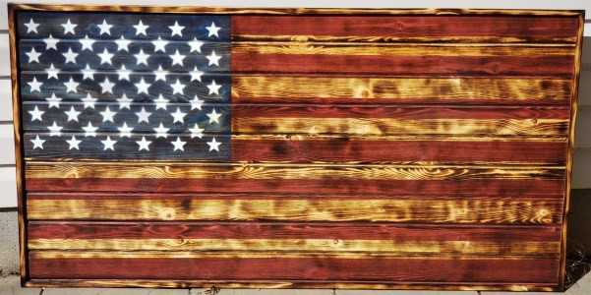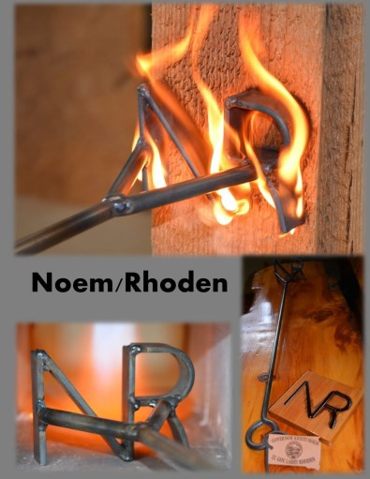

**March & April 2021**

*South Dakota Federation of Republican Women*

***S D F R W A u c t i o n***

***R e t u r n s***

***i n***

***2 0 2 1***

Items that were listed on the Online Auction:

3x5 Wooden American Flag.

Black Hills Mountain Lion Hunt

Noem/ Rhoden Branding Iron,

Montana Silver Necklace, Cookies For a Year

Pheasant Hunt for 2 w/ Senator Kolbeck

Summer Fishing for 2 on the Missouri

1

**R E P O R T S**

**I N S I D E T H I S I S S U E :**

Beadle Co. 2

Cyberspace 3-4

Membership Report 5-7

Cenkota Co.- 8-9

Pennington Co

Calendar of Events 10

History/ Spotlight 11

Information Page 12

**S P E C I A L P O I N T S O F I N T E R E S T :**

* Snippet of History
* Club Reports
* Calendar of Events
* Spotlight
* Newsletter & Quarterly Meeting information



*South Dakota Federation of Republican Women*

**B e a d l e C o u n t y R e p u b l i c a n W o m e n**

The Beadle County Republican Women were excited to travel to our Capital City in February to attend the SDFRW Legislative Day and Quarterly Board Meeting.

We had three members and three guests attending. The guests especially enjoyed our meeting, the Capitol visit and the Mansion visit. That was a first for them. One of the three guests has joined BCRW and Regents!

Our March 8th noon meeting location has been changed to the Scoreboard, back room—because of Covid changes at our regular meeting location. We are scheduled to meet here through May at least. We are very pleased that our **South Dakota State Treasurer Josh Haeder will be our guest speaker!**

Our members attending the Pierre meeting provided cleaning products to be shared with the Pierre residents of the apartment building which had a major

fire. In addition to this Caring for America opportunity, we will be providing “brown paper charcuterie board" for the Huron Fire Department fire fighters at their meeting this spring.

In April, our State Legislators from District 22 will be our guest speakers, explaining the final Legislative issues. Senator David Wheeler, Rep Roger Chase, Rep Lynn Schneider will be with us—BCRW members have also attended their Saturday morning Legislative Coffees to participate in issue discussions.

2

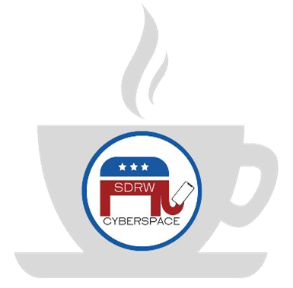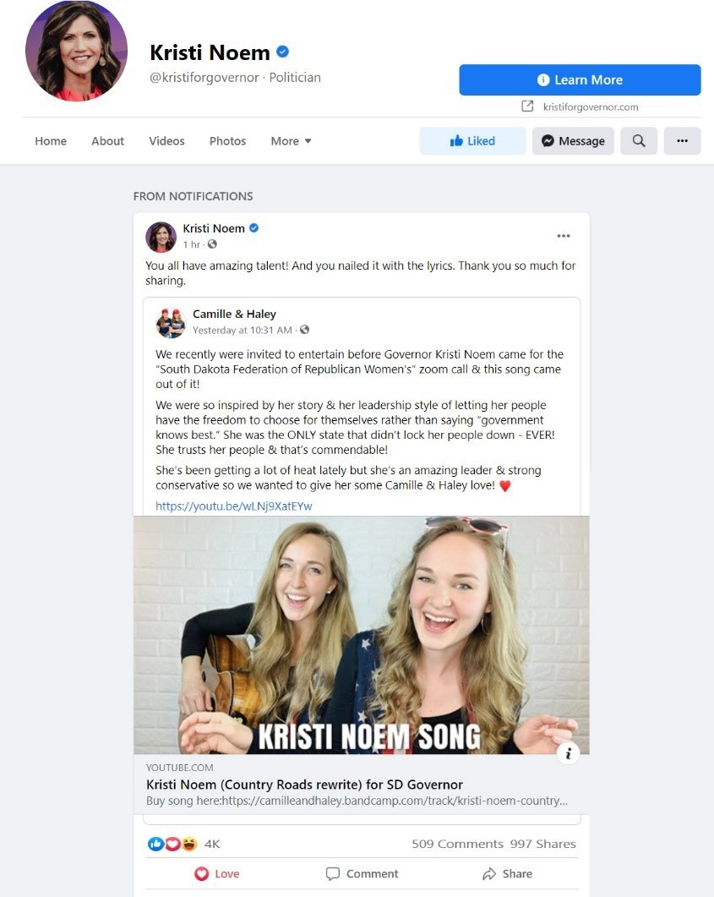

*South Dakota Federation of Republican Women*

**C y b e r s p a c e R e p u b l i c a n W o m e n**

Wow, we’ve been busy!! Several weeks ago, we

had so much fun holding a mini-concert with **Camille & Haley Harris** (of “Keep America Great” fame) followed by Zoom call with **Governor KRISTI NOEM**!! Hundreds of people from over 30 states and territories tuned in to watch! In case you missed it, here’s the link to the video: <https://youtu.be/ONygwAb5bUo?t=1>

Well, that led us on an incredible journey! The

endlessly talented Camille & Haley decided to write a song dedicated to South Dakota and our Governor: *The Kristi Noem Song*! Set to the tune of John Denver’s *Country Roads*, Camille & Haley’s fabulous lyrics will tug at your heartstrings, featuring an all-star cast of South Dakota tourist destinations, nods to our favorable economic environment, and, of course, praise for

our Governor.

The song dropped just last

Thursday. Kristi shared it on her Facebook page

on Friday along with the SD Office of Economic

Development.

By the end of the weekend,

Kristi’s Facebook showed over 4,000 reactions

and almost 1,000 shares. Meanwhile, the girls’

YouTube video had over 55,000 views!!

On

Monday, our Club was spotlighted by NFRW for

our members’ incredible achievement!

Since our last newsletter report, we have also enjoyed Zoom Calls with **Iowa Lt. Gov. Adam Gregg** and **Jacki Deason** (host

of The Jacki Daily Show). Our fantastic Programs Chair (**Scyller Borglum**) launched a new program to facilitate early risers: the Cyberspace Morning Coffee Series! We’ve now enjoyed coffees with Reagan historian Craig Shirley as well as the General Manager of Austin Energy, Jacqueline Sargent, who gave a behind-the-curtain perspective on the Texas Freeze.

Our amazing Caring for America Committee, led by Chair (**Kari Shanard-Koenders**), is blazing the trail! Her fabulous

weekly posts keep everyone aware of special days coming up, and each month, they pick one special day and ask every- one to do something to give back to the community that day. **This month, the chosen day is this Thursday, April 22nd – Earth Day! Do something for the planet, take a picture, and send it to** [**SDRWCyberspace@gmail.com!**](mailto:SDRWCyberspace@gmail.com)

We are incredibly grateful to our talented Associate Member out of Texas **Lori Coiner**, who has developed four different

logos for us to help keep everything straight!

**Official Cyberspace**

**Morning Coffee**

**Caring for America**

**Cyberspace Prayer Warrior**

3



*South Dakota Federation of Republican Women*

**\*\* UPCOMING EVENTS \*\***

Our next meeting will be Tuesday, April 27th at 8:00pm CST / 7:00pm MST and will feature a strong defender of

conservatism, **US Representative Dan**

Carolina!! You do not want to miss this!

**Bishop**

from

North

With everything going on in the world today, I think a lot

of us feel the need to pray. So, we’re launching a monthly Cyberspace Prayer Warrior Zoom Call. They’ll be near the beginning of the month… days and times will vary. Our first will be Tuesday, May at 7:30pm CST / 6:30pm

MST.

4th

Our May Meeting will feature the fearless defender

of our

Constitutional Right to Bear Arms, **US Representative Lauren**

**Boebert** from Colorado!! Save the date: Thursday, May 27th at 7:30pm CST / 6:30pm MST

**How to Register + Giveaway Program!**

Register for these and future events using the Zoom link listed in each description under “Events” on our Facebook page: <https://www.facebook.com/CyberspaceRepublicanWomen/events>

In case you haven’t heard, we’ve launched a fun **Giveaway Program**!! At this time, anyone and everyone can join our Cyberspace Zoom calls and enjoy our fabulous speakers! But…. Cyberspace Active and Associate members on the call are eligible to win a free giveaway! The prizes vary -- so far, we’ve given away Scheel’s gift cards, an autographed copy of the author’s book, and a bag of premium coffee. To become an official Active or Associate member,

email: [SDRWCyberspace@gmail.com](mailto:SDRWCyberspace@gmail.com)

4

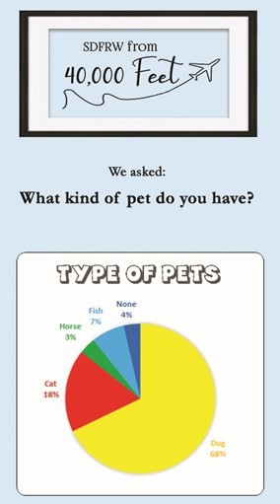

*South Dakota Federation of Republican Women*

**M e m b e r s h i p R e p o r t**

Greetings from your Membership Committee! We have been working hard for you! Can’t wait for

you to see our updates below. Then at the May Board Meeting, we’ll announce our new Ambassadors Program!!

1st

**SDFRW from 40,000 Feet Program**

One of our greatest pleasures in SDFRW is getting to know our wonderful members better. We now

have two programs specifically designed to help! "SDFRW from 40,000 Feet" gives us an overview of our membership, while "SDFRW Member Spotlight" offers us an in-depth interview with one select member each month. Below is the results from our first SDFRW from 40,000 Feet Surveys!

This month, in honor of National Gardening Day, April 14th, we asked about what you like to

garden! **Please submit your answers soon** -- we'll collect everyone's answers in a few days and send

out the results next week.

Here's the link: <https://forms.gle/PKsFVyArhnNGSDXq9>

********************************

In February, we asked our members "What kind of pet do

you have?" It was such fun to read all the extra comments with fun anecdotes about your fur-babies! I must admit -- I was amazed at how many people own yorkiepoos!! **Nancy Stewart**, **Valerie Johnson**, and **Carol Johnson** are just three yorkiepoo moms! In my mind's eye, I can see golden retriever Rylee playing fetch with new member **Tina Castle**! And I smile thinking about Freddy the Cat snuggling in with **Marcie Tranquill**'s sweet daughter at night. (I wonder if Freddy sleeps on Katelyn's pillow the way my Merlin used to...?) Special shoutouts to go my favorite name on the list: Wiggles (**Jen Boerger**'s goldfish). Bragging rights for the most Republican name goes to .... wait for it ....

**Kathy Schaunaman**'s 13-year-old vallhund: Trump!!!

*********************************

For March, in honor of Pi Day, we asked our members "What

kind of pie is your favorite?" with a critical follow-up question, "What's your favorite pie topping?" Strawberry-

5

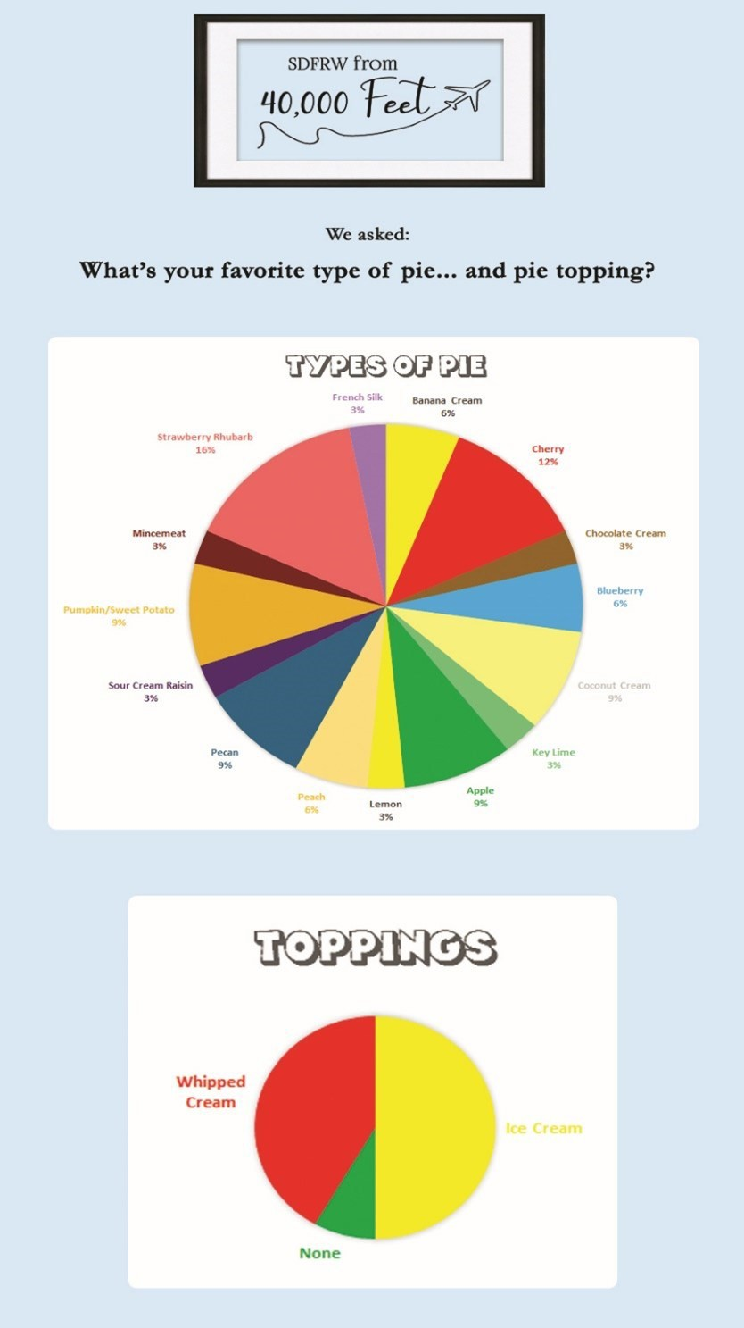

*South Dakota Federation of Republican Women*

-Rhubarb with ice-cream eeked out the win in a highly contest vote. It was such fun to read all the extra comments! I have never had a sour cream raisin meringue pie, **Becky Scott**’s favorite! The next time we’re in Charles Mix, we may need to do a pie tasting with Becky! As for strange ingredients, one tale that stood out was the story of a church pie gone awry! It turns out that, instead of grabbing a piece of rhubarb from the freezer,

the baker mistakenly grabbed a piece of

celery. Bless her heart… we can

all

relate!! There were some other surprisingly

*intentional* ingredients! I have not heard of a Grapenut pie before, but it sounds delicious! **Nancy Stewart** explained it’s like a pecan pie but with Grapenuts cereal. Maybe she'll bring one for our next Board of Directors

meeting? And **Lois VanDusseldorp** mentioned

that

she’s

had

a

pie

featuring

green

tomatoes. Fried green tomatoes are a big thing

in the South; fried green tomato hand pies might actually be good...?

As for advice on how best to make a

pie, **Maggie Hunt** makes her crusts with love, kneading the dough by hand. **Jacqueline Sly** brought a smile to my face with her sage advice: Find a well-used, tattered recipe card in

your grandmother’s recipe box.

6

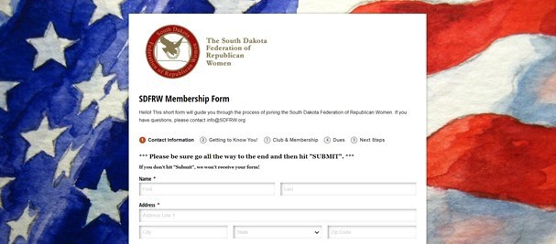

*South Dakota Federation of Republican Women*

-**Membership Form**

We now have a universal membership form! In the future, it'll help streamline the process by which

members join or renew their memberships in any of our clubs. Another wonderful benefit is that it collects everyone's information in a quick, consistent way. Treasurers don’t have to spend hours retyping information, and because each member types in her own email and such, it will dramatically cut down on typos from misreading people’s handwriting and speed up the process of adding them to the SDFRW email distribution list. Here's the link:

<https://www.cognitoforms.com/SDFRW/SDFRWMembershipForm>

**This is meant to supplement – not replace – your current system.** Please don’t abandon your

current system! This is just another tool in your member-recruiting toolkit. This form is our creation and ours alone. We didn’t get it from any other organizations, so nobody other than us has access to the data collected. Whether you submit your members’ information the old way or the new way, the information all ends up in the same place, and the member’s dues still come directly to your Treasurer just like always.

7

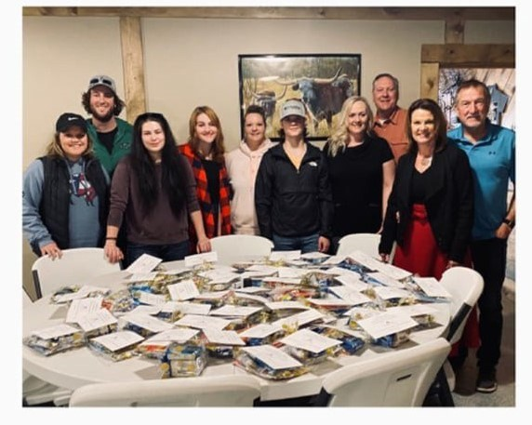

*South Dakota Federation of Republican Women*

**C o d i n g t o n C o u n t y R e p u b l i c a n W o m e n**

No Report

**C e n k o t a R e p u b l i c a n W o m e n**

February

1. Members Penny Sattgast and Claire Rydberg attended the SFRW 2021 Legislative Day
2. Held a monthly meeting which included a Legislative Update from our District 24 Legislators

Featured in the NFRW Newsletter for our joint Cen-Kota/SDFRW Caring for America Project which included collecting cleaning supplies for victims of an apartment fire in Pierre, SD

March

Members worked on procuring items throughout the month for the SDFRW Online Auction Fundraiser

April

Held a monthly meeting which included another Caring For America Project where we

assembled “Spring Baskets” for 60+ members of the Edgewood Assisted Living Center in

Pierre. SD

8

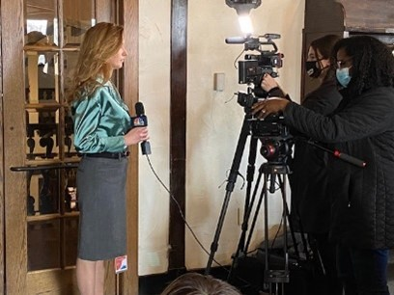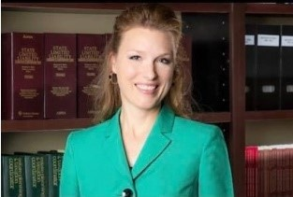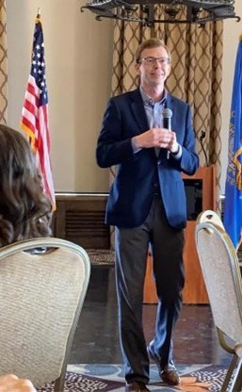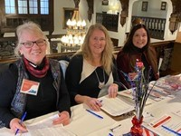

*South Dakota Federation of Republican Women*

**P e n n i n g t o n C o u n t y R e p u b l i c a n W o m e n**

September 2020

*Save the Senate* team travelled to Montana to help with Senator Daine's Senate Campaign.

Hosted Electoral College expert, Trent England, to speak at monthly membership meeting on the subject of the *Electoral College vs. the Popular Vote*.

Started and hosted phone bank campaigns for Senate races in Montana, Arizona, Michigan and Colorado.

October 2020

Hosted special guest, Jackie Barber, at monthly membership meeting, speaking on "*The Most Contested Senate Races in the 2020 Election"*

Participated in campaign sign waiving efforts.

Participated in Zoom Prayer efforts for elections. Promoted MAGA Marches.

November 2020

Voted in the 2021-2022 PCRW Executive Board, including new President Sara Frankenstein.

December 2020

Installed the 2021-2022 PCRW Executive Board. Promoted Georgia Senate race phone banking.

January 2021

Attorney Matt Naaz spoke about South Dakota state commissions, including how the recommendations of these commissions become statues and administrative rules, as well as how citizens can serve on

these commissions.

February 2021

U.S. Representative Dusty Johnson provided an update on his work during the monthly membership meeting.

9



*South Dakota Federation of Republican Women*

10

Calendar of Events

*April:*

27th - SDFRW Cyberspace Zoom Mtg 8pm CST (7pm MST)

US Rep. Dan Bishop (North Carolina)

*May:*

1st - Quarterly Meeting - Rapid City, SD

4th - Prayer Warrior Zoom Call 7:30pm CST (6:30pm MST)

7th - Meade Co Rep. Women Mtg. Sturgis SD Pizza Ranch @ Noon

10th - Beadle Co. Rep. Women Mtg. Huron SD The Plains @ Noon

20th - Brown Co. Area Rep. Women Mtg. Aberdeen, SD The Flame @ 11:30am

* Pennington Co Rep. Women Mtg. Rapid City, SD

Alex Johnson Hotel @ 11:45am

21st - Codington Co Rep. Women Mtg. Watertown SD Pizza Ranch @ 11:30am

27th - Minn-Lincoln Co.Rep. Women Mtg. Sioux Falls SD

Luciano’s North @ 11am

27th - SDFRW Cyberspace Zoom Mtg.

7:30pm CST (6:30pm MST)

US Rep. Lauren Boebert (Colorado) 31st - Memorial Day

June:

4th - Meade Co Rep. Women Mtg. Sturgis, SD Pizza Ranch @ Noon

14th - Beadle Co. Rep. Women Mtg. Huron, SD The Plains @ Noon

17th - Brown Co. Area Rep. Women Mtg. Aberdeen, SD The Flame @ 11:30am

* Penn. Co. Rep. Women Mtg. Rapid City, SD

Alex Johnson Hotel @ 11:45am

18th - Codington Co. Rep Women Mtg. Watertown, SD Pizza Ranch @ 11:30am

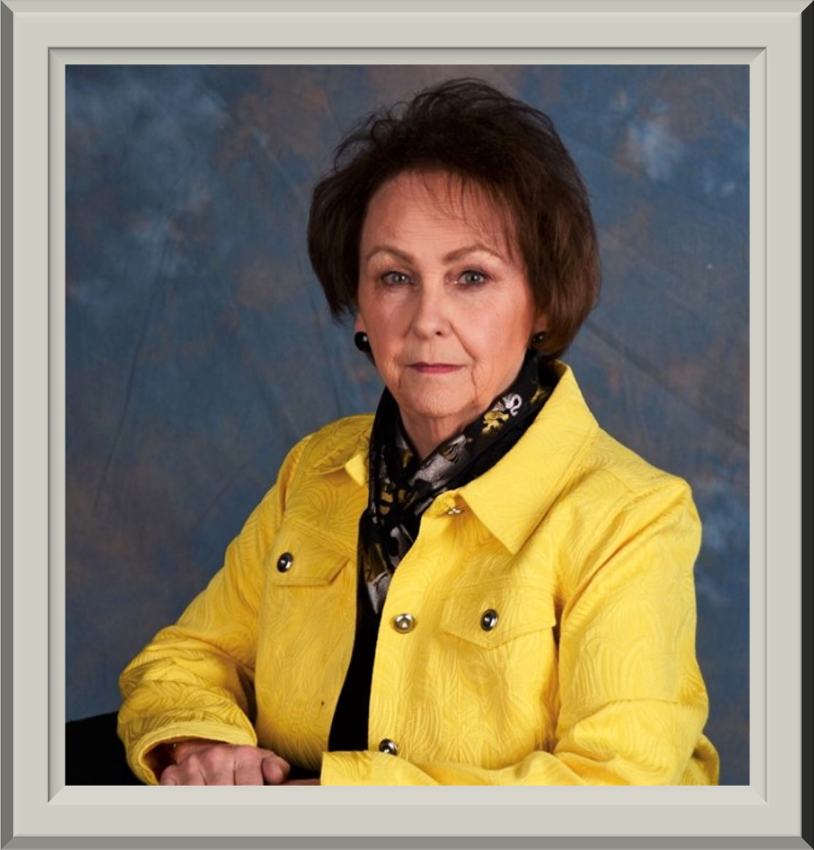

*South Dakota Federation of Republican Women*

SDFRW April Spotlight

Judy Trzynka

Codington County Republican Women

Please check out the website for the

complete story on Judy.

[www.sdfrw.org](http://www.sdfrw.org/)

11



*South Dakota Federation of Republican Women*

*Newsletter Monthly Report Schedule*

January, April, July, & October: Codington, Cenkota & Pennington February, May, August & November: Brown, Minnehaha -Lincoln, & Meade

March, June, September & December: Cyberspace, Beadle, Fall River & Charles Mix Please find your Club and Write down the months that you are in the Newsletter.

**The reports are due the 1st of the month.**

Send the Reports to [sdfrwweb@gmail.com](mailto:sdfrwweb@gmail.com)

If you have anything that you deem important and would like to share with the state please send it in.

It can be photos, and article or report.

12

Next Quarterly Meeting:

*May 1, 2021*

*Registration: 9-10:15am Meeting: 10:15am-3:30pm Holiday Inn-Rushmore Plaza Rapid City, South Dakota*

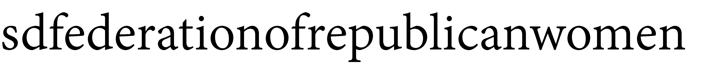

**See Us Now!**

13