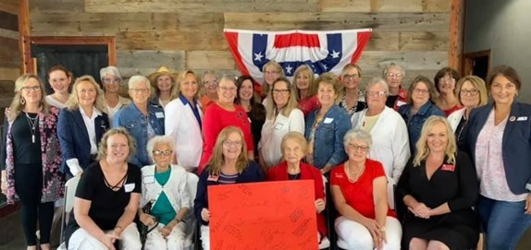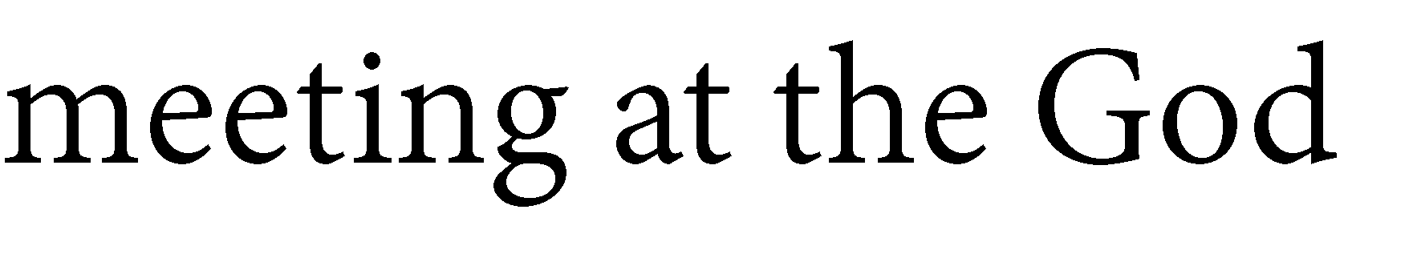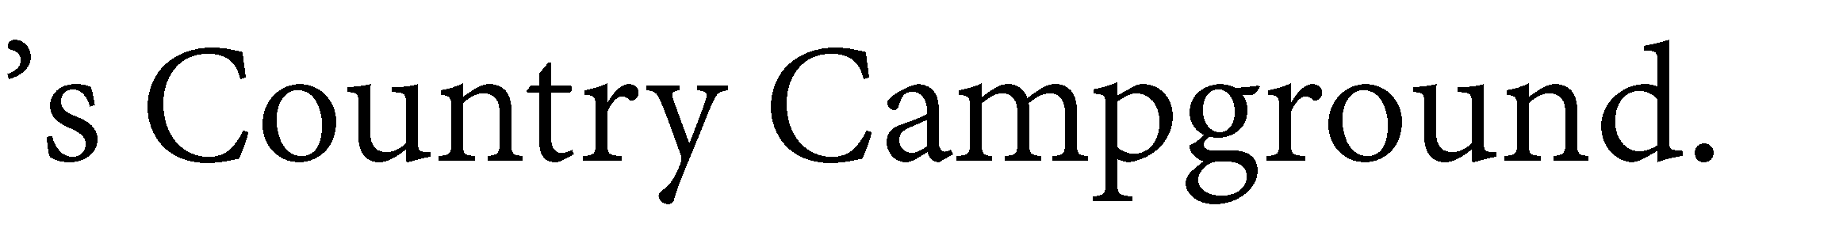

**August 2021**

*South Dakota Federation of Republican Women*

S D F R W

Q u a r t e r l y

M e e t i n g

1

**R E P O R T S**

**I N S I D E T H I S I S S U E :**

NFRW Convention 2-3

President’s Report 4-6 Ads/ Calendar of 7

Events

Caring for America 8

Club Reports 9-

16

This Month In History 16

Member Spotlight 17

**S P E C I A L P O I N T S O F I N T E R E S T :**

* Calendar of Events
* NFRW Convention Info
* President’s Report
* This Month in History ~ Olympics
* Caring for America Report

*South Dakota Federation of Republican Women*

41st Biennial Convention

The National Federation of Republican Women is #LaunchingLeaders this September at the 41st Biennial Convention in Orlando, Florida -- and all Federated Republican women's club members are invited!

Convention attendees will have the opportunity to:

* Network with more than 1,000 like-minded Republican women from across America
* Hear from top-level national speakers
* Receive cutting-edge training to help counter the radical left

Help chart the future of the NFRW, which includes the election our next national officers

Thursday, September 23, 2021

10:00 am – 12:00 pm: Executive Committee Meeting *(closed)*

3:00 pm – 7:00 pm: Convention Registration / Information Desk Open

4:00 pm – 6:00 pm: State Federation Presidents Meeting

*(state federation presidents only)*

Evening: Regents Reception

*For more information about the Regents Reception, contact Liz Matro at* [*lmatro@nfrw.org.*](mailto:lmatro@nfrw.org)

Friday, September 24, 2021

9:00 am – 6:00 pm: Convention Registration / Information Desk Open

10:00 am – 12:00 pm: Pre-Convention Board of Directors Meeting 1:00 pm – 5:00 pm: Campaign Management School *(separate ticket)*

*Instructor:*

NFRW Trainer Holly Robichaud will provide intensive training on the latest techniques in fundraising, voter contact and GOTV.

Evening: Convention Welcome Reception

*Special Guests:*

Florida Governor Ron DeSantis and First Lady Casey DeSantis

2

*South Dakota Federation of Republican Women*

41st Biennial Convention Cont.

Saturday, September 25, 2021

8:00 am – 5:00 pm: Convention Registration / Information Desk Open

8:30 am – 11:30 am: Convention General Session

*Speakers:*

Mike Huckabee, former Governor of Arkansas and host of *Huckabee*

12:30 pm – 2:30 pm: Luncheon

3:00 pm – 4:30 pm: Workshops / Training Seminars Critical Race Theory, panel discussion Election Integrity, panel discussion

Communications, presented by the [Leadership Institute](https://leadershipinstitute.org/) Fundraising, presented by the [Leadership Institute](https://leadershipinstitute.org/)

Membership, presented by the [Leadership Institute](https://leadershipinstitute.org/) and featuring tips from presidents of fast-growing clubs

Bylaws and Parliamentary Procedure, presented by NFRW Parliamentarian Theresa Kosmoski

5:00 pm – 6:30 pm: Achievement Awards Ceremony

Dinner: Attendees on own

Sunday, September 26, 2021

6:00 am – 12:00 pm: Convention Registration / Information Desk Open

6:30 am – 8:00 am: Voting for National Officers *(if necessary)*

7:30 am – 8:30 am: Prayer Breakfast *(separate ticket)*

9:30 am – 12:00 pm: Convention General Session

*Speakers:*

Gordon Chang, author, commentator and leading expert on China, "Saving America from China's Existential Threat"

12:00 pm – 2:00 pm: Networking Luncheon

2:30 pm – 5:00 pm: Post-Convention Board of Directors Meeting *(to elect the three Members-at-Large to the NFRW Executive Committee)*

5:00 pm – 6:00 pm: Post-Convention Executive Committee Meeting *(closed)*

3

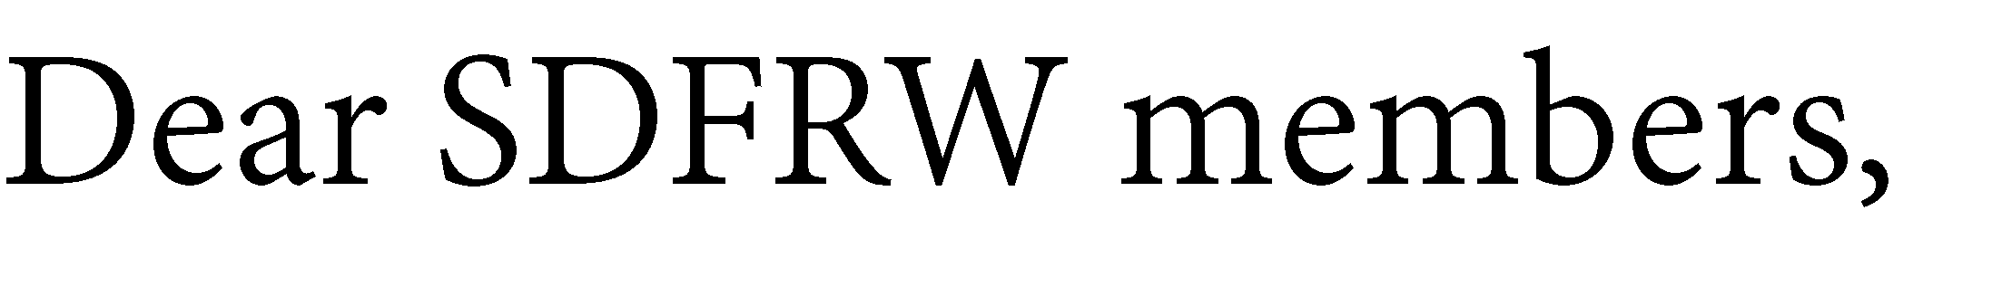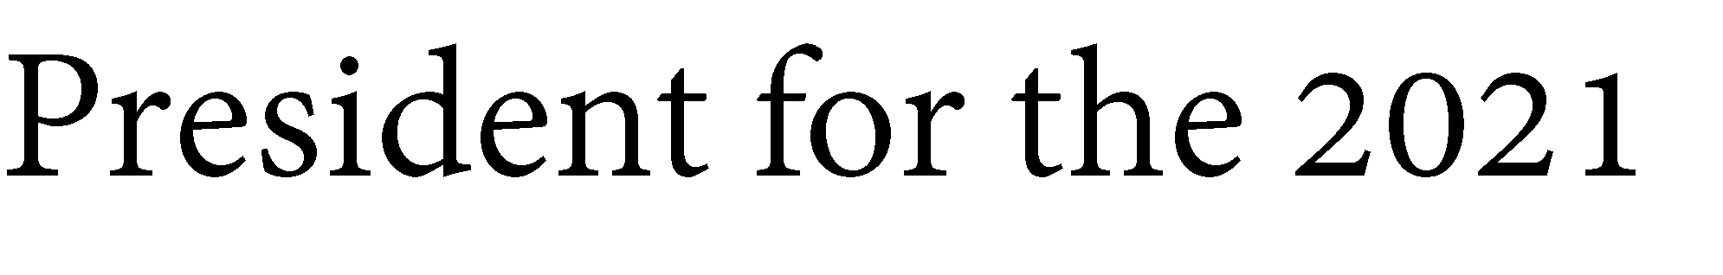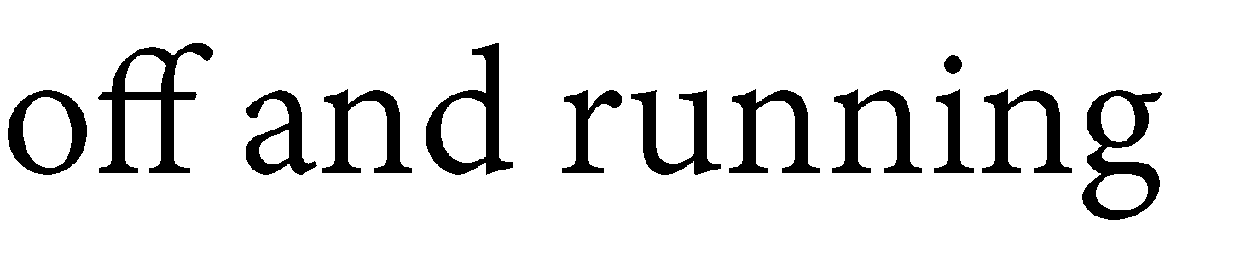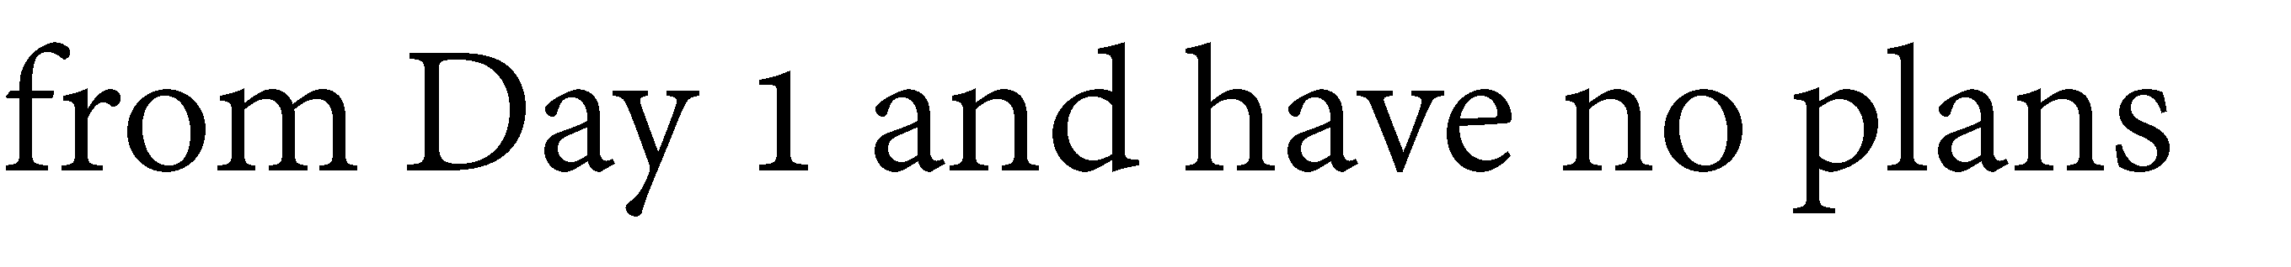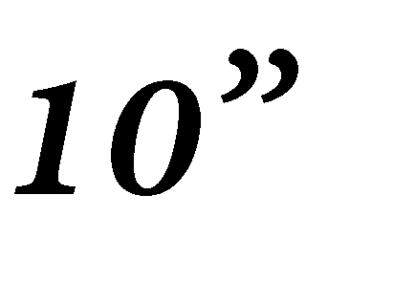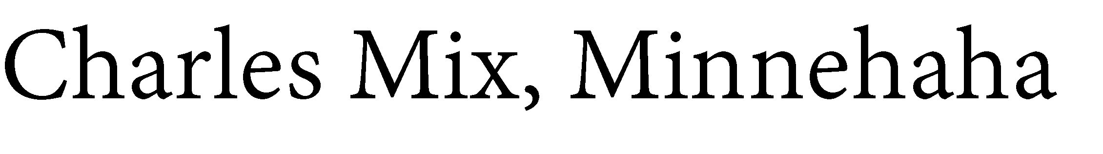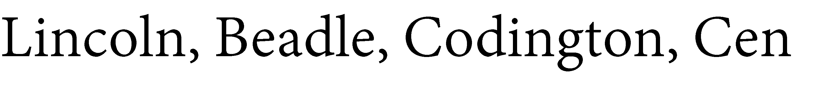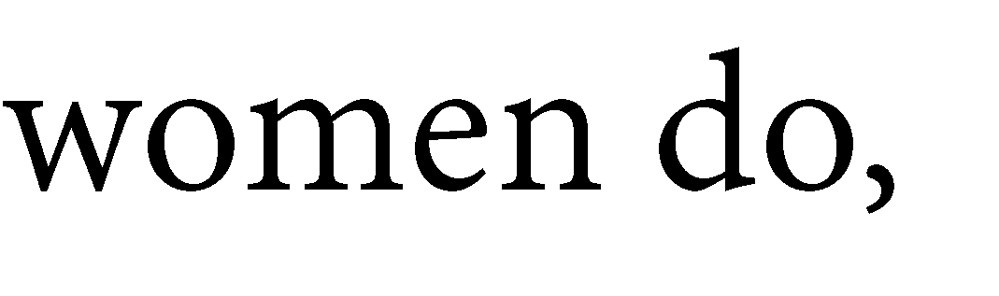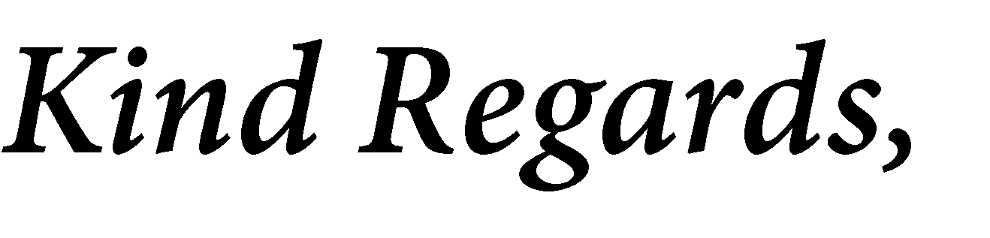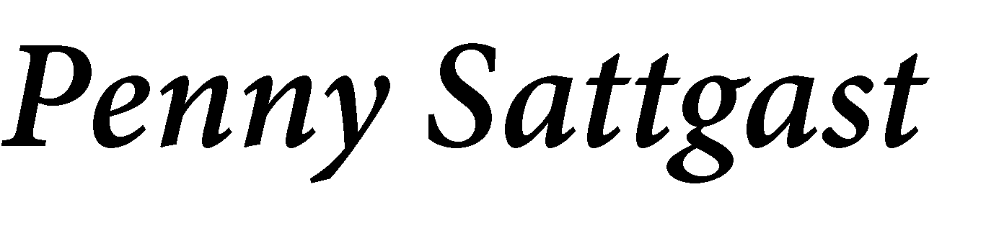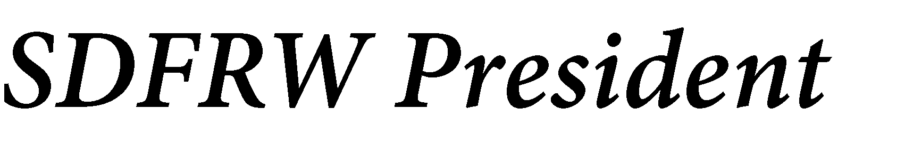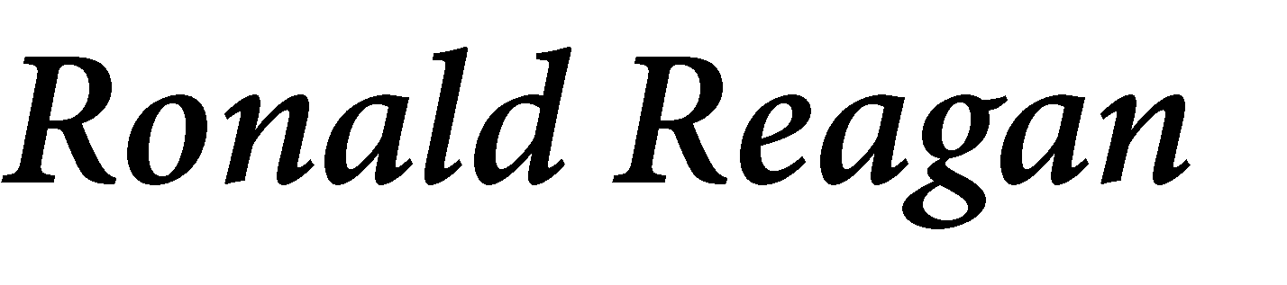

*South Dakota Federation of Republican Women*

4

*South Dakota Federation of Republican Women*

***SDFRW’s ‘Top 10 highlights’ through July 2021:***

**1**-Have already held three successful Board of Directors Meetings (in Pierre, Rapid City,

and Platte), and we also hosted our Annual Legislative Day in February at our beautiful State Capitol.

**2**- We found ourselves in the National Spotlight with NFRW (through their Facebook,

their Newsletter, or both) a total of FOUR times for the following:

**1st one:** Cen-Kota and SDFRW’s joint Caring for America Project (where we

collected cleaning supplies for victims from the Pierre Apartment Complex Fire).

**2nd one:** CyberSpace was featured as the NFRW Club Spotlight!

**3rd one:** Cen-Kota was featured for their Caring for America Project (where they assembled spring baskets for the residents of the Edgewood Assisted Living Center in Pierre)! The extra-exciting news with this project was that NFRW President Ann Schockett also featured this project on her weekly You-Tube Fast Forward video!

**4th one:** This one has an extra special place in my heart, as I was very honored (along with SDFRW 1st VP Catherine Barranco), to join Governor Kristi Noem and other dignitaries, along with 2,000 other South Dakotans in welcoming home the

South Dakota National Guard’s 196th Maneuver Enhancement Brigade!

These brave patriots spent the last 10 months deployed to Africa in support of

Operation Enduring Freedom. To show our appreciation, we presented each

soldier with a custom pin featuring the returning Brigade’s unit patch, along with customized “thank you” cards expressing SDFRW members’ sincere gratitude.

A special thank you to our Armed Forces Committee Chair Sandy Marlette and

Vice-Chair Sandy Davalos for their hard work on this amazing project!!

**3**- SDFRW had "boots on the ground" across the state back in July, as members

participated in 4th of July parades for our fabulous Governor Kristi Noem in Spearfish, Deadwood, Lead, Central City, Belle Fouche, Fort Pierre, and Watertown! Several also

were caught wearing our custom SDFRW "*Love My Gov*" Shirts!

5

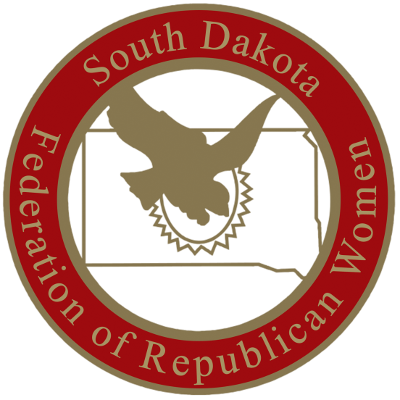

*South Dakota Federation of Republican Women*

***SDFRW’s ‘Top 10 highlights’ through July 2021:***

**4**- Held a very successful auction fundraiser, which brought lots of fun and exciting items for people to bid on and enjoy! A huge thank you to all members and donors who participated! Due to popularity, we are already getting asked when the next one is! Stay

tuned!

**5**- Worked on Youth Engagement efforts including voter registration emails and custom

Facebook videos (encouraging recent 2021 graduates to get registered before leaving to

college in the fall). We also partnered with the South Dakota GOP during one of our SDFRW Truth for our Youth “Layered Government” panels.

1. Several of our members worked extremely hard and were heavily involved in helping

to ensure conservative-minded school board candidates were elected across the state. A special “shout-out” to the Pennington County Republican Women for their extraordinary efforts!

1. Under the leadership of our Membership Committee Chair-Catherine Barranco, we have experienced amazing membership victories thus far for 2021, and still have 5

months to go!

1. We now have over 1000 likes on our Facebook page and continue to expand our social

media reach!

**9**- During our July 31st Board of Directors meeting, we voted on sending 12 delegates

and 1 alternate to the upcoming September NFRW Biennial Convention in Orlando, Florida!

**10**- We continue to put God at the center of our organization!

6



*South Dakota Federation of Republican Women*

7

Calendar of Events

August:

23rd- Cyberspace Zoom Monthly Meeting 7:30pm CST / 6:30 MST

26th- Minnehaha-Lincoln Republican Women

11am CST Josiah’s Coffeehouse & Café,

Sioux Falls, SD

September:

3rd- Meade County Republican Women 2pm MST, Pizza Ranch, Sturgis, SD

9th- Cyberspace Morning Coffee

9:37am CST ~ in memory of those that perished when flight 77 struck the Pentagon in 9/11 attacks.

13th- Beadle County Republican Women 12pm CST, Scoreboard, Huron, SD

16th- Brown County Republican Women 11:30am CST, The Flame, Aberdeen, SD

-Pennington County Republican Women

11:45am MST, Alex Johnson Hotel, Rapid City, SD 17th- Codington County Republican Women

11:30am CST, Pizza Ranch Watertown, SD

23rd- Minnehaha- Lincoln County Republican Women 11pm CST, Josiah’s Coffeehouse & Café Sioux Falls, SD

23-26 NFRW Conference, Orlando, FL

October:

1st- Meade County Republican Women 2pm MST, Pizza Ranch, Sturgis, SD

11th- Beadle County Republican Women

12pm CST, Pizza Ranch, Watertown, SD

14th- Cyberspace Morning Coffee, 9am CST 15th- Codington County Republican Women

12pm CST, Pizza Ranch, Watertown, SD

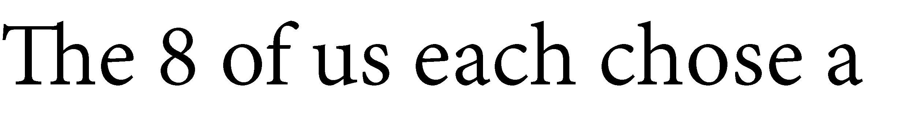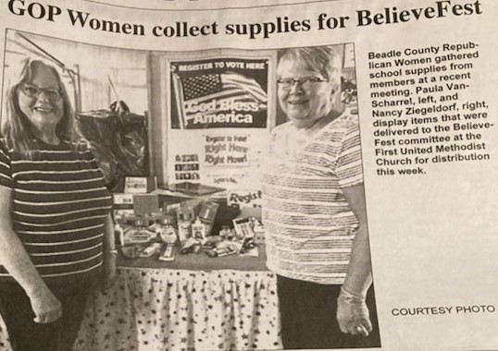

*South Dakota Federation of Republican Women*

**C a r i n g F o r A m e r i c a A c t i v i t i e s**

8

*South Dakota Federation of Republican Women*

**C e n k o t a R e p u b l i c a n W o m e n**

May

-SDFRW (and Cen-Kota) President Penny Sattgast traveled to Alexandria, VA for the National Federation of Republican Women’s Board of Directors Meeting

-Cen-Kota Vice-President Claire Rydberg was featured as the SDFRW Member Spotlight

-Cen-Kota was featured for their Caring for America Project (where they assembled spring baskets for the residents of the Edgewood Assisted Living Center in Pierre), which was featured in both the NFRW newsletter and on NFRW’s Facebook page. The extra-exciting news with this project was that NFRW President Ann Schockett featured this story on her weekly You-Tube Fast Forward video and gave our Vice-President Claire Rydberg a special “shout-out” for leading the project! See youtube link below:

<https://m.youtube.com/watch?v=eX8dBORw2pE&feature=youtu.be>

June:

-SDFRW (and Cen-Kota) President Penny Sattgast and Treasurer Kristin Gabriel worked on preparing submissions for all required NFRW Club Achievement Awards

July:

-Cen-Kota promoted and had members participate in the Fort Pierre 4th of July parade for Governor Kristi Noem and District 24 candidates.

-SDFRW (and Cen-Kota) President Penny Sattgast traveled to Platte for the SDFRW Summer Board of Directors Meeting

-Cen-Kota won the SDFRW Membership contest award for “ Largest % Increase in Active

Members” and received a trophy during the Summer Board of Directors Meeting

August:

-Upcoming Joint Cen-Kota/Hughes County Republicans Summer BBQ in Fort Pierre

***Kind Regards,***

***Penny Sattgast-SDFRW President***

***"Freedom is never more than one generation away from extinction. We didn't pass it to our children in the bloodstream. It must be fought for, protected, and handed on for them to do the same, or one day we will spend our sunset years telling our children and our children's children what it was once like in the United States where men were free". -Ronald Reagan***

9

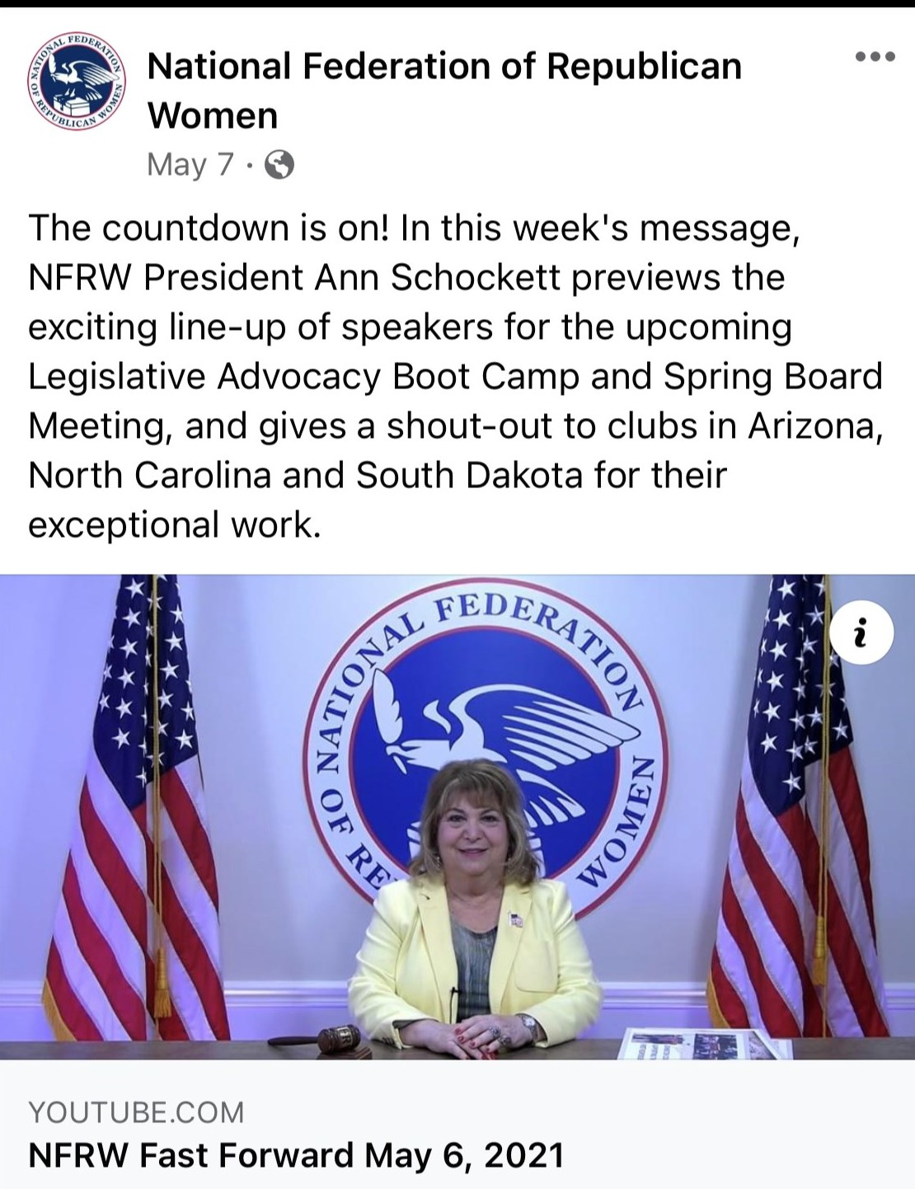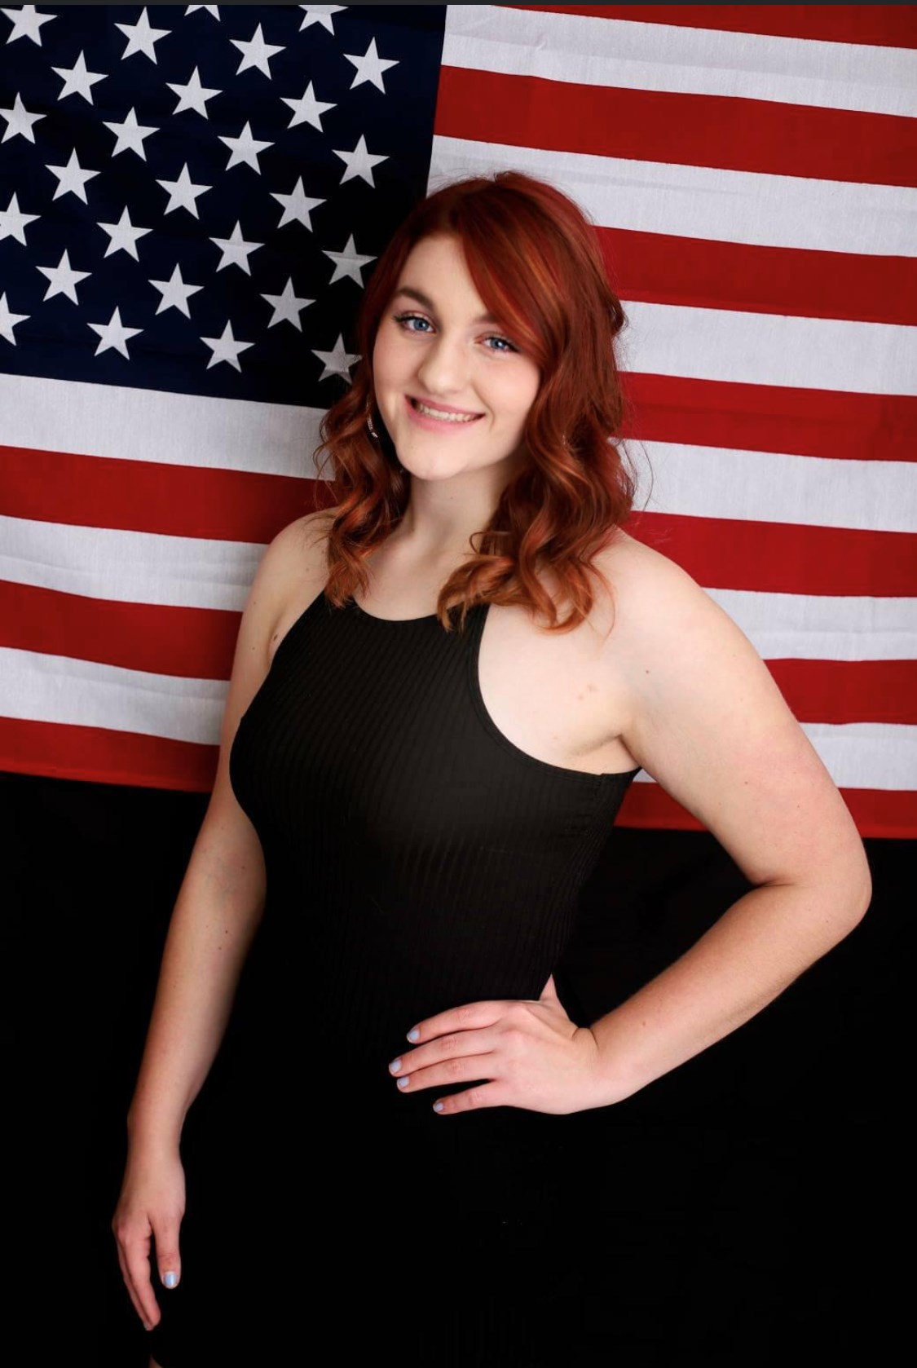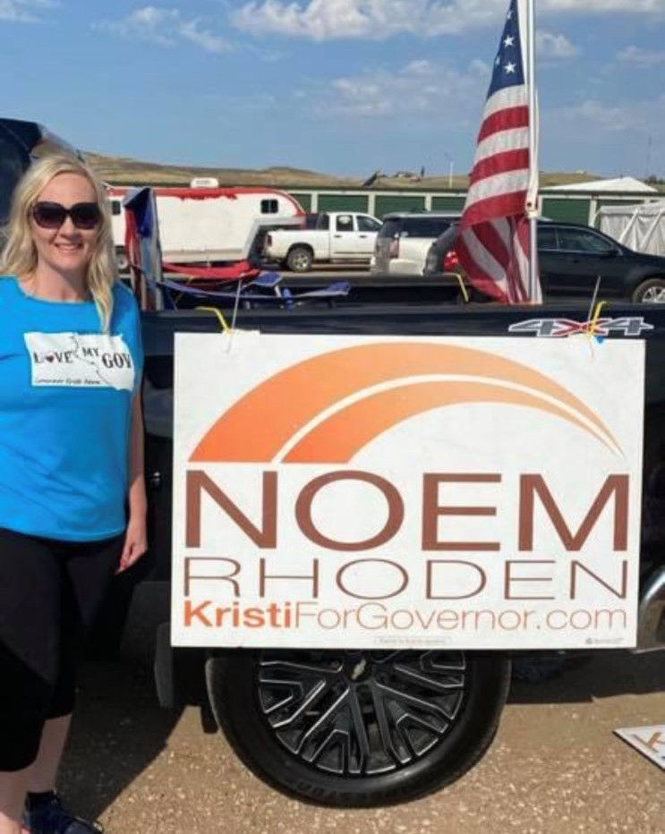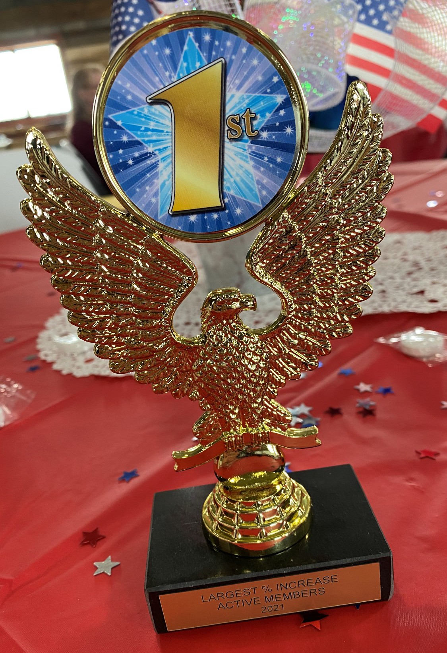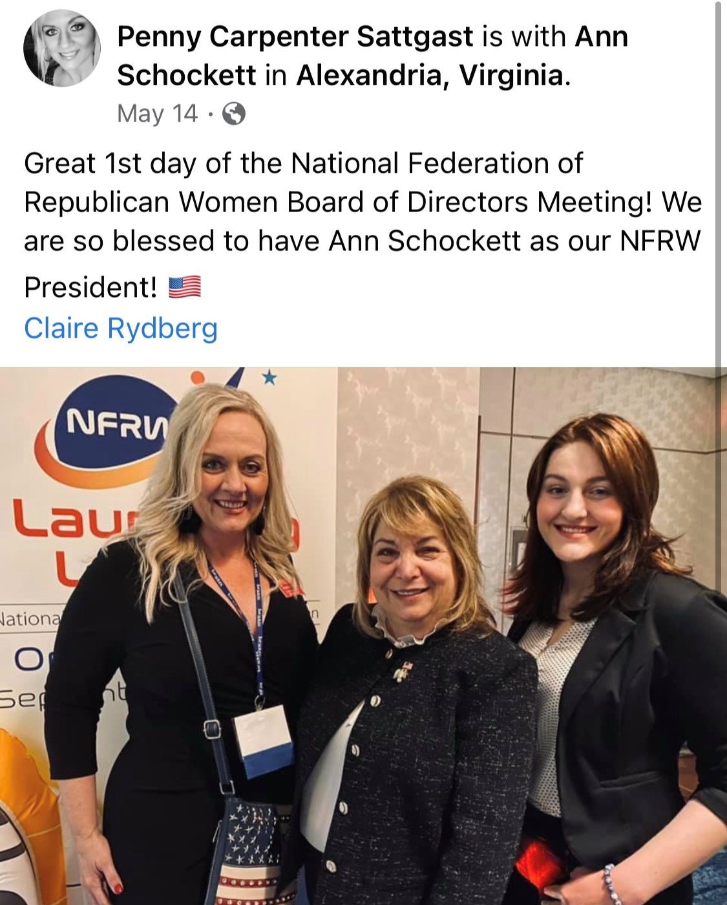

*South Dakota Federation of Republican Women*

**C**

**e**

**n**

**k**

**o**

**t**

**a**

**R**

**e**

**p**

**u**

**b**

**l**

**i**

**c**

**a**

**n**

**W**

**o**

**m**

**e**

**n**

**C**

**o**

**n**

**t**

**.**

10

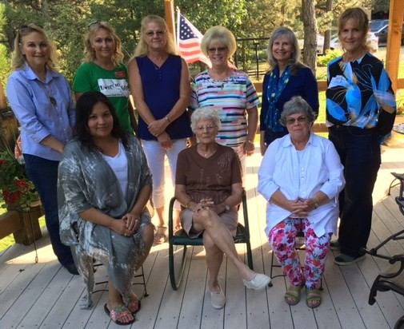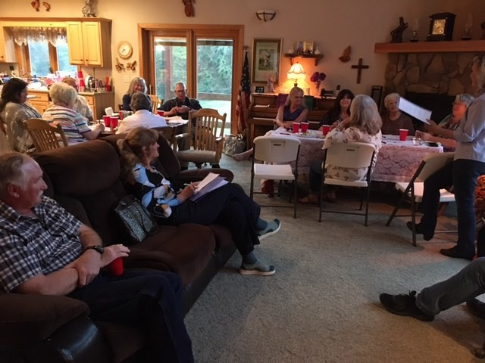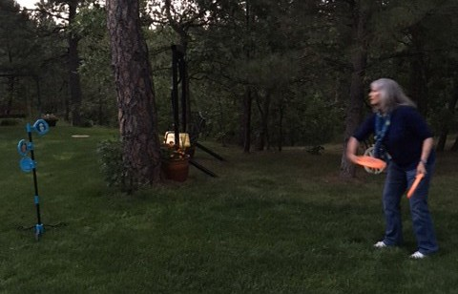

*South Dakota Federation of Republican Women*

**M e a d e C o u n t y R e p u b l i c a n W o m e n**

Meade County Newsletter for August, 2021

Our club has been active during these summer months.

11

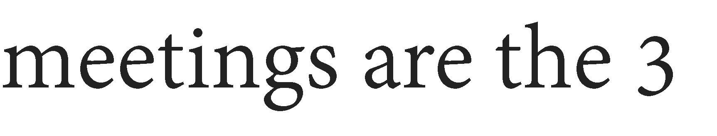

*South Dakota Federation of Republican Women*

**B r o w n C o u n t y A r e a R e p u b l i c a n W o m e n**

12

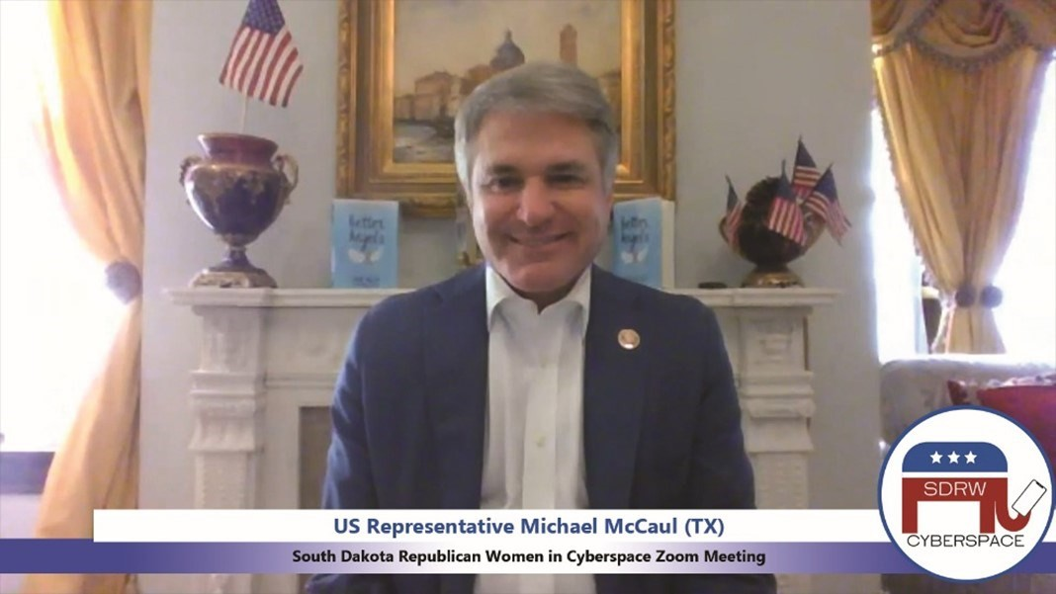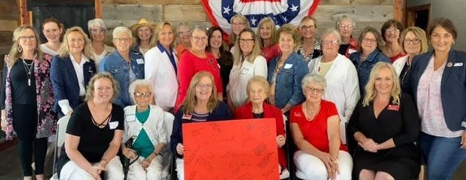

*South Dakota Federation of Republican Women*

*Cyberspace Republican Women*

Another

terrific

month

for

Cyberspace!

We

are

so

grateful

to

**U.S. Representative Michael McCaul (TX)** for speaking with us about so many

timely topics, from

eye-opening call!

energy

policy

to

the

Border

Crisis.

It

was

quite

an

We had a wonderful

time at the SDFRW Board of

Directors

Meeting

at

the

beautiful new God’s Country Campground in Platte!

13

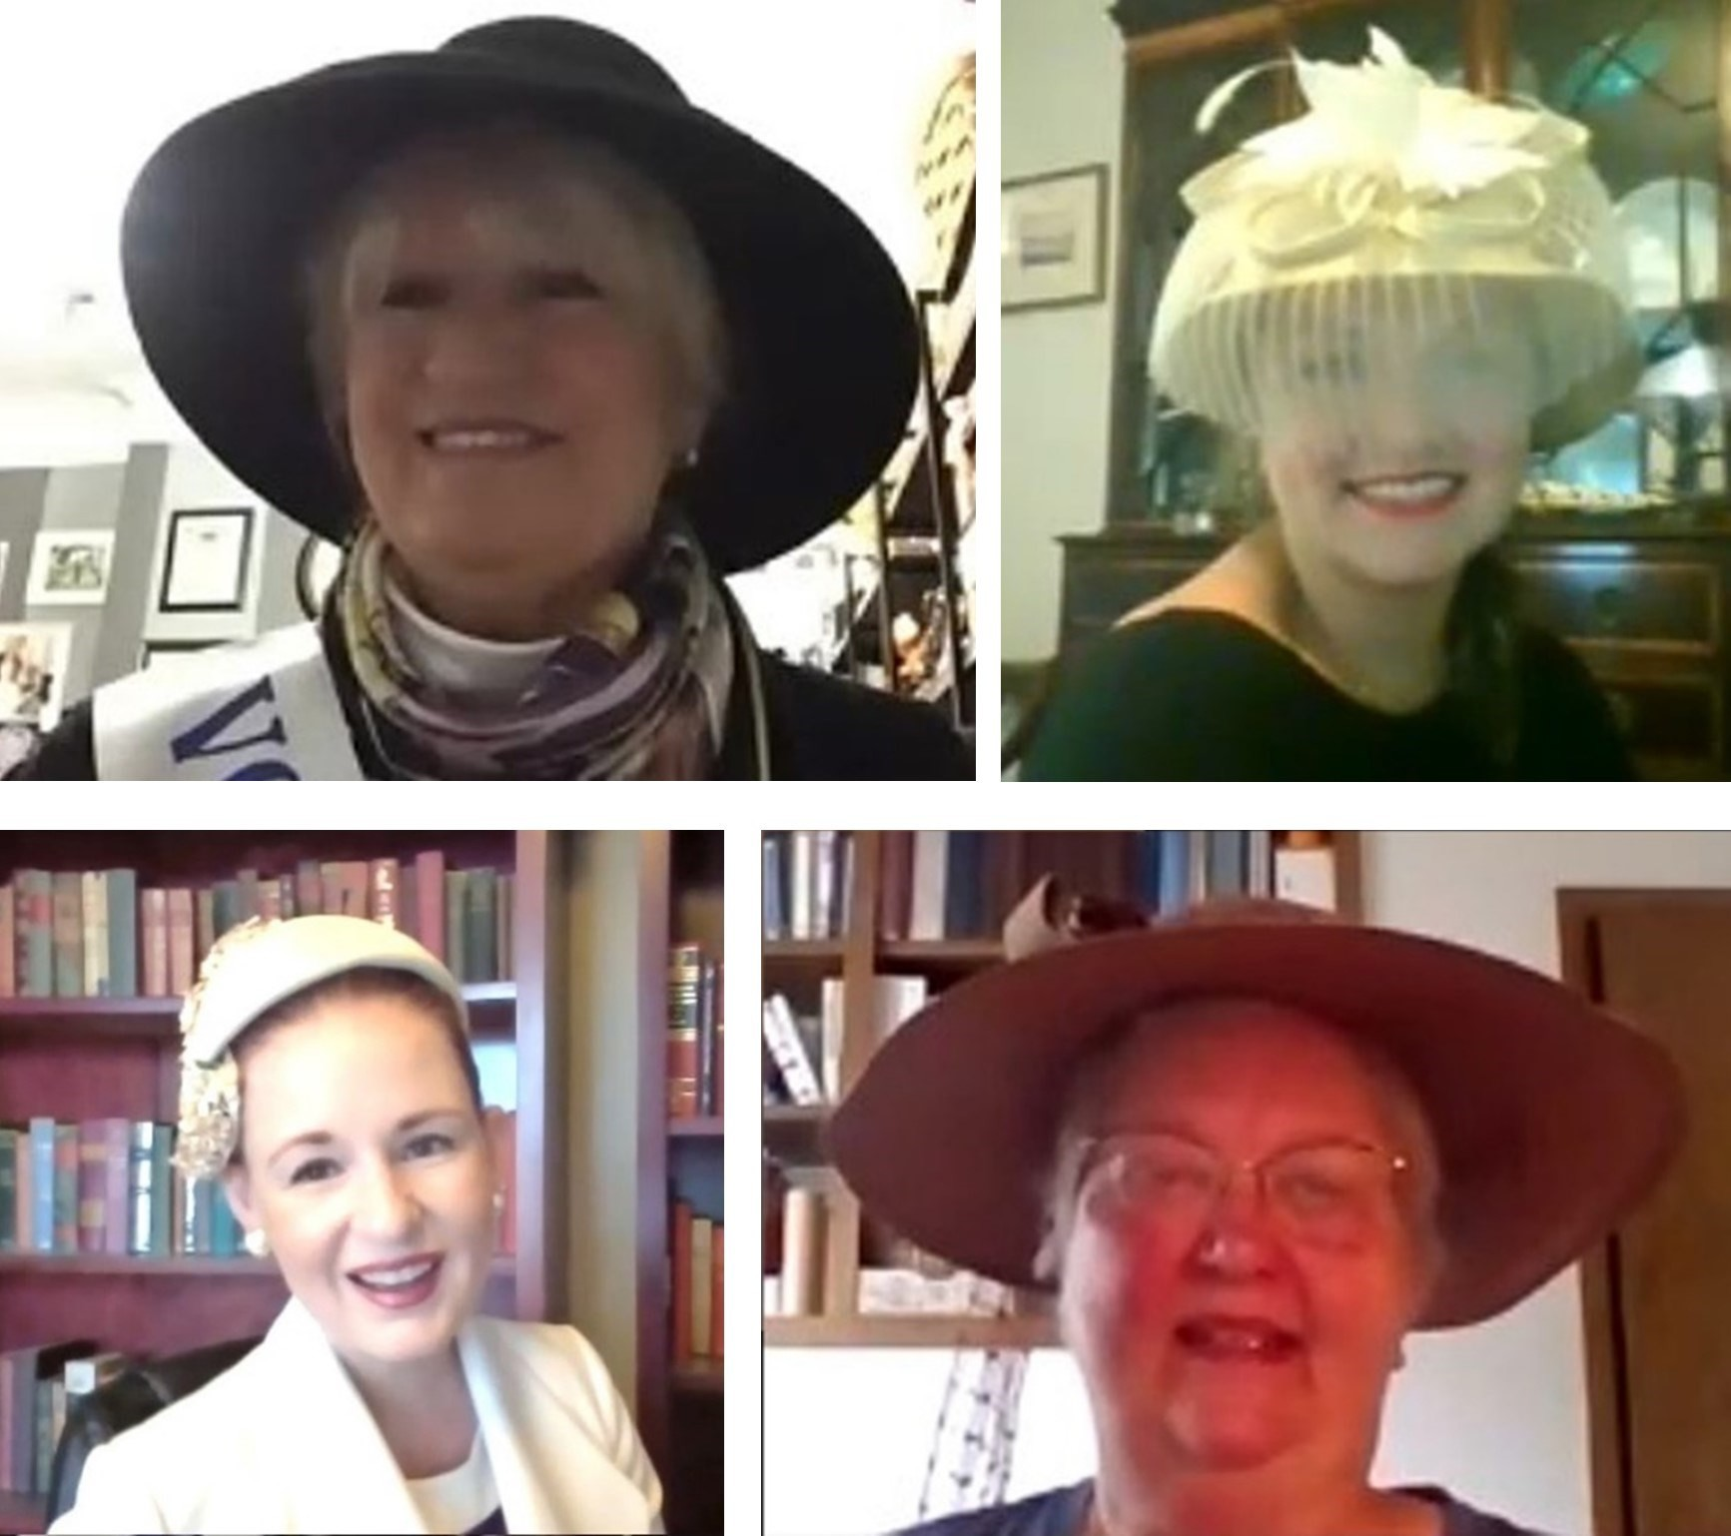

*South Dakota Federation of Republican Women*

*Cyberspace Republican Women cont.*

We enjoyed a delightful Morning Coffee learning about Women’s Suffrage, thanks to our

fabulous Nina Akin! Below are photos of some of our members’ hats, including one worn by an actual suffragette!

Cyberspace has partnered

with SDFRW to offer a 50% promotional discount on 2021 Active

Memberships! **Through the end of the year, Active Memberships will run just $20 and include**

**membership in Cyberspace, SDFRW, and NFRW!!** For more information, contact SDRWCyberspace@gmail.com!

14

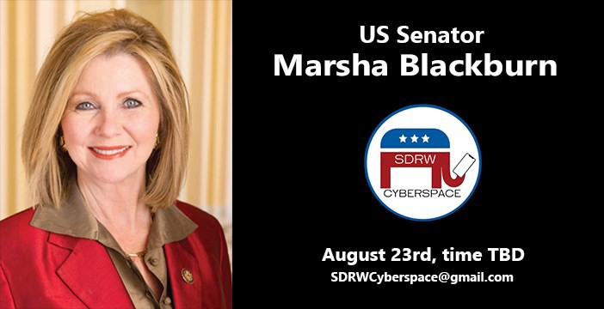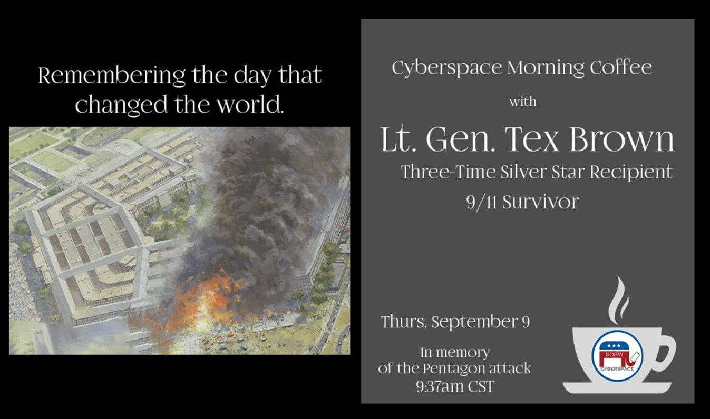

*South Dakota Federation of Republican Women*

*Cyberspace Republican Women Cont.*

If you haven’t liked and followed our Facebook page, you should! It’s a great source of

information, including registration links for these and more upcoming events:

**https://**[**www.facebook.com/CyberspaceRepublicanWomen**](http://www.facebook.com/CyberspaceRepublicanWomen)

**\* Invite friends and family across the nation to sign up for our upcoming Zoom Calls! \***

**\* Please note:** the time is set for our Zoom Call with Senator Marsha Blackburn!! **\***

Join us at 7:30pm CST / 6:30pm MST on Monday, August 23rd!

15

*South Dakota Federation of Republican Women*

*Cyberspace Republican Women cont.*

On September 11, 2001, a horrified world watched al Qaeda terrorists hijack four airplanes and murder nearly 3,000 innocents. Together we mourned these deaths, wept to read heart-wrenching tales of heroism and sacrifice, and, for a time, united against evil. The French paper *Le Monde* made the

statement, beautiful in its simplicity,

"Today, we are

all

Americans."

Please join us on Thursday, September 9th as we memorialize that tragedy's 20th anniversary and dis- cuss the important lessons our nation learned at such dreadful cost. We are deeply honored to hear from an American hero and 9-11 attack survivor, Lt. General Richard "Tex" Brown who was, upon his retire- ment, the single most decorated member of the Air Force. Among his many, many honors, he earned the

Silver

Star

on

three

separate

occasions.

In remembrance of the Pentagon attack, our call will begin at 9:37am CST / 8:37am MST.

***This Month in History ~ Olympics***

Margaret Abbot took first in women's golf in Paris in 1900, making her the first female American Olympic champion.

•

•

Fourteen-year-old Aileen Riggin, the youngest athlete on the US team, won the diving gold medal in 1920 in

Antwerp, the first games to include women's aquatic events.

•

Elizabeth “Betty” Robinson of Riverdale, Illinois won the 100 meters in 1928 in Amsterdam, the first Olympic games

to include women’s track and field events.

•

While elite, predominantly white universities eliminated women's athletic programs, many historically black

colleges retained them. The most prolific program arose at Tennessee State University where Ed Temple served as

head women's track coach from 1950 to 1994. During his tenure, forty members of his famed Tigerbelle teams

represented Tennessee State in Olympic competition, winning a total of 23 medals (13 Gold, 6 Silver, and 4 Bronze). Temple coached famed Olympian Wilma Rudolph to three gold medals at the 1960 Rome Olympics.

•

US Representative Patsy Mink (D-Hawaii) was a principal author of the Education Amendments of 1972—later

renamed the Patsy T. Mink Equal Opportunity in Education Act. A former high school basketball player who was restricted to half-court play under the girls’ rules, Mink made fighting gender discrimination a hallmark of her Congressional career.

•

In 1991, the IOC implemented a requirement that new Olympic sports include women’s events, exponentially

increasing the number of female Olympians. The London 2012 US team was the first to feature more women than

men. Correspondingly, US women outperformed the men in the medal count.

Credits:

National Women’s History Museum

Alexandria, VA

16

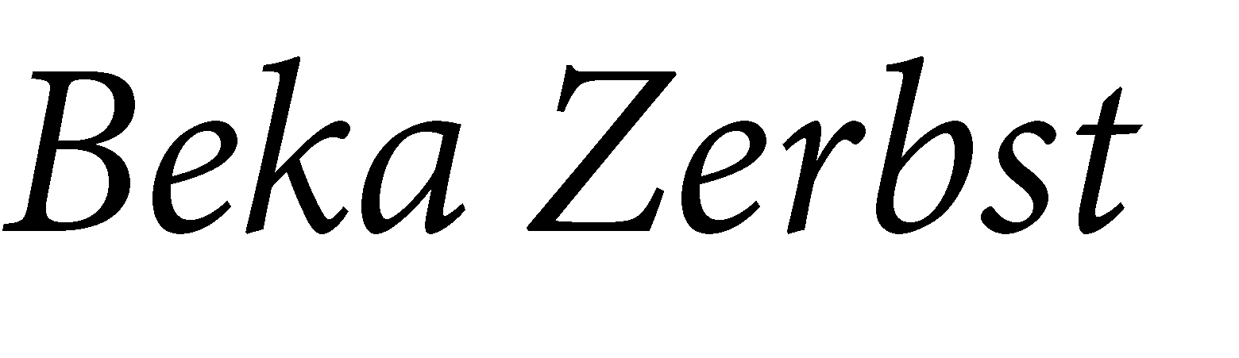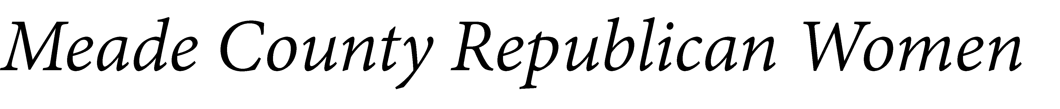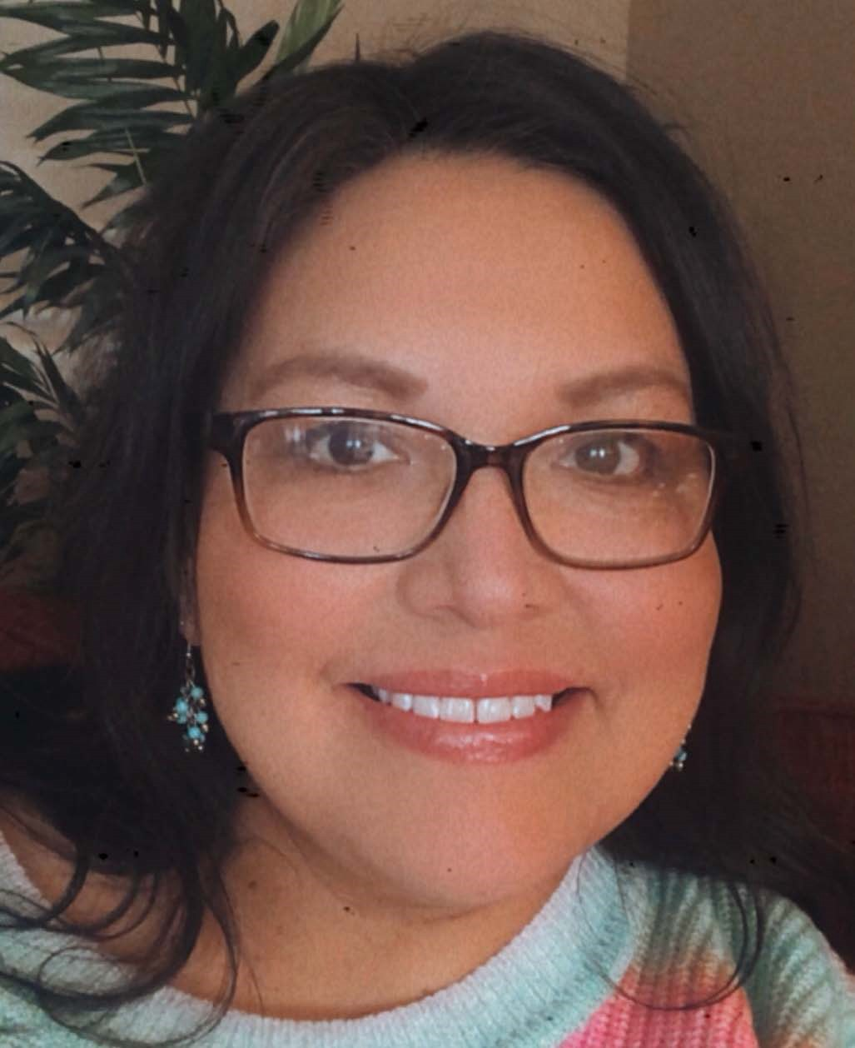

*South Dakota Federation of Republican Women*

17

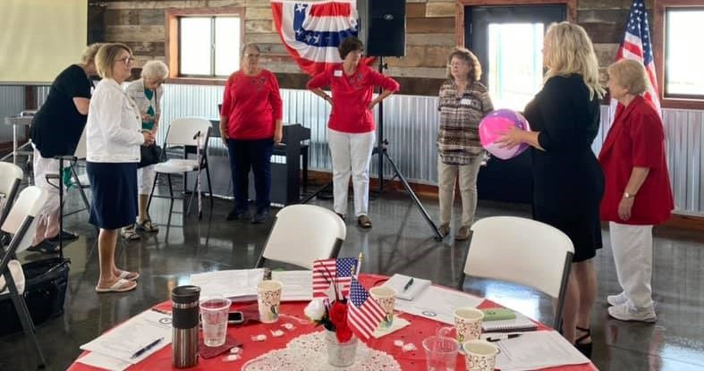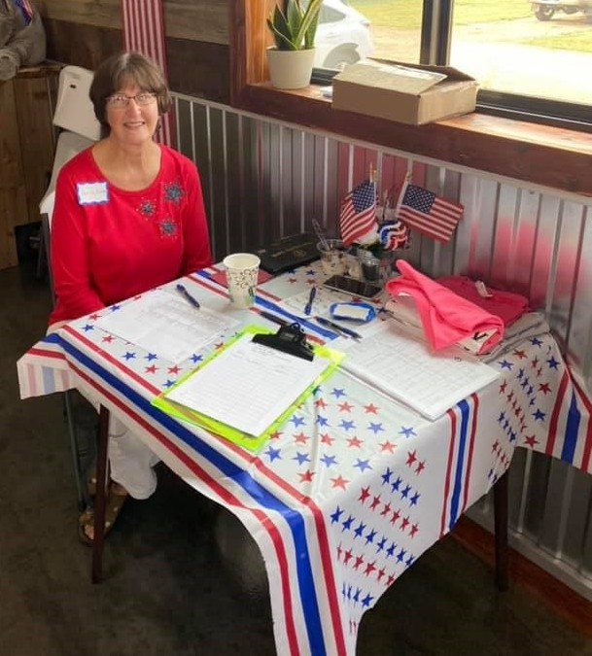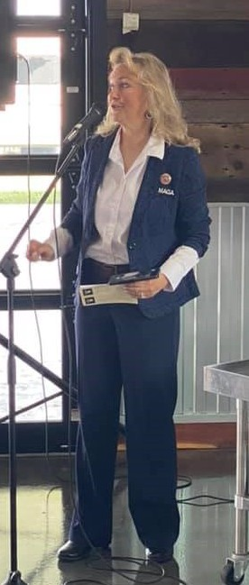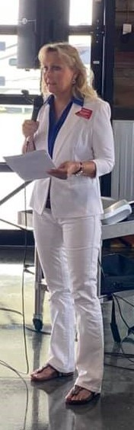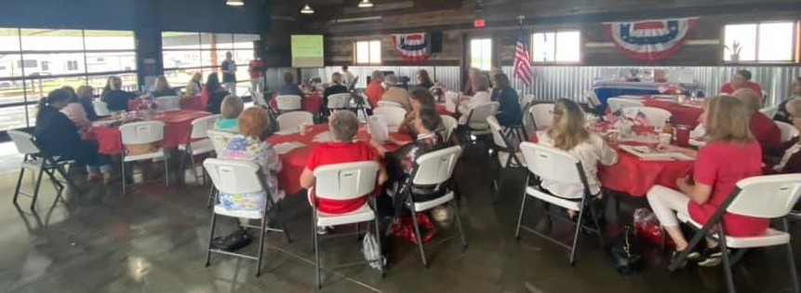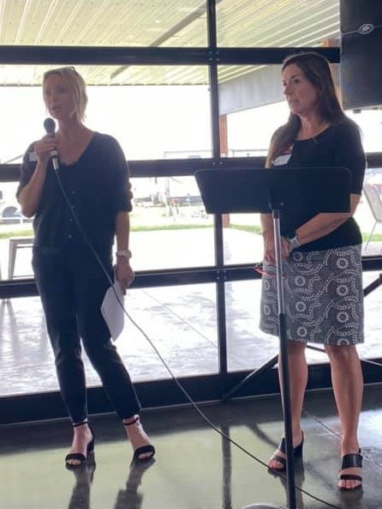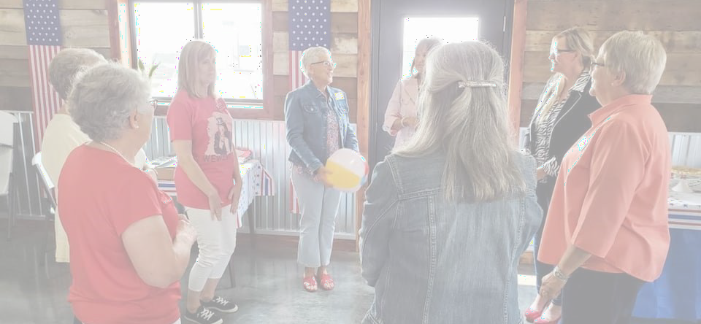

*South Dakota Federation of Republican Women*

*Newsletter Monthly Report Schedule*

January, April, July, & October: **Codington, Cenkota & Pennington**

February, May, August & November: **Brown, Minnehaha -Lincoln, & Meade**

March, June, September & December: **Cyberspace, Beadle, Fall River & Charles Mix**

Please find your Club and Write down the months that you are in the Newsletter.

**The reports are due the 1st of the month.**

Send the Reports to [sdfrwweb@gmail.com](mailto:sdfrwweb@gmail.com)

If you have anything that you deem important and would like to share with the state please send it in.

It can be photos, an article or report.

*More Photos From Fall Mtg.*

18

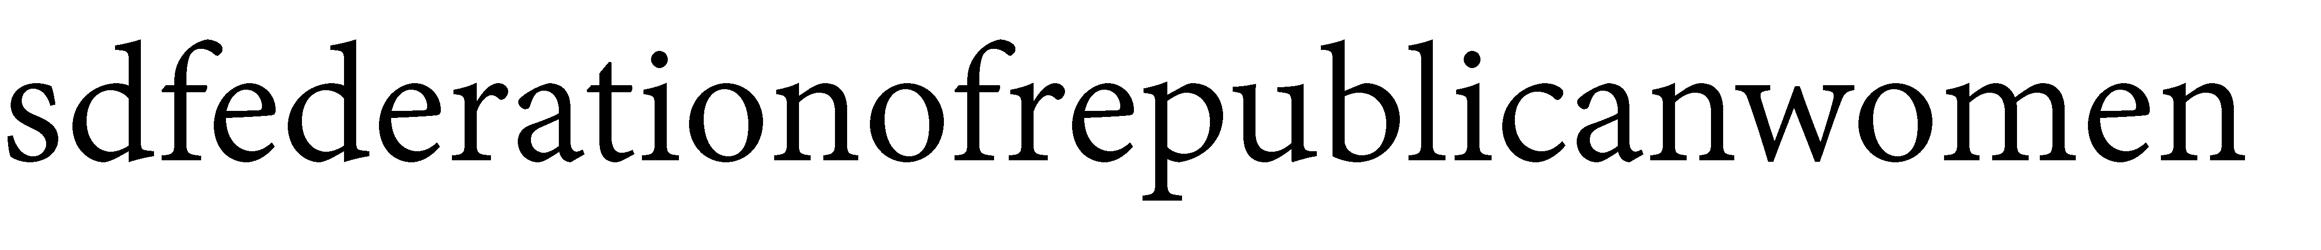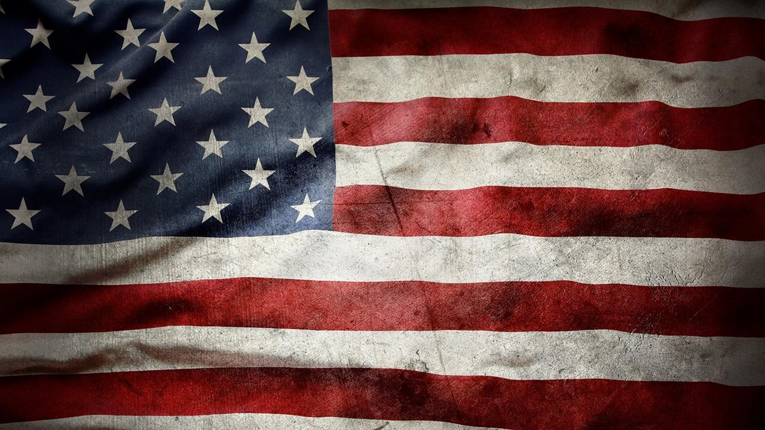

**See Us Now!**

*America Home of the Free & the Brave!*

19