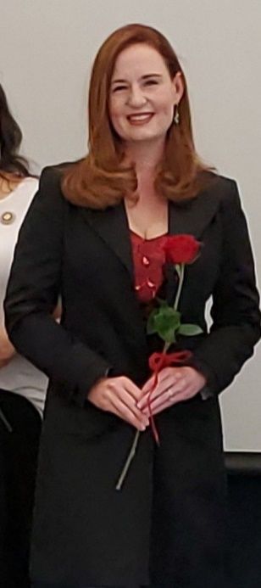

**February 2021**

*South Dakota Federation of Republican Women*

**SDFRW Moves Forward in 2021**

SDFRW has pushed forward in 2021 with

a new SDFRW President

& Executive Board.

New projects being formed to be announced soon.

Please look for new news to come to you

via the Website, Facebook, & Newsletter.

Congratulations to Catherine Barranco

She has been chosen to represent South Dakota Federation of Republican Wom-

en & South Dakota by serving as

Corpo-

rate Fundraising Vice Chair for the National

Federation of Republican Women.

**CONGRATULATIONS CATHERINE!**

1

**S P E C I A L P O I N T S O F I N T E R E S T :**

* Club Reports
* Membership Re- port
* Cyberspace Club
* Brown Co Area Club Report
* Cenkota Report
* Calendar of Events
* SDFRW Spotlight

**R E P O R T S**

**I N S I D E T H I S I S S U E :**

President’s Report 2

Membership Report 3

Cyberspace Report 4

Bown Co. Area Report 5

Cenkota Report & 6

SDFRW Spotlight

Calendar of Events 7

Newsletter Report 8



*South Dakota Federation of Republican Women*

*President’s Report*

adver-

this

2

Dear SDFRW members,

What an amazing honor and privilege it is to have been elected to serve as your new President for the 2021-2022 term! I am so proud to belong to an organization that has worked tirelessly to make a difference amidst the many obstacles that 2020 has inherently placed before us. Under the leadership of President Sandy Rhoden, SDFRW has accomplished so much, as she has truly put us ‘on the map’ as an organization that knows how to put ‘boots on the ground’!

I am excited to keep our ‘boots on the ground’ efforts moving across all focus areas and plan to not only continue our youth engagement efforts, but grow them exponentially, as our youth are the future of the Republican party and will be the ones left to protect and defend our freedoms.

**2 Timothy 4:7 states, “I have fought the good fight, I**

**have finished the race, I have kept the faith."**

Under my leadership, I will work towards ensuring that our

organization:

1. Continues to fight the good fight: (as we promote good republican candidates and stand up to liberal ideas and infiltration into our schools and public policies).
2. Finishes each race: (as we work hard and support one another to achieve and deliver real results with our identified goals).
3. Keeps the faith: (as we always remember that God guides

us and gives us our strength through all our endeavIonrsse.rt you

God bless every one of you! tisement in

Kind Regards, space!

Penny Sattgast- SDFRW President

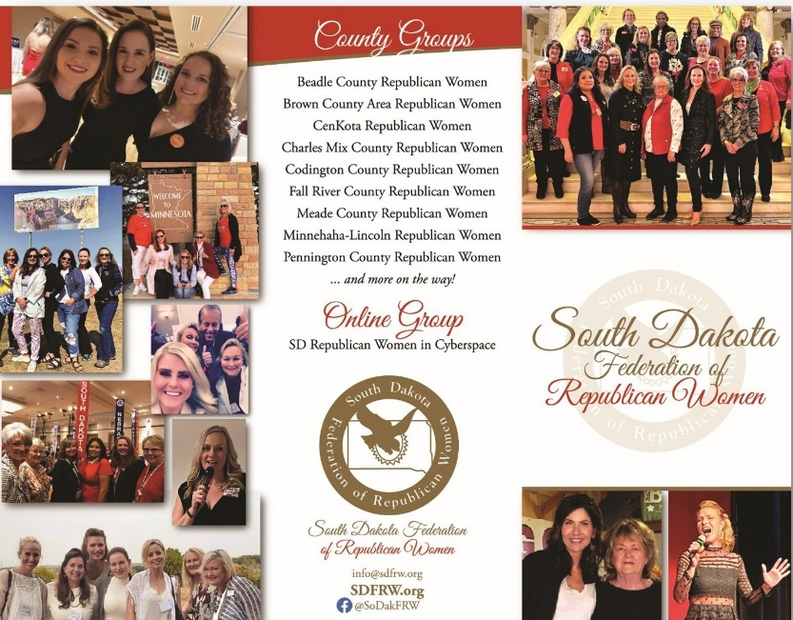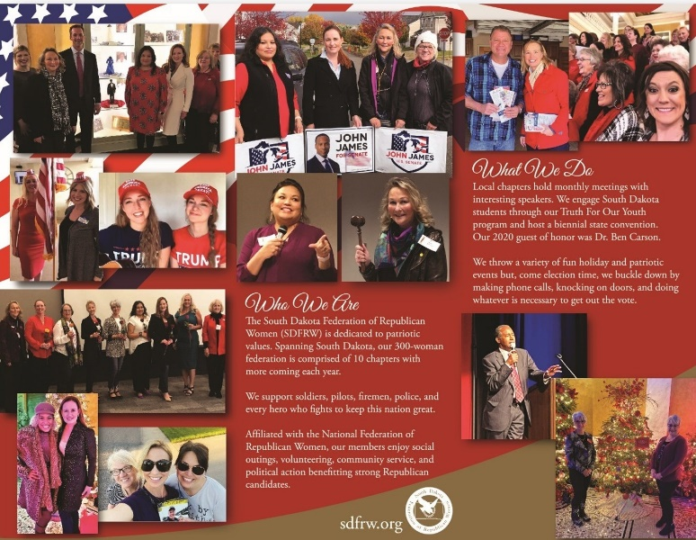

*South Dakota Federation of Republican Women*

*Membership Report*

*Membership Numbers paid for 2021 as of 2/14/21 are 113 with 10 Regents.*

Coming soon to a club near you: brand new SDFRW brochures! Because they show all the fun we have

and the incredible work we accomplish, these are very helpful for attracting members and recruiting

donors. We’ll give each club

meetings, and fairs.

a

stack of brochures;

you can bring them to Lincoln Days, parades,

Here are the unfolded mockups –actual

brochures fold into thirds. We’d like to thank Rocky Hayes for his amazing work sifting

through photos and conceiving this fantastic design!

IMPORTANT REMINDER: To remain a member in good standing, one’s dues must be **received** by

**NFRW** less than three weeks from now. **To give your club and state treasurers enough time to process your payment, please renew your membership ASAP!!** Active Membership in any of our 9 local clubs or our virtual club automatically grants membership in the state and national federations. If you’re active in one club and you’d like to join another club, you can! Just join the second club as an Associate Member! If you know someone who would be a good fit for SDFRW, please let us know! We’re more than happy to reach out and invite her to join!

3

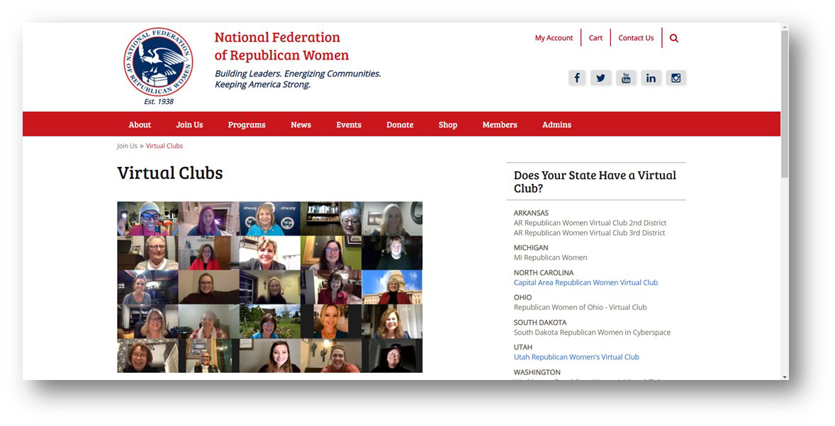

*South Dakota Federation of Republican Women*

**C y b e r s p a c e R e p u b l i c a n W o m e n**

Cyberspace is off to an exciting start in 2021!! Since our last newsletter report, we co-hosted Prayer

Zoom Calls with SDFRW, featuring special guest speakers Gov. Kristi Noem, Will Graham (Billy Gra- ham’s grandson), and Candy Carson (wife of Dr. Ben Carson). In our January Cyberspace meeting, we enjoyed a terrific Zoom call with NFRW President Ann Schockett. Then just last week we received word that SD Republican Women in Cyberspace has received a very special honor: If you select “Virtual Clubs” under the “Join Us” tab on the NFRW website, you’ll see we’re the face of NFRW Virtu- al Clubs!!

If you’re interested in tuning in to our Zoom calls in the future, wonderful!

Active Members of local

clubs are encouraged also to join Cyberspace as Associate Members and get the best of both worlds!

Just email [SDRWCyberspace@gmail.com](mailto:SDRWCyberspace@gmail.com) to get started. And if you know of someone else who might be interested in joining, please let us know! We’re more than happy to reach out! As with all clubs, membership in Cyberspace automatically includes memberships in the state and national federations.

4



*South Dakota Federation of Republican Women*

**B r o w n C o u n t y A r e a R e p u b l i c a n W o m e n**

November came around and all of us thought we’d be past the election and moving on to getting

ready for the holiday and that just did not happen. The election result/irregularities were still looming over us. It was so nice to have First Gentleman Bryon Noem speak for us and hear where both he and Governor Noem find their strength to continue on during hard times and that is from the Lord Jesus.

Bryon also shared the different ways he is proud of Governor Noem on how she is handling the issues

that arise and affect SD as a state.

In December, we had our club elections and Heidi Engelhart will serve one more term as club

president. Nancy Stewart will serve as 1st Vice President, Monica Meyer will serve as 2nd Vice

president, Korine Grismer will serve as 3rd Vice President and Rachel Pearson will serve as Secretary/ Treasurer. Senator Brock Greenfield and Representative Lana Greenfield were the speakers and they spoke on the upcoming legislative session for 2021.

January, we had fun and few gals got together and put on a Stop the Steal Rally that was held outside,

January 2, at Central Park in Aberdeen. There were about 125 people there and was a huge success.

It was hard to believe a week and a half later we were being blocked on Facebook for the violent

language of “Stop the Steal!” Our featured speaker at our January meeting was our State President Penny Sattgast. Penny spoke about the future of SDFRW, Covid-19 from her science background and working in politics and handling a huge disappointment like the last election. We are getting back to starting up our Caring for America project of supporting our local law enforcement since the onset of

COVID 19.

*Happy Valentine’s Day*

5

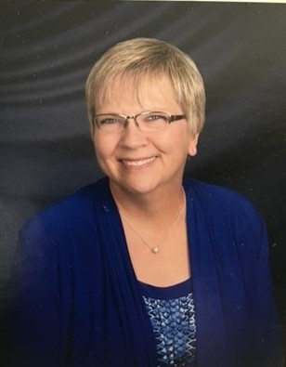

*South Dakota Federation of Republican Women*

**C e n - k o t a C o u n t y R e p u b l i c a n W o m e n**

**September 2020**

-Cen-Kota Members Penny Sattgast and Claire Rydberg were delegates at the SDFRW Convention.

-Cen-Kota Member Penny Sattgast was elected as the new SDFRW President for the 2021-2022 term.

-Cen-Kota members worked on the Love My Gov T-shirt Donation Fundraiser

-Cen-Kota members participated in the Trump Boat Parade in Pierre

**October 2020**

-Cen-Kota members participated on several phone banking and canvassing events to help Candidates in the 2020 General Election

**November 2020**

-Cen-Kota members helped participate in the SDFRW Christmas Tree at the Capitol

**December 2020**

**-**Cen-Kota members attended the SDFRW Quarterly Board of Directors Meeting in Pierre

-One of three 2020 SDFRW Women of the Year awards was presented to Cen-Kota member Penny

Sattgast

**February 2020**

-Cen-Kota members attended the SDFRW Quarterly Board of Directors Meeting and Legislative Day in Pierre

-Had their monthly meeting which included officer elections and a District 24 Legislative Update

-Cen-Kota initiated a state-wide Caring for America Project for victims from the Pierre apartment complex fire

SDFRW Spotlight

Nancy Ziegeldorf

Beadle county Republican Women Huron, SD

Please Check out the Website

for the Nancy’s full story.

[www.sdfrw.org](http://www.sdfrw.org/)

6



*South Dakota Federation of Republican Women*

7

Calendar of Events

*February:*

14th- Valentine’s Day 15th- President’s Day 17th- Ash Wednesday

18th- BCARW Meeting 11:30am The Flame, Aberdeen, SD

* PCRW Meeting 11:45am

Alex Johnson Hotel, Rapid City, SD

19th- CCRW Meeting 11:30am Pizza Ranch, Watertown, SD

25th- MLRW Meeting 11am

Luciano’s North, Sioux Falls, SD

*March: Women in History Month* 2nd- National Read Across America Month 5th- MCRW Meeting 12pm

Pizza Ranch, Sturgis, SD

8th- BCRW Meeting 12pm The Plains, Huron, SD

17th- St. Patrick’s Day

18th- BCARW Meeting 11:30am The Flame, Aberdeen, SD

* PCRW Meeting 11:45am

Alex Johnson Hotel, Rapid City, SD

19th- CCRW Meeting 11:30am Pizza Ranch, Watertown, SD

25th- MLRW Meeting 11am

Luciano’s North, Sioux falls, SD

*April:*

2nd- Good Friday 4th- Easter Sunday



*South Dakota Federation of Republican Women*

January, April, July & October : Codington, Cenkota,

Pennington

February, May, August & November : Brown, Minnehaha- Lincoln & Meade

March, June, September & December : Cyberspace, Beadle, Fall River & Charles Mix

Please find your Club and Write down the months that you are in the Newsletter.

The reports are due the 1st of that month.

Send Reports to [sdfrwweb@gmail.com](mailto:sdfrwweb@gmail.com)

If you have anything that you would like to share with the state please send in, Photos

and/ or report.

Next Quarterly Meeting:

TBA

8



9

**See Us Now!**

[www.sdfrw.org](http://www.sdfrw.org/)

@SoDakFRW

sdfederationofrepublicanwomen

**WANTED!**

**Donations to the SDFRW Online Auction!**

**Contact:** [**info@sdfrw.org**](mailto:info@sdfrw.org) **for information**