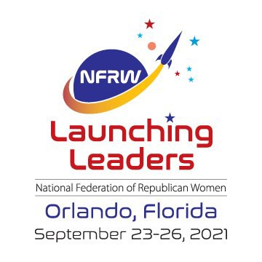

**July 2021**

*South Dakota Federation of Republican Women*

N F R W

4 1 s t

B i e n n i a l

C o n v e n t i o n

1

**R E P O R T S**

**I N S I D E T H I S I S S U E :**

NFRW Convention 2

Calendar/ Advertising 3

Club Reports 4-8

Beadle Co Update 9

This Month in History 9

**S P E C I A L P O I N T S O F I N T E R E S T :**

* Calendar of Events
* Convention Info
* This Month in

History

*South Dakota Federation of Republican Women*

41st Biennial Convention

The National Federation of Republican Women is #LaunchingLeaders this September at the 41st Biennial Convention in Orlando, Florida -- and all Federated Republican women's club members are invited!

Convention attendees will have the opportunity to:

•

•

Network with more than 1,000 like-minded Republican women from across America

Hear from top-level national speakers

•

Receive cutting-edge training to help counter the radical left

Help chart the future of the NFRW, which includes the election our next national officers

(Below is a Tentative Schedule listed on website)

T H U R S D A Y , S E P T E M B E R 2 3 , 2 0 2 1

10:00 am – 12:00 pm: Executive Committee Meeting *(closed)*

3:00 pm – 7:00 pm: Convention Registration / Information Desk Open

4:00 pm – 6:00 pm: State Federation Presidents Meeting *(state federation presidents only)*

Evening: Regents Reception

*For more information about the Regents Reception, contact Liz Matro at* [*lmatro@nfrw.org.*](mailto:lmatro@nfrw.org)

F R I D A Y , S E P T E M B E R 2 4 , 2 0 2 1

9:00 am – 6:00 pm: Convention Registration / Information Desk Open 10:00 am – 12:00 pm: Pre-Convention Board of Directors Meeting

1:00 pm – 5:00 pm: Campaign Management School *(separate ticket)*

Evening: Convention Welcome Reception

S A T U R D A Y , S E P T E M B E R 2 5 , 2 0 2 1

8:00 am – 5:00 pm: Convention Registration / Information Desk Open 8:30 am – 11:30 am: Convention General Session

12:30 pm – 2:30 pm: Luncheon

3:00 pm – 4:30 pm: Workshops / Training Seminars 5:00 pm – 6:30 pm: Achievement Awards Ceremony Dinner: Attendees on own

S U N D A Y , S E P T E M B E R 2 6 , 2 0 2 1

6:00 am – 12:00 pm: Convention Registration / Information Desk Open 6:30 am – 8:00 am: Voting for National Officers *(if necessary)*

7:30 am – 8:30 am: Prayer Breakfast *(separate ticket)*

9:30 am – 12:00 pm: Convention General Session 12:00 pm – 2:00 pm: Networking Luncheon

2:30 pm – 5:00 pm: Post-Convention Board of Directors Meeting *(to elect the three Members-at-Large to the NFRW Executive Committee)*

5:00 pm – 6:00 pm: Post-Convention Executive Committee Meeting *(closed)*

2

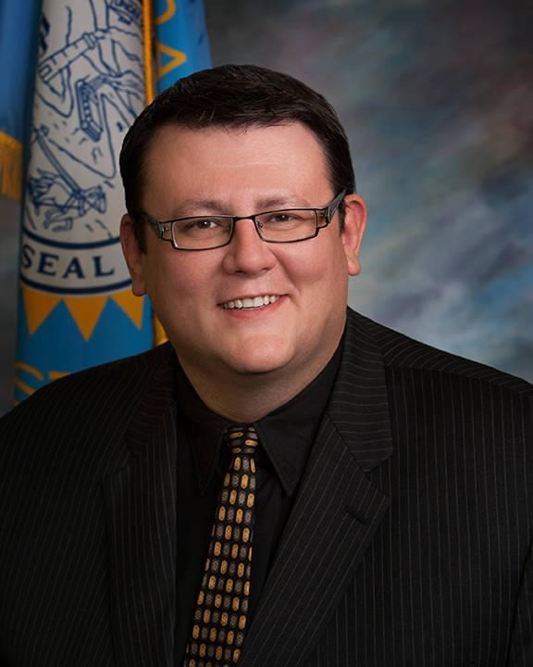

*South Dakota Federation of Republican Women*

Calendar of Events

July:

31st - Quarterly Board of Directors Meeting, Platte, SD Registration 9-10am, Meeting 10:15am - 3:30pm

Aug:

5th- Cyberspace Prayer Warrior Zoom Call 7:30pm CST

6th- Meade County Republican Republicans 2pm, Pizza Ranch, Sturgis, SD

9th- Beadle County Republican Women 12pm, Scoreboard, Huron, SD

12th- Cyberspace Morning Coffee Series Zoom

10am CST

19th- Brown County Area Republican Women 11:30am, The Flame, Aberdeen, SD

- Pennington County Republican Women 11:45am, Alex Johnson Hotel, Rapid City, SD

20th- Codington County Republican Women 11:30am, Pizza Ranch, Watertown, SD

23rd- Cyberspace Zoom Monthly Meeting

26th- Minnehaha-Lincoln Republican Women

11am Josiah’s Coffee & Café, Sioux Falls, Sd

Sept:

3rd- Meade County Republican Women 2pm, Pizza Ranch, Sturgis, SD

13th- Beadle County Republican Women

12pm, Scoreboard, Huron, SD

16th- Brown County Republican Women 11:30am, The Flame, Aberdeen, SD

-Pennington County Republican Women

11:45am, Alex Johnson Hotel, Rapid City, SD

3

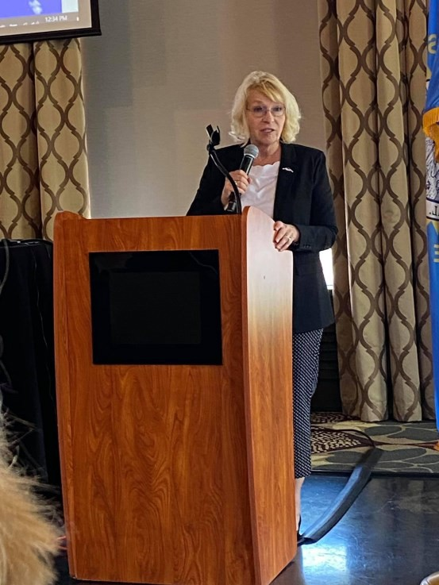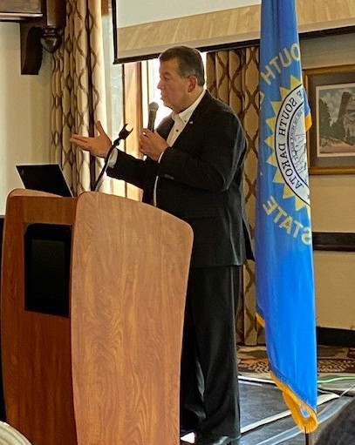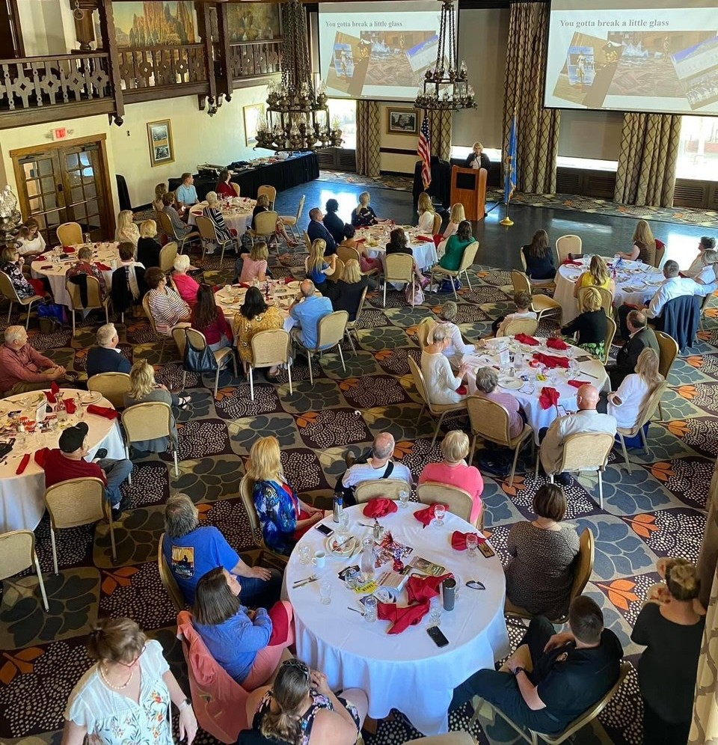

*South Dakota Federation of Republican Women*

**P e n n i n g t o n C o u n t y R e p u b l i c a n W o m e n**

Our monthly membership meetings have featured timely topics of local interest, generating strong attendance of 50-100 each month.

May – Retired Air Force Major General Kathryn J. Johnson talked about being a woman in a leadership position in the military and South Dakota Ellsworth Development Authority Executive Director Scott Landguth discussed the changing mission of

Ellsworth Air Force Base with the arrival of the B-21’s. Prior to the meeting, we hosted a Meet & Greet of Rapid City School Board candidates, with 7 of 10 candidates providing a brief introduction of themselves and their priorities.

June – The PROs (represented by former City Attorney Jason Green) and CONs (represented by former RC Councilman Jordan Mason) of a Home Rule and City

Manager plan currently being considered by the Rapid City Common Council were discussed in front of a robust crowd.

July – Qusi Al-Haj, Deputy State Director & Air Force Advisor for United States Senator John Thune, provided an in-depth look at immigration and the impact on the

U.S. economy, national security, population demographics and politics in his presentation entitled “Immigration – The Opportunities and Challenges”.

Our upcoming August and September meetings will feature discussions both for and against Medicaid expansion, which will be on the ballot for South Dakota voters to consider in 2022.

Qusi Al-Haj

Ret. AF Major General

Kathryn J. Johnson

School Board

Meet & Greet

4

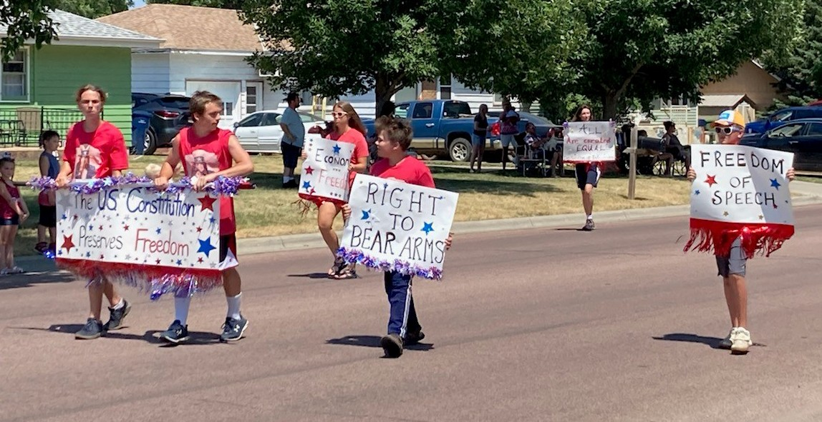

*South Dakota Federation of Republican Women*

**C o d i n g t o n**

**C o u n t y**

**R e p u b l i c a n**

**W o m e n**

May

The Codington County Republican Women’s Club met in May and we introduced two guests: Heidi Engelhart and Nancy Stewart from the Brown County Club who talked

about how exciting it is to get involved with making a difference in your community through SDFRW. Our speaker was one of our mayoral candidates, Reid Holien, who served as a State Senator, National Committeeman, and City Council member. He discussed his plans to bring people together and be a problem solver for the town of Watertown. He was elected our new Watertown Mayor on June 15th and we are

extremely happy and thankful for all the hard work from our great volunteers! We also handed out flags to our Veterans and their friends and family members at the Memorial Day service at the Mount Hope Cemetery.

June

Our June meeting involved a discussion from Daro Crandall, on a “Civics Bowl”

which will be held in the near future to get kids and adults involved in learning more

about our country. We also discussed our plans for the 4th of July Parade and voted on the theme for the parade: Freedom and the Constitution. We also chose the theme for our t- shirts, “Stand for Freedom.” Many posters were decorated during the meeting. They con- tained important themes for our country that we hold dear to our hearts such as: All Are

Created Equal, One Nation Under God, and Welcome Legal Immigration.

July

Our July 4th Parade was an exceptional event especially since Governor Noem was able to attend and walk with us through the streets of Watertown. Many hard-working volunteers helped make the day perfect as they decorated vehicles and handed out flags,

candy and constitutions. It was an amazing day! A special thank you to all who worked so hard and to the Governor for taking the time to visit with us and take pictures and provide t-shirts for participants. We look forward to hearing from our SDFRW President, Penny Sattgast, at our July 16th meeting.

5

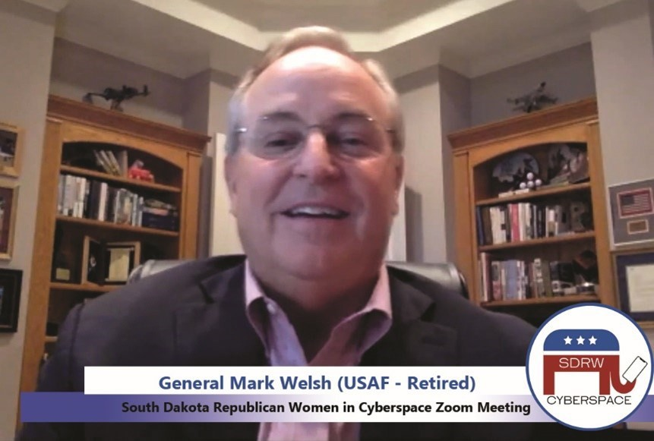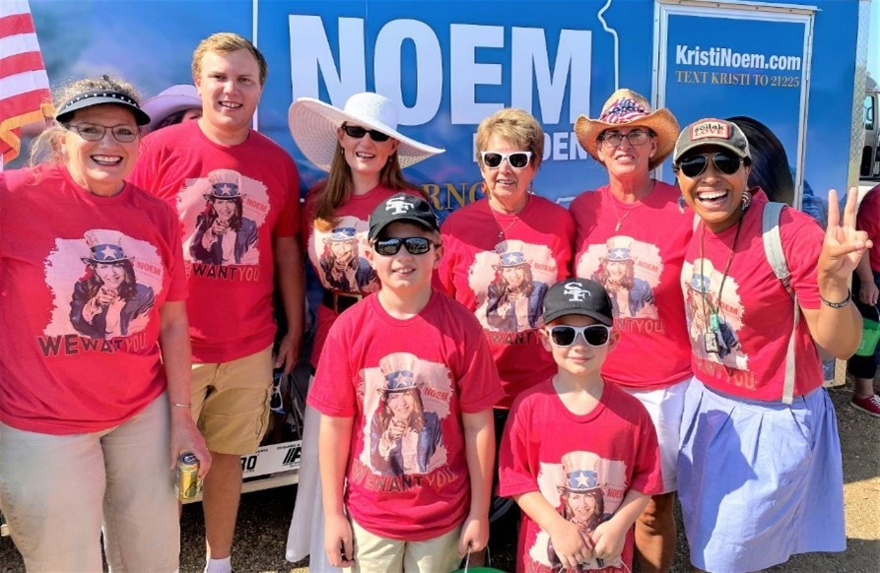

*South Dakota Federation of Republican Women*

*Cyberspace Republican Women*

Wow! What a month!!

We had an incredible Zoom Call with **General Mark Welsh**, a 4-star General who served on the Joint Chiefs until his retirement. We laughed… we cried… wow, what a talk! If you missed it, not to worry – you can watch the video on our Cyberspace YouTube Channel! Here’s the

direct link:

<https://youtu.be/rFuhIw0Rw7E>

We joined together for our Prayer Warrior Zoom

Call and we held an eye-opening Morning Coffee

about the Border Crisis from Paul Perez, President of the National Border Patrol Council.

Members attended the Welcome Home Ceremony

for the 196th and walked in Independence Day Parades for Governor Kristi Noem!

6

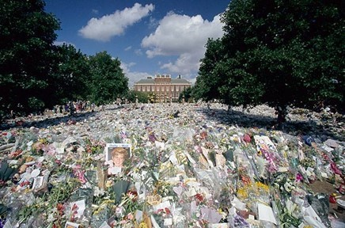

*South Dakota Federation of Republican Women*

*Cyberspace Republican Women cont.*

**\* A Change of Plans \***

Our Coffee speakers have shifted around just a bit.

The morning of Thursday, August 12th, we’ll virtually

travel to London to hear from Dennis McGuinness -- a

delightful

gentleman

full

of

fascinating

stories!

Dennis was originally with Scotland Yard before going

into the Queen’s employ. There he was in charge of

simultaneously running several of

estates, including Hampton Court

Her

(the

Majesty’s

palace of

Henry VIII), (the palace

Kensington

Palace

in which Princess

Diana

and

Princess

Margaret

lived until their deaths), Kew

Palace,

Queen

Charlotte’s

Cottage, and Whitehall.

Dennis and his delightful wife

resided in a lovely Hampton Court apartment that was at

one time the private residence of Queen Catherine Howard, Henry VIII’s fourth

wife.

As director of Kensington Palace, one of Dennis’ many duties was to

oversee the handling of the mountains of memorials that the mourning public

left after Diana’s tragic death. The anniversary of Diana’s passing is Aug 31, so it seems especially fitting for Dennis to Zoom with us just before that milestone.

7

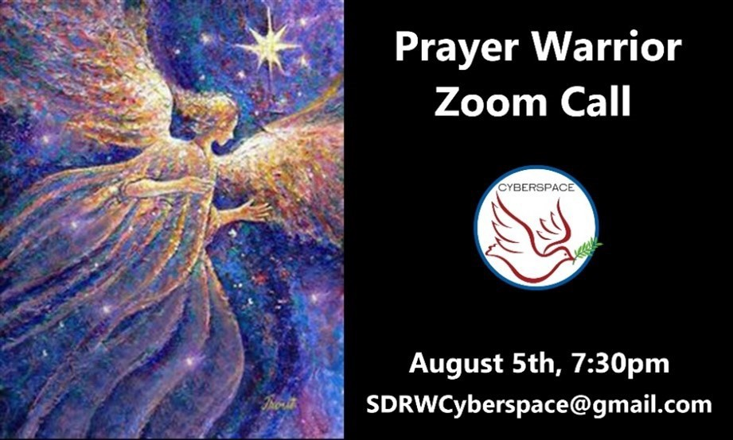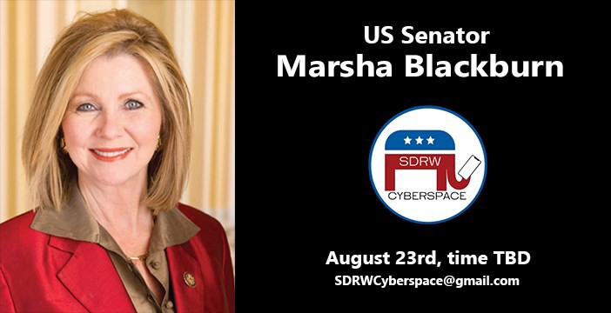

*South Dakota Federation of Republican Women*

*Cyberspace Republican Women Cont.*

**\*\* UPCOMING EVENTS \*\***

If you haven’t liked and followed our Facebook page, you should! It’s a great source

information, including registration links for these and more upcoming events!

of

•

**Invite friends and family across the nation to RSVP for our upcoming Zoom Calls! \***

8

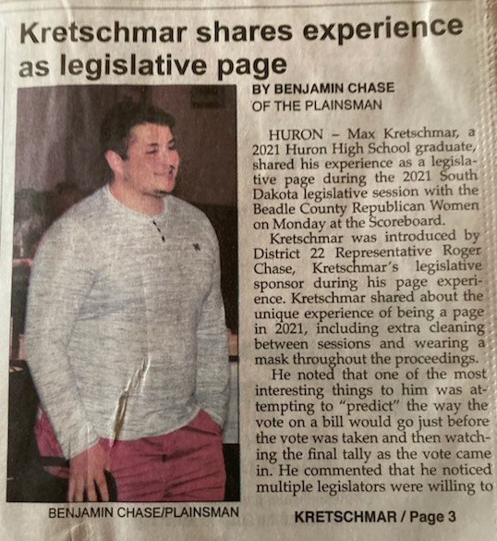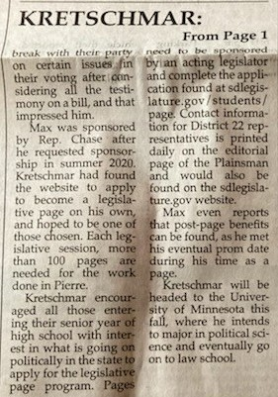

*South Dakota Federation of Republican Women*

Beadle County Update

***This Month in History***

**1945:** The [United States](https://www.britannica.com/place/United-States) tested the first [atomic bomb](https://www.britannica.com/technology/atomic-bomb) this day in 1945 near [Alamogordo,](https://www.britannica.com/place/Alamogordo) New Mexico, and the following month dropped atomic bombs on [Hiroshima](https://www.britannica.com/place/Hiroshima-Japan) and [Nagasaki](https://www.britannica.com/place/Nagasaki-Japan) in Japan, hastening the end of [World War II.](https://www.britannica.com/event/World-War-II)

**1933:** American aviator [Wiley Post](https://encyclopaediabritannica.apms5.com/anywhere/m?s=encyclopaediabritannica&m=tr_4960730f-804d-4d5a-ba86-736329a4d6f9&u=e1jq4wvfdtfk6dtg60tm8hhq5mv3ee1p5mu38hht5mwked245mrmcgu66cu3jh216rwka&r2=d1u78w3k78qjyxvqewq64wk9ehgpwvk9cdgjwrvfdmqp4ubfcxt62w38f4qneub) completed the first solo flight around the world; he covered 15,596 miles (25,099 km) in 7 days, 18 hours, 49 minutes.

**1923:** American [baseball](https://encyclopaediabritannica.apms5.com/anywhere/m?s=encyclopaediabritannica&m=tr_4960730f-804d-4d5a-ba86-736329a4d6f9&u=e1jq4wvfdtfk6dtg60tm8hhq5mv3ee1p5mu38hht5mwked245mrmcgu66cu3jh216rwka&r2=d1u78w3k78qjyxvqewq64wk9ehgpwvk9cdgjwrvfdmqq6w3fe9u76bv2c5tpark) player [Walter Johnson](https://encyclopaediabritannica.apms5.com/anywhere/m?s=encyclopaediabritannica&m=tr_4960730f-804d-4d5a-ba86-736329a4d6f9&u=e1jq4wvfdtfk6dtg60tm8hhq5mv3ee1p5mu38hht5mwked245mrmcgu66cu3jh216rwka&r2=d1u78w3k78qjyxvqewq64wk9ehgpwvk9cdgjwrvfdmqp4ubfcxt62w38f4qnerb) became the first pitcher in the [MLB](https://encyclopaediabritannica.apms5.com/anywhere/m?s=encyclopaediabritannica&m=tr_4960730f-804d-4d5a-ba86-736329a4d6f9&u=e1jq4wvfdtfk6dtg60tm8hhq5mv3ee1p5mu38hht5mwked245mrmcgu66cu3jh216rwka&r2=d1u78w3k78qjyxvqewq64wk9ehgpwvk9cdgjwrvfdmqq8vvgd5hjykb1d9qq4ba) to strike out 3,000 batters; his career record of 3,508 strikeouts stood until 1983.

**1899:** Born July 21 Ernest Hemingway, American Writer

**1848:** On the 19th in 1848, the [women's suffrage](https://www.britannica.com/topic/woman-suffrage) movement in the [United States](https://www.britannica.com/place/United-States) was launched with the opening of the [Seneca Falls Convention,](https://www.britannica.com/event/Seneca-Falls-Convention) which sought to gain certain rights and privileges for women, notably the right to vote.

**1784**: Born July 22 Friedrich Wilhelm Bessel German Astronomer. German astronomer whose measurements of positions for about 50,000 [stars](https://www.britannica.com/science/star-astronomy) and rigorous methods of observation (and

correction of observations) took [astronomy](https://www.britannica.com/science/astronomy) to a new level of precision. He was the first to measure

accurately the [parallax,](https://www.britannica.com/science/parallax) and hence the distance, of a [star](https://www.britannica.com/science/star-astronomy) other than the [Sun.](https://www.britannica.com/place/Sun)

9



*South Dakota Federation of Republican Women*

*Newsletter Monthly Report Schedule*

January, April, July, & October: **Codington, Cenkota & Pennington**

February, May, August & November: **Brown, Minnehaha -Lincoln, & Meade**

March, June, September & December: **Cyberspace, Beadle, Fall River & Charles Mix**

Please find your Club and Write down the months that you are in the Newsletter.

**The reports are due the 1st of the month.**

Send the Reports to [sdfrwweb@gmail.com](mailto:sdfrwweb@gmail.com)

If you have anything that you deem important and would like to share with the state please send it in.

It can be photos, an article or report.

10

Summer BOD Meeting:

*July 31st, 2021*

*God’s Country Campground &*

*Event Center Platte, South Dakota*

*Hosted by Charles Mix Republican Women*

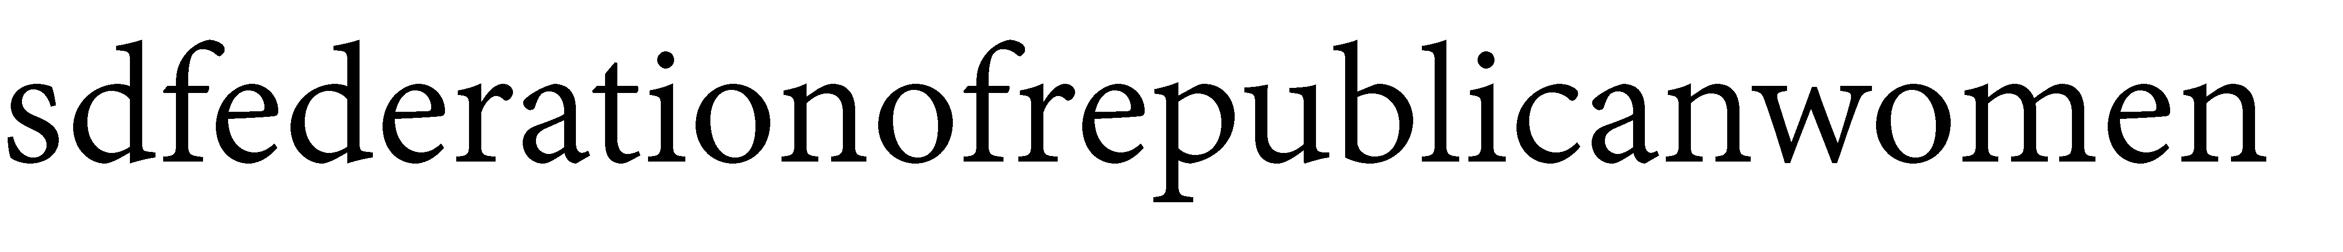

**See Us Now!**

*America Home of the Free & the Brave!*

11