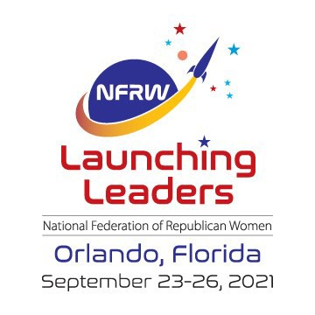

**June 2021**

*South Dakota Federation of Republican Women*

N F R W

4 1 s t

B i e n n i a l

C o n v e n t i o n

1

**R E P O R T S**

**I N S I D E T H I S I S S U E :**

Cyberspace 2-5

Campaign Activities 6-7

Membership 8

Competition

Membership Spotlight 10

Quarterly Meeting 11

**S P E C I A L P O I N T S O F I N T E R E S T :**

* Calendar of Events
* Membership Ideas
* Member Spotlight

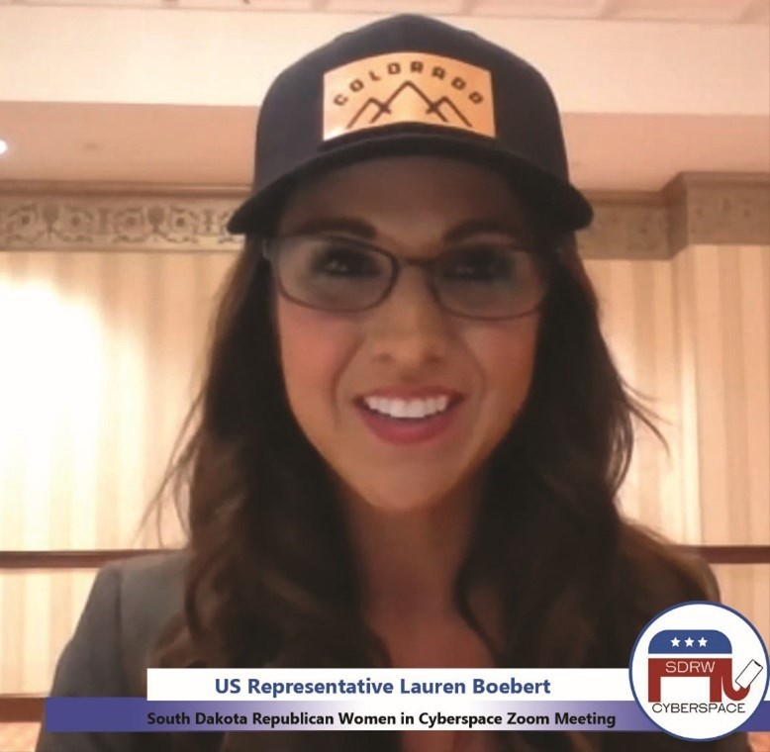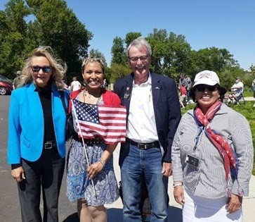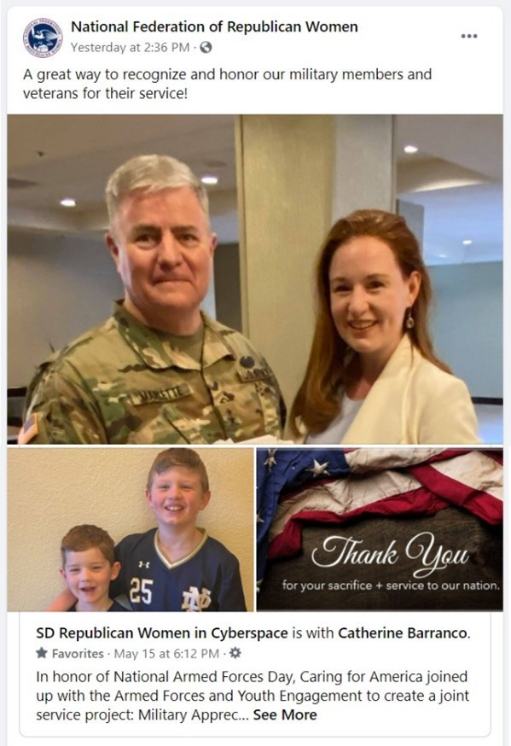

*South Dakota Federation of Republican Women*

**C y b e r s p a c e R e p u b l i c a n W o m e n**

Cyberspace had another fantastic month!

We had an incredible Zoom Call with a Republican star on

the rise, **US Representative Lauren Boebert** (Colorado).

We held an eye-opening Morning Coffee Zoom Call about

protecting religious freedom in the most hostile environs,

featuring Presidential appointee Max Primorac.

We hosted the first ever Cyberspace Candidate Forum

Zoom Call, helping Republican School Board Candidates from Rapid City to Vermillion find new

Avenues of support.

Cyberspace members continue to be dedicated to community

service.

We were proud to have members attend the Veteran Cemetery Ribbon-

Cutting Ceremony over Memorial Day, and we gained national attention for our Caring for America-Armed Forces-Youth Engagement joint project: Military Appreciation Coloring Cards for Kids!

2



*South Dakota Federation of Republican Women*

3

Calendar of Events

June:

24th- Minnehaha-Lincoln Republican Women 11am-12pm Josiah’s Coffeehouse & Café Sioux Falls SD

29th- Cyberspace Zoom Meeting 7pm CST - 7pm CST

July:

2nd- Meade County Republican Women 2-3pm Pizza Ranch ,Sturgis, SD

4th- Independence Day

8th Cyberspace Prayer Warrior Zoom Call 7:30pm CST

12th- Beadle County Republican Women

12-1pm Scoreboard Bar & Grill Huron, SD

13th- Cyberspace Morning Coffee Series Zoom 10am CST

Brown Co. Area Republican Women 11:30- 1pm The Flame, Aberdeen, SD

Pennington Republican Women

1:45-3:30pm Hotel Alex Johnson, Rapid City, SD

16th- Codington County Republican Women 11:30-1pm Pizza Ranch, Watertown, Sd

22nd- Minnehaha-Lincoln Co Republican Women 11-12pm Josiah’s Coffeehouse & Café, Sioux Falls, SD

29th- Cyberspace Zoom Meeting 7pm CST

Aug:

6th- Meade County Republican Republicans 8th - Cyberspace Prayer Warrior Zoom Call

7:30pm CST

13th - Cyberspace Morning Coffee Series

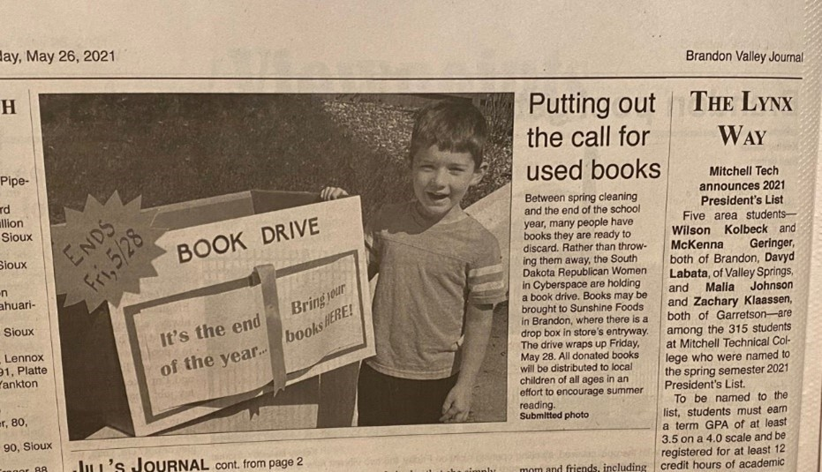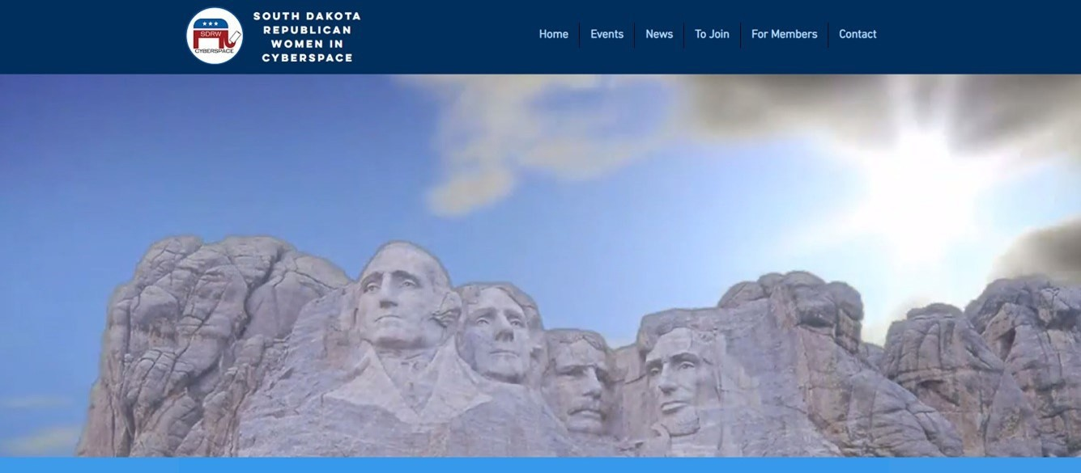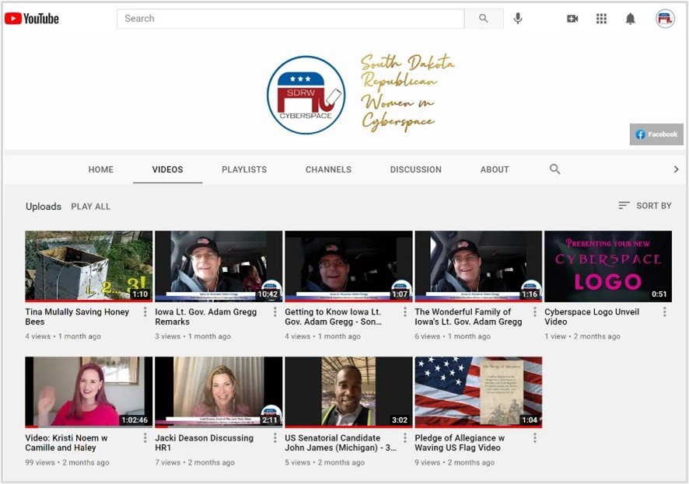

*South Dakota Federation of Republican Women*

**C y b e r s p a c e R e p u b l i c a n W o m e n C o n t i n u e d**

We completed our first Book Drive, which resulted in over a hundred book donations and a shoutout in the local

newspaper!

To help our members continue stay connected, we launched

([https://sdrwcyberspace.wixsite.com/home)](https://sdrwcyberspace.wixsite.com/home) …

the Cyberspace

website

… as well as the Cyberspace YouTube Channel, featuring select videos and clips.

[www.youtube.com/channel/UCc1MoW4-2Bu0Zqo128NxaQg/videos)](https://www.youtube.com/channel/UCc1MoW4-2Bu0Zqo128NxaQg/videos)

([https://](https://www.youtube.com/channel/UCc1MoW4-2Bu0Zqo128NxaQg/videos)

Welsh previously served as Commander of U.S. Air Forces in Europe, as the Central Intelligence Agen-

cy Associate Director for Military Affairs, and as Commandant of the Air Force Academy. Currently, Mark is Dean of the Bush School of Government and Public Service at Texas A&M University.

4

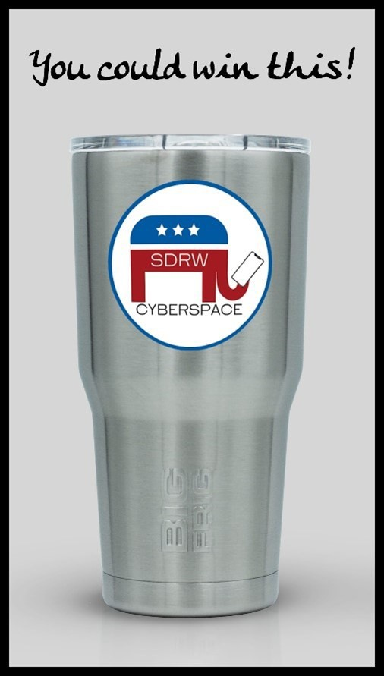

*South Dakota Federation of Republican Women*

**C y b e r s p a c e R e p u b l i c a n W o m e n C o n t i n u e d**

**\*\* UPCOMING EVENTS \*\***

Just before Independence Day, on Tuesday, June 29th at 7pm CST / 6pm MST, we have the honor of visiting with **General Mark Welsh – a 4-star General who represented the Air Force for four years on the Joint Chiefs of Staff** where he offered advice to the President, the Secretary of Defense, and the

National Security Council.

Welsh previously served as Commander of U.S. Air Forces in Europe, as the Central Intelligence

Agency Associate Director for Military Affairs, and as Commandant of the Air Force Academy.

Mark is Dean of the Bush School of Government and Public Service at Texas A&M University.

Currently,

**How to Register**

Register for these and other events using the Zoom link listed in each description

on the “Events” tab of our Facebook page or website. Remember: anyone and everyone can register for our Cyberspace Zoom calls and enjoy our fabulous speakers! But…. only Active and Associate members on the call are eligible to win the free giveaways, including [Sheel’s](https://www.scheels.com/) gift cards, [BigFrig](https://bigfrig.com/) coffee tumblers, and

[ShePraise](https://shepraise.com/) prayer card games, among other things.

**Associate memberships cost just $10!!**

If you’d like to join, use the SDFRW Membership Form:

<https://www.cognitoforms.com/SDFRW/SDFRWMembershipForm> or email us at

[SDRWCyberspace@gmail.com](mailto:SDRWCyberspace@gmail.com)

5

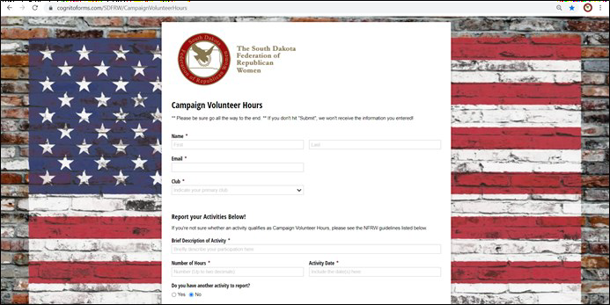

*South Dakota Federation of Republican Women*

*Campaign Activities Report*

In the past, only a handful of SDFRW members have submitted their campaign hours. For some, it’s too daunting to go back and tally all the hours they’ve spent volunteering. For some, it’s too time consuming to go through the process of sub-

mitting their hours. Some think it’s more noble to volunteer anonymously. Some simply aren’t sure how to submit them.

For a variety of reasons, though, it’s important everyone start reporting them. The NFRW calendar for campaign hours

starts on July 1st of odd-numbered years. In a little less than a month, we get a fresh start!! To take advantage of the op- portunity, we are rolling out a new system for recording Campaign Hours!

Our system is a two-pronged approach:

1) For those who prefer to submit their hours online: Maybe you don't attend meetings as often as you’d like? Maybe you’re worried you’ll forget their hours by the next meeting, or you would prefer to not have to think about hours during the meeting? Maybe you prefer typing to handwriting? For you, **we created a very streamlined online form.** Simply enter your name and email; then select your club. Now you’re ready to start reporting your

hours! Put the number of hours and a very brief description. It can even be just a couple of words: e.g. "Georgia Phonebanking", "Parade Walking - Harrisburg", etc. Then type the date or range of dates. It can even be

something as generic as “May 2021" or "3/10-3/12/2021". We trust you! However you want to do it is fine. :-

) Here’s the link -- we recommend you bookmark it for easy access in the future. Additionally, you can reach it through the SDFRW website.

[**https://www.cognitoforms.com/SDFRW/CampaignVolunteerHours**](https://www.cognitoforms.com/SDFRW/CampaignVolunteerHours)

**We strongly recommend that you enter your hours either on an as-you-complete-them basis or on a regularly**

**schedule, ideally weekly or bi-weekly.** Presidents, we recommend that you include reminders to submit campaign hours in your emails – we all know how busy our members are!

6

*South Dakota Federation of Republican Women*

*Campaign Activities Report*

**\***2) For those who like a paper form, just let me know – I’m happy to send you a Word Document that you can

print! It breaks out different categories of hours – simply find your category and fill in your hours! We recommend Presidents pass the form around during every meeting so people can fill in their hours **at LEAST** monthly, though more often is preferred. **If you like a paper form but can’t attend meetings regularly or you don’t want to wait**

**that long, print your own to keep at home!** Then you can turn it in to your club President when you’re ready!

The hours submitted online will continue to accumulate. Then, two years from now as we finish our Awards forms for the

2023 NFRW Convention, we will send each club President a list of all the hours submitted online for her club. (Of course, if you need a report sooner than that, let us know!) Clubs that use a paper form or some other reporting method as well will need to add those hours to the hours submitted online. Once you have your total number of hours, you’ll put that total on the NFRW awards form before submitting it to our SDFRW President.

**\* Men ARE allowed to submit their hours to their primary club! Those hours DO count!! \*\***

It’s important to note and Presidents to emphasize: We don’t want to double count hours. **Members should ONLY submit**

**their hours to ONE club via ONE method.** If they submit their hours online, they should NOT submit them to the clubs on a paper form, and vice versa.

If you have any questions, please don't hesitate to let me know!

***Lois Van Dusseldorp*** SDFRW Campaign Activities Chair [ivan@midstatesd.net](mailto:ivan@midstatesd.net)

7



*South Dakota Federation of Republican Women*

The SDFRW Membership Competition has officially begun! Your Club Presidents received an email with the rules, but if you have any questions, please don’t hesitate to let us know! Clubs will compete in 3 categories:

1. The largest increase in the number of Active Members
2. The largest % increase in the number of Active Members The largest number of Associate Members

In order for a member to count towards this competition, the SDFRW Treasurer Connie Wagner must receive the member’s name and contact information and (for Active Members) the state/national portion of the member’s dues prior to the end of the competition. **The competition officially ends at 5pm CST/4pm MST on June 25, 2021.** However, we strongly encourage your Treasurer to submit your members the week prior. Not only does that build in a cushion should the mail be delayed, but it gives Connie time to process the members prior to the NFRW convention delegate calculation deadline.

To help in your efforts….

Below is the link to our SDFRW membership form. It's an adaptive fillable form, which collects the new member's information and leads them through how to pay their dues, dramatically simplifying the process to join. **You do not have to use this form, but you’re more than welcome to!** It’s designed to lighten the burden on the club Presidents and Treasurers as well as on the new members. Please note: This is our form and our form only. Nobody has access to this information but us. As always, we do NOT share members’ contact information with groups outside the Federation.

<https://www.cognitoforms.com/SDFRW/SDFRWMembershipForm>

**Ambassador Program**

Once you’ve done the work of identifying potential new members, we want to be sure they follow through with actually joining. That’s where the New Member Ambassador Program comes in! Each club has been asked to send us the name/contact info for **at least** one Ambassador. If you have any questions about the program or would like to volunteer to serve as a New Member Ambassador, please let us know!

8

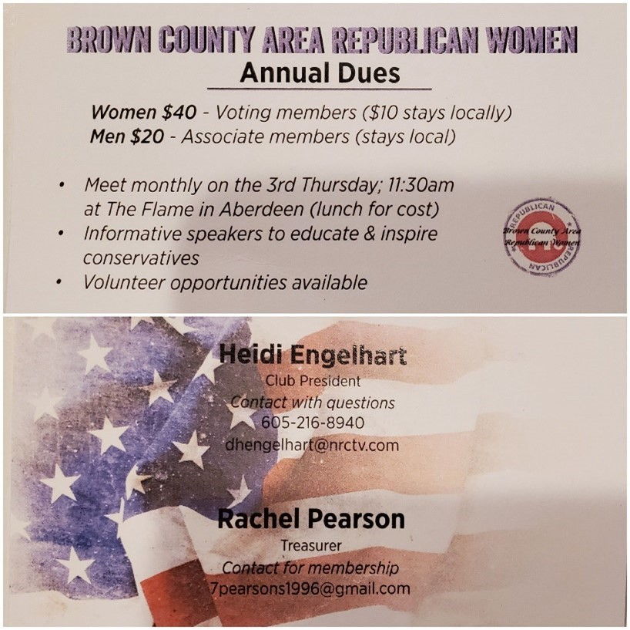

*South Dakota Federation of Republican Women*

**\*\* Ideas for How to Drive Membership \*\***

This month, the Membership Committee hosted an SDFRW Zoom Call Membership Workshop with representatives from clubs across the state. Here are some of the tips and suggestions!

**From SDFRW President Penny Sattgast:**

The Legislator Letter is a wonderful way to invite legislators and their spouses to join! Contact us at [info@SDFRW.org](mailto:info@SDFRW.org) and we’ll email you a Word Document that you can modify and customize as de- sired. This letter can also be tweaked and sent to other Republican leaders and supporters. Remember,

men

are

welcome

to

join

as

Associate

Members!

Our SDFRW brochure and palm card can help you convey what an active, productive organization we are – and how much fun we have doing it! If you’d like digital or paper copies of the brochure and palm card, just let us know!

**From Charles Mix County:**

Trudy Qualm called people in her contact list and simply asked if they’d be interested in joining. Just with that approach, she recruited an incredible number of members, winning 3rd place **nationally** last year! Her remarks were echoed by others – the personal touch of individual phone calls as well as texts, emails, and Facebook messages has a much stronger impact than email blasts and Facebook posts. We strongly suggest everyone reach out to people in your contact lists – there’s nothing more powerful than hearing from someone who already knows you.

NFRW suggests reaching out to previous members who haven’t rejoined. If you’d like to do that, let us

know! We would be happy to help create a list for you!!

**From Codington County:**

Have a Club officer or advocate take a clipboard and go around Lincoln Day Dinners and other Republican events, getting people to sign up to receive information about their meetings. If you have the opportunity to speak – especially at Lincoln Day Dinners and Central Committee Meetings – in- clude a shoutout to SDFRW!

**From Pennington County / Cyberspace:**

Consider

running

a

promotion

to

help

drive membership! Pennington had super cute glasses made

and announced that the first 50 to sign up would get a glass. Cyberspace has giveaways on every call – anyone can participate in the call, but only Active & Associate members are eligible to win.

**From Brown County:**

“Here are the business card (front/ back) and postcard that we designed for our club use. We used a local printer to help us design and print what we wanted. The idea came from an associate member, an older gentleman in our club. He's been handing them out and inviting his coffee buddies. Maryann Bierman and I **….Continued next page**

9



*South Dakota Federation of Republican Women*

handed some out at the Brown County Republicans' Reagan Lunch last week. I keep them in my wallet. They are a small thing to carry and hand out when occasions arise.”

- Rachel Pearson,

BCARW Secretary/Treasurer

Thank you, Rachel, for bringing these to life! Love it!!

**Another idea that many clubs have used:**

For a limited time (such as during the Membership Competition!), waive or discount the club’s portion of the dues to incentivize people to join. Consider subsidizing the dues for College Republicans and/or Recent Graduates.

**From NFRW:**

Consider having a Membership Drive event: in order to attend, you have to bring a new member with you!

**\*\* If you have more ideas or suggestions for how to drive membership, please let us know!! We’d love to share them with the rest of the clubs! \*\***

*SDFRW Spotlight Member*

Claire Ryberg

Cenkota Republican Women

To see more of her story….

Go to [www.sdfrw.org](http://www.sdfrw.org/)

10



*South Dakota Federation of Republican Women*

*Newsletter Monthly Report Schedule*

January, April, July, & October: **Codington, Cenkota & Pennington**

February, May, August & November: **Brown, Minnehaha -Lincoln, & Meade**

March, June, September & December: **Cyberspace, Beadle, Fall River & Charles Mix**

Please find your Club and Write down the months that you are in the Newsletter.

**The reports are due the 1st of the month.**

Send the Reports to [sdfrwweb@gmail.com](mailto:sdfrwweb@gmail.com)

If you have anything that you deem important and would like to share with the state please send it in.

It can be photos, an article or report.

11

Summer BOD Meeting:

*July 31st, 2021*

*God’s Country Campground &*

*Event Center Platte, South Dakota*

*Hosted by Charles Mix Republican Women*

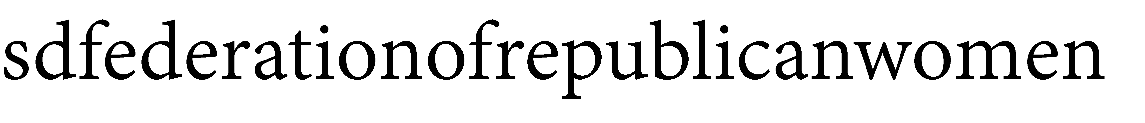

**See Us Now!**

12