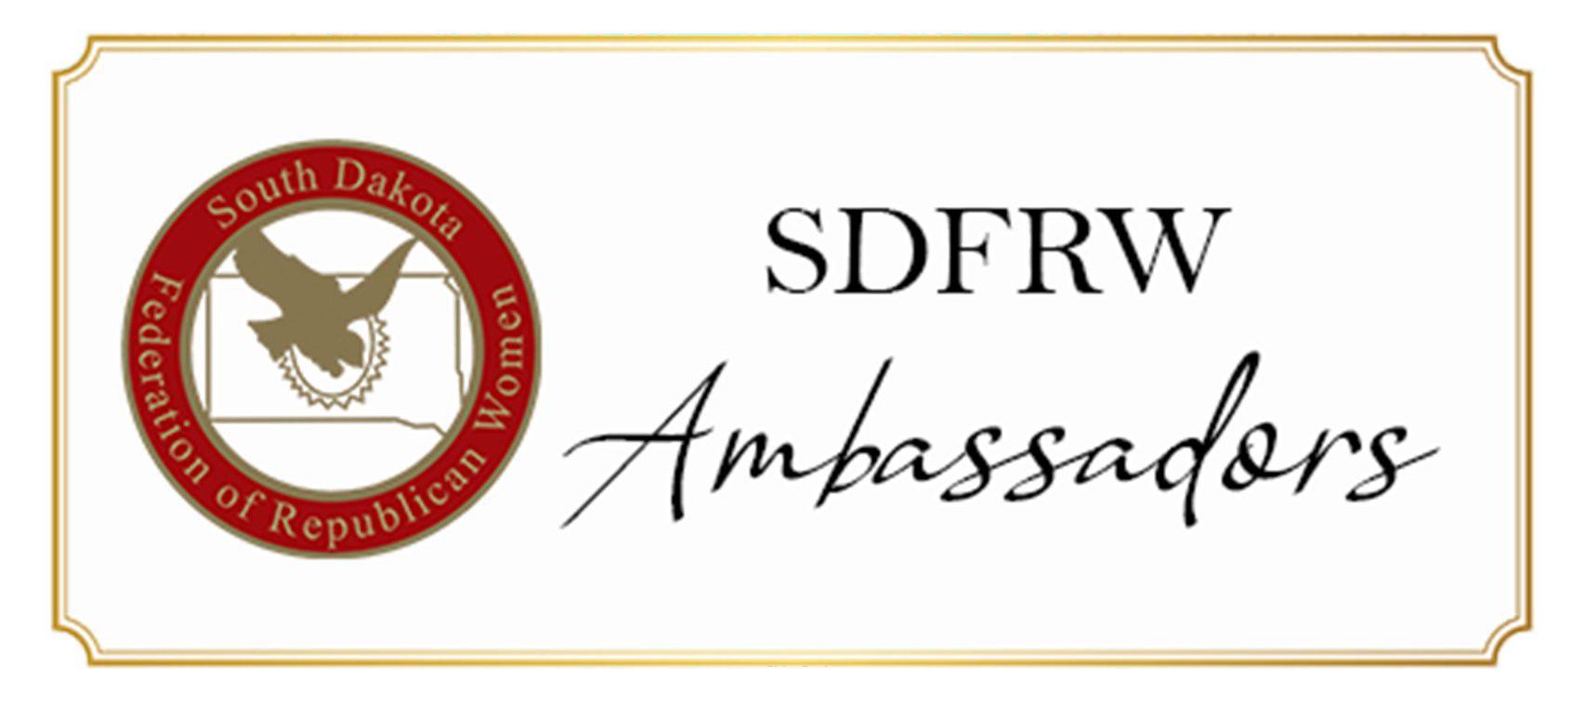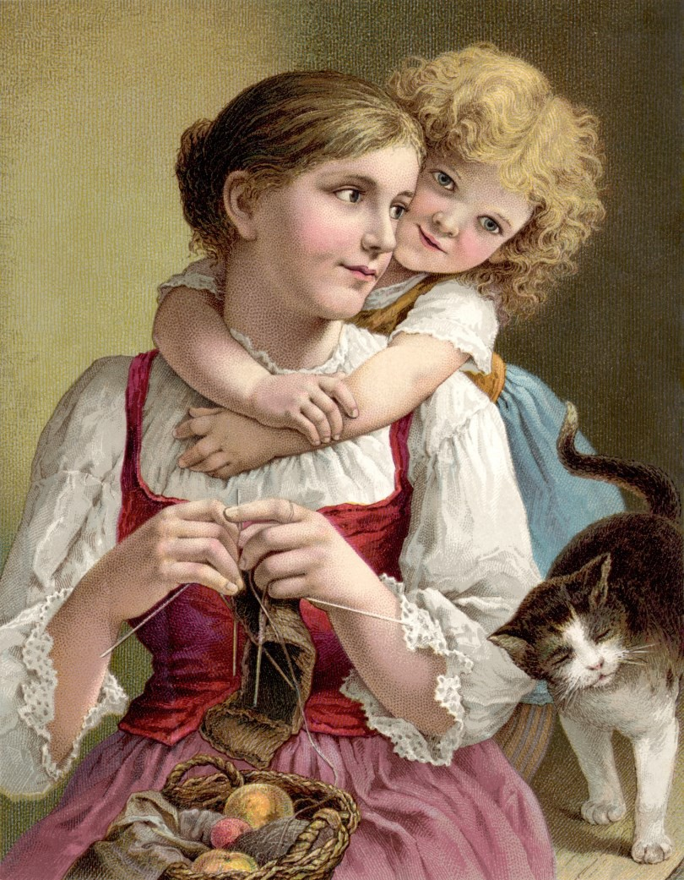

**May 2021**

*South Dakota Federation of Republican Women*

N e w

P r o g r a m

L a u n c h

The Membership committee has launched a new

program to help introduce people and new members to the South Dakota Federation of Republican Women. Please look inside for the look at the whole program.

*Happy Mother’s Day To*

*Soouth Dakota Federation of Republican Women*

*Moms!*

1

**R E P O R T S**

**I N S I D E T H I S I S S U E :**

Minnehaha-Lincoln

Co. & Meade Co. 2-3

From the President 4-5 Codinton Co. & 6

Membership 7-9

Cyberspace Club 10-

11

Calendar of Events & 12-

Spotlight Member 13

SDFRW Misc. 14-

Information 145

**S P E C I A L P O I N T S O F I N T E R E S T :**

* President’s

Report

* Quarterly Meeting Pictures
* Snippet of History
* Club Reports
* SDFRW Spotlight
* Newsletter Schedule & Calendar of Events

*South Dakota Federation of Republican Women*

**M i n n e h a h a - L i n c o l n C o u n t y R e p u b l i c a n W o m e n**

Minnehaha-Lincoln Republican Women of Sioux Falls have had a great beginning for

2021. Thanks to the SDFRW holding their State Convention in Sioux Falls last fall, great interest was generated in MLRW. We now have a membership of 43 regulars plus 14 associates.

On May 3rd, our club baked and delivered over 400 dozen cookies/bars/etc. to 12 fire

stations, 36 members of the Minnehaha County Sheriff’s Department, and 300 members of the Sioux Falls Police Department. This was done as part of our Caring for America project.

One of our members, Paulette Ludens, has stepped up to run for the local school board

election on May 18th. Sioux Falls school district is widely known for its liberal agenda, but Paulette and a just-retired military man are two conservative candidates running again three liberal candidates. There are two seats available on the school board this year (usually only one seat is available). The board president is Cynthia Mickelson, wife of Mark Mickelson, and she may or may not be conservative.

We have had good program speakers to date: January was election of officers; in

February we hosted Penny Sattgast to give us the broader picture of the Federation; March was our local sheriff; and in April we had six local legislators.

MLRW donated a handsome Indian Elephant pillow to the online auction. It was

hand-made by our club treasurer, Mary Jane Ceretto, and she was quite pleased with the results.

We have begun selling jewelry and it is very well received by the women who are new to

“activism” politics. All over Sioux Falls we are seeing the various conservative clubs gain more and more in attendance each month. People are “awake” and want to be involved to “do something”. The information we provide them through our various speakers each month is greatly appreciated.

2

*South Dakota Federation of Republican Women*

**M e a d e C o u n t y R e p u b l i c a n W o m e n**

*Our year began with a fantastic speaker, Dale Bartscher, Executive Director for South*

*Dakota Right to Life speaking on the need for encouragement during these troubled times rather than fear, aniety, and depression. Our club voted unanimously to donate*

*$200.00 to South Dakota Right to Life. We also welcomed a new member, Theresa*

*Thompson in January.*

*We had several members attend the Legislative Day in Pierre in February where we*

*heard First Gentleman, Brian Noem, speak. It was a fantastic time. Several days later, we had several of our members attend session to view committee meetings, talk to Representatives, and see how the vote would go on the Women in Sports fairness bill.*

*Speakers we've had speak are District 29 State House legislator Kirk Chaffe, State*

*Senator Gary Cammack, and Lt. Governor Larry Rhoden. Bills that had been discussed were Fairness in Women's sports, the new bombers coming to Elsworth AFB, and the constitutionality of recreational marijuana.*

*Our club helped host crackerbarrels through the Chamber of Commerce in both*

*February and March in Sturgis.*

*We continue to thank members of our community on a monthly basis calling it our "Pat*

*on the Back" program. We have delivered goodies with thank you notes to our Meade County workers, County Court house workers, Box Elder Police Department, and*

*teachers at Sturgis Elementary School, among others.*

*Our club participated in the SDFRW Facebook silent auction. There were so many great*

*items to bid on. Our club donated items as well as bid and won several items. We were*

*able to make a nice profit for our club as well as help out SDFRW so it was definitely a "win win" for all parties.*

*Meade County's newest member is Donna Hunt who joined us in April. We continue to*

*stay educated on political issues, contribute to worthy causes, give back to our community, build friendships, and welcome Republican women and men that have*

*similar concerns and wish to preserve our liberties and freedoms.*

3

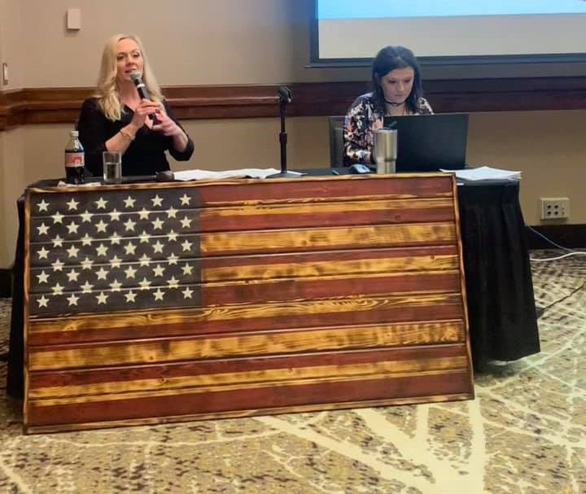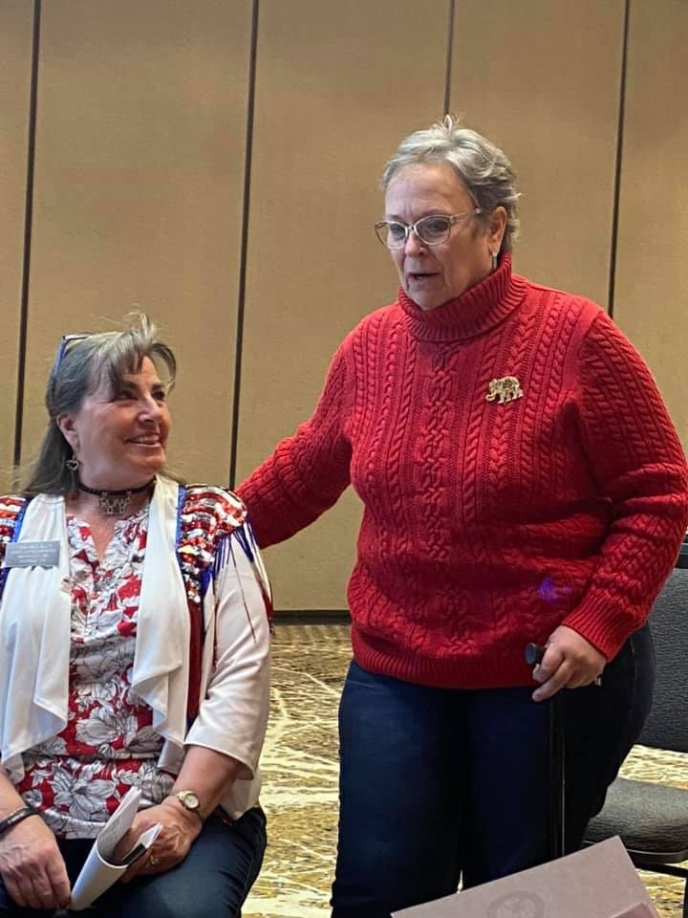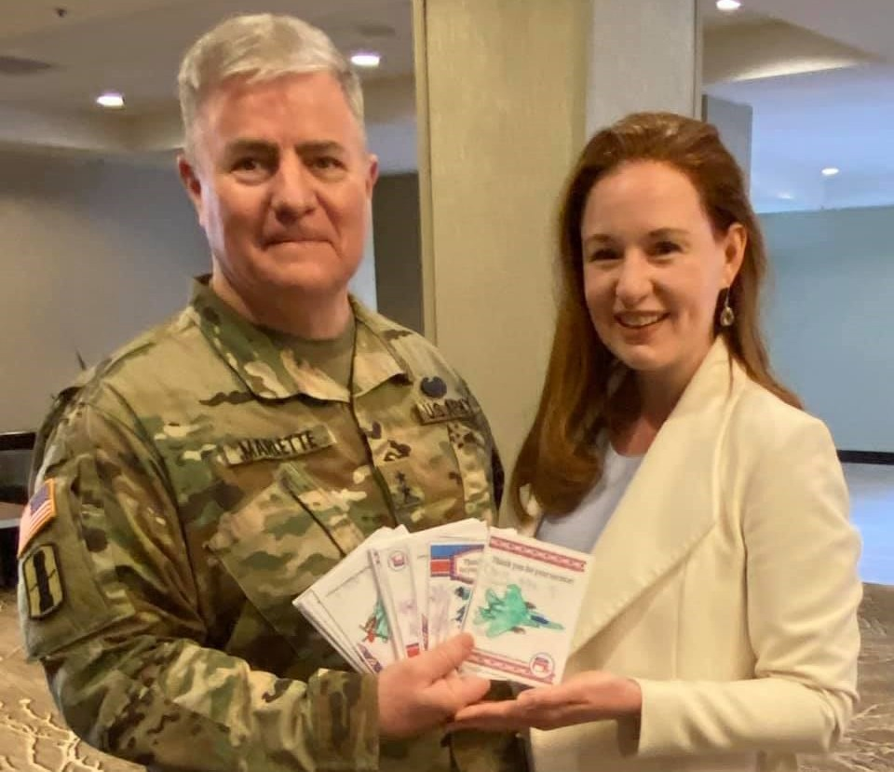

*South Dakota Federation of Republican Women*

**F r o m t h e P r e s i d e n t**

What an amazing honor and privilege it is to have been elected

to serve as the new President of SDFRW for the 2021-2022 term! Our organization is off to a fast-pace start thus far in 2021, as our fantastic clubs across the state have been working hard on projects and programs such as membership initiatives, prayer-warrior Zoom calls, Caring for America Projects, hosting legislative updates, supporting our police, and inviting dynamic speakers to educate and inspire our members (including our wonderful freedom-loving Governor: Governor Kristi Noem)! Our local clubs are truly the heart and soul of SDFRW!

Regarding our state-wide SDFRW efforts, we held our annual Legislative Day in February

and have already had two fun and productive Board of Directors’ meetings! Our last

meeting, which was held in the beautiful Black Hills of South Dakota in Rapid City (hosted by the Pennington County Republican Women), was a spectacular event where we heard from our South Dakota Adjutant General Jeff Marlette, as he gave us an update on the South Dakota National Guard. SDFRW is very proud of our South Da- kota National Guard and at the meeting we worked on writing customized thank you cards for a group of soldiers that are currently deployed and will be returning home this summer!

4

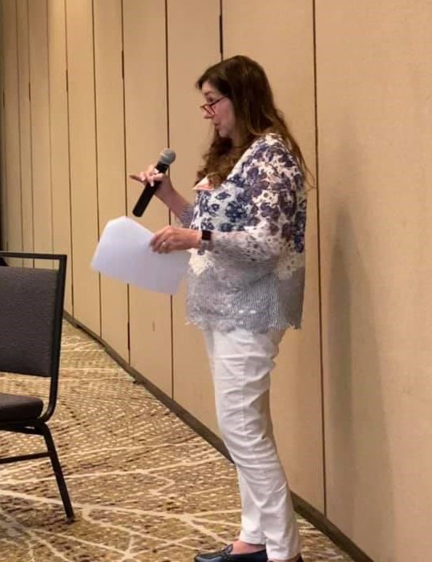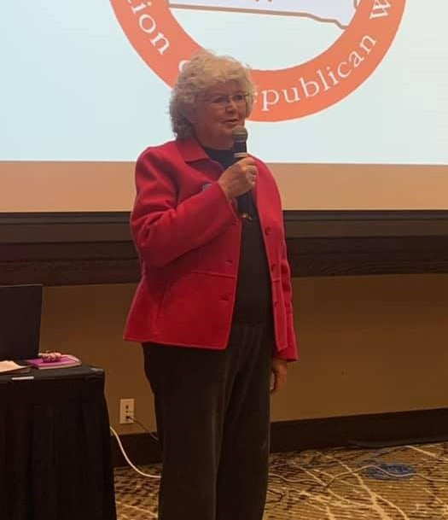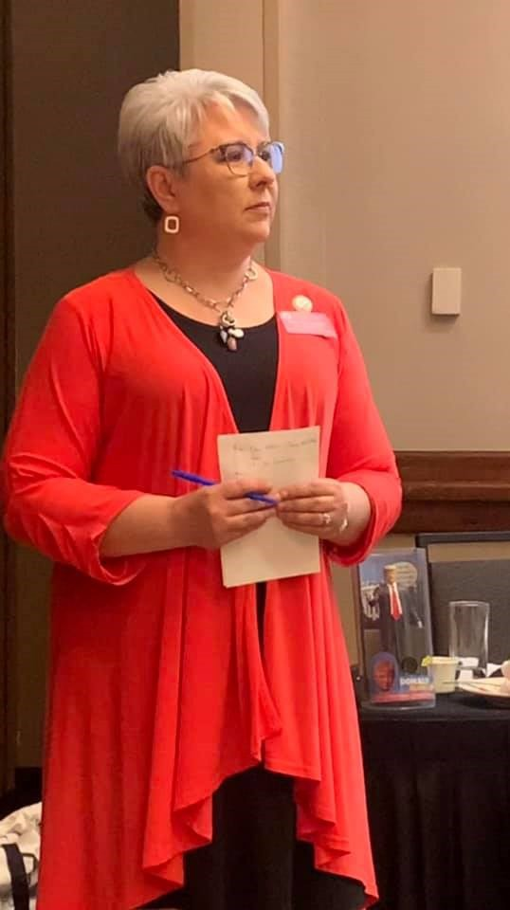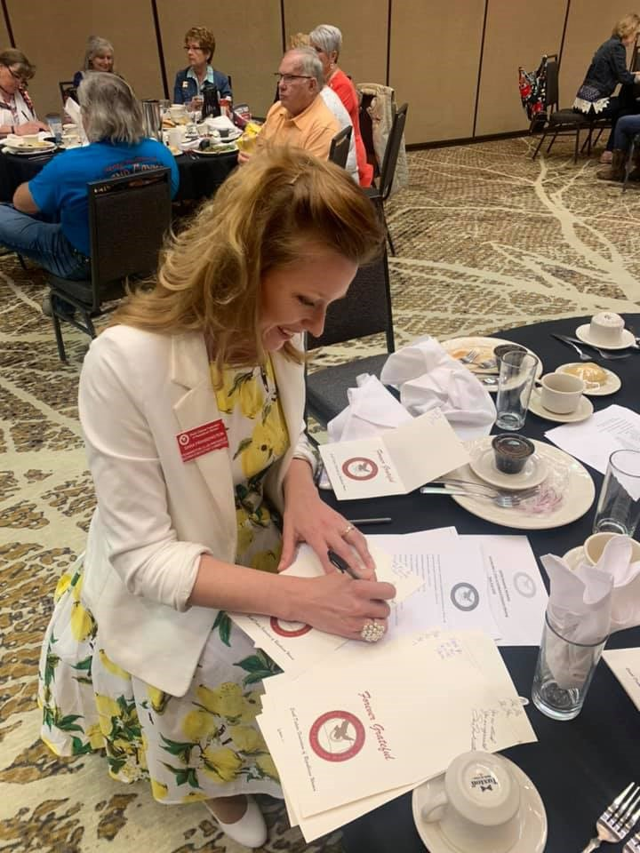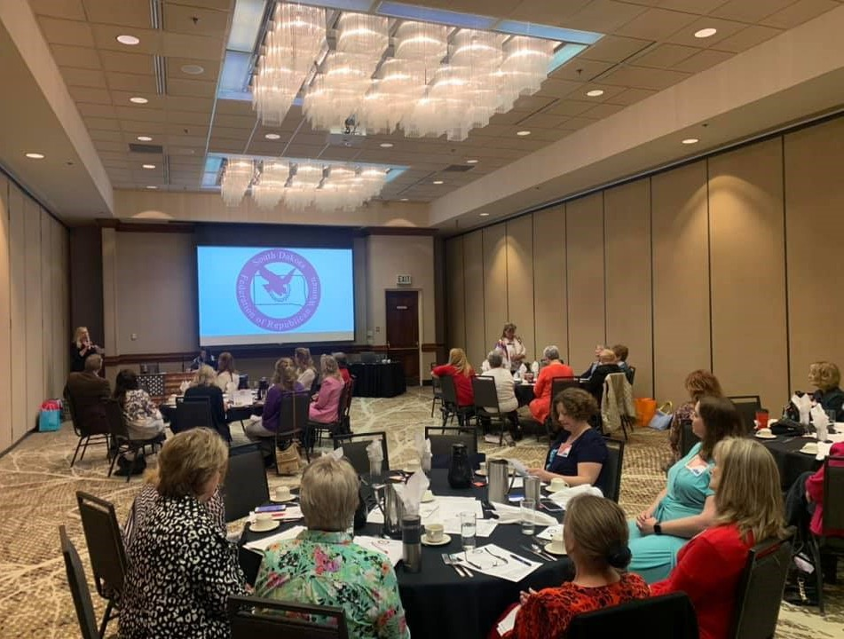

*South Dakota Federation of Republican Women*

I would also like to thank our Fundraising Chair Lauri Davis for her amazing work on leading our organization through a very successful online auction fundraiser! Thank you to all who worked to procure fun and exciting items! In addition, I want to give an extra special thank you to Catherine Barranco and Connie Wagner for their extraordinary ef- forts to assist Lauri! Because of the success of this fundraiser, SDFRW is in a great posi- tion to continue our “Boots on the Ground” efforts for the second half of 2021! Stay tuned and God Bless!

5

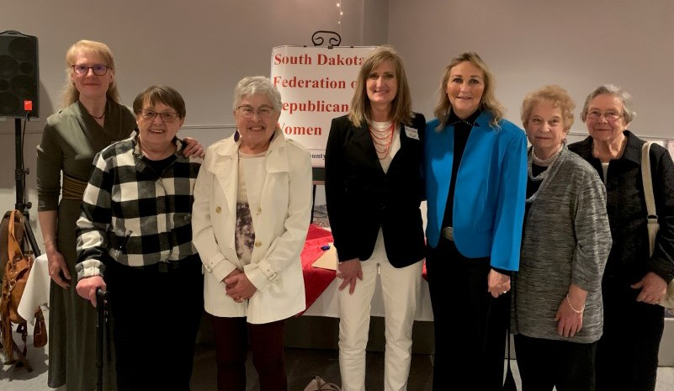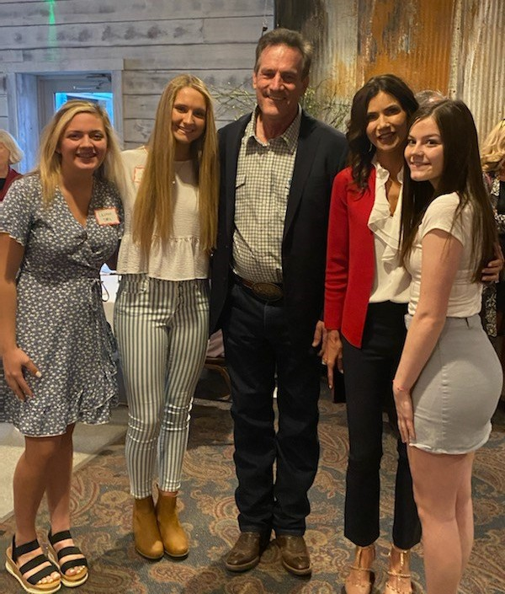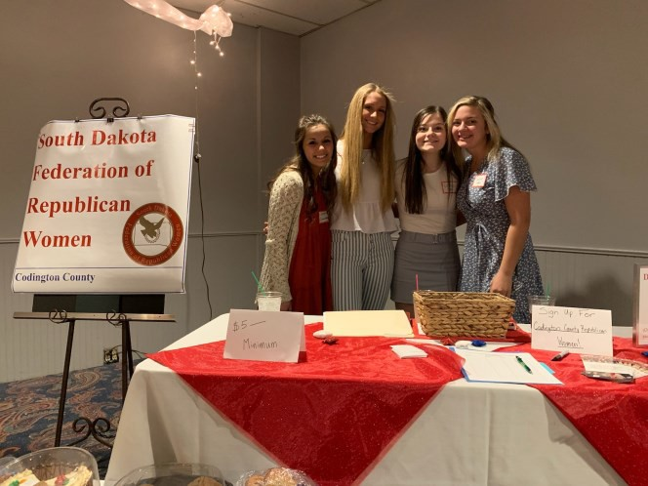

*South Dakota Federation of Republican Women*

**C o d i n g t o n C o u n t y R e p u b l i c a n W o m e n**

January

The Codington County January meeting was at Pizza Ranch in Watertown. Roger Papka, a Vietnam

Veteran, shared a message on “Patriotism.”

February

The Codington County Republican Women enjoyed traveling to Pierre in February to attend the SDFRW Legislative Day and Quarterly Board Meeting.

We had three members and six guests attending. Everyone enjoyed the tour of the Capitol and the

wonderful desserts and program at the Governor’s Mansion.

Our February guest speaker, John Harper, talked about losing his job on the Keystone XL Pipeline.

March

Nancy York, our District 5 State Legislator, gave us very interesting information on:

“What’s Happening in Pierre.”

April

Our County Commissioner, Lee Gable, and his wife Anne, along with our County Auditor, Cindy Brugman, spoke on The HR1 Election Reform Bill and the problems that would arise if it passes.

May

Brad Howell, our Codington County Sheriff will be our May speaker. We are also working on a

“Caring for America” project to provide “Spring Baskets” for the Adventera Care Center in Watertown.

The Codington County Lincoln Day Dinner was held on **April 29th** at the 2nd Street Station in Watertown, SD. Governor Kristi Noem was the featured speaker.

She spoke about how South Dakota has been an example to the nation. We have the lowest unemployment and the fastest growing economy in the nation. She said we need to be bold, honest, and true to our conservative ideals and say yes when asked to serve in any capacity for our state and our country.

The Codington County Republican Women held a bake sale to raise money for Teen Age

Republican Camp Scholarships, Girl’s State Delegates, community projects, and for supporting our good

conservative candidates.

Our Lieutenant Governor, Larry Rhoden, and his wife Sandy were also in attendance.

6



*South Dakota Federation of Republican Women*

**M e m b e r s h i p C o m m i t t e e R e p o r t**

**Announcing the Launch of**

The SDFRW Membership Committee is very excited to launch our brand new

**SDFRW New Member Ambassador Program**!

As part of the effort to grow our membership, we want to make it super easy and fun for new members to

join. Consequently, SDFRW is asking each club to name at least one (although two or three would be fantastic!) seasoned member who will serve as that club's Ambassador. Our Club Presidents are the BEST!! But Presidents have SO much on their plates already ... we need someone else in the club to serve as Ambassador so she can

really focus on giving new members the extra TLC that they need. The initial phase is a very sensitive time for new members.... if it's a hassle or it's intimidating to join, they are likely to back out. We want potential new members to feel at ease and welcome so they're motivated to see it through and become happy,

active members of SDFRW!

Ambassadors are there to lead new members by the hand. Once you've signed up, we'll work with you on the

specifics, offering you whatever support you need and sharing email templates that can help save you time. Here are the general functions you'll fulfill:

*Guide new members through the joining process, ensuring they understand how to submit their

dues and gathering all the required contact information

*Make sure the new members know about the Club and State Facebook pages and the utility of liking/following those pages to stay abreast of announcements

*Ensure that the new members are added to the Club and State contact lists

*For their first meeting or two, offer to let the new members sit with you and make a point of intro- ducing them to other members, helping to ensure that the new member has a

wonderful experience

*New Members are often excited to get involved! If they want to just go to meetings and get their feet under them before they get involved, that’s great! But if they're passionate and want to get going with projects, help connect them with

7



*South Dakota Federation of Republican Women*

the right person to get them involved in the projects that interest them. Worst case scenario, connect them with our SDFRW Membership Committee. We'd be happy to help them as well!

**So, if you respond promptly to emails, have great follow through, and are a "people-person" inter-**

**ested in making new friends, please consider serving as a New Member Ambassador!!** If you'd like to sign up or would like more information about the Ambassador Program, **please contact Catherine, our SDFRW Membership Chair, at** [**cob@CatherineBarranco.com**](mailto:cob@CatherineBarranco.com)

**Announcing the Launch of the 2021 Membership Competition!!**

This year is an NFRW convention year! The number of delegates we get to send depends on our

membership numbers as of June 25th. So, we’re launching a our 2021 SDFRW Membership Competition!! There are three categories of competition:

Increase in the Number of Active Members

Percent Increase in Active Members

Increase in the Number of Associate Members

Each winning club will receive two trophies to give to their top recruiters as well as bragging rights

and the joy of helping our Republican sisterhood grow!

8



*South Dakota Federation of Republican Women*

**SDFRW from 40,000 Feet Program**

It turns out that Star Wars fans didn’t introduce the oft-quoted

phrase, May the Fourth Be With You: "It was 1979, and Britain elected the first female Prime Minister, Margaret Thatcher. On May 4th, the day she took office, the Conservative Party placed an advertisement in The London Evening News, which read, 'May the Fourth Be with You, Maggie. Congratulations.'"

In honor of Star Wars Day, our 40,000 Feet Survey this month

asked you to choose your favorite classic Star Wars hero and

villain.

thirds Lord

With over two-

of

the

votes,

(the

Sidious

Emperor) was resounding named the scariest villain!

Meanwhile, our favorite heroes are the dynamic-duo: Han

Solo and his trusty sidekick, Chewbacca. The two tied for first place in our hearts!

It turns out that many of us went to the movie theater for

the very first time to see Star Wars.

We have many

heartwarming memories of watching Star Wars movies with

our friends and families.

Happy

Mother’s Day!

9



*South Dakota Federation of Republican Women*

**C y b e r s p a c e R e p u b l i c a n W o m e n**

Wow, it’s been a full month!! We gave back to the community

through a variety of Earth Day projects. This month, our Caring for America Committee is asking everyone to remember those who made the ultimate sacrifice on Memorial Day. Send us photos of how you honor our fallen.

The evening of April 27th, we had an incredible meeting with the

charismatic US Representative from North Carolina, Dan Bishop. I can’t tell you how many people contacted me after to say that they’re now huge Dan Bishop fans! We have more fantastic events coming up: **US Representative Lauren Boebert** (Colorado) on May 27th and **retired 4-Star General and member of the Joint Chiefs of Staff, Mark Welsh** on June 29th. Details are below. Sign up soon -- you don’t want to miss these incredible speakers!!

We have an inspiring Coffee scheduled for the morning of May

13th. And if you missed our Prayer Warrior Zoom Call last week, not to worry! We have another scheduled for June 8th.

**\*\* UPCOMING EVENTS \*\***

Our May Meeting will feature the fearless de-

fender of our Constitutional Right to Bear Arms, **US Representative Lauren Boebert** from Colorado!! Save the date: Thursday, May 27th at 7:30pm CST / 6:30pm MST.

With everything going on in the world today, many of us

feel helpless and even fearful. In our hour of need, we seek solace in God’s grace.

Join us for our next **Prayer Warrior Zoom Call** Tuesday, June

8th at 7:30pm CST / 6:30pm MST.

10



*South Dakota Federation of Republican Women*

Join us May 13th at 9am CST / 8am MST to hear from Presidential

appointee, **Max Primorac**, about protecting religious freedom in the most hostile environs.

We are very excited to announce that just before

Independence Day, on Tuesday, June 29th at 7pm CST /

6pm

MST,

we

have

the

honor

of

visiting

with **General Mark Welsh – a 4-star General who repre-**

**sented the Air Force on the Joint Chiefs of Staff until his retirement**!!

About General Mark Welsh

Welsh's military career culminated in achieving the rank

of General (four stars) and serving as the [Chief of Staff of](https://en.wikipedia.org/wiki/Chief_of_Staff_of_the_United_States_Air_Force) [the United States Air Force](https://en.wikipedia.org/wiki/Chief_of_Staff_of_the_United_States_Air_Force) and a member of the [Joint](https://en.wikipedia.org/wiki/Joint_Chiefs_of_Staff) [Chiefs of Staff.](https://en.wikipedia.org/wiki/Joint_Chiefs_of_Staff) During his tenure as a service chief, Mark

'wore two hats' as is customary for the role. As the chief of the Air Force, he was the senior-ranking uniformed officer within the Air Force, responsible for the organizing, training and equipping of over 600,000 personnel, as well as related budgeting and planning functions, liaison with other services and agencies, and interaction with legislators and

policymakers. Separately, as a member of the Joint Chiefs of Staff, he offered advice to the President, the Secretary of Defense, and the National Security Council.

Welsh previously served as Commander of U.S. Air Forces in Europe, as the Central Intelligence Agency Associate Director

for Military Affairs, and as Commandant of the Air Force Academy. Currently, Mark is Dean of the Bush School of Government and Public Service at Texas A&M University.

**How to Register + Giveaway Program!**

Register for these and future events using the Zoom link listed in each description under “Events” on our Facebook page: <https://www.facebook.com/CyberspaceRepublicanWomen/events>

In case you haven’t heard, we’ve launched a fun **Giveaway Program**!! At this time, anyone and everyone can join our

Cyberspace Zoom calls and enjoy our fabulous speakers! But…. Cyberspace Active and Associate members on the call are eligible to win a free giveaway! The prizes vary -- so far, we’ve given away Scheel’s gift cards, an autographed copy of the author’s book, and a bag of premium coffee. To become an official Active or Associate member,

email: [SDRWCyberspace@gmail.com](mailto:SDRWCyberspace@gmail.com)

11



*South Dakota Federation of Republican Women*

12

Calendar of Events

*May:*

20th - Brown Co. Area Rep. Women Mtg. Aberdeen, SD The Flame @ 11:30am

* Pennington Co Rep. Women Mtg. Rapid City, SD Alex Johnson Hotel @ 11:45am

21st - Codington Co Rep. Women Mtg. Watertown SD

Pizza Ranch @ 11:30am

27th - Minne-Lincoln Co.Rep. Women Mtg. Sioux Falls SD

Luciano’s North @ 11am

27th - SDFRW Cyberspace Zoom Mtg.

7:30pm CST (6:30pm MST)

US Rep. Lauren Boebert (Colorado) 31st - Memorial Day

June:

4th - Meade Co Rep. Women Mtg. Sturgis, SD Pizza Ranch @ Noon

8th - Prayer Warrior Zoom Call 7:30pm CST

13th - Cyberspace Morning Coffee Zoom Call 9am CST 14th - Flag Day

14th - Beadle Co. Rep. Women Mtg. Huron, SD The Scoreboard @ Noon

17th - Brown Co. Area Rep. Women Mtg. Aberdeen, SD The Flame @ 11:30am

* Penn. Co. Rep. Women Mtg. Rapid City, SD Alex Johnson Hotel @ 11:45am

18th - Codington Co. Rep Women Mtg. Watertown, SD

Pizza Ranch @ 11:30am

24th - Minne- Lincoln Co Rep. Women Mtg. Sioux Falls SD

Luciano’s North @ 11am

29th -SDFRW Cyberspace Zoom Mtg. 7:30 CST USAF General Mark Welsh III

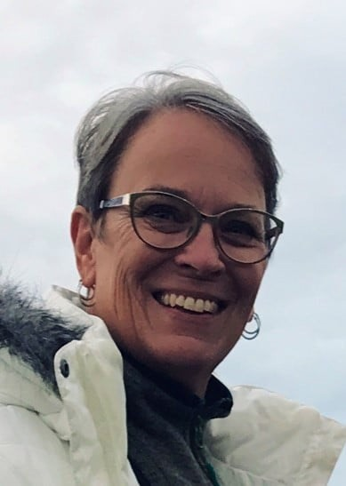

*South Dakota Federation of Republican Women*

History of Mother’s Day

Celebrations of mothers and motherhood can be traced back to

the [ancient Greeks](https://www.history.com/topics/ancient-history/ancient-greece) and Romans, who held festivals in honor of the mother goddesses Rhea and Cybele, but the clearest modern precedent for Mother’s Day is the early Christian festival known as “Mothering Sunday.”

Once a major tradition in the United Kingdom and parts of Europe, this celebration fell on the fourth Sunday in Lent and was originally seen as a time when the faithful would return to their “mother church”—the main church in the vicinity of their home—for a special service.

Over time the Mothering Sunday tradition shifted into a more secular holiday, and children would present their mothers with flowers and other tokens of appreciation. This custom eventually faded in popularity before merging with the American Mother’s Day in the 1930s and 1940s.

*

https://[www.history.com/topics/holidays/mothers-day](http://www.history.com/topics/holidays/mothers-day)

***SDFRW Spotlight***

Connie Wagner

Charles Mix County

Republican Women

Please Check out the Website for the

complete Story on Connie.

13



*South Dakota Federation of Republican Women*

*Newsletter Monthly Report Schedule*

January, April, July, & October: Codington, Cenkota & Pennington February, May, August & November: Brown, Minnehaha -Lincoln, & Meade

March, June, September & December: Cyberspace, Beadle, Fall River & Charles Mix Please find your Club and Write down the months that you are in the Newsletter.

**The reports are due the 1st of the month.**

Send the Reports to [sdfrwweb@gmail.com](mailto:sdfrwweb@gmail.com)

If you have anything that you deem important and would like to share with the state please send it in.

It can be photos, and article or report.

14

Next Quarterly Meeting:

*TBA*



**See Us Now!**

15