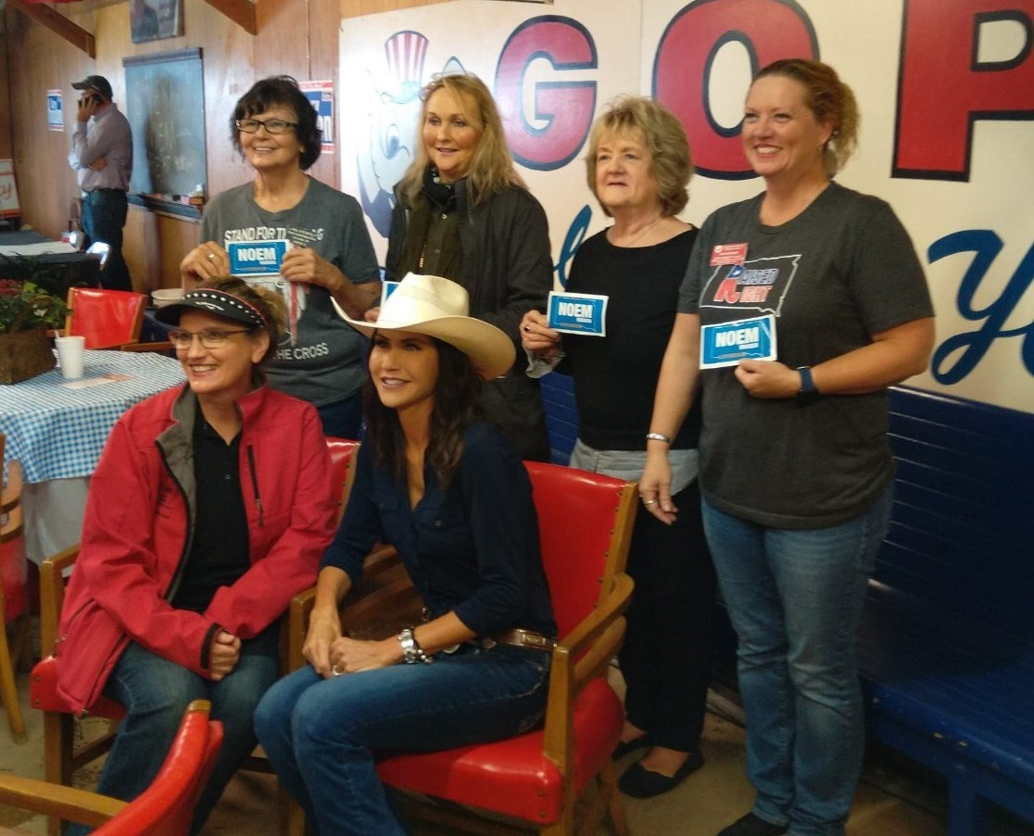

**September 2021**

*South Dakota Federation of Republican Women*

***S o u t h D a k o t a S t a t e F a i r***

1

**R E P O R T S**

**I N S I D E T H I S I S S U E :**

NFRW Convention 2-3

Minnehaha/Lincoln 4 Co. Report

Ads/ Calendar of 5

Events

Caring for America 6

Activities

Cyberspace Club 7-9

Report

SDFRW Americanism 10-

Project/ This Month In 11

Member Spotlight 12

**S P E C I A L P O I N T S O F I N T E R E S T :**

* Calendar of Events
* NFRW Convention Info
* This Month in History
* Caring for America Activities
* Winter Quarterly Meeting Date



*South Dakota Federation of Republican Women*

41st Biennial Convention

The National Federation of Republican Women is #LaunchingLeaders this September at the 41st Biennial Convention in Orlando, Florida -- and all Federated Republican women's club members are invited!

Convention attendees will have the opportunity to:

* Network with more than 1,000 like-minded Republican women from across America
* Hear from top-level national speakers
* Receive cutting-edge training to help counter the radical left

Help chart the future of the NFRW, which includes the election our next national officers

Thursday, September 23, 2021

10:00 am – 12:00 pm: Executive Committee Meeting *(closed)*

3:00 pm – 7:00 pm: Convention Registration / Information Desk Open

4:00 pm – 6:00 pm: State Federation Presidents Meeting

*(state federation presidents only)*

Evening: Regents Reception

*For more information about the Regents Reception, contact Liz Matro at* [*lmatro@nfrw.org.*](mailto:lmatro@nfrw.org)

Friday, September 24, 2021

9:00 am – 6:00 pm: Convention Registration / Information Desk Open

10:00 am – 12:00 pm: Pre-Convention Board of Directors Meeting 1:00 pm – 5:00 pm: Campaign Management School *(separate ticket)*

*Instructor:*

NFRW Trainer Holly Robichaud will provide intensive training on the latest techniques in fundraising, voter contact and GOTV.

Evening: Convention Welcome Reception

*Special Guests:*

Florida Governor Ron DeSantis and First Lady Casey DeSantis

2



*South Dakota Federation of Republican Women*

41st Biennial Convention Cont.

Saturday, September 25, 2021

8:00 am – 5:00 pm: Convention Registration / Information Desk Open

8:30 am – 11:30 am: Convention General Session

*Speakers:*

Mike Huckabee, former Governor of Arkansas and host of *Huckabee*

12:30 pm – 2:30 pm: Luncheon

3:00 pm – 4:30 pm: Workshops / Training Seminars Critical Race Theory, panel discussion Election Integrity, panel discussion

Communications, presented by the [Leadership Institute](https://leadershipinstitute.org/) Fundraising, presented by the [Leadership Institute](https://leadershipinstitute.org/)

Membership, presented by the [Leadership Institute](https://leadershipinstitute.org/) and featuring tips from presidents of fast-growing clubs

Bylaws and Parliamentary Procedure, presented by NFRW Parliamentarian Theresa Kosmoski

5:00 pm – 6:30 pm: Achievement Awards Ceremony

Dinner: Attendees on own

Sunday, September 26, 2021

6:00 am – 12:00 pm: Convention Registration / Information Desk Open

6:30 am – 8:00 am: Voting for National Officers *(if necessary)*

7:30 am – 8:30 am: Prayer Breakfast *(separate ticket)*

9:30 am – 12:00 pm: Convention General Session

*Speakers:*

Gordon Chang, author, commentator and leading expert on China, "Saving America from China's Existential Threat"

12:00 pm – 2:00 pm: Networking Luncheon

2:30 pm – 5:00 pm: Post-Convention Board of Directors Meeting *(to elect the three Members-at-Large to the NFRW Executive Committee)*

5:00 pm – 6:00 pm: Post-Convention Executive Committee Meeting *(closed)*

3

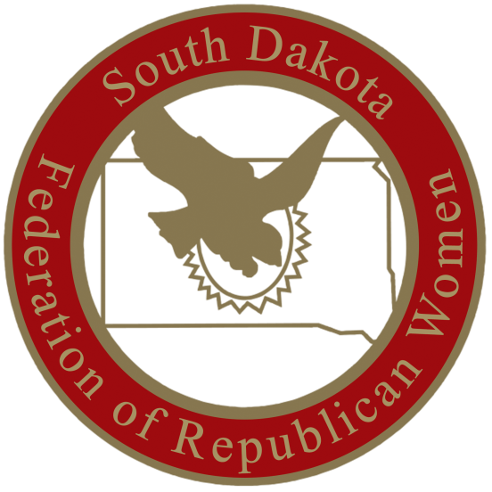

*South Dakota Federation of Republican Women*

**M i n n e h a h a - L i n c o l n C o u n t y R e p u b l i c a n W o m e n**

Minnehaha Lincoln Republican Women held our August meeting in our new location, the Military Heritage Alliance at 1600 West Russell in Sioux Falls. Our speaker was the new Sioux Falls Chief of Police John Thum (pronounced toom). He joked about how disappointed people are when he shows up instead of John Thune! Chief Thum has 16 years experience on the force, but has only been in this job for about a

month. MLRW is pleased to see many new faces at our meetings, and quite a few have become members. The reduced dues rate for the remainder of 2021 has been a very positive tool in recruiting new members. MLRW will honor the Mamie

Eisenhower Project in September with new books for toddlers

to teens

being donated to a church in one of Sioux Falls’

ethnic neighborhoods. We will also be donating new household items to Call To Freedom for their women rescued

from human trafficking.

4



*South Dakota Federation of Republican Women*

5

Calendar of Events

September:

16th- Brown County Area Republican Women 11:30am CST, The Flame, Aberdeen, SD

-Pennington County Republican Women

11:45am MST, Alex Johnson Hotel, Rapid City, SD

17th- Codington County Republican Women 11:30am CST, Pizza Ranch Watertown, SD

23rd- Minnehaha- Lincoln County Republican Women 11:30am CST, SD Military Heritage Alliance, Sioux Falls, SD

23-26 NFRW Conference, Orlando, FL

October:

1st- Meade County Republican Women 2pm MST, Pizza Ranch, Sturgis, SD

11th- Beadle County Republican Women

12pm CST, The Scoreboard, Huron, SD 14th- Cyberspace Morning Coffee, 9am CST

15th- Codington County Republican Women 12pm CST, Pizza Ranch, Watertown, SD

21st- Brown County Area Republican Women 11:30am CST, The Flame, Aberdeen, SD

* Pennington County Republican Women

11:45am MST, Alex Johnson Hotel, Rapid City, SD

28rd- Minnehaha-Lincoln County Republican Women 11:30am CST, SD Military Heritage Alliance, Sioux Falls, SD

November:

5th- Meade County Republican Women 2pm MST, Pizza Ranch, Sturgis, SD

8th- Beadle County Republican Women

12pm CST, The Scoreboard, Huron, SD

18th- Brown County Area Republican Women 11:30am, The Flame, Aberdeen, SD

* Pennington County Republican Women

11:45am MST, Alex Johnson Hotel, Rapid City, SD

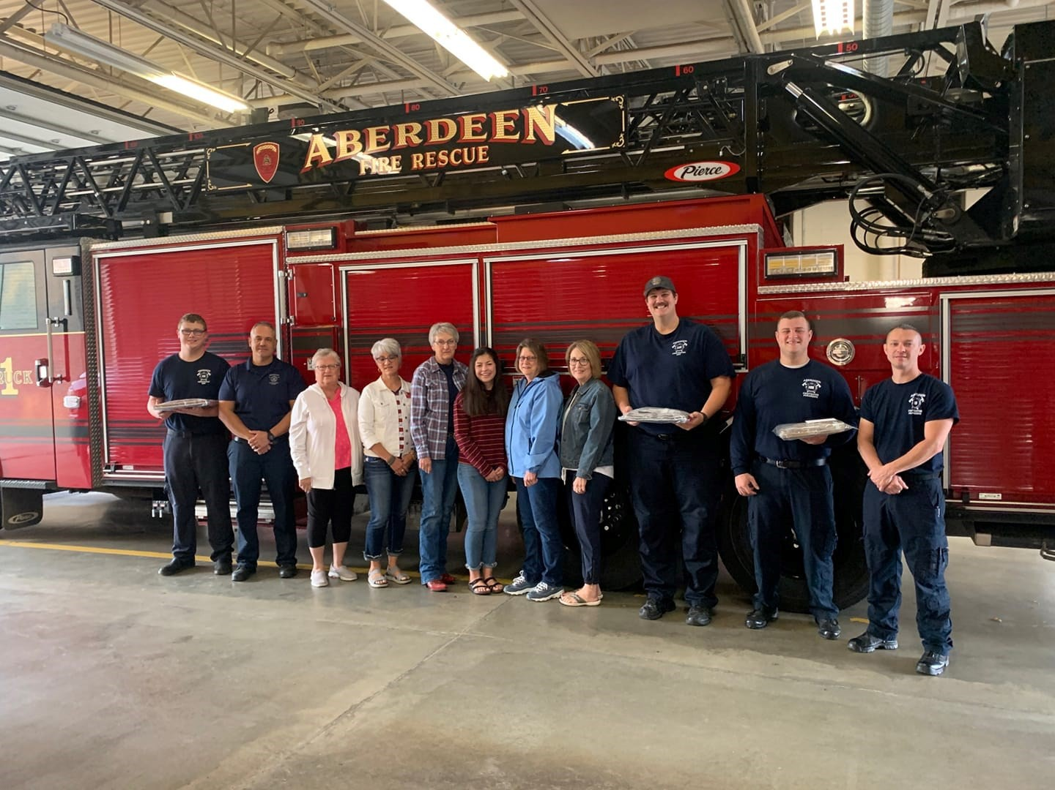

*South Dakota Federation of Republican Women*

**C a r i n g F o r A m e r i c a A c t i v i t i e s**

Sept. 10th, 2021

Caring for America project took treats to the downtown Aberdeen fire station this morning.

We are so grateful for all our first responders!

6

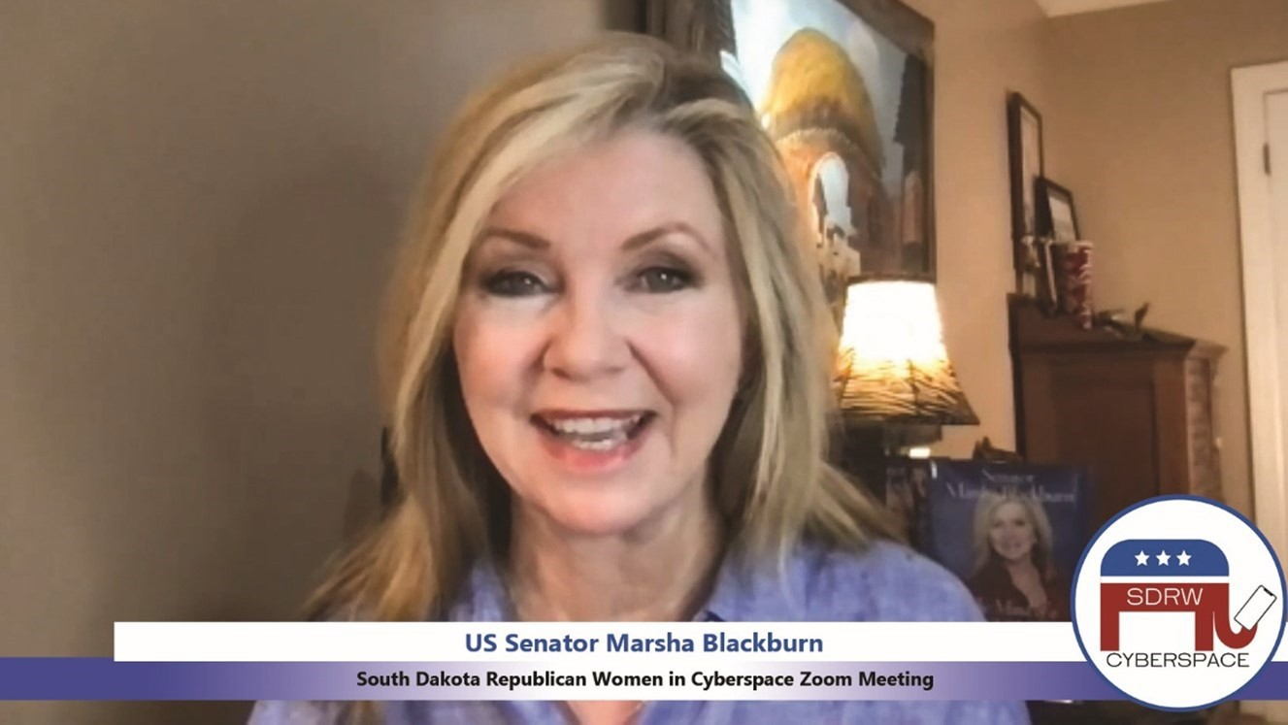

*South Dakota Federation of Republican Women*

*Cyberspace Republican Women*

**Another fantastic month for Cyberspace!**

Republicans coast-to-coast tuned in to hear the renowned **US Senator Marsha Blackburn (TN)**!

We traveled across the “pond” to London, where we visited with **Dennis McGuinness** –

a

delightful gentleman full of fascinating stories! Dennis was originally with Scotland Yard before

going into the Queen’s employ. There he was in charge of simultaneously running several of Her Majesty’s estates, including Hampton Court (the palace of King Henry VIII), Kensington Palace

7

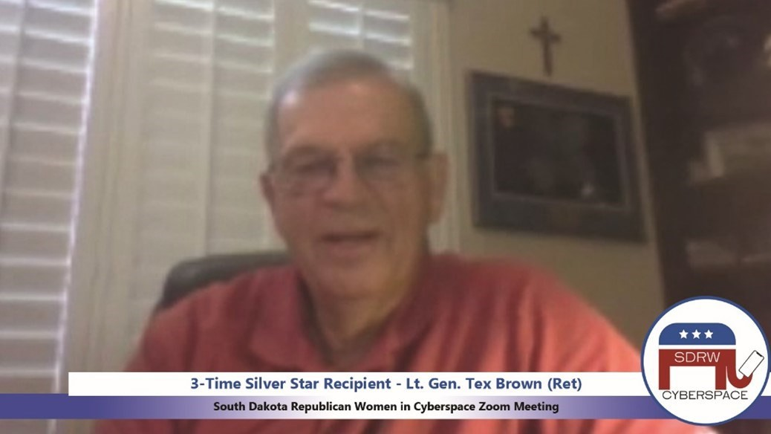

*South Dakota Federation of Republican Women*

*Cyberspace Republican Women cont.*

(the residence where Princess Diana and Princess Margaret lived until their deaths), Kew Palace,

Queen Charlotte’s Cottage, and Whitehall.

We honored the heroes and the fallen from the 9-11 Terrorist Attacks as we heard the firsthand

account of three-time Silver Star Recipient and 9-11 Survivor, **Lt. Gen. Tex Brown (Ret)**.

**\*\* UPCOMING EVENTS \*\***

**PLEASE NOTE: Due to the NFRW Convention, we will NOT be holding an end-of-the-month Zoom Call in**

**September. Our next event will be a Coffee on the morning of Thurs, October 14. Save the date – it’s**

**going to be an incredible talk!**

As the Border Crisis worsens, news broadcasts have become riddled with stories of Americans abducted

by cartels and the Mexican mob, yet few of us truly understand what that means. Most of us imagine the Prohibition Era Italian mafia in which mobsters follow a form of civility, a code of conduct that allows violent retribution against those who cross the mob but protects civilians and innocents. The cartels and Mexican mafia are *nothing* like that. In our October Morning Coffee, we'll hear from **Major General Simeon Trombitas (Ret)**. Himself a Green Beret, Sim headed the Army's Special Forces. Now retired from the Army, his job is to travel to third-world countries, negotiate the release of hostages held by the drug cartels and mafia, and personally escort them home to ensure they make it back safely. Boy, does he have stories to tell!!

8



*South Dakota Federation of Republican Women*

*Cyberspace Republican Women Cont.*

Join us **October 14th** at **9:00am CST / 8:00am MST** to learn what the cartels are really like and why it’s so terrifying that the Border Crisis has allowed them to extend their reach way beyond the border, well into the United States.

Cyberspace has partnered

with SDFRW to offer a 50% promotional discount on 2021 Active

Memberships! **Through the end of the year, Active Memberships will run just $20 and include**

**membership in Cyberspace, SDFRW, and NFRW!!** For more information, contact SDRWCyberspace@gmail.com!

9



*South Dakota Federation of Republican Women*

***This Month in History***

September 11, 2001

1941

Attack on the World Trade Center & Pentagon by

terrorists

Construction began on Pentagon

**Elizabeth Feinler-** In 1960, Feinler joined SRI International as an information scientist leading the Information

Research Department. In 1972, she became a part of Dr. Douglas Engelbart's Augmentation Research Center, where her work on the Internet started. It was her who pioneered and took charge of the first ARPANET (Advanced Research Projects Agency Network) and then the Defense Data Network (DDN) under a contract with the Department of Defense. Both of these early networks were the precursors of the Internet we know today.

10



*South Dakota Federation of Republican Women*

S E P T E M B E R B I R T H D A Y S

**September 1, 1896 (1987)** – Mary Jones, a pioneer in the field of behavior therapy and a celebrated developmental

•

psychologist, her famous patient was a small boy who was terrified of his stuffed white rabbit and gradually overcame

his fear with rewards of food

•

**September 1, 1909 (1999)** – Hildegard Peplau, a nurse educator, created the foundation for modern nursing in her

1952 book, Interpersonal Relations in Nursing, enlisted in the Army Nurse Corps in World War II, served in England and

New York and then in the New York Women’s Disturbed Service, president of American Nurses Association, 1970-72

•

•

**September 1, 1933 (2006)** – Ann Richards, second woman elected governor of Texas (1990)

**September 1, 1939** – Lily Tomlin, beginning in the 1960s, a major force in American comedy on television (“Laugh-

In,”) Broadway, and in the movies

•

**September 2, 1948 (1986)** – Christa McAuliffe, New Hampshire teacher, selected in 1985 to be the first teacher in

space, died aboard space shuttle Challenger

•

**September 3, 1910 (1996)** – Dorothy Maynor, operatic soprano of mixed ethnic heritage, sang German lieder as well

as spirituals, sang at the inaugurations of Presidents Truman and Eisenhower

•

**September 3, 1914 (1984)** – Dixy Lee Ray, marine biologist whose scientific papers and research on marine inverte-

brates led to public television programs, appointment to the Atomic Energy Commission (1973-75), and election as Gov-

ernor of Washington on conservative issues in 1976

•

**September 3, 1920 (1966)** – Marguerite Higgins, first woman to win Pulitzer Prize for International Reporting (1951)

for coverage of the Korean War

•

**September 3, 1921 (1985)** – Ruth Orkin, denied admission to the Cinematographer’s Union because she was a wom-

an, went to New York where she filmed a street-scene series and then to Florence where she shot “American Girl in Italy”

in 1956

•

**September 4, 1906 (1988)** – Elaine Yoneda, Communist labor organizer with the International Longshoreman’s Un-

ion, argued for free day care for women and equal pay for equal work in 1930s, interned in 1942 with her Japanese-

American husband because she felt family should stay together

•

**September 5, 1914 (1994)** – Hannah Wormington, studied and compared American Paleo-Indian artifacts with Euro-

pean anthropological findings, also studied minerals from those areas and eastern Colorado, resistance to women scien-

tists prevented her talents from being utilized but she remained a model for women in interdisciplinary archaeology

•

**September 6, 1860 (1935)** – Jane Addams, founder of Hull House in Chicago, first major settlement house, first

American woman to receive the Nobel Peace Prize (1931), suffragist, helped establish American Civil Liberties Union

(1920)

11

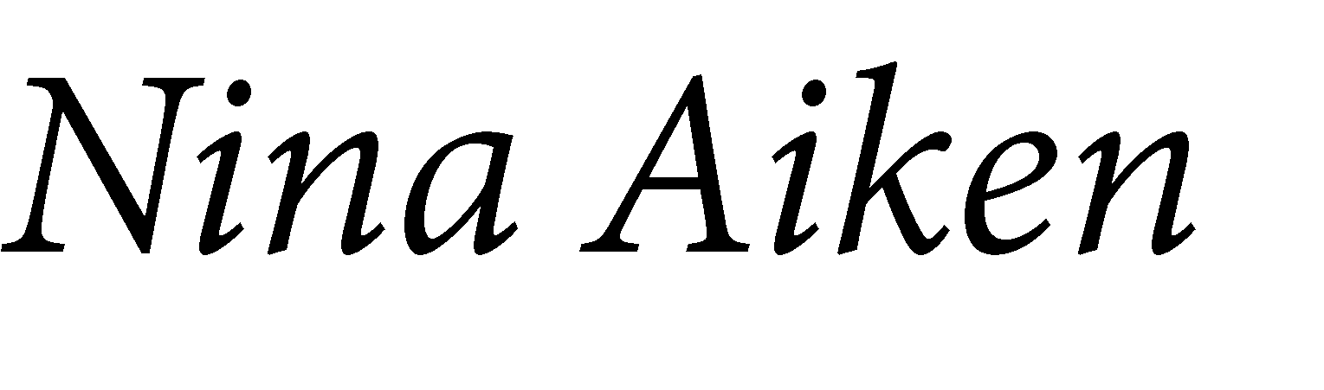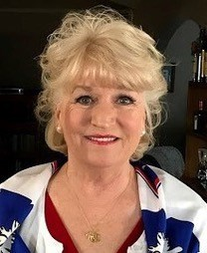

*South Dakota Federation of Republican Women*

12



*South Dakota Federation of Republican Women*

*Newsletter Monthly Report Schedule*

**January, April, July, & October: Codington, Cenkota & Pennington**

**February, May, August & November: Brown, Minnehaha -Lincoln, & Meade**

**March, June, September & December: Cyberspace, Beadle, Fall River & Charles Mix**

Please find your Club and Write down the months that you are in the Newsletter.

**The reports are due the 1st of the month. Send the Reports to** [**sdfrwweb@gmail.com**](mailto:sdfrwweb@gmail.com)

If you have anything that you deem important and would like to share with the state please send it in.

It can be photos, an article or report.

*Winter Quarterly*

*Meeting*

*Saturday, December 4th, 2021*

*Capitol Lake Visitor Center, Pierre, SD*

13



**See Us Now!**

*America Home of the Free & the Brave!*

14