**Copy and paste the following below as an Email and Attach the “Guidelines” and “Check in instructions”**

The PCL online orientation has been updated with various comments and feedback. The orientation now consists of (2) separate modules:

1. “Peacock Solar – 9300002” Site Specific Orientation (~15-20 mins)
2. PCL HSE Orientation (~80 mins)

Important notes:

* Once you register, please take the time to complete orientation modules.
* Orientation has to be completed by each worker separately.
* Orientation has to be completed prior to coming to the site.
* Online modules can be accessed on any device (smartphone, tablet, computer, etc.)
* PCL HSE Orientation and Site-Specific Orientation is valid for 2 years.

Translations:

* PCL HSE orientation is available in Spanish translation.
* Site specifics are in English only and a translator must be provided by Supervisor if needed.

How to access Online Orientation:

1. Click on this link here: [Login - PCL Denver (constructionlearn.com)](https://den.constructionlearn.com/login) It will bring you to this page:

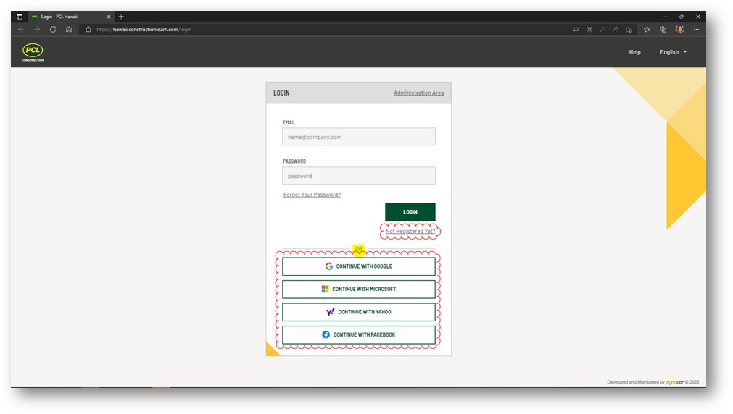



1. QR code:

**You will use your email and password to login in the future, so please remember this information.

**Please enter your company name.**

Use the “Project Guidelines for Online Orientation Registration” document.

Once all modules are complete, workers will have the option to print or email their certificates. If they do not have access to a printer, they can log back into their account at any time to show completion or the certificate via their email.

Upon arriving at the site, workers are instructed to show up at the Check-In area – HSE Training Trailer to verify completion and receive their orientation stickers. (See Check in instructions for site.)

Let me know if you have any questions.