Project Guidelines for
Online Orientation Registration

Issues Email: Chris Saia
Project Contact:

Chris Saia, HSE Manager
cjsaia@PCL.com
or
970-409-7320

Welcome to the PCL HSE online orientation. To start your PCL HSE online orientation, you will need to create an account by clicking PCL Denver OR use QR code on page 4.
Step 1: Click the link above of scan the QR code on the last page
Step 2: Create an account by selecting “Not Registered Yet”

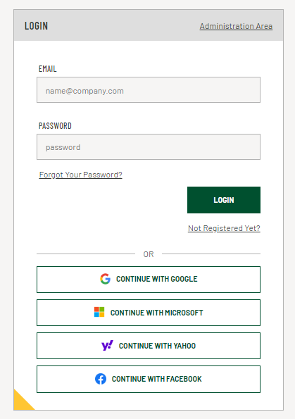
SYSTEM REQUIREMENTS

To use the Service, Users and Administrators must meet the following minimum system requirements:

- Laptop, desktop, tablet, or mobile device (1600x900 minimum resolution)
- Current version of Chrome, Firefox, Edge, or Safari web browsers
- 2 Mbps minimum internet connection

Step 3: Complete the required information and select “Create Account”

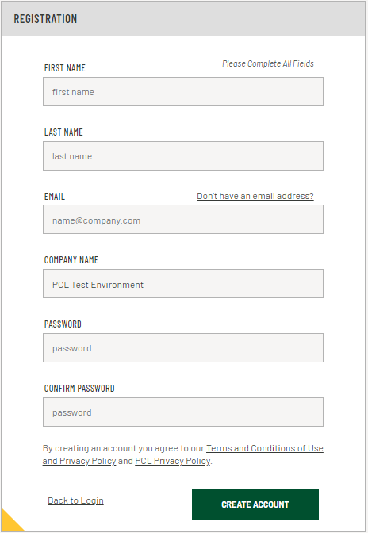

Step 4: Review and click “Agree” to the terms and conditions
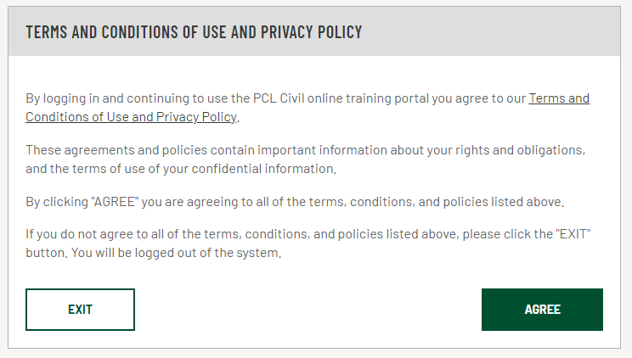

Step 5: Click on the “PCL HSE Online Orientation” and “LAUNCH” the course.
Note: this process will take 80 minutes.

Step 6: Click on “PROJECTS”, select “Peacock Solar – 9300002” and then click the “ASSIGN PROJECT” button on the right. Once you assign this project course, you will have 48 hours to complete it.
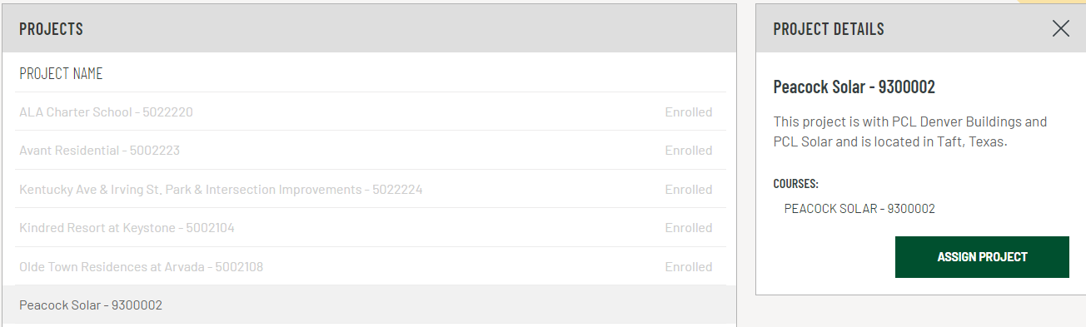

Step 7: Click on “COURSES”, select “Peacock Solar – 9300002” and then click the “LAUNCH COURSE” button on the right.
Note: this process will take 15 minutes.
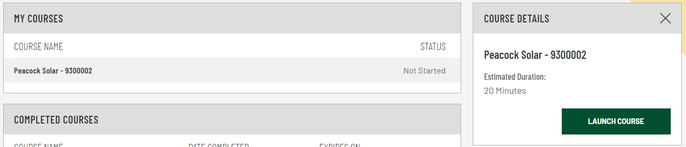

Once you launch course – please complete it. The system will save your progress if you log out, we recommend just completing the training course. If you don’t complete the course within 7 days, it will lock you out. You will have to be unlocked and start over.

Click exit course, then click on the “X”.

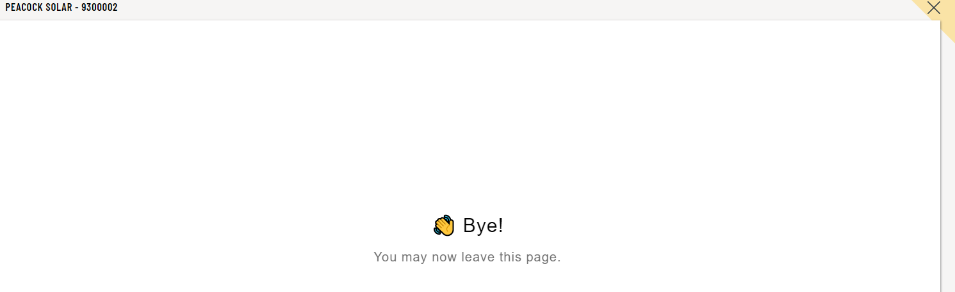

Step 8: Click on “EMAIL CERTIFICATE”, Type your supervisor’s email or mroston@pcl.com and then click the “SEND” button. You have now completed the PCL Orientations. Follow the Check-in Instructions to receive your Peacock Solar project Orientation Sticker.

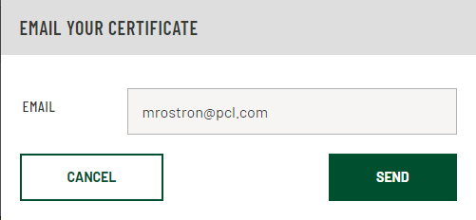

BE SURE TO PUT YOUR PROJECT EMAIL

The End

