Strategic Construction Solutions Toolbox Talk #17: Fall Protection Clearance Distance
[Reference OSHA 1926.502]

Fall Protection Clearance Distance
Calculating PFAS Clearance Distance

Personal Fall Arrest Systems (PFAS) must be used in accordance with the following OSHA requirements:
OSHA Construction Standard 1926.501 (b)(1) "Each employee on a walking/working surface (horizontal and vertical surface) with an unprotected side or edge which is 6 feet (1.8 m) or more above a lower level shall be protected from falling by the use of guardrail systems, safety net systems, or personal fall arrest systems."

OSHA Construction Standard 1926.502 (d)(16) "Personal fall arrest systems, when stopping a fall, shall: limit maximum arresting force on an employee to 1,800 pounds when used with a body harness; be rigged such that an employee can neither free fall more than 6 feet, nor contact any lower level; bring an employee to a complete stop and limit maximum deceleration distance an employee travels to 3.5 feet; and, have sufficient strength to withstand twice the potential impact energy of an employee free falling a distance of 6 feet, or the free fall distance permitted by the system, whichever is less."

It is important that employees be trained in calculating PFAS clearance distance. In the event of a fall it is important to ensure that the worker will not free fall more than 6 feet. Free falling more than 6 feet has broken workers necks from impact force. If workers contact lower levels the PFAS is useless. Use a deceleration device to ensure forces do not exceed 1,800 pounds. Use this chart from when calculating PFAS clearance distance.
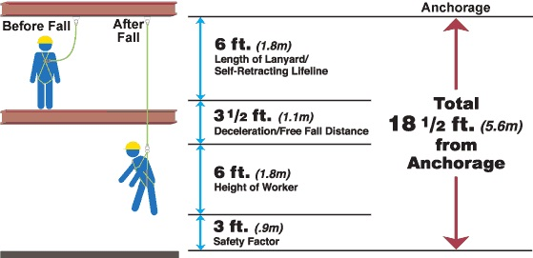
Photo Courtesy of: https://www.millerfallprotection.com/smart-solutions/connecting-devices/calculating-fall-clearance-3

TOOL BOX TALK ATTENDENCE FORM

Toolbox Topic Covered: ____ Fall Protection Clearance Distance

Company Name: Date:

Training led by:

PRINT NAME SIGNATURE

