Towards a Neo-Bohrist Realist Model of the Atom

By

Robert E. French

EMAIL – robert.e.french@gmail.com

Abstract

In this paper I describe and defend a variant on the Bohr model of the atom. While the model differs from the original Bohr model in postulating spread-out electrons over orbitals, like Bohr, it both gives a realist interpretation of electron orbitals and accounts for absorption and emission spectra in terms of both superpositions of and shifts between these orbitals when suitably construed. The energy levels for the hydrogen spectrum as given by the Balmer formula are derived in terms of the model. An addendum is given suggesting some possible moves for accommodating electron spin in terms of the model.

In this paper I develop a highly-speculative variant on the Bohr model of the atom, with significant differences regarding certain details. One point of difference is that I reject the dipole model of radiation, which I hold is responsible both for the ad hoc character of Planck's avoidance of the so-called ‘ultraviolet catastrophe’ associated with the Raleigh Jeans law of blackbody radiation and also the ad hoc avoidance of the result of classical electromagnetism that an electron in an orbit radiates due to its acceleration. Also, instead of claiming that electrons are like finitely-sized miniature planets in an orbit (or even worse point particles) I claim that they are spread out over entire orbitals. I should emphasize that I only deal with circular and not elliptical orbitals. Thus, I do not account for the fine structure of spectra as being due to changes of energy when adding components from changes in orbital radii. However, I do not give an alternative account for this fine structure in the paper either.
Still, I agree with Bohr both in being a realist about the existence of electrons independently of observation (unlike the modern construal, the so-called ‘Copenhagen interpretation,’ associated with the later Bohr) and in the angular momenta of electrons being quantized. I also agree with Bohr in explaining absorption and emission spectra of atoms in terms of literal switches between electron ‘orbitals’ when these are suitably construed. I will now elaborate on some considerations for my differences with the Bohr model.
With respect to the issue of distinguishing between an orbital and a bound electron occupying it, one consideration is that of Rutherford’s scattering experiments with alpha particles; helium nuclei. Since these particles easily transverse an ‘electron cloud’ before being scattered by a much smaller nucleus it follows that either the cloud is easily penetrated by at least certain particles, or is comprised of much smaller components. However, since I hold that electrons are spread out over entire orbitals only the former conjecture is relevant here. I will not speculate in this paper on how this could be the case though.
I agree with Bohr (and also Schrodinger) that the radii of successive orbitals is a quadratic function of the principal quantum number n. However, I both disagree with the rationale which Bohr gives and also add a subtlety concerning unoccupied ‘thin shells’ existing at linear intervals. As is well known Bohr [1913/1967, p. 136] gave a theoretical consideration for the quadratic dependence involving the claim that a Coulomb electrical central force field holds electrons in their orbitals which results in the centripetal acceleration mv²/r. However, as was also known at the time, the resulting orbits (at least if classically interpreted) are unstable, since accelerated charges radiate energy. It is interesting that Bohr [1913/1967, p. 141] also cites one piece of empirical evidence here, that being that in a high vacuum more spectral lines of the Balmer series for hydrogen are apparent. To the best of my knowledge though the subject of orbital radii of excited states in different degrees of a vacuum has never been systematically investigated from terrestrial sources, and it is not possible in the case of the spectra of stars to independently quantitatively establish the degree of the vacuum. This raises questions concerning how much precision on these matters there actually is empirical evidence to support and thus more testing would appear to be called for with respect to these issues.
In order to motivate the following discussion I need to introduce two new concepts, the concept of a ‘thin shell’ and of an ‘ideal liquid.’ As I conceive of them, ‘thin shells’ may or may not be either actually occupied or even potentially occupied by an electron. The thin shells will be integrally spaced but can only be occupied at quadratically-spaced intervals; i. e., when r ∝ n² as is illustrated in Figure 1. I will not speculate here on the issue as to what is responsible for the quadratic spacing of potential electron orbitals, but instead merely postulate it. I should also note that as far as I can see it is also possible to have variants of the model where the spread-out electrons occupy whole orbitals, but I will not discuss these variants further in this paper.
I will now turn to a discussion of what I take to be the ideal concept of an incompressible liquid which I am using as a model of the electron. I conceive of ideal incompressible liquids as possessing a constant volume, and as being impenetrable from each part unless these parts are pushed aside. Unlike ideal solids they are conceived as changing shape under pressure and as ceasing to cohere together when pulled from different direction, in which case they are conceived as dividing into parts. Thus I both conceive of the parts of an electron as being capable of separating and subsequently reuniting, with these reuniting portions sometimes originating from different sources. I also hold that the ideal liquids constituting electrons possess streamlines in circular contours in orbitals where these streamlines possess different angular velocities as a function of the radii of the contours.
Clearly more needs to be said both on the subject of the nature of ideal liquids and on the ontological status of unoccupied rings. However, I will not tackle either of these topics here. Instead, I will merely emphasize that, as Whitehead [1925, p. 106] points out in Science and the Modern World, the laws of nature may be quite different in strikingly different environments, in this case within the atomic microcosm.
From the foregoing considerations, it follows that the difference in volumes V_{r} between an electron orbital and the preceding thin shells is given by

Figure 1 Possible orbitals with radii proportional to n² together with interally-spread thin shells. --- refers to the equipartition of mass of the possible orbital. The arrows represent the relative velocities at different orbitals.

$V_{r}=\frac{4}{3}{πr}_{n}^{3}−\frac{4}{3}π{\left(r_{n}−1\right)}^{3}$ [1]

where n is the principal quantum number (the ordinal number of the orbital) and where r_{n} is the radius of the nth orbital.
Since I hold that electrons are ideal liquids, I hold that the rectilinear velocities of the circular streamline contours for electrons in their orbitals are a constant as a function of changes in the orbitals’ radii. It can be pointed out next that the expression L =$\sqrt{l\left(l+1\right)}ℏ$ for the relationship between the azimuthal quantum numbers l and the magnitude of the orbital angular momentum vector L approximates (l + ½)ħ as l increases. One possible construal of the expression L =$\sqrt{l\left(l+1\right)}ℏ$ then would be to have the radius of the orbital be proportional to n² – ¼ and the rectilinear velocity of the orbital be proportional to 1/(n - ½) since
$\frac{n^{2}−\frac{1}{4}}{n−\frac{1}{2}}=n+12$ [2]
Obviously other construals which do not come out with such simple ratios are also possible. Furthermore, as I previously pointed out, it is questionable how much precision there is in the empirical evidence for the radii of excited states of atoms, so it is not at all clear that this construal is ruled out.
One possible suggestion for a variant on the foregoing account (with a different radius) is to have it correspond to the radius of a spherical surface for the equipartition of mass distribution in an orbital (which n - ½ approximates as n increases). Since the spherical surface constituting the equipartition of mass distribution in an orbital will also have equal volumes on either side, and since the width of each ring is 1 (due to the integral spacing of their radii), this results in equipartition volumes V_{em} of successive orbitals being given by

$V_{\text{em}}=\frac{4π}{3}\left[\frac{r_{n}^{3}−{\left(r_{n}−1\right)}^{3}}{2}\right]$ [3]
where r_{n} is the outer radius of the n^{th} possible orbital. The resulting radius of the n^{th} equipartition surface is then given by

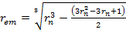 [4]
The resulting rectilinear velocity v for this orbital would be
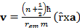 [5]
where m is the mass of the electron and ȓ and a are unit vectors respectively in the direction of the equator where the rectilinear velocity is a maximum and in the axis of rotation direction.
It can be pointed out that under the foregoing model the three-dimensional volumes of electron orbitals asymptotically approximate being proportional to r² with increasing r values. There may well be other possible interpretations here as well which I will not speculate on in this chapter. In any event I now turn to a discussion of how a superposition of electron states is created during the period in between the absorption and the emission of a photon by an electron. There may well be other possible interpretations here as will which I will not speculate on in this paper.
When a photon is absorbed an electron switches orbitals from a lower orbital (e. g. the ground state) to a higher orbital (an excited state), and when an electron switches from a higher orbital to a lower one a photon will be emitted. I claim that when a photon
is absorbed, the absorbing electron acts like an ideal liquid in that it is temporally 'split in half,' with one 'half' remaining in the original orbital, and the other half 'jumping' to an orbital with an energy higher by a factor hν, the energy of the photon. In effect this constitutes a superposition of the two states inasmuch as each orbital is occupied, albeit each with only half of the electron. The time for a realignment of the electron halves is determined by the period T (i. e., the reciprocal of the frequency, or 1/ν) of the light ray being absorbed. This fits in well with the old Bohr quantum theory, where Bohr [1913/1967, p. 136] also equated the frequency associated with an emitted photon with the difference in frequencies of revolution of electrons in the orbitals being jumped between. I will not speculate on the nature of any mechanisms which might be causally responsible for determining the frequency of the emitted and absorbed light here other than to suggest that they may involve the radial angle of a portion of the spread-out electron occupying one orbital ‘catching up’ and thus realigning with the radial angle of a corresponding portion of the spread-out electron occupying the other orbital.
I will now turn to the details of my derivation of the Balmer formula for the spectrum of hydrogen:

$\frac{1}{λ}=R\left(\frac{1}{n_{1}^{2}}−\frac{1}{n_{2}^{2}}\right)$ [5]
where n₁ and n₂ are respectively the principal quantum numbers of the lower and upper quantum states and n₂ > n_{1.} R is the Rydberg constant. It can be remarked that the circumference c₁ of the original orbital is directly proportional to the original radius r₁; i. e., c₁ = 2πr₁. Similarly, the circumference of the orbital jumped to will be directly proportional to the radius of that orbital; i. e., c₂ = 2πr₂. The angular speeds Ω₁ and Ω₂ of the electron orbitals can now be derived. In order to have the angular momentum be an integral function of n, these angular speeds are proportional to 1/r_{n} ∝ 1/n². Thus the difference in angular speeds (the time for the radial angle of one orbital to realign with the radial angle of the other orbital) is given by 1/n₁² – 1/n₂². When this is multiplied by the Rydberg constant it gives the Balmer formula. I will now turn to my discussion of the energy of orbitals.
It can be recalled that I agree with Bohr that the angular momenta of bound electrons is quantized. Thus, at each subsequent orbital the angular momentum will be proportional to n and also be equal to rv where v is the rectilinear velocity of the electron in its orbital. Since r ∝ n², the angular momentum is also proportional to n, and thus the rectilinear velocity is directly proportional to 1/n. It can be recalled that I hold that the rectilinear velocities of electrons are constants as a function of changes in radii of their circular contours within a particular electron orbital. Thus, since the kinetic energy is proportional to the square of the rectilinear velocity, it follows that the kinetic energies of the respective orbitals will be proportional to 1/r². When this is multiplied by the Rydberg constant, and using the Planck formula E=hν it gives the Balmer formula for the hydrogen spectrum. It can be noted that this makes the kinetic energy of the lower orbital less than that of the upper one. It can be pointed out though that bound states are held to possess negative energies both under the Bohr theory [Ter Haar, 1967, p. 36] and under wave mechanics [Bohm, p. 247]. Thus, less kinetic energy is subtracted from the higher orbital and it will have less total potential energy here.
It is true that it is usually held that the Bohr theory has been superceded by the modern quantum theory of wave mechanics. Thus, obviously in order to be at all complete much more is needed here in accounting for the successes which modern quantum theory has had with such matters as predicting transition probabilities together with the resulting intensities of spectrum lines and the spectrum of helium. I will not tackle any of these subjects in this paper though.

Addendum on Spin

It is well known that a fourth degree of freedom ‘spin’ is necessary in order to account for such phenomena as the anomalous Zeeman effect (splitting of spectral lines in a magnetic field) and the Pauli exclusion principle. It is perhaps noteworthy, in regard to the relationship of spin to defenses of the Bohr model that Von Neumann [1955/1983, p. 5] asserts that "almost all difficulties of the model disappear" when it is supplemented with Goudsmit and Uhlenbeck's [1926] account of spin and the magnetic moment of the electron.
It can be recalled that in keeping with my avoidance of the ignorance interpretation, my model differs from traditional treatments of quantum mechanics in that it holds that electrons are not point particles, but that instead they are 'spread out' over entire orbitals. It both follows that no distinction is made between the spatial location of an electron and its orbital, and also that the spin angular momentum cannot be sharply separated from the orbital angular momentum.
Traditionally spin is accounted for in terms of a literal precession (“the Larmor precession”) of the axis of rotation of the electron in the presence of a magnetic field where the spin is held to be responsible for the precession. This account is illustrated in Figure 2, where the diagram for the electron precession on the left is adapted from Gerhard Herzberg (1937/1944, p. 109).
Instead of the traditional account I hold that spin involves a property over the entire shell constituting an electron, namely the vorticity. In order to motivate this alternative account it can first be noted that both orbital angular momentum L and spin S
effects only occur in the presence of a magnetic field; the normal and anomalous Zeeman effects, although the spin effects cancel out for the normal Zeeman effect for atoms possessing an even-numbered number of electrons. This suggests that spin and orbital
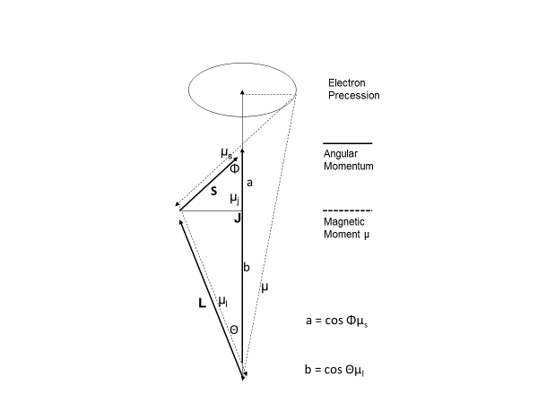
Figure 2 precession of electron in the presence of a magnetic field with magnetic moment μ

angular momentum are not intrinsic properties of electrons but rather, along with the total angular momentum J, are activated as a coupled system by the presence of a magnetic field. Thus, unlike the traditional conception of a fixed-valued quantized “electron spin” interacting with the magnetic field to result in the splitting of spectral lines associated with the Zeeman effects, I instead hold that the magnetic field creates the splitting. The result is context dependent, and thus has something in common with the contextualist account of spin postulated by John Bell (1987, Ch. 17) in the context of presenting a counterexample to “proofs” (such as those by John Von Neumann (1932/1955, Ch. 4, Sec. 2) and Simon Kochen and Ernst Spector (1967) against at least local hidden variable theories. Bell’s example is discussed in some detail by Bohm and Hiley (1993, Ch. 10).
The presence of a magnetic field causes the magnitude of the split in spectral lines to be determined by two factors. As illustrated on the lefthand side of Figure 3, one factor is the component of the magnetic momentum of the electron in the field direction. Notice that this magnetic moment is parallel to the axis of rotation given by Equation 5 associated with the electron's orbital angular momentum. The second factor is Alfred Landé's g factor which is defined as where j, l and s are respectively the total angular momentum, orbital angular momentum, and spin quantum numbers. The g factor in turn is a component of the formula for the Larmor frequency

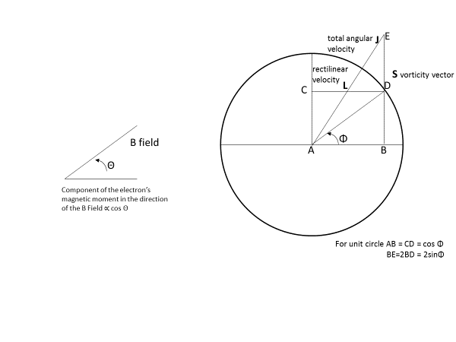
Figure 3 Account of spin in terms of vorticity

$−\frac{\text{egB}}{2m}$where B is the magnitude of the magnetic field, m is the mass of the electron, and e is its charge.
With respect to rectilinear velocities, my hypothesis is that the magnetic field causes a deviation of a spherical electron orbital away from that of a rigid sphere in the sense that there is relative motion among the internal parts. In particular, I claim that the rectilinear velocities (resulting in the orbital angular momentum) are a constant as a function of polar angle. The resulting difference in rectilinear velocity as a function of polar angle here causes a coupling effect which in turn results in a rotation (the vorticity) which I associate with spin. The situation is analogous to the model for polarization of the Poincaré sphere as illustrated in Figure 4. Thus, as with the case of polarization, since the resulting angular velocity increases monotonically as a function of polar angle away from the equator, this will result in microscopic circulatory movements, or eddies, with opposite rotations on opposite sides of the equator.
The following is based on my analysis of magnetism in terms of vorticity in Chapter Two of my Ebook “A Model of the Physical World.” I hold that in many respects (aside from the fact that its magnitude is quantized) spin is the analogue within an atom of an external magnetic field. Vorticity Ω is a hydrodynamic concept corresponding to the circulation per unit area for an infinitesimal loop. Vorticity itself is a macroscopic property, being a curl ∇ x v where v is a velocity field, while its subject matter, the circulation per unit area in the limit of an indefinitely small loop, is a subject in the small. In my analysis, the velocity field corresponds to the magnetic field, and the couple creating the vorticity (spin) corresponds to the infinitesimal loop. Also, since vorticity is defined as the curl of the velocity it should be emphasized that the direction of the vorticity vector is perpendicular to that of the velocity field.
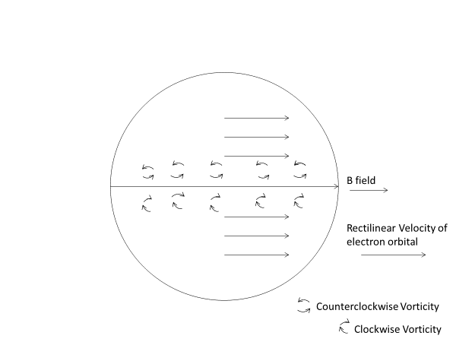
Figure 4 Spin analogue of the Poincaré sphere for polarization

My next series of remarks involve the gyromagnetic ratio – the ratio of the spin’s angular momentum to its magnetic moment. It can be noted that the traditional account of the gyromagnetic ratio being two from Paul Dirac’s (1930/1981, p. 266) relativistic wave mechanics is not available here since it presupposes special relativity. Thus, an alternative account for this ratio being two is necessary. Also, as Richard Feynman (1964, Vol. II, p. 40-5) points out, the vorticity of a fluid is twice the magnitude of the local angular velocity. This would make the vorticity correspond to the magnetic moment of spin and thus the macroscopic local angular velocity would then be associated with the spin angular momentum vector S. This would then agree with the observed gyromagnetic ratio of two.
In view of the preceding considerations a possible suggestion for motivating the quantization of total angular momentum J can be sketched as follows. As illustrated in Figure 3, the orbital velocity L varies as function of the cosine of the polar angle Φ. I identify the angular velocity of the electron orbital with J quantized as a complete rotation. Thus, the ratio of L with respect to J will vary as an inverse of the cosine (i. e., the secant) as a function of Φ. It should be emphasized again that the spin angular momentum vector S (which I identify with the vorticity vector) is orthogonal to L inasmuch as the vorticity is the curl of the local velocity field. Since the gyromagnetic ratio is two (due under my account to the vorticity being twice the local angular velocity), the total rotation vector J possesses a precession of the angular location of a complete rotation. It can then be recalled that a complete rotation plays a key role in my explication of the nature of spectra. Thus, I hold that a precession in the location of a complete rotation results in a shift of these lines by changing the magnitude of the vorticity vector and that this results in a greater split in spectral lines depending upon the direction of the precession.
I now address the issue as to why it is the case that electrons have opposite spins when paired together in an orbital. In the presence of a magnetic field this corresponds to the vorticities having opposite directions – clockwise and counterclockwise. Spin states can be thus be characterized as being “spin up” or as being “spin down” depending upon whether the rotation associated with the vorticity vector is clockwise or counterclockwise. It can be seen that, depending upon whether these rotations are clockwise or counterclockwise, they will either contribute positively or negatively to the velocity of the orbital, thus accounting for the splitting of spectral lines in a magnetic field with the anomalous Zeeman effect. It should be emphasized again that there are paradoxes associated with any non-contextualist traditional conception of a fixed-valued quantized “electron spin” interacting with the magnetic field to result in the splitting. Instead, I hold that the magnetic field creates a non-fixed value vorticity (which the “spin” is identified with), which in turn creates the splitting.
For electron orbitals, according to Pauli’s exclusion principle two electrons share the orbital with opposite spins. I discuss two variants of the model here. In the first variant (which I term "spin model 1") I hold that since the electrons come from different nucleons each of the electrons is located in a distinct parallel subspace – the subspace originally associated with that nucleon. The opposite spins of the paired electrons bound together in an orbital will then be, so to speak, “actualized in tandem” in the presence of a magnetic field. That is, I hold that they come jointly into existence in the process of being “measured” as with spectroscopic measurements of the splitting of spectral lines associated with the normal Zeeman effect which applies when there is an even number of electrons. Of course, I do not construe what is going on epistemically, but instead in terms of energy either being added or subtracted (depending upon the direction of the vorticity) to the electron in the absence of a magnetic field by the presence of a magnetic field. Admittedly, it might seem then that in the absence of a magnetic field that there would be no way to distinguish between the two spin states. However, once a magnetic field is present, the two directions of rotation are not determined in an ad hoc manner inasmuch as these directions are determined in terms of which side of the equator they are on as previously discussed.
In the case of electron orbitals with only one electron (i. e., for elements with an odd atomic number) it might be thought that the electron would be confined to just one hemisphere since that is the only way for it to spin in only one direction. However, this appears to be rather ad hoc since it arbitrarily confines the electron to just one hemisphere. Instead I strongly suspect that it is not so much a fixed spin in one direction but rather a superposition of spinning over the whole orbital; i. e., with a partial electron spinning in one hemisphere and a partial electron, with the opposite spin in the other hemisphere. Again, this is based off of the case of the Poincaré sphere model of polarization as illustrated in Figure 4. This suggests my second variant of an electron pair (which I term "spin model 2"). In this variant both electrons comprising an electron pair exist in a single subspace. This would have to involve electron from separate nucleons in some manner "collapsing" into a single subspace.
Various Stern Gerlach experiments can also be cited as confirming at least some of the foregoing points. These experiments are akin to those of optical experiments using horizontal and vertical polarizers to completely block light, and where light re-emerges when a third polarizer with an intermediary angle (e. g., 45º) is inserted in between the two other polarizers. Thus, I do not hold that the magnets of a Stern Gerlach device do anything like filtering for a given spin. Instead I hold that in effect they change the angle of rotation of an electron orbital, and hence also the angle of the equator orbital. It may possibly also be the case that in effect numerically new electrons are created in this process. I will not speculate any further on these matters in this paper though.

References
Bell, John, 1987, Speakable and Unspeakable in Quantum Mechanics, Cambridge
University Press.
Bohr, Neils, 1913, “On the Constitution of Atoms and Molecules,” Philosophical
Magazine 26, 1 (1913), republished in Ter Haar, D. 1967, The Old Quantum
Theory, Pergamon Press, pp. 132-159.
Bohm, David, 1951/1989, Quantum Theory, Dover.
Bohm, David and Hiley, Basil, 1993, The Undivided Universe, Routledge.
Dirac, P. A. M., 1930/1981, The Principles of Quantum Mechanics, Oxford University
Press.
Feynman, Richard, 1964, The Feynman Lectures on Physics, Addison Wesley.
Goudsmit, S. and G. E. Uhlenbeck, G. E., “Spinning Electrons and the Structure of
Spectra,” Nature 117, 264 (1926).
Herzberg, Gerhard, 1937/1944, Atomic Spectra and Atomic Structure, Dover.
Kochen, Simon and Specker, Ernst, “The Problem of Hidden Variables in
Quantum Mechanics,” Journal of Mathematics and Mechanics 17, pp. 59-87.
Von Neumann, John, 1955/1983, Mathematical Foundations of Quantum Mechanics,
Princeton University Press.
Whitehead, Alfred North, 1925, Science and the Modern World, Macmillan.

