Still Control Eagle is a water management system only. You must consult the law in regards to distilling in your country.

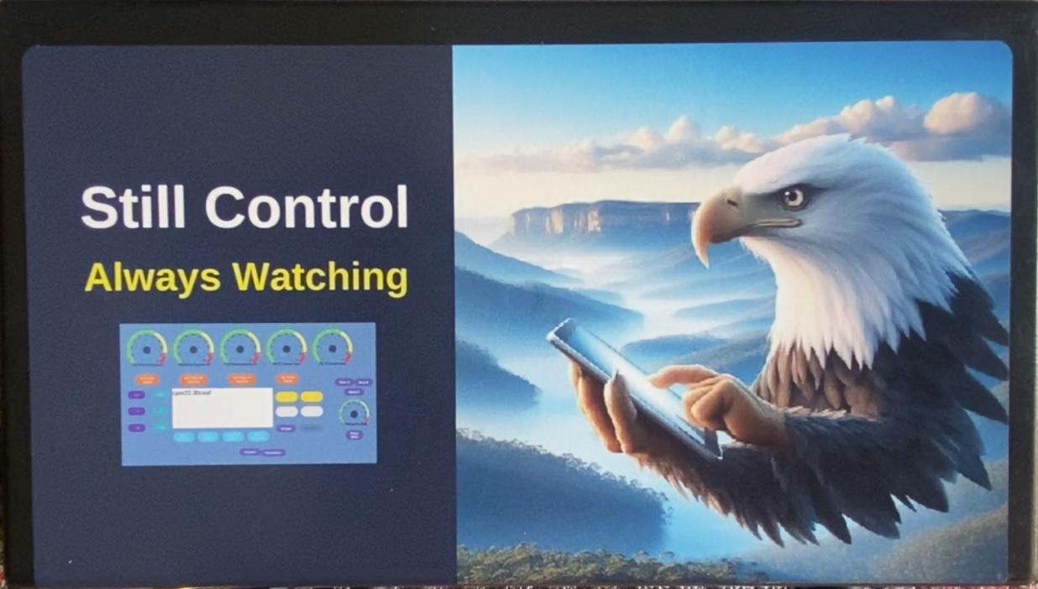

Cautions & Warnings
The External switch must be installed by a licensed electrician.
You must consult your electrician about the power requirements of your still. We will not be liable for injuries due to mismanagement of the external switch.

Introduction
Welcome to Still control and thank you for your purchase.
Still Control Eagle is a water management system only. You must consult the law in regards to distilling in your country.
Still control Eagle provides a comprehensive set of controls for your still. Reading and understanding the instructions manual is essential to gain maximum benefit of your system.

Overview
Still Control Eagle is a modern water control system designed to run your still automatically or manually.
Monitoring via Bluetooth gives you full control of your still on an android tablet, with visual gagues and digital displays, making a seamless transition from manually operating your still to knowing with confidence.
Still Control Eagle will run it for you.
Adjusting your stills temperature with ease down to
+/- 0.2C to ensure you’re getting the result you require.

Still Control Eagle has many helpful functions.
- Wash mode to maintain the temperature of your wash.
- Automatic and Manual distill modes.
- Pulse mode for Alembic stills.
- Pumping wash into boiler.

Main Menu

1.0 Setting up Still Control Eagle

1.1 Downloading the interface

1.2 What’s in the box

1.3 The pump

1.4 Tank

1.5 Exhaust water

1.6 Temperature probe

1.7 External Switch

1.7.1 Cautions & Warnings

1.7.2 External switch.

1.7.3 Uses of external switch

2.0 Using the system

2.1 Connecting up all your leads

2.2 Connecting tablet to Eagle

3.0 Gauges

3.1 Identifying the 6 gauges

3.2 Making adjustments to gauges

4.0 Button and display descriptions

4.1 To adjust gauge

4.2 Mode selection

4.3 Pump

4.4 External Switch

4.5 Gauges / Sensitivity buttons.

4.5.1 The Sensitivity button.

4.6 Alarm off

4.7 Pump Delay

4.8 Start / stop

4.9 Reset button

5.0 Mode descriptions
5.1 Manual mode
5.2 Automatic mode
5.3 Pules mode
5.4 Wash mode
6.0 Set-up Considerations

1 Getting Started
Setting up Still Control Eagle
The Eagle is a sensitive piece of equipment. Please ensure the system is fully connected before power is applied.
1.1
Downloading the interface
Go to Still Control web site to download the Android tablet interface @
www.stilcontroll.com.au and follow the prompts to install the interface onto your tablet. download file Is here.
download or copy file into your tablet. Tap the file and it will install onto your tablet. Note you may need to set permission to allow file to install.
No personal information or data gathering is present in the application.
Or visit One drive @stillcontrol and follow the instructions.

1.2 What’s in the box.
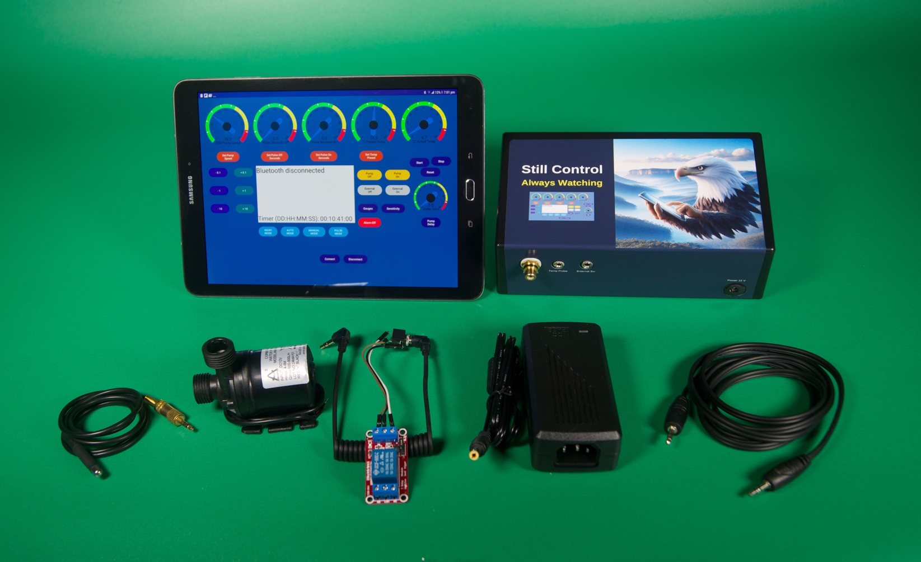
- Tablet not supplied
- 1 X Still Control Eagle controller
- 1 X Thermometer
- 1 X External Main switch components
Optional Extras
Power supply and Pump
Note: Minimum speciation’s for the power supply are 12V, 5 A, 2.5mm DC plug, centre positive.
The pump needs to be 12V PRM compatible, with at least 600 Litres flow rate. The pump is connected via an RCA, connector centre positive.

1.3 Pump
The pump is submersible. Do not connect the pump to any pressured water supply. In doing so your pump will have no control of water flow.
You have 2 options using the pump supplied by us.
Submersed or not submersed.
Option 1. Submersed the pump will need to be secured in your water reservoir.
Option 2. The pump can be used externally from the water revivor via hoses.
In either case the pump must be mounted horizontal and firmly secured so it cannot move during use.

1.4 Tank
Using a small reservoir with a float valve will ensure the water will remain at a constant level.
The pump will pump the water from the reservoir eliminating any fluctuations of water pressure. Attach the water hoses to the pump and still as you would normally connect your still.

1.5 Exhaust water
For reliable water flow it’s advisable to run water exiting / exhaust water free falling without having to worry about the system siphoning.

1.6 Temperature Probe
warnings about probe
Note do not connect or disconnect temperature probe once power to controller is on.
Arrange your still so there’s room to attach your thermometer (ensuring lead is not coming in contact with your still).

You can either use vapour or water to measure your temperature. Place the temperature probe where you would normally monitor your temperature.

The probe must be able to sense the still’s internal temperature.
In water it must be attached to your still in a way that if there is no water flow it still conducts heat to temperature probe to tell if its heating.

1.7 External Switch

1.7.1 Cautions & Warnings
The External switch must be installed by a licensed electrician.
You must consult your electrician about the power requirements of your still. We will not be liable for injuries due to mismanagement of the external switch.
1.7.2
The external switch GPO is a major safety feature for your system. It ensures your still is switched off in the event of a malfunction.
Note the use of the cable from the controller to the relay in the external switch GPO ensures the power only remains on if the controller commands it. In the case of a malfunction occurring the in the controller or there is a high temperature warning, the still will turn off. If the cable is detached or broken, the external switch GPO will not work. If you plug the Eagle controller power supply into the external switch GPO, it will not work.
GPO: general purpose outlet, mains power outlet.

1.7.3
The external switch can be used in many ways.
If running your still for the safety Emergency shutdown feature to work your boiler must be plugged in to the external switch.
In Wash mode, any heater can be plugged into the switch as long as it can be turned on and off at the external switch and your liquid will be kept at your desired temperature.

2.0 Using the system.
Still control
Setting up your system from the start is import.
Powering up is the last step.
2.1 Connecting up all your leads.
At the front of the controller there are 4 plugs each is unique.
Plug all 4 plugs into the controller.
Connect external switch lead into the external switch.
External switch plugs into mains power.
Plug your boiler into the external switch
Place your pump in water revivor (see Pump section)
Power supply Must be connected to mains power and not to external stitch.

2.2 Connecting the tablet to the Eagle via Bluetooth.
On your tablet Select Still Control Icon
Power up control box and a beep will alert you that the power is on.
On the tablet press the connect button, a list of Bluetooth devices will appear.
Select Still Control from the list.
Once connected, the interface will be activated. This will be confirmed by the gauges displaying pre-set values.

3 Gauges
The gauges mimic the digital display and do not respond to touch.
3.1 Identifying the 6 gauges

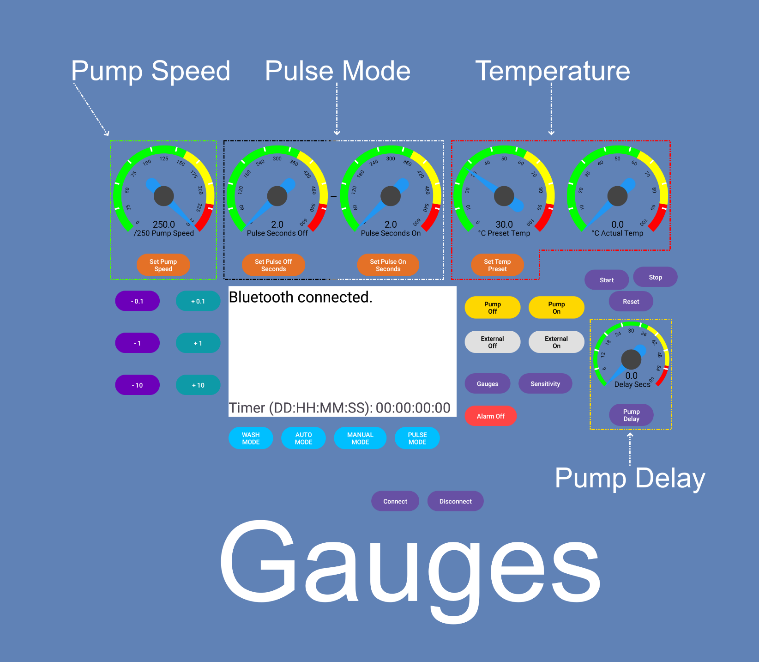

  - Pump speed from 1-250 units. This adjusts the water flow.
  - Pulse seconds off. Default 2 seconds.
  - Pulse seconds on. Default 2 seconds.
  - Pre-set temperature is the temperature you wish to maintain. Default 30 ºC.
  - Actual temperature ºC (non-adjustable) is always on.
  - Pump Delay Default 0 seconds. Bottom right of the tablet. Button for adjustment in purple below gauge.

3.2 Making adjustments to gauges

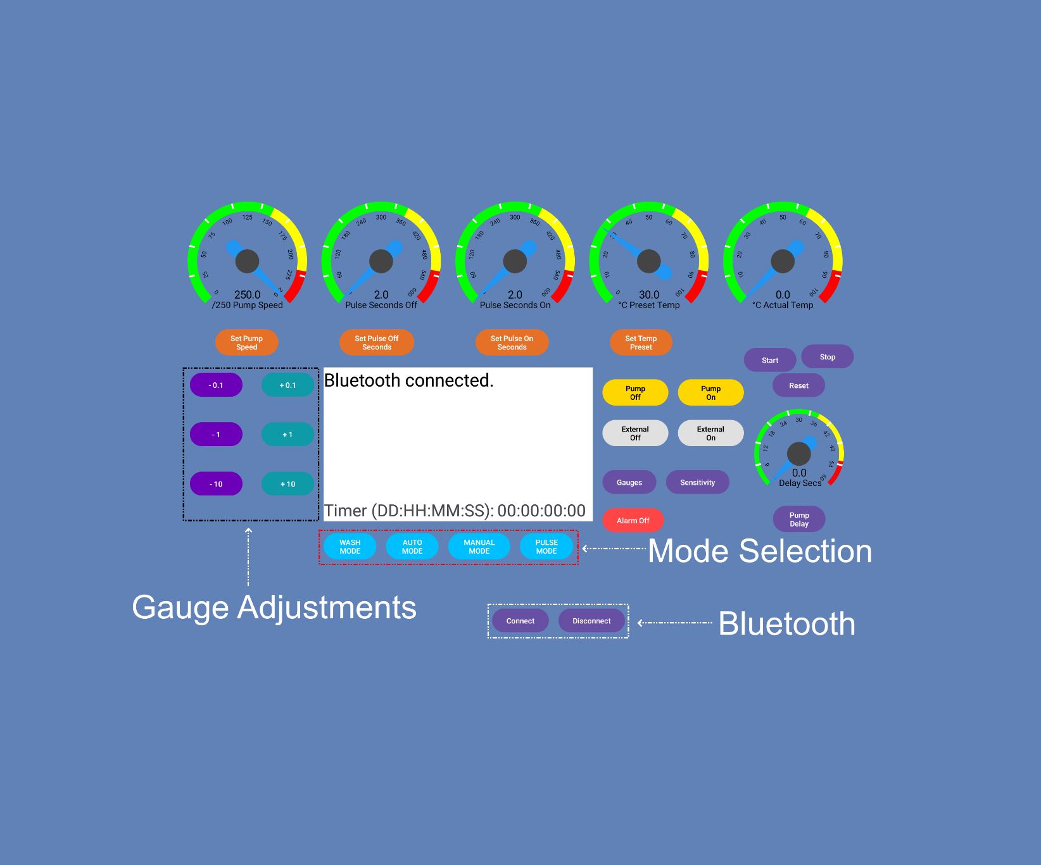
To adjust any gauge (except actual temperature), press the button under the gauge you require to change.
There are 4 options in orange below the main gauges. Select the gauge you wish to change and press the button underneath the gauge. Go to the +\- buttons displayed on the left in purple / green and adjust the gauge you just selected.
The Pump Delay button is below the Pump Delay gauge.
Every time a button is pressed, the digital display under the gauge changes to reflect your choice.

4.0 Button and display descriptions
Any button pressed will be confirmed in the text box
4.1 To adjust gagues
In purple there are 3 choices:
- 0.1 units
-1.0 units
-10 units

In green there are 3 choices
+ 0.1 units
+ 1.0 units
+ 10 units

4.2 Mode selection
Under the dialogue box are 4 options in blue depending on your goal.
- Wash mode.
- Auto mode for distilling.
- Manual mode.
- Pulse mode.

4.3 Pump
The pump will be pre-set at 250 units as a default, there is no decimal point.
There are 2 yellow buttons to manually operate the pump.
Clearly labelled pump on & pump off. You can operate the pump at any time. Once auto distil is active the program has control of the pump and you cannot turn it off.

4.4 External Switch
There are 2 grey buttons to manually operate the external switch.
Clearly labelled External off and External on.

4.5 Gauges / Sensitivity buttons.
In purple there are 2 buttons.
Gauges and Sensitivity.
The Gauges button is usually used if your tablet has dropped out of Bluetooth range or has been turned off. Reconnect the tablet and refresh your gauges with this button.

4.5.1 The Sensitivity button.
Sensitivity is the range of temperature the still maintains. The options are 0.1c - 0.5c. By pressing the sensitivity button, it will rotate from 0.1c to 0.5c in a continuous loop.
4.6 Alarm off
If the alarm sounds to alert you that the system shutdown has been activated, you can press the alarm off button labelled in red
Alarm Off and the alarm will be turned off.

4.7 Pump Delay
In purple pump delay measured in seconds is used by the program to regulate the pumps adjusting period.

4.8 Start /stop buttons in purple
They start and stop the mode that has been selected
4.9 Reset button
This clears the timer and starts at zero again. You can do this at any time, in any mode.

5.0 Mode Descriptions
There are 4 modes
Wash mode
Auto distilling mode
Manual mode
Pulse mode

5.1 Manual mode
In manual mode you have full control of the interface.
Turn on or off any function you wish. See Manual mode details

5.2 Auto distilling mode
Auto Mode will start heating boiler and switch to distilling and maintain your temperature for you. See Auto mode details.

5.3 Pules mode
Pulse mode runs your pump on a timed cycle, time on and time off. See Pulse mode details.

5.4 Wash mode
Wash mode is an excellent feature in the Eagle. It is used to maintain the temperature of your wash.
See Wash mode details.

5.0 Mode details.

5.1 Manual mode
To use manual mode, you select (manual mode) then press start. It starts the clock and turns on the external switch.
The stop button
Stops everything you have turned on in manual mode
In manual mode you have full control of the interface.
Anything you wish to do you can achieve in manual mode.
Turn on any function you wish
Pump external switch on or off same as the boiler.
Its handy to test your still and the system. You can use manual mode to find the happy medium of your still then switch over to auto mode.
With any mode used, once you have programmed the tablet the controller takes over and if tablet is turned off the controller will continue to do its job.

5.2 Auto distilling mode
We need to check that your system is fully operational.
Test the following.
- Pump has adequate water flow.
- External switch activates.
- The temperature gauge is working.
- Boiler plugged into external switch.

Now need to put some data into Still Control Eagle
Set (preset temp) at the temperature the manufacturer recommends for your still. We suggest going a little under at first.
Sensitivity is by default set at 0.5c
The pump is set at 250 by default and that’s ok.
Don’t worry if there is too much flow, when auto distill mode starts the pump starts at full speed for 5 seconds then will regulate the water flow according to the temperature of your still.
Pump Delay needs setting as a starting point. 3 seconds is ok and can be fine-tuned.
(it’s important to read the section on Pump Delay)
Select Auto Mode and press start.
Heating mode is now displayed and active.
The external switch is on and the timer starts.
Auto distill will start 5c degrees below your preset temperature.
Once auto distill mode activates you will hear a beep and the display will show.
Auto Distil and Pump On full. The display will after 5 seconds display Pump Adj.
The pump on full will cool your still. As the temperature drops the pump will adjust down. If your temp drops 10c below your preset value it will go back into heat mode.
However, the pump speed will have gone down and the next cycle it’s starting at a lower speed.
This may happen multiple times until it has found the sweet spot of the still.
Note down the pump units in your notes and the next time you start Auto mode you can manually input that data into your preset pump speed. For safety we recommend entering a pump speed faster than recorded value so the still will not overheat.
Now the Eagle has stabilized the temperature it will continue to monitor the temperature and keep it at your preset temperature. You can adjust the pre-set at any time to get the maximum yield.
Adjustments of up to 2c can be made easily waiting each time for the controller to reestablish the still to its new temperature.

Now you need to have a look at the pump speed and read section 6 to fine tune your understanding of the
Eagle’s control of the water flow
With any mode used, once you have programmed the tablet the controller takes over and if tablet is turned off the controller will continue to do its job.

5.3 Pules mode
Pulse mode runs your pump on a timed cycle, time on and time off. When selected and started the pump will turn on for the selected time and off for the selected time. You can change pump speed at any time down to 100 units.
A countdown timer will be displayed informing you of how much time is remaining on the cycle. The pump is adjustable down to 100 units.
The thermometer will still monitor any part you wish distillate, water or still just to name a few.
To use Pulse mode select pulse mode and press start. You can adjust the time in seconds up or down at any time by selecting the appropriate button under the gauge you wish to change.

5.4 Wash mode
Wash mode is an excellent feature in both the Eagle & Hawk
It must be used in conjunction with the external Switch. Your equipment must be able to be turned on and off at the switch to work in with the external switch.
It will keep any liquid at the desired temperature (As long as your heating equipment is plugged into the external switch and able to heat that high.)
It is excellent at maintaining temperature, enabling you to get your wash ready for fermenting.
Melting sugar and water, preheating your boiler ahead of time just to name a few.
To start Wash Mode
Set your desired temperature using (Preset Temp)
Make sure your external switch is correctly plugged into the controller.
Plug your heating device into the external power point and ensure it’s turned on.
Plug external switch in to mains power.
Place your thermometer in an appropriate spot to read your liquid’s temperature.
Select WASH Mode on your tablet.
And press start.
Be Aware
Once wash mode is started the external switch will activate. And power will run through the external switch. Wash mode will take control of the external switch and cannot be turned off using (External Off button on display)
To end wash Mode select off button.
Wash mode is off.
Your tablet has programed (Still controller) and it is no longer essential to be connected via Bluetooth.
It will still do its job. If you wish to check progress reconnect to Bluetooth and refresh gauges.
A full display of time elapsed will be shown in
DD:HH:MM:SS . And actual temperature of liquid.
Wash mode will continue until you turn it off.
If making a grain mash the wash mode will maintain your temperature for you. When cooling down time comes you can just turn down your preset temperature to what you wish and when wash reaches that temp it will maintain it.

Pump delay

This feature is used to help your still to maintain its temperature depending on your still’s reaction time. Each still has its own reaction time.

It is the time it takes from changes in water flow to be represented in temperature at the temperature probe.

All stills fluctuate in temperature (T 500 ) and can fluctuate up to 0.6c from preset setting

That’s 0.3c +/- e.g. 50c can mid run read 49.7c to 50.3c.

If your sensitivity is set at 0.3c and temperature goes beyond your settings +/-

and your Pump Delay is set at 0 Seconds, the pump will change every second until it’s in the range of your sensitivity.

For example, my preset is 50c and the temperature reaches 50.4, the pump will increase speed 1 unit every second until it drops 0.1c.

It may take 6 seconds to cool the still 0.1c.

In that time, the water pump has increased its speed by 6 units. Your temperature will fall too much and your pump will decrease its speed 1 unit every second until preset temperature is reached again.

And the cycle will continue over and over again.

If you put a delay of 5 seconds in and your temperature is 0.1 out of range the Still Control Eagle program will compensate and wait 5 seconds before taking another reading.

If it’s still outside of your parameters, it will compensate again. And in 5 seconds take another reading and so on.

In this way, the reaction time of water flow adjustments to temperature has been streamlined.

6.0 Set-up Considerations
The height if your still compared to your pump's reservoir and exhaust water will play an important part in setting up your Still Control Eagle.

The size of water hoses selected need to be considered. We recommend using 12mm hoses to allow plenty of water flow and use the height of water reservoir and exhaust water to maintain a reasonable flow rate. For example, if your pump is working on 30 units and it needs to go down one unit, the difference between 30 and 29 is more than 130 to 129 In flow rate.

We recommend a speed between 100units and 150 out of 250 units.

Once you’re still has settled any movement of the hoses will change your water flow and affect your temperature.

