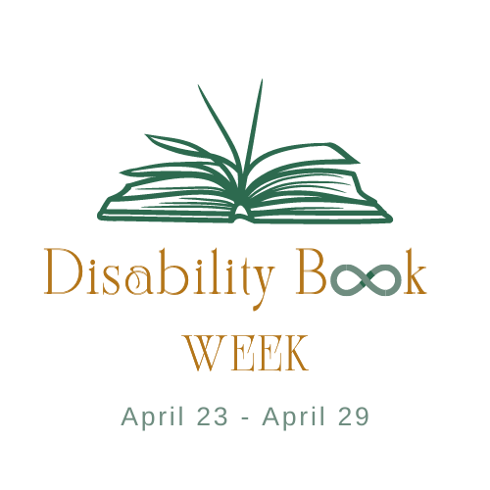

What is Disability Book Week?

Hello, and thank you for taking time to learn about our exciting event!

Disability Book Week is an event that runs from April 23rd to April 29th. World Book Day, April 23rd, kicks us off, and then for seven days, people all over the United States will be invited to:
- Read books recommended by our sensitivity panelists that utilize inclusive language, stories, and depictions of those with various disabilities
- Be made aware of authors with disabilities and educate themselves on the importance of supporting their work
- Uncover new practices and ways we can best represent and incorporate individuals with disabilities in literature.

What is the Purpose of Disability Book Week?
Simply put, Disability Book Week’s purpose is to promote disability inclusion in literature by working with the Governor’s Office, schools, libraries, and bookstores across America to recognize this special week. With April being “School Library Month”, using this week to highlight both books featuring characters with disabilities and books by authors with disabilities is a wonderful opportunity to expose readers to disability inclusive titles.

How Would Our Organization Get Involved?
We are requesting that schools, libraries, and bookstores set up displays of books that feature characters with disabilities, or else books that are written by authors with disabilities.

How Do We Know Which Books are Inclusive?
A carefully selected team of 12 disability advocates are working hard to read and review books so we can recommend the best books in the field of disability inclusion via our recommended reading list. We will be posting our recommended reading list on our social media pages @disability.book.week as they get reviewed, as well as a comprehensive list that will be available on our website: disabilitybookweek.org. We will also be featuring various authors with disabilities on our website as well.

How Can the Average Person Get Involved?
First, follow us on social media. We will be posting challenges and prizes, ways to get involved, and calls to action from time to time in addition to book reviews. Whether it is your school, library, bookstore, or book club participating, we would love to see your displays and hear what books everyone is enjoying during Disability Book Week.

