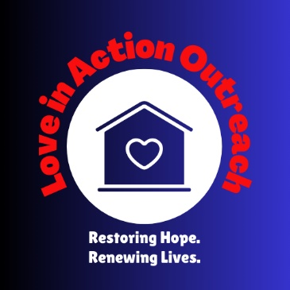
903-315-6083
6144 Old HWY 135 N.
Kilgore, TX 75662
joshuafhunt@restorationofthespectrum.com

Mission Statement
At Love In Action Outreach, our mission is to reflect Christ’s love by providing safe shelter, compassionate care, and transformative support to individuals experiencing homelessness. Rooted in faith and driven by a commitment to restore dignity and hope, we strive to meet both immediate needs and foster lasting change through community partnerships, practical resources, and spiritual encouragement. Together, we work to inspire and empower individuals on their journey toward stability, purpose, and a renewed life.

