SHIRTS ... SHIRTS … SHIRTS!!!! GET YOUR NEW ALFA SHIRTS NOW!

NEW MEMBERS: Get your Mid-Florida Alfa Shirts NOW!!
TENURED MEMBERS: We have a new, non-sweat POLOS for you! You’ll love them!
We have TWO different, excellent quality brands of shirts! At least 12 are needed for an order.

(ONE FORM PER PERSON PLEASE)

Name: Phone: Email Address:
Mailing Address (your shirts will be mailed to you):

1. NEW- “CORE 365” – MOISTURE WICKING POLO SHIRT:(new style, non-sweat polos)

(Circle one) Ladies’ Shirt 78181 Men’s Shirt 88181
(Circle size) Ladies’ XS-M-L-XL-2XL-3XL (Sizes 4XL-5XL not offered in ladies)
(Circle size) Men’s S-M-L-XL-2XL-3XL-4XL-5XL (XS not offered in men)
(Circle Color) Acid Green - Black – Burgundy – Campus Gold – Campus Orange-
Campus Purple – Carbon – Charity Pink – Classic Navy – Classic Red –
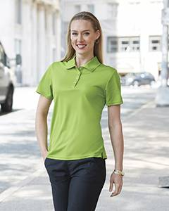
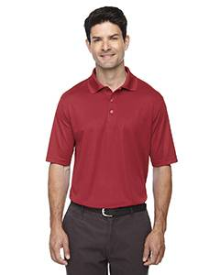
Electric Blue – Forest - Platinum – Safety Yellow – True Royal - White (see attached color chart)

PRICES: XS-XL $ 35.00
2XL --5XL $ 40.00

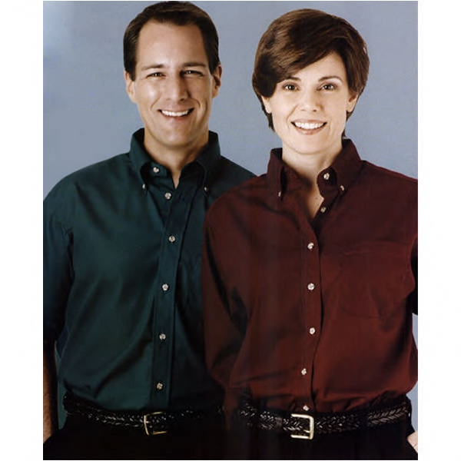
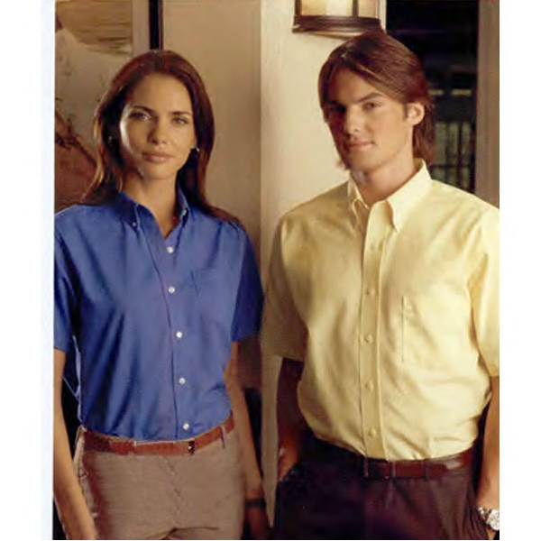

2. EDWARDS BUTTON-DOWN,
DRESS CLUB SHIRT:

(Circle one) Ladies’ Shirt Men’s Shirt
(Circle one) Short Sleeve 5230 (Ladies) /1230(Men) Long Sleeve 5280 (Ladies)/1280(Men)
(Circle size) Ladies’ XS – S – M – L – XL -2XL - 3XL (Sizes 4XL-5Xl not offered in ladies)
Men’s S – M – L – XL - 2XL - 3XL - 4XL - 5XL - 6XL (XS not offered in men)
(Circle color) Black–Brick–Dark Teal-Denim Blue-French Blue–Navy–Red–Royal-Rust –
Sapphire–Tan–Titanium-White–Wine-Yellow (see attached color chart)

Ladies’/Men’s Short AND Long Sleeve
PRICES: XS-XL $ 35.00
2XL-6XL $ 40.00

Pricing includes shipping and tax
FILL OUT ONE FORM PER PERSON AND MAIL WITH CHECK MADE PAYABLE TO
Mid-Florida Alfa Romeo Club
c/o Margo Miller - 679 Silvercreek Drive
Winter Springs, FL 32708
(one check per family is fine) - Call Margo at (407) 346-8446 or email: maggiesredheads@hotmail.com

