|  |  |  |  |  |
| --- | --- | --- | --- | --- |
| **Monday** | **Tuesday** | **Wednesday** | **Thursday** | **Friday** |
|  | **1**  CLOSED  (Canada Day) | **2**  Spray Painting with  Water | **3**  Water  Sponge  Play | **4**  Water and Oil  Experiment |
| **7**  Making  Homemade  Bubbles | **8**  Bubble  Song/ Movement | **9**  Chasing Bubbles, Bubble Pop Game | **10**  Bubble  Picture | **11**  Bring  Bubbles for Outside Play |
| **14**  Beach  Day  (wear beach clothes) | **15**  Bring a  Beach  Ball | **16**  Make  A Sand  Castle | **17**  Making  Soapy Sea Foam | **18**  Playing  With  Shells |
| **21**  What happens in Summer | **22**  Water Fun Day  (bring swim clothes) | **23**  Chalk  Art | **24**  Comic  Day  (bring a comic book) | **25**  Water  Colours  Painting |
| **28**  Fizzing  Ice  Cubes | **29**  Freeze  Tag  Game | **30**  Ice Cream  Math  Game | **31**  Ice  Cube  Painting |  |

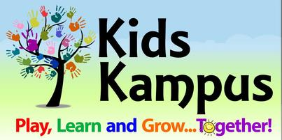 **Preschool 1 Room**

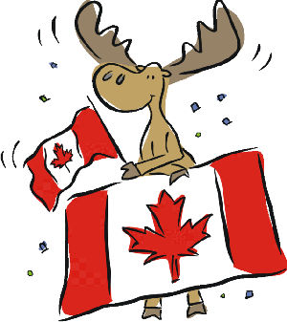

**Note**:

1. Kids Kampus will be closed on Tuesday, July 1st for Canada Day.
2. July 11th – Bubbles Day, please bring bubbles.
3. July 14th – Beach Day, please wear beach type clothes.
4. July 22nd – Water Fun Day, please bring swim wear, towel, water shoes (sandals/crocs) and a towel for Water Fun! Also Extra clothes!!!
5. Any day can be water day if warm, please have **ALL** water clothing (towel, swim wear, water shoes) each day in child’s bag. Also Extra clothes!!!

**July 2025**