|  |  |  |  |  |
| --- | --- | --- | --- | --- |
| **Monday** | **Tuesday** | **Wednesday** | **Thursday** | **Friday** |
|  | **1**  CLOSED  (Canada Day) | **2**  Yellow  Water  Play | **3**  Bring Bubbles for creating a bubble picture | **4**  Yoga  Moves |
| **7**  Fun  With  Music | **8**  Sand  Art | **9**  Superhero  Day | **10**  Magnet  Exploration | **11**  Make  Pink  Playdough |
| **14**  Bring a Summer  Book | **15**  Bottle  Top  Races | **16**  Shaving  Cream  Sensory Play | **17**  Toothpick  Painting | **18**  Sports  Day |
| **21**  Ring  Toss  Fun | **22**  Ice  Cube  Painting | **23**  Picnic  Day | **24**  Wear Your Favourite  Hat | **25**  Sea  Shell  Hunt |
| **28**  Branch  Painting | **29**  Very Hungry Caterpillar  Felt Story | **30**  Making  Moon  Sand | **31**  Outside  Water  fun |  |

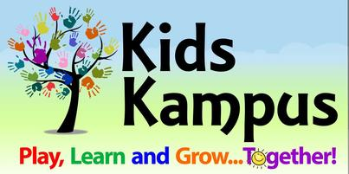 **Toddler Room**

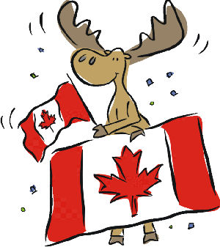

Note:

1. Kids Kampus will be closed on Tuesday, July 1st for Canada Day.
2. July 3rd – Bring bubbles.
3. July 9th – Dress like a Superhero.
4. July 14 – Bring a Summer book.
5. July 23rd - Picnic Day. Bring snacks for picnic.
6. July 31st – Please send swim wear, water shoes (sandals/crocs) and a towel for Sprinkler Fun Day! Also Extra clothes.

**July 2025**