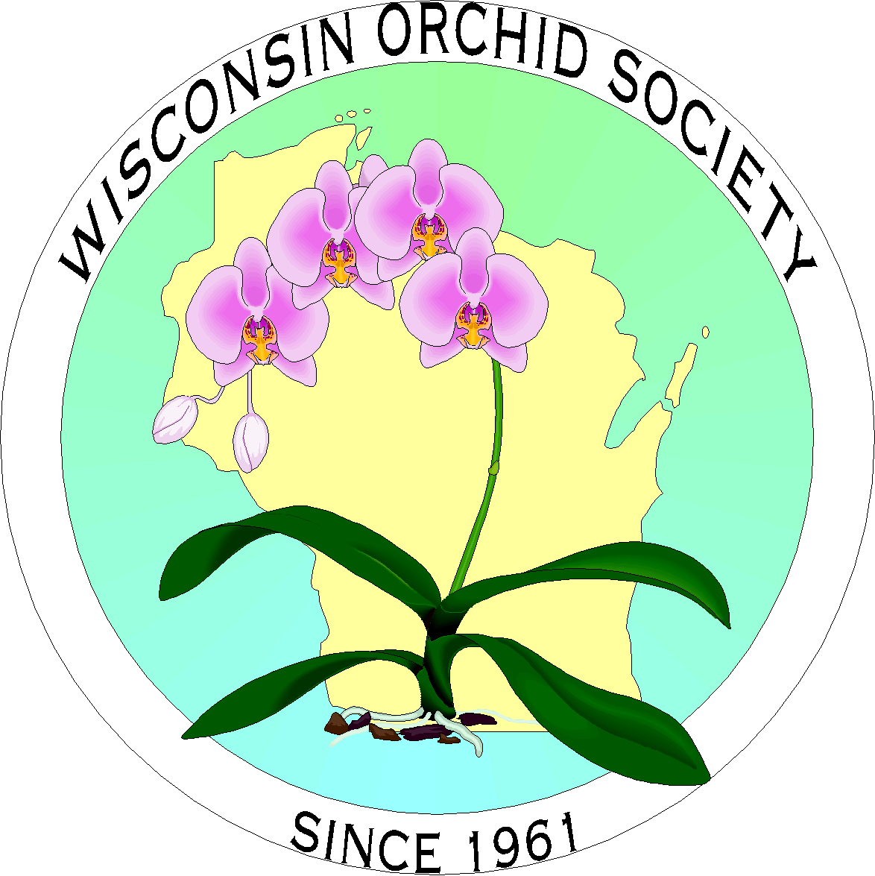 | Fall In Love with Orchids 2019  and The Mid-America Orchid Congress  September 14-15, 2019  www.wisconsinorchidsociety.com  Registration (Please type or print legibly)
 | First Registrant |  |  | Second Registrant
Name (for your name tag)

Society Affiliation

Street Address
City, State/Province, Zip
Telephone
E-Mail
AOS Judging Status (please circle) | Emeritus Accredited Associate Student |  |  | Emeritus Accredited Associate Student
Participating in ribbon judging? | Yes | No |  | Yes | No
Do you wish to clerk? | Yes | No |  | Yes | No
Participating in AOS judging? | Yes | No |  | Yes | No
 |  |  | First Registrant | Second Registrant |  |  | Sub Total
Full Registration (includes welcome bag, and unlimited access to show, vendors, and speakers) |  |  | $70 | $70
Full Registration (after 8/31/19) |  |  | $85 | $85
Banquet – Mediterranean Buffet |  |  | $45 | $45
Affiliated Societies Breakfast |  |  | $25 | $25
Please let us know if you have any dietary restrictions. We will do our best to accommodate your needs.
 |  |  |  | TOTAL PAYMENT |  |  | _____________

Are you flying into Mitchell International? If you fill in your flight details, we will provide them and your contact information to other registrants who may want to share a taxi or shuttle to/from the hotel. | Arrival Date: | Airline: | Flight #: | Time:
 | Departure Date: | Airline: | Flight #: | Time:

Return this registration form with a check payable to Wisconsin Orchid Society to:
Bruce Efflandt; 3518 North 98th Street; Milwaukee, WI 53222-2410

