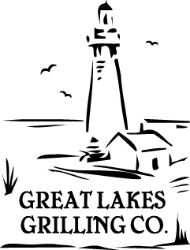

Hickory planked beef flank steak salad with sweet macerated red onions, grape tomatoes, honey crisp apples, crispy caramel shallots and gorgonzola cheese dressing.
Beef Marinade
1 ea. trimmed flank steak
1 T. red wine vinegar
1 T. Dijon mustard
1 T. Balsamic vinegar
2 T. fine chopped fresh cilantro
- Mix the ingredients together and apply to flank steaks and allow to marinade overnight.
2 T. kosher salt
2 tsp. fresh ground black pepper
- Before grilling season with salt and pepper.
- Cut each flank into four even pieces.
- Grill on soaked cedar plank to mid rare and cool for service.
- Carve onto salad.

Sweet pickled onions
2 ea. red onion very thinly sliced
4 T. Champagne vinegar
6 T. powdered sugar
2 tsp. Kosher salt
- Toss the onions in the vinegar, sugar and seasoning.
- Vacuum seal at half pressure and store for service.

Gorgonzola blue cheese dressing
½ C. sour cream
½ C. mayonnaise
1 C. Gorgonzola blue cheese
½ C. olive oil
1 T. lemon juice
2 T. powdered sugar
1 T. chopped parsley
2 T. water to bring the dressing to pouring consistency
- Blend all the ingredients in the food processor until very smooth.
- Correct the consistency and the seasoning.
- Store for service.
- The sauce may thicken when chilled and may need adjustment with water to achieve the correct consistency before service.

Crispy croutons
2 C. small diced French bread
1 tsp. garlic powder
1 tsp. onion powder
1 tsp. smoked paprika
1 tsp. salt
2 T. olive oil
- Toss the bread, oil and seasonings together.
- Bake until golden brown.

Crispy Shallots
7 ea. medium shallots very thinly sliced
2 tsp. Kosher salt
- Peel and julienne shallots
- Fry them in a pan with oil on the stove top until very brown and very crisp.
- Place the fried shallots on paper to drain, and season with salt.
- Hold in paper lined container for service, do not chill.

For the salad
5 oz. sliced planked beef flank
3 oz. mixed greens
1 oz. diced apples
6 ea. grape tomatoes halved
1 oz. sweet pickled onion
1 oz. crispy shallots
2 oz. Gorgonzola blue cheese dressing

